DINIYAT CLASSES (GIRLS)….2007-2008
Test # _1_ , Manual # __M08__ , Teacher:____Mrs Nafisa___

Marks:______/20 , % :_______ , Grade:______, Bonus:_______/ 10 ,Parents’ sign:_________
Topic: Fiqhi Iatelahaat,masail e roza,fadak,Tawheed,dua-quran ke sajday ki

Name:____________________________________________ Date:__2-11-07__

I-Fill in the blanks: (5)
1.} Woh naa waaqif shakhs jis kay liye masael ka seekhna mumkin raha ho lekin us nay kotaahi ki ho aur jaan boojh kar masael maalum na kiye ho jaahil e ______________________ kehlaata hai.
2.} Aisa wajib jisay agar kuch log anjaam day to baaqi logo say saaqit ho jaayega waajib e ____________________________ kehlaata hai.
3.} Mujhtahid e aalam fatwa na de balke yeh kahe ke ehtiyaat isme hai ke yu amal kiya jaaye to yeh ehtiyaat e _____________________ hai.
4.}Azhar yani Ziyaada zaahir. Yeh mujhtahid ka ____________________ hai.
5.} Agar rozedaar ishaaratan A….. ya Rasul ya aimma may say kisi say jaan boojh kar jhoot baat mansoob kare aur phir foran keh day kay mainay jhoot kaha hai to ehtiyaat e laazim ki bina par is ka roza _______________________ hai. 1577
6.} Agar insaan na janta ho ke huqna lenay say roza baatil hota hai aur wo jahil e qsir hai to iska roza __________________________hai.(batil hai/ batil nahi hai). (1625)
7.}Aakhri ramazan ke paanch rozon ki qaza iske zimme ho aur aainda ramazan ke shuru hone mein bhi paanch hi din baaki ho to________________yeh hai ke pehle aakhri ramazan ke rozon ki qaza baja laye.
8.}Umar was stabbed thrice in the stomach by his killer, Abu Lulu . in______________ A.H.
9.}Umayyad Caliph________________________, who returned Fadak to Imam _________________ ( However, the next Caliph took it away).
10.}The lands conquered through ____________________ are the property of all the Muslims and lands that are submitted to the Muslims without war, belong to the _________________________.

II-TRUE OR FALSE: (5)
- Jis din ke bare may ilm na ho ki Mahe Shaabaan ki aakhri taareekh hai ya Mahe Ramadhan ki pehli to ehtiyaat ki bina par pehli Ramazan ki niyyat say roza rakhle----------______________
- Agar rozedaar jaan boojh kar beemari ki wajah se vomit karay to is ka roza baatil nahi hota_______
- Rozay ki halat may ghusle mase mayyit wajib ho jaye to iska roza baatil nahi hota.______________
- Istehaza-e-mutawassita wali aurat agar ghusl na kare tab bhi, is ka roza sahee hai._______________
- Sayal cheezse huqna (anema) agar elaj ki gharz se liya jaey to rozay baatil nahi hota.____________
- Jo shakhs jaanboojh kar apna roza baatil kar lay aur zuhr say pehlay usay ittefaaqan safar karna padhay tab kaffara us par wajib hai. ----------------------------------------____________
- Agar koyi shakhs jaan boojh kar apna roza tod day aur us kay baad haiz, nifaas ya beemari jaisa koyi uzar pesh paida ho jaaye to ehtiyaat e wajib hai kay kaffara day. _______________
- Agar kisi shakhs ko shak ho kay aaj Ramadahan ki aakhri taareekh hai ya Shawwal ki pehli taareekh aur who jaan boojh kar roza tod day aur baad may pata chalay ki pehli shawwal hai to us par kaffara wajib nahi hai. ------------------------------------------------_______________
- Jo shaks ramazan ka qaza roze rakhay aur wo zohr say pehlay jaanbooch kar koi aise kaam kare jo roze ko baatil karta ho to zaroori hai ki dus fakeeron ko fardan fardan ek mudh khana de aur agar na de sakta ho to teen roze rakhe.------------------------------------------------------------- _______________
- Agar ksi shaks par chand salon ke ramzan ke rozon ki qaza wajib ho aur woh roze ki niyyat karte waqt moayyan na kare ke kaunse ramazan ke roze ki qaza kar raha hai to iska shumaar aakhri ramazan ki qaza mein nahi hoga magar taakheer ka kaffarah saakit hojata hai.__________________

III-CHOOSE THE RIGHT ANSWER (circle the alphabet) (5)
1.} Agar ek shakhs Mahe Ramadahn ke wajib roze ke darmiyaan muzabzab ho ki apne roze ko batil kare ya na kare aur agar dobaara niyaat karle to.
- Ehtiyaat e wajib yeh kay is din ka roza pura kare aur baad may koyi qaza zaruri nahi
- Ehtiyaat e wajib yeh hai is din ka roza pura kare aur baad may iski qaza kare.
- Ehtiyaat wajib ki bina par is ka roza baatil hai. 1551
2.} Agar aurat Ramzan mei subh ki azan se pehle haiz se paak ho jaey aur ghusl karne mei kotahi kare aur subh ki azan tak ghusl na kare aur waqt tang honay ki soorat mai tayammum bhi na kare to.
- Is din ka roza pura karay aur usay iski koyi qaza nahi dena
- Is ka roza baatil hai par zaruri nahi kay is ki qaza de
- Is ka roza pura karay aur zaruri hai kay is ki qaza de. 1614
3.} Mahe Ramadhan kay roza todnay ka kaffarah agar dena mumkin na ho to
- baqadre imkaan sadaqa dena zaroori hai
- tauba o istaghfaar kare
- teen din musalsal rozay rakhay (1632)
4.}Agar koi aurat subh ki azan ke nazdeek haiz ya nifas ke khoon se paak ho jaey aur uske ghusl ya tayammum mei se kisi ka waqt na ho to iska roza.
- sahee hai
- batil hai aur baad may qaza karay
- mukammal karay aur baad may qaza karay (1611)
5.} Agar rozedaar be ikhtiyar qay(vomit) karnay ke baad ye samajhte huwe ke iska roza batil ho gaya hai dobara amadan khana khaye to is soorat may (1626)
- iska roza baatil hoga , magar kaffara nahi.
- iska roza baatil hoga aur kaffara bhi hai.
- iska roza sahi hoga , aur kaffara nahi hai.
6.} Agar rozedaar ek aisay shakhs kay kehnay par jo kahy kay magrib ka waqt hogaya hai lekin jis kay kehnay say itminaan haasil na hua ho, roza iftaar kar lay aur baad may usay pata chalay kay magrib ka waqt nahi hua to (1644)
- us par qaza hai aur kaffara nahi
- us par qaza aur kaffara dono wajib ho jaate hai
- us par qaza aur kaffara dono nahi hai
7.} Agar kisi shakhs ko Mahe ramadhan may tehqeeq kar nay kay baad maaloom na ho kay subah ho gayi hai aur who koyi aisa kaam karay jo roay ko baatil karta hai aur baad may maalun ho kay subah ho gayi thi to uskay liye (1663)
- roza pura karay aur baad may qaza bhi karay
- roza ki qaza karna zaruri hai
- roza ki qaza karna zaruri nahi hai
8.}Insaan ko itminaan ho kay magrib ho gayi hai aur who roza iftaar kar lay aur baad may pata chalay kay magrib nahi huyi thi to 1659
- roza pura karay aur baad may qaza aur kffara bhi day
- roza ki qaza karna zaruri hai
- roza ki qaza karna zaruri nahi hai

9.} Insaan pyaas ki wajah say kulli kar lay aur be ikhtiyaar paani pet may chala jaaye(jabke pata nahi tha pani halaq may jaye ga ya nahi) 1659
- to is ki qaza nahi hai
- to is ki qaza zaroori hai
- to is ki qaza aur kaffara hai
10.} Agar kisi shakhs ko malum ho ke rozy may kulli karne se be-ikhtiyar pani iske halaq main chala jaye ga aur agar is soorat main wo kulli kare lekin pani halaq se na utre to is rozay ki (1662)
- qaza zaroori hai. (ehtiyate wajib ki bina par)
- qaza zaroori nahi hai
- qaza aur kaffara zaroori hai
IV- Write a short note on existence of God,through Evidence in Creation. Give two eg.(2).
Ans:_________________________________________________________________________________________________________________________________________________________________________________________________________________________________________________________________________________________________________________________________________________________________________________________________________
V- Bibi Fatima nay Fadak ka Mutaliba (demand) kyoun kia? Give 2 reasons. (2 mark)
Ans:________________________________________________________________________________________________________________________________________________________________________________________________________________________________________________________________________________________________________________________________________________________________________________________________________
VI- Complete the dua: (1 mark)
Ans:__lailaha illalaho haqqan haqqa
lailaha illalaho emanaw wa tasdeeqa __________________________________________________________________________________________________________________________________________________________________________________________________________________________________________________________________________________________________________________________________________
BONUS (5)
- Eid e Mubahilaa kay baad hi roz e 25th Zilhaaj ko kounsa azeem waaqeya hua?
Ans. _______________________________________________________________________
- Youm e Tarwiya koun sa din hai?
Ans. _______________________________________________________________________
- Pani, Zameen aur Suraj kay ilaawa koyi 2 mutahiraat likhiye.
Ans. _______________________________________________________________________
- Name two items on which khums is never wajib
Ans. _______________________________________________________________________
- Which prophet built masjid-e-Aqsa?
Ans. _______________________________________________________________________
Name:_________SOLUTION_________________ Date:__2-11-07__
I-Fill in the blanks:
A.} Woh naa waaqif shakhs jis kay liye masael ka seekhna mumkin raha ho lekin us nay kotaahi ki ho aur jaan boojh kar masael maalum na kiye ho jaahil e ___muqassir___ kehlaata hai.
2.} Aisa wajib jisay agar kuch log anjaam day to baaqi logo say saaqit ho jaayega waajib e ___kifayi___ kehlaata hai.
3.} Mujhtahid e aalam fatwa na de balke yeh kahe ke ehtiyaat isme hai ke yu amal kiya jaaye to yeh ehtiyaat e ____wajib__ hai.
4.}Azhar yani Ziyaada zaahir. Yeh mujhtahid ka fatwa hai.
5.} Agar rozedaar ishaaratan A….. ya Rasul ya aimma may say kisi say jaan boojh kar jhoot baat mansoob kare aur phir foran keh day kay mainay jhoot kaha hai to ehtiyaat e laazim ki bina par is ka roza ____batil_____ hai. 1577
6.} Agar insaan na janta ho ke huqna lenay say roza baatil hota hai aur wo jahil e qsir hai to iska roza batil nahi hai.(batil hai/ batil nahi hai). (1625)
7.}Aakhri ramazan ke paanch rozon ki qaza iske zimme ho aur aainda ramazan ke shuru hone mein bhi paanch hi din baaki ho to behtar yeh hai ke pehle aakhri ramazan ke rozon ki qaza baja laye. (1669)
8.}Umar was stabbed thrice in the stomach by his killer, Abu Lulu . in 24 A.H.
9.}Umayyad Caliph Umar bin Abdul Aziz, who returned Fadak to Imam Muhammad al-Baqir (A).( However, the next Caliph took it away).
10.}According to the rules of Islam, the lands conquered through war / military power are the property of all the Muslims and lands that are submitted to the Muslims without war, belong to the Holy Prophet (S)
II-TRUE OR FALSE:
- Jis din ke bare may ilm na ho ki Mahe Shaabaan ki aakhri taareekh hai ya Mahe Ramadhan ki pehli to ehtiyaat ki bina par pehli Ramazan ki niyyat say roza rakhle__F_ 1550
- Agar rozedaar jaan boojh kar beemari ki wajah se vomit karay to is ka roza baatil nahi hota ____F____. (1618)
- Rozay ki halat may koi mayyit ko mas karay aur ghusle mase mayyit wajib ho jaye to iska roza baatil nahi hota._____T____ (1616)
- Istehaza-e-mutawassita wali aurat agar ghusl na kare tab bhi, is ka roza sahee hai.__T__ (1615)
- Sayal cheezse huqna (anema) agar elaj ki gharz se liya jaey to rozay baatil nahi hota._F_ (1617)
- Jo shakhs jaanboojh kar apna roza baatil kar lay aur zuhr say pehlay usay ittefaaqan safar karna padhay tab kaffara us par wajib hai. ____T__ (1645)
- Agar koyi shakhs jaan boojh kar apna roza tod day aur us kay baad haiz, nifaas ya beemari jaisa koyi uzar pesh paida ho jaaye to ehtiyaat e wajib hai kay kaffara day. ____F___ (1646)
- Agar kisi shakhs ko shak ho kay aaj Ramadahan ki aakhri taareekh hai ya Shawwal ki pehli taareekh aur who jaan boojh kar roza tod day aur baad may pata chalay ki pehli shawwal hai to us par kaffara wajib nahi hai. ____T____-(1648)
- Jo shaks ramazan ka qaza roze rakhay aur wo zohr say pehlay jaanbooch kar koi aise kaam kare jo roze ko baatil karta ho to zaroori hai ki dus fakeeron ko fardan fardan ek mudh khana de aur agar na de sakta ho to teen roze rakhe. _____F___(1658)
- Agar ksi shaks par chand salon ke ramazan ke rozon ki qaza wajib ho aur woh roze ki niyyat karte waqt moayyan na kare ki kaunse ramazan ke roze ki qaza kar raha hai to iska shumaar aakhri ramazan ki qaza mein nahi hoga magar taakheer ka kaffarah ispar se saakit hojata hai.____F____(1670)
III-CHOOSE THE RIGHT ANSWER(circle the alphabet)
1.} Agar ek shakhs Mahe Ramadahn ke wajib roze ke darmiyaan muzabzab ho ki apne roze ko batil kare ya na kare aur agar dobaara niyaat karle to.
- Ehtiyaat e wajib yeh kay is din ka roza pura kare aur baad may koyi qaza zaruri nahi
- Ehtiyaat e wajib yeh hai is din ka roza pura kare aur baad may iski qaza kare.
- Ehtiyaat wajib ki bina par is ka roza baatil hai. 1551
2.} Agar aurat Ramzan mei subh ki azan se pehle haiz se paak ho jaey aur ghusl karne mei kotahi kare aur subh ki azan tak ghusl na kare aur waqt tang honay ki soorat mai tayammum bhi na kare to.
  - Is din ka roza pura karay aur usay iski koyi qaza nahi dena
  - Is ka roza baatil hai par zaruri nahi kay is ki qaza de
  - Is ka roza pura karay aur zaruri hai kay is ki qaza de. 1614
3.} Mahe Ramadhan kay roza todnay ka kaffarah agar dena mumkin na ho to
- baqadre imkaan sadaqa dena zaroori hai
- tauba o istaghfaar kare
- teen din musalsal rozay rakhay
4.}Agar koi aurat subh ki azan ke nazdeek haiz ya nifas ke khoon se paak ho jaey aur uske ghusl ya tayammum mei se kisi ka waqt na ho to iska roza. (1611)
- sahee hai
- batil hai aur baad may qaza karay
- mukammal karay aur baad may qaza karay
5.} Agar rozedaar be ikhtiyar qay(vomit) karnay ke baad ye samajhte huwe ke iska roza batil ho gaya hai dobara amadan khana khaye to is soorat may (1626)
- iska roza baatil hoga , magar kaffara nahi.
- iska roza baatil hoga aur kaffara bhi hai.
- iska roza sahi hoga , aur kaffara nahi hai.
6.} Agar rozedaar ek aisay shakhs kay kehnay par jo kahy kay magrib ka waqt hogaya hai lekin jis kay kehnay say itminaan haasil na hua ho, roza iftaar kar lay aur baad may usay pata chalay kay magrib ka waqt nahi hua to (1644)

- us par qaza hai aur kaffara nahi
- us par qaza aur kaffara dono wajib ho jaate hai
- us par qaza aur kaffara dono nahi hai
7.} Agar kisi shakhs ko Mahe ramadhan may tehqeeq kar nay kay baad maaloom na ho kay subah ho gayi hai aur who koyi aisa kaam karay jo roay ko baatil karta hai aur baad may maalun ho kay subah ho gayi thi to uskay liye (1663)
- roza pura karay aur baad may qaza bhi karay
- roza ki qaza karna zaruri hai
- roza ki qaza karna zaruri nahi hai
8.}Insaan ko itminaan ho kay magrib ho gayi hai aur who roza iftaar kar lay aur baad may pata chalay kay magrib nahi huyi thi to 1659-point 8
- roza pura karay aur baad may qaza aur kffara bhi day
- roza ki qaza karna zaruri hai
- roza ki qaza karna zaruri nahi hai
9.} Insaan pyaas ki wajah say kulli kar lay aur be ikhtiyaar paani pet may chala jaaye(jabke pata nahi tha pani halaq may jaye ga ya nahi) 1659-point 9
- to is ki qaza nahi hai
- to is ki qaza zaroori hai
- to is ki qaza aur kaffara hai
10.} Agar kisi shakhs ko malum ho ke rozy may kulli karne se be-ikhtiyar pani iske halaq main chala jaye ga aur agar is soorat main wo kulli kare lekin pani halaq se na utre to is rozay ki (1662)
- qaza zaroori hai. (ehtiyate wajib ki bina par)
- qaza zaroori nahi hai
- qaza aur kaffara zaroori hai

IV- Write a shor note on existence of God,through Evidence in Creation. Give three evidences(2 eg).
The perfect harmony of creation around us points to the existence of a Creator. Can such beautiful, original and perfect creations, from single-celled amoeba to the complex brain of man, have evolved by chance?
One day, the Prophet (S) and some of his companions were going out. On the way they saw an old woman working at a spinning-wheel and heard her praising Allah for His bounties.
The Prophet (S) went up to her and enquired about her health.
Then he said to her:
"Your faith in Allah is good to see. Would you tell me what made you believe in Allah ?"
On hearing this, the woman stopped working on the spinning-wheel, thought for a while and then replied:
"O Prophet of Allah ! You see this spinning-wheel. As long as I don't move it, it can't spin. When this happens with such an ordinary thing, how can it be possible that such a big universe should work so well without a driving force? There must be someone to run it. One who must be controlling every detail. That can only be Allah, who is the Creator and the Master of Everything ! "
The Prophet (S) was very pleased with the old woman's reply. He told his companions:
"Just see how this old lady has come to know about Allah in such a fine and simple way. Your faith in Allah should also be firm like hers."
Imam Ali (A) has said,
"The footprints of a camel and the dung of a donkey give a clue that the camel and donkey have passed, despite the fact that you cannot see them - then what of all creation?"
Imam's (A) example shows that the existence of the Creator cannot be denied just because we do not see Him - His creations point to His existence.
V- Bibi Fatima nay Fadak ka Mutaliba (demand) kyoun kia? Give 2 reasons.
(Ref.-Fatima Zahra(sa) Islam ki misali khatoon-By A. Ibrahim Amini)
- Hazrat Fatima (s.a.) nay socha kay agar main janaab e Abu Bakr ke dabao main aa jaoon aur apne musallam haq se difa na karoun to janaab e Abu Bakr ki hukumat doosron par ghalat dabao daalne ki aadi ho jaye gi aur phir logon ke huqooq ka khayal na rakha jayega.
- Janab e Fatima (s.a.) ne fikr ki ke agar main ne apne haq ka difa na kiya to log khayal karainge apne haq se sarf e nazar karna aur zulm o sitam ke zair bar hona (zulm kay under main aana) achcha kaam hai.
- Janab e Fatima (s.a.) nay socha ke agar main ne Abu Bakr ko badnaam na kiya to doosre khulafa ke darmiyan awaam ko dhoka daine ka riwaaj paa jaye ga.
- Hazrat Fatima (s.a.) nay fikr ki kay paighambar ki dukhtar ho kar apne sahi haq se sarf e nazar kar loon to musalman khayak karenge ke aurat tamaam ijtemai huqooq say mehroom hai aur ise haq nahi pohonchta ke woh apne haq ke liye fight kare.
- Hazrat Fatima (s.a.) nay socha kay main jo wahi kay daman aur wilayat kay ghar ki tarbiyat yaafta houn aur main Islam ki khawateen ke liye namoona hoon aur mujhe aik Islam ki tarbiyat yafta maana jata hai maire amaal aur raftaar ko aik Islam ki namoona aurat ki raftaar aur amaal jana jata hai agar main is maqaam main susti karoun aur apne haq ke laine main aajizi ka izhaar karoun to phir Islam main aurat uzw e muattal (destitute) samjhi jayegi.
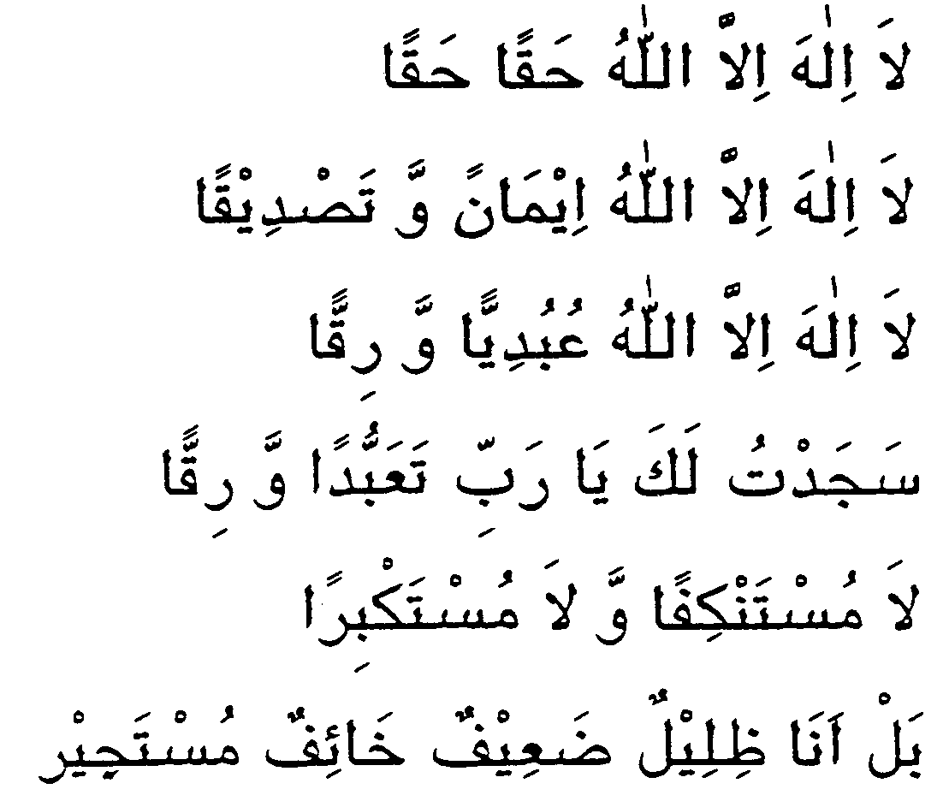
VI- Complete the dua:

BONUS
- Eid e Mubahilaa kay baad hi roz e 25th Zilhaaj ko kounsa azeem waaqeya hua? 1
Ans. Ehlebait ki shaan may Sure Dahr naazil hua
- Youm e Tarwiya koun sa din hai? 1 Ans. 8 th Zilhajja
- Pani, Zameen aur Suraj kay ilaawa koyi 3 mutahiraat likhiye. 2
Ans. Istehaala, Inqilaab, Islam, Musalmaan ka gaayab hona, Tabaiyat etc
- Name two items on which khums is never wajib
_Mahr, Meras, Mukhammas items, Usual necessities (Any
- Which prophet built masjid-e-Aqsa? ______Prophet Sulaiman__________
Test # 1 (26-10-07) manual #08
Topics:
Fiqhi istelahaat
Ehkaam e roza:
masail # 1550 to 1553 + 1562, 1577, 1586,1590,1608,1611,1614 to 1618,1625 to1632,1639,1642 to 1648,1655 to 1660,1661,1662,1663,1664,1668,1669 to 1671…till done
Fadak
Tawheed
Dua-quran kay sajday ki

