Diniyat Course Book
for Girls
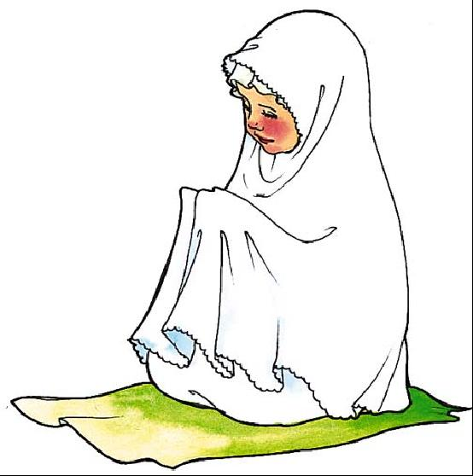

Name: ................................................

Manual No.: ........M09....................

