Ghufayla prayers
One of the Mustahab prayers which is offered between Maghrib and Isha prayers. (Rule 783)
In its first Rak'at after Surah al-Hamd, instead of any other Surah, the following verses should be recited:
21.87: And Yunus, when he went away in wrath, so he thought that We would not straiten him, so he called out among afflictions: There is no god but Thou, glory be to Thee; surely I am of those who make themselves to suffer loss.  21.88: So We responded to him and delivered him from the grief and thus do We deliver the believers  (Surah Anbiyah (21), Verse 87-88) | 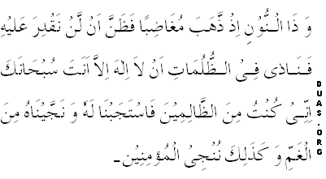
In the second Rak'at after Surah al-Hamd, instead of other Surah, the following verse should be recited:
And with Him are the keys of the unseen treasures — none knows them but He; and He knows what is in the land and the sea, and there falls not a leaf but He knows it, nor a grain in the darkness of the earth, nor anything green nor dry but (it is all) in a clear book.  (Surah Ana'am (6), Verse 59) | 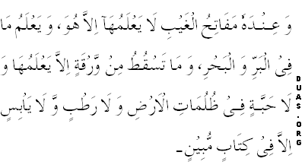
And in Qunut this Dua be recited:
(here one should mention his wishes). | 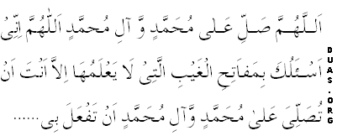
Thereafter, the following Dua should be recited:
