WORKSHEETS
FOR
MANUAL 01
GIRLS’ MADRESA
(2008-2009)

NAME :_____________________________________________________

YEAR:______________________________________________________

GROUP:_____________________________________________________

WORKSHEET - ALLAH HAS NO BEGINNING OR END:

BEFORE NOW LATER

Stick a photo of you as a baby in the first square, a picture of you now in the middle square and a picture of your mummy / daddy in the last square - as that is what you will probably look like when you get older

Egg

Duckling

Duck
Allah has always been there, He is here now, and He will always be there forever.

Me as a baby Me – Now Me – older
WORKSHEET - ALLAH NEVER DOES ANYTHING WRONG:

Husain had wished for a cat but did not get it as it was better for him not to.
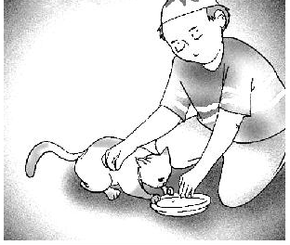

Draw below something that you have wished for but not got.

WORKSHEET - QAYAMAT:
WORKSHEET - ANGELS

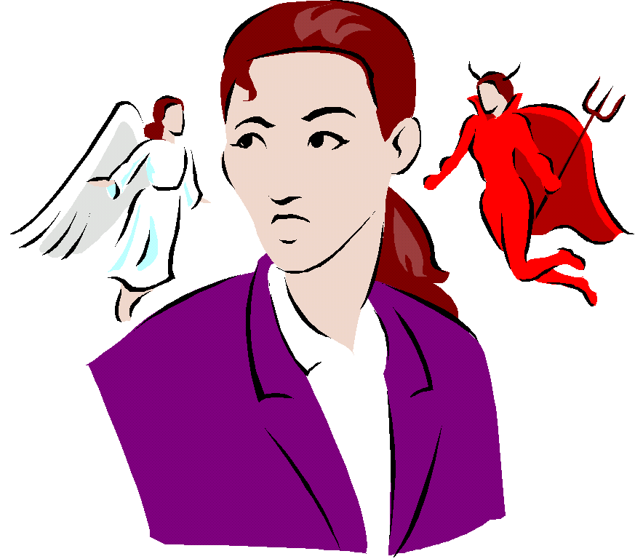

Draw a line to match the angels on the right with their work on the left:
Naughty deeds
Rizk
Good deeds


Message from Allah

WORKSHEET - AL-HAMDO-LILLAH
Draw (or write)something else for which you can say Alhamdulillah:
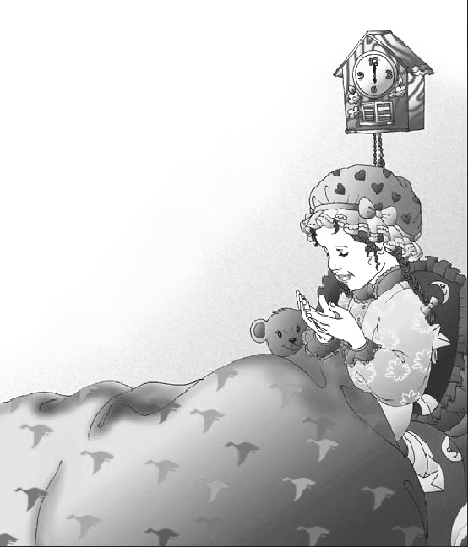
E.g.: To be thankful for a bed to sleep in
WORKSHEET - JAZAKALLAH
When someone helps you or gives you something you say Jazakallah.
Draw 2 pictures(or write)of when someone would say Jazakallah:
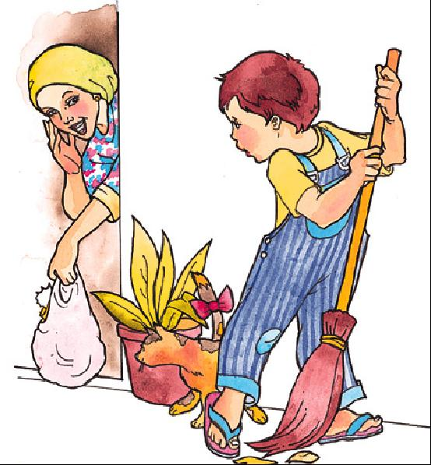
E.g.: Helping Mummy to sweep up the leaves:
Jazakallah

WORKSHEET - INSHAALLAH
You should always say Inshaallah when you decide to do something.
Draw a picture(or write of something you should say Inshallah after you decide to do it:
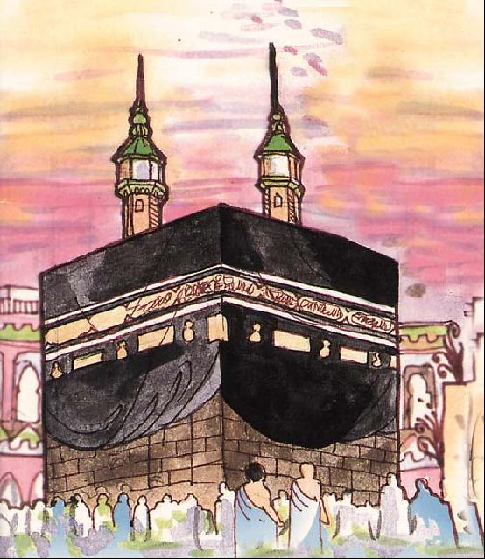
E.g. I will go for Umrah in the Summer, INSHAALLAH:

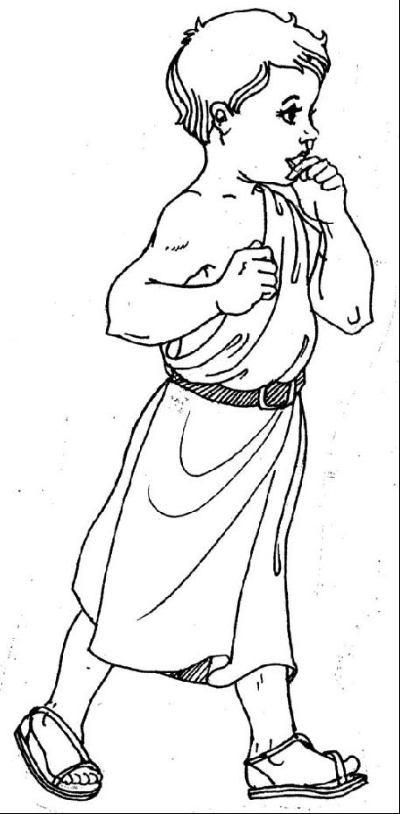
WORKSHEET - ALL CREATURES OF ALLAH ARE IMPORTANT
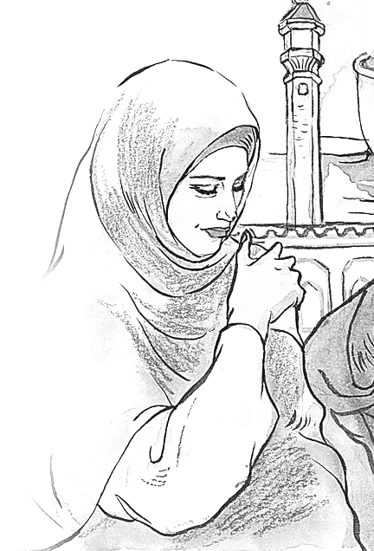
Colour the creatures whose prayers Allah will answer.
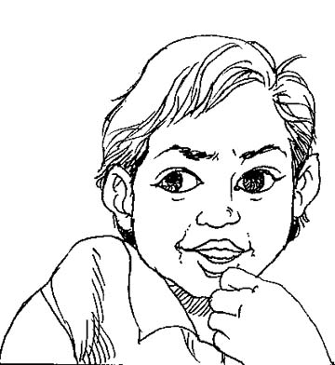
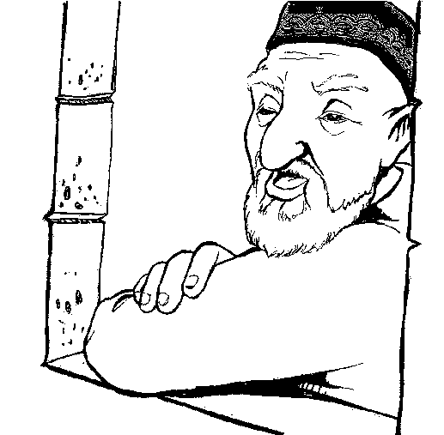
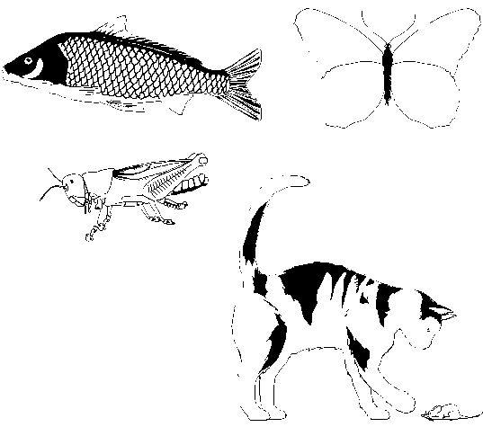

WORKSHEET - BEING NICE TO OTHERS

Draw the kind of face that Allah is pleased with.

WORKSHEET - SHARING WITH SIBLINGS
Colour the pictures below and draw how many of your bunny sweets you will share:
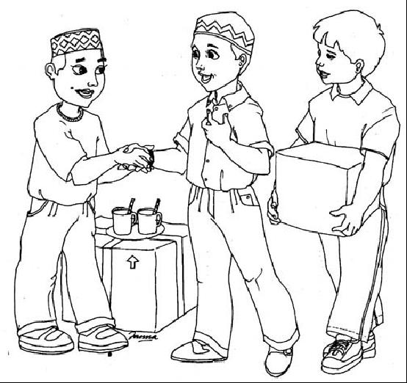
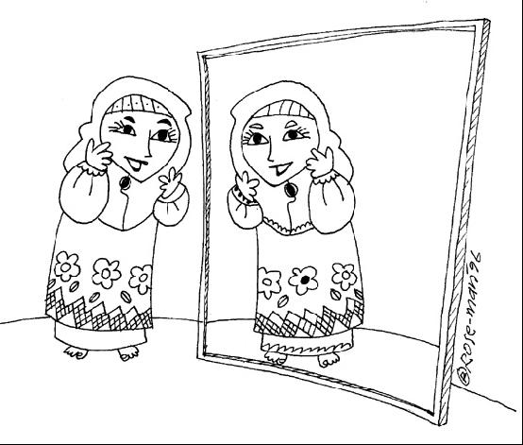

Bunny sweets

WORKSHEET - SALAWAAT
Below is the name Our Holy Prophet (s.a.w.) in Arabic. Remember to recite Salawaat as you colour it in:

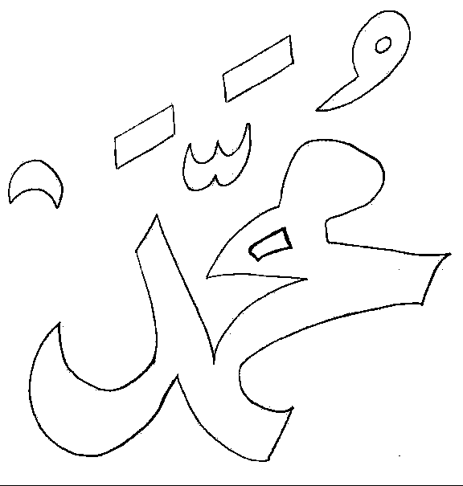

WORKSHEET - SNEEZING

Below is a game you can play in the class with your friends:

Your teacher will give you a big spinner:

How to play:

Spin the arrow

Take it in turn to sneeze (pretending)
Who has to say the word the spinner lands on? the person who sneezed or the friend?

Alhamdulillah
Alhamdulillah
Alhamdulillah
Yarhamukullah
Yarhamukullah
Yarhamukullah

WORKSHEET - MANNERS BEFORE A LESSON
Remember always to concentrate on your lesson completely:
Learn the little poem!
Work while you work,
Play while you play,
One thing each time,
That is the way,
All that you do,
Do with your might,
Things done by halves,
Are not done right.

Draw a picture of something you should NOT do in your lesson:
WORKSHEET - MANNERS OF SLEEPING
Imam jaffer sadiq(a.s) has said that before going to bed one should recite the
sura inna anzalna 11times and even sura ikhlas 11times. One who does this will be pardoned his sins for the next 50 years.
Ref: Ain ul hayat-Allama Majlisi
sonay se pehle ki dua
الَلهُمَ لا تُؤمِني مَكْرَك. وَ لا تُنْسِنِي ذِكْرَك. وَ لا تَجْعَلنِي مِنَ الغَافِلِين
Ay Khuda mujhay itni taufeeq day kay mai khud ko tairi saza say mehfuz na samjhu.
Aur yai kay mai tairi yaad say ghafil na ho jau.
Aur mujhay ghafilo mai shumar na ker..

Put a (√ ) for the things you did and a ( × ) if you hav’nt done.(with help of your mother)
 | FRI | SAT | SUN | MON | TUE | WED | THUR
1.brush your teeth
2.do wuzu
3.say fi-amanillah to parents
4.recite sonay se pehle ki dua
5.recite tasbeehe fatema
6.recite any sura from quraan
7.sleep on right arm
8.keep face towards holy kaaba

Mother’s signature: _________
Draw or write all the things you should try and do before you go to sleep:
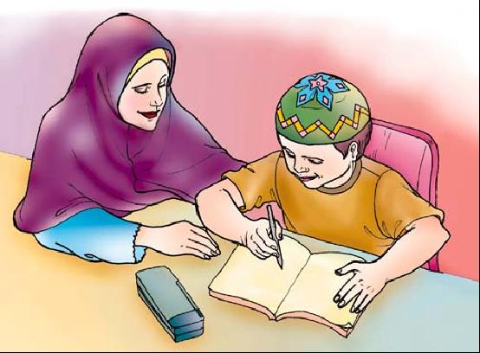
E.g. Finish your howework:

WORKSHEET - MANNERS OF WAKING UP
We remember Allah as soon as we wake up, then send Salaams to our 12th Imam (a.s.) and then go and greet out parents.
Draw or write 2 other things you can do after you wake up:
E.g.: Put on our clothes:
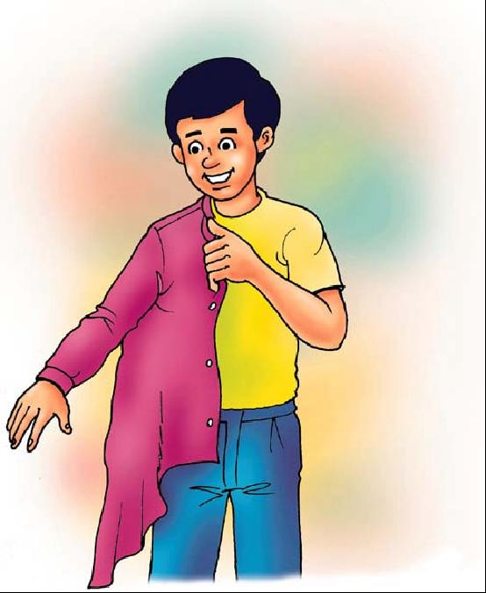

WORKSHEET : RESPECT OF PARENTS
Allah wants us to be kind to our parents.
Draw 2 pictures or Write of how you can be kind to you parents:
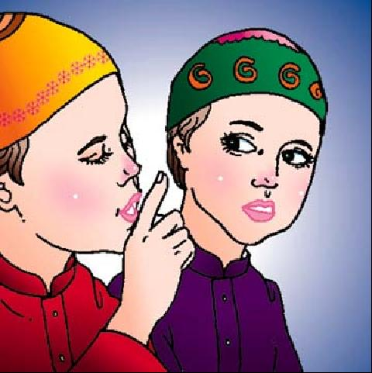
E.g. By playing quietly when they are resting:

WORKSHEET - WATCHING TV WITH IMAM MEHDI(atf)
With the help of your mother fill the chart daily.
DAYS | Name of the TV programmes watched | Note the time duration | Positive points in the programme | Negative points in the programme
Friday
Saturday
Sunday
Monday
Tuesday
Wdnesday
Thursday
NOTE: At the end of the week sincerely note that can you watch these programmes for such durations ,while your Imam e Zamana(atf) is besides you.

WORKSHEET - NAJASAAT:

WORKSHEET - WUDHU-EXPLANATION
Draw a circle round those things that you have to do Wudhu for AND
A square around those things it is good to do Wudhu for.
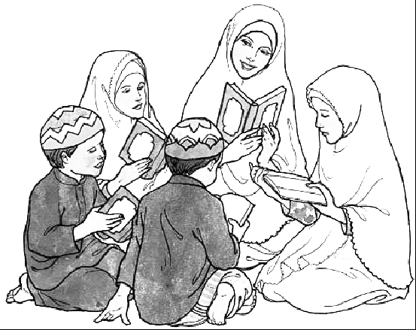
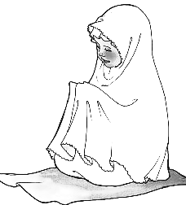

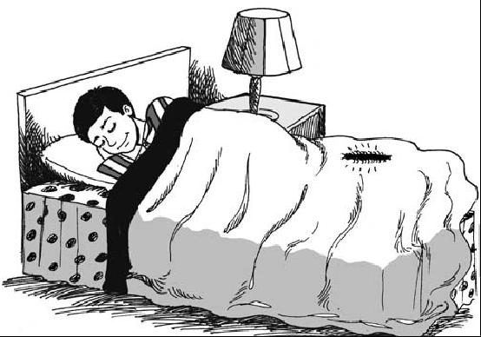
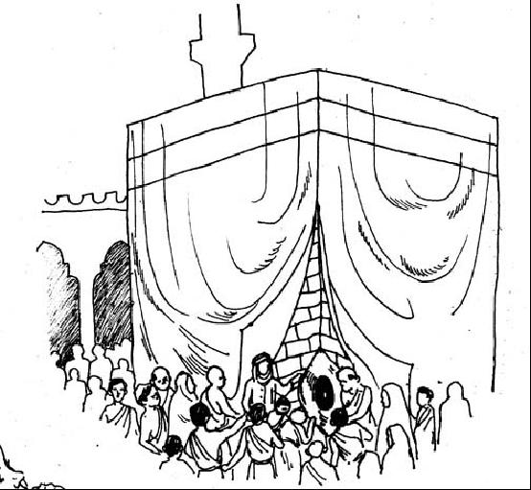
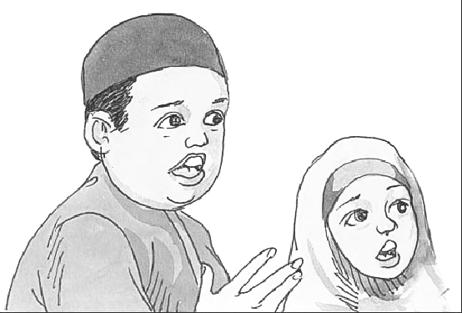
Before reciting Qur’an
Before going to sleep
Before offering Salaat
Before going to the Mosque
Before Tawaf of Kaa’ba
When you become angry
WORKSHEET - WUDHU- MUSTAHAB ACTIONS
The following are the Mustahab actions of Wudhu.
Colour them in and write how many times each one has to be done.
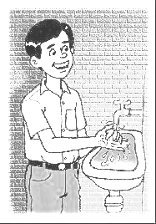

__________ times


____________ times.

__________ times.
WORKSHEET - WAJIB ACTIONS OF WUDHU

Number the Wajib actions of Wudhu to show the right order and then colour them in:

COMPLETE WUDHU: PRACTICAL DEMONSTRATION:
THE CHILD WILL BE TAKEN TO THE SINK TO OBSERVE THE DEMONSTRATION OF WUDHU – BOTH MUSTAHAB AND WAJIB ACTIONS.
MUSTAHAB ACTIONS WAJIB ACTIONS

Wash hands 2 times

Niyyat

Gargle 3 times
Washing the face

Washing arms
Wash Nose 3 times

Masah of the head

Masah of the feet

WORKSHEET - Takbeeratul Ihraam

Allahu Akber

Using white tissue paper make a chadar which a girl would use to cover herself.

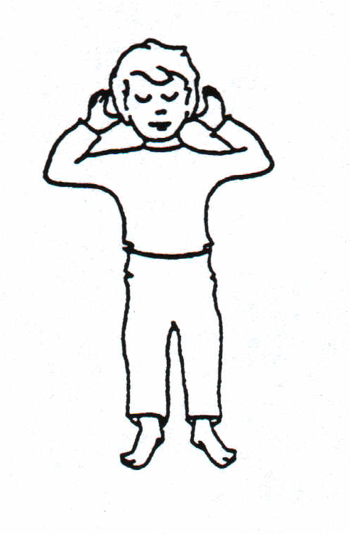

Draw a cap on his head

WORKSHEET - Qiyaam

Activities
Where should the boy look? Draw a mohr / turbat / sajdagah.
What should he recite in qiyaam?

Colour the picture.

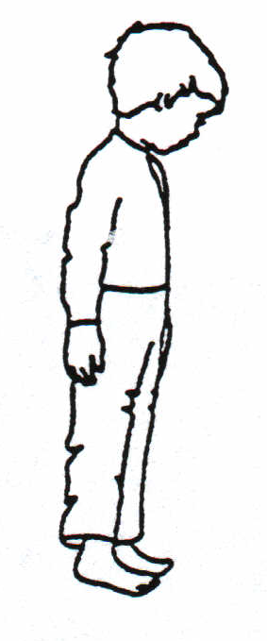

WORKSHEET - Rukoo

Activities
Where is the boy looking?
Draw (in the box) how a girl should stand for rukoo?
What do you say in rukoo?
Colour the picture.

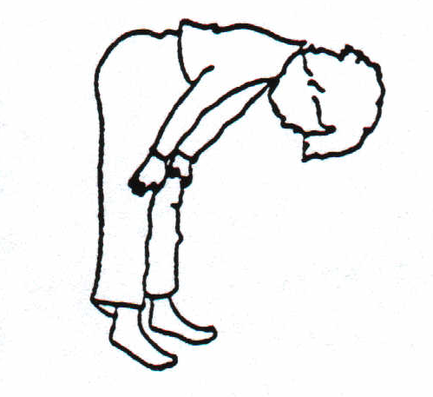

WORKSHEET - SIJDA

Activities
Colour the seven parts which must touch the ground when doing sijda
What should he recite in sijda?

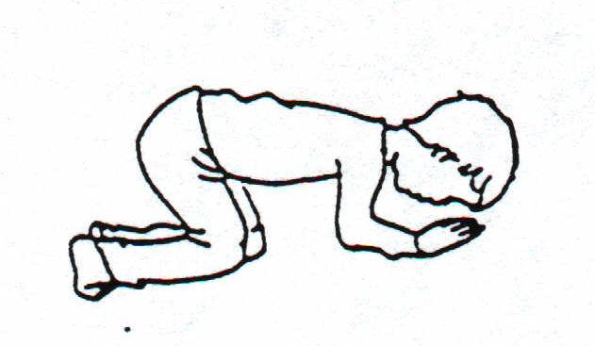

WORK SHEET - TA’QEEBAAT
Recite ☺•  3 times 

Recite Salawaat     ▪   
     

Recite Tasbee of sayyida Fatema Zehra (A.S)
                                    ☺•  
                         
                                 ⬇⬇⬆ ☺   
          Recite specific Dua after every namaz ( Fajr , Zuhr , Asr , Isha & Maghrib)

Recite a surah From The Holy Quran

In sajda recite the following as many times as possible
           ⬇⬆⬇ ⬅  ⬅  ⬅
             ⬅▪  ⬅▪  ⬅▪

Send salaams to Masumeen(A.S.)

To sit and recite the Holy Quran, or dua’as, narrated by the Holy Ahlul Bayt, after the obligatory Salaat, is called “Ta’qeeb” .
Pu
put a star in the box adjacent to the ta’qeebaat you recite after Namaz.

WORKSHEET - TASBEEH
Colour the beads saying:
- 34 - Allahu Akbar,
- 33 - Alhamdulillah, AND

- 33 - Subhanallah

WORKSHEET: HABIL & QABIL

Draw what sacrifice did Qabil offerd to Allah:

Now draw and write what sacrifice would you like to offer Allah:

WORKSHEET - PROPHET YUNUS (A.S.)

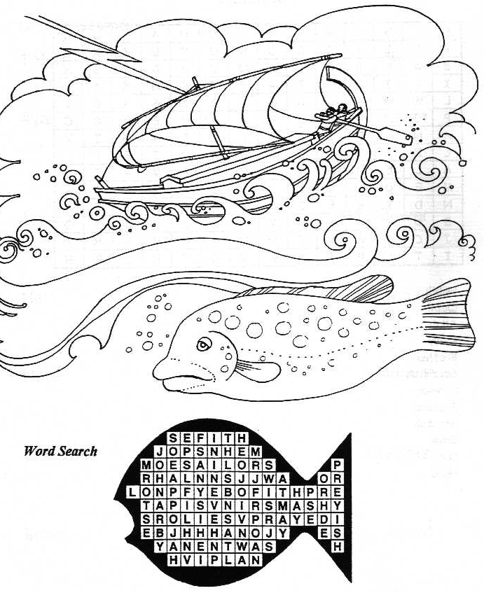

Fish, Ninevah, obey, plant, prayed, sailors, sea, sorry, storm.

WORKSHEET - PROPHET MUSA
Colour the picture and answer the questions:
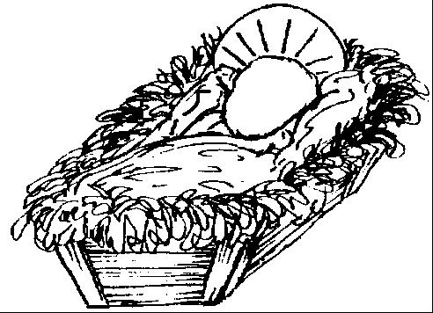

Why did Prophet Musa’s mother place him in a box and let it float away in the river Nile?
Prophet Musa’s mother put him in the box and let him float away because:
_________________________________________________________.
What happened to this box with Prophet Musa in it?___________________________________________________________.

WORKSHEET - AHLUL KISA

Find the names of the Panjatan in the Word-search below:

F L T A L I B P H H
A U A N A S A H U I
T H S A T W Q S S W
M U H A M M A D A I
J K H S L I L F I Q
H A M I T A F B N X

_________________________________________________________________________________________________________________________________________________________________________________________________________________________________

WORKSHEET - IMAM MUHAMMAD AL-BAQIR (A.S.)
Tell your parents why Imam Muhammad Al-Baqir (a.s.) was working very hard on his farm on a very hot day.
Colour in the pictures of the different work the people are doing:
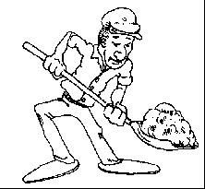

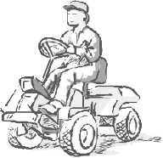
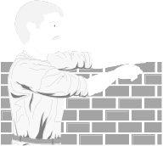

Now draw below a type of work that you can do to help your family.

WORKSHEET - IMAM JA’FAR AS-SADIQ (A.S.)
Our 6th Imam (a.s.) has taught us always to be kind and helpful to our parents.
Draw 3 pictures of how you can help your Mummy and Daddy:
E.g.: By keeping our room tidy:
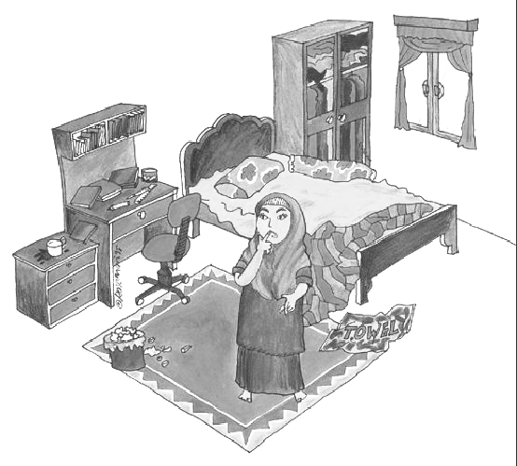

WORKSHEET - MUSA AL-KADHIM (a.s.):
In Islam, everyone is equal. Colour all these people:

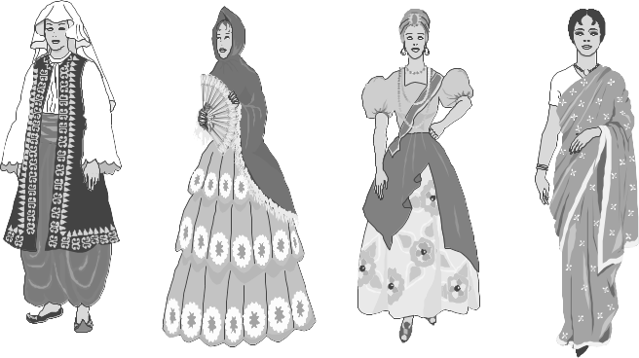
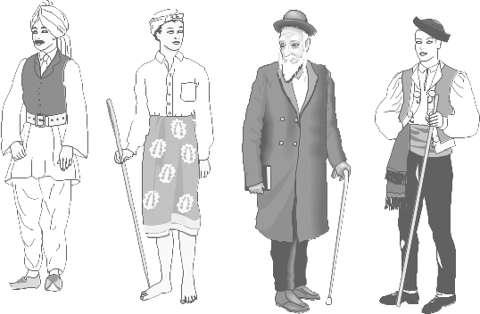
WORKSHEET - IMAM ALI AR-RIDHA (A.S.)
Colour the door and curtains, and
Tell your parents what happened when the naughty servants decided not to open the doors and curtains for our 8th Imam, Imam Ali Ar-Ridha (a.s.)
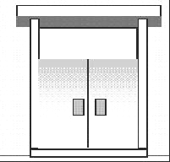


WORKSHEET - IMAM MUHAMMAD AL-MAHDI (A.S.)
When Syed Amili saw water in the desert, he drank some of it, then did Wudhu and prayed his Salaat.
Colour the picture of someone praying their Salaat:
