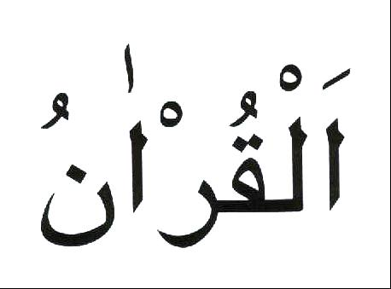

QUR’AN MANUAL
M-01
2008-2009

My name is _____________________________________

This is how it is written in Arabic:___________________

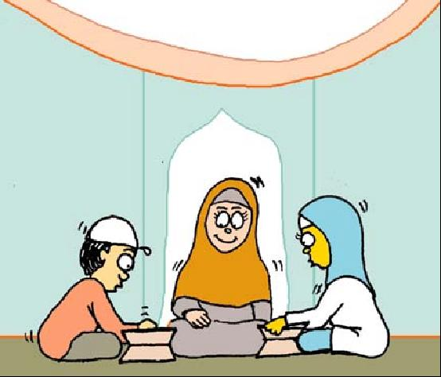
QUR’AN SYLLABUS CLASS 2 (5 YEARS OLD) M01
Lesson Topic Date Completed
LESSON 1: INTRODUCTION [ ]
LESSON 2: HURUF – REVISION [ ]
LESSON 3: HURUF – REVISION [ ]
LESSON 4: HURUF – REVISION [ ]
LESSON 5: JOINING OF HURUF (LETTERS) - BEGINNING [ ]
LESSON 6: JOINING OF HURUF (LETTERS) - BEGINNING [ ]
LESSON 7: JOINING OF HURUF (LETTERS) - BEGINNING [ ]
LESSON 8: JOINING OF HURUF (LETTERS) – BEGINNING [ ]
LESSON 9: JOINING OF HURUF (LETTERS) - BEGINNING [ ]
LESSON 10: JOINING OF HURUF (LETTERS) - BEGINNING [ ]
LESSON 11: HARAKA – FATHA (MAKHRAJ) [ ]
LESSON 12: HARAKA – FATHA (MAKHRAJ) [ ]
LESSON 13: HARAKA – FATHA (MAKHRAJ) [ ]
LESSON 14: HARAKA – FATHA (MAKHRAJ) [ ]
LESSON 15: HARAKA – FATHA (MAKHRAJ) [ ]
LESSON 16: HARAKA – FATHA (MAKHRAJ) [ ]
LESSON 17: HARAKA – FATHA (MAKHRAJ) [ ]
LESSON 18: KASRA [ ]
LESSON 19: DHAMMA [ ]
LESSON 20: SURATUL FATIHA – MEMORISATION AND TAFSEER [ ]
MEMORISATION FOR AZ-ZAHRA CERTIFICATE:
TERM 1: SURATUN NAAS: TERM 2: SURATUL FALAQ: TERM 3: SUATUL KAFIROON:
LESSON 2.1: INTRODUCTION:
Qur’an as a Gift:
(Introduce the Qur’an as a gift from Allah. Show the children a Qur’an wrapped up as a gift. Ask the children what they think is inside it. Tell them it is something precious and a gift they can keep for life. Open it and show them what the whole Qur’an looks like, what the Arabic is like, how it is read etc.)
Ramadhan has just gone; this was the month the Qur’an was revealed. What presents did you get on Eid? Allah’s present to you is the Qur’an.
What is the Holy Qur'an?
It is a book that contains the words of Allah.
Who wrote the Holy Qur'an?
It was not written by anyone; Allah sent down the words to the Holy Prophet (s.a.w.) through the Angel Jibrail.
The Holy Prophet (s.a.w.) then recited the verses to the people. Most of the people would remember the verses by heart but the Holy Prophet (s.a.w.) chose some special people called scribes to write down the verses.
In which language is the Holy Qur'an written?
   ☹ 
It is written in Arabic.             

Arabic is read from right to left and back to front.
What does Allah tell us in the Holy Qur'an?
- He tells us true stories of the Prophets.
- He tells us how He wants us to act.
- He tells us about heaven and hell.
RESPECT OF THE HOLY QUR'AN:

We have to look after the Holy Qur'an because it is such a special book.

We should look after the Holy Qur’an by:
- holding it properly. (Show the child).
- never leaving it open when no-one is reciting it.
- Never touching the writing in it without first doing Wudhu.

You can read it without touching it, or put a plastic sheet on it.

When reciting the Holy Qur’an, it is Sunnat:
for boys to wear a cap

for girls to wear a scarf.

to face Qiblah (the Ka’aba)
Before starting to recite the Holy Qur’an, you should say:

And

WORKSHEET 2.1: INTRODUCTION:
Learn the correct pronunciation and meaning of:

I seek refuge from Shaitan the outcast
And

I begin in the Name of Allah, the Kind, the Merciful

LESSON 2.2: REVISION OF HURUF:

Colour the Flags:

RED =     GREEN =  BLUE = ☹ 

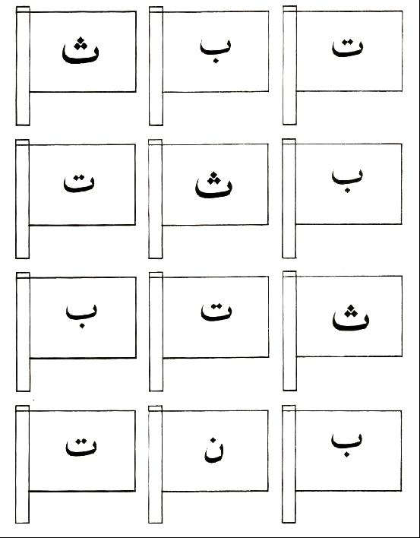

LESSON 2.3: REVISION OF HURUF:

Colour the Bears:

RED =     GREEN =  BLUE =  

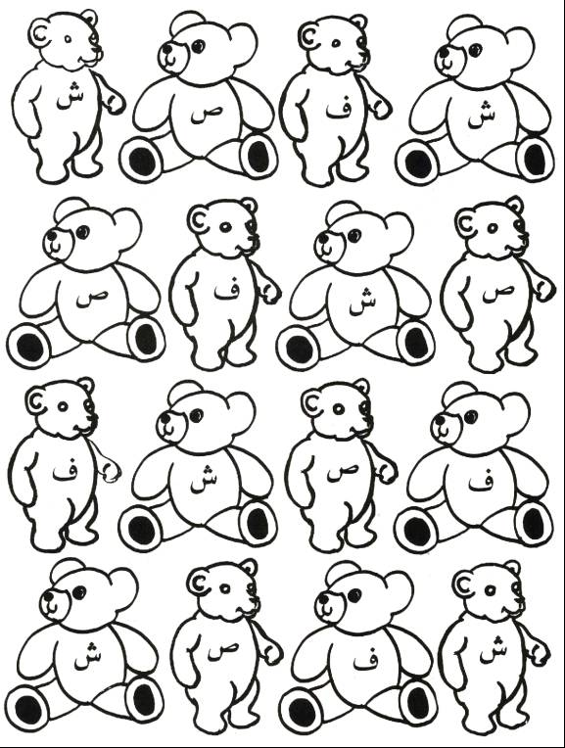

LESSON 2.4: HURUF – REVISION:

Complete the 2 dot to dot puzzles and colour the picture:
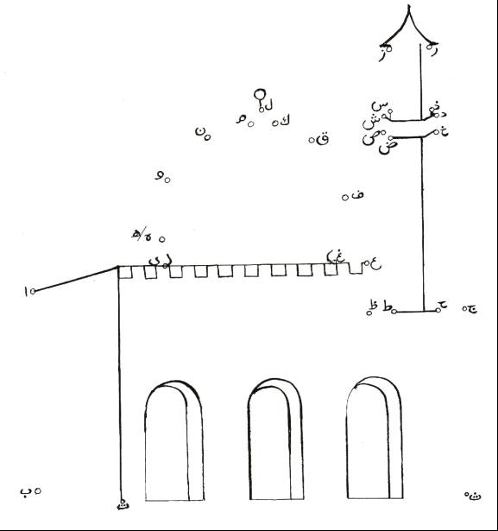

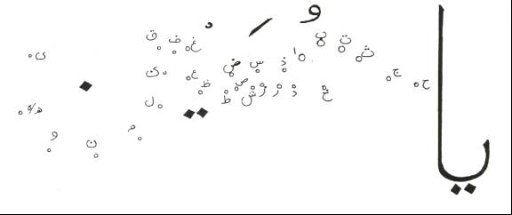

LESSON 2.5: JOINING OF HURUF (LETTERS) - BEGINNING:
In Arabic when the Huruf are joined to each other the 'tails' are cut off (unless at the end of a word).
The Huruf are put into groups, to make it easier to remember how they join to other Huruf.
The first group you will learn is the Boat Family AND their Cousins:
Boat Family
Their Cousins
☹    
Beginning of word | The Harf
 | ☹
 | 
 | 
 | 
 | 
All of these Huruf are cut in half and the dots are placed above or below it as shown.

WORKSHEET 2.5: JOINING OF HURUF (LETTERS) - BEGINNING:
a: Revise Suratul Fatiha
   
◻ ☹ 
 
  
◻   ☺◻ 
  
▪ ◻  
▪ ☹
 

b: Learn the correct pronunciation of:
           

WORKSHEET 2.5: JOINING HURUF (LETTERS) - BEGINNING:
Draw a line to match the complete Huruf with the way they look at the Beginning of a word:

☹ 

 

 

 

 

LESSON 2.6: JOINING HURUF (LETTERS) - BEGINNING:
Today you will learn a group which is like the Boat Family but have a loop - these Huruf when joined act in the same way as the Boat family.
This group is like the Boat Family but they have a loop:
Boat Family with a loop
✰ 

Beginning of word | The Harf
✵ | 
 | ✰
These Huruf are cut in half and the dots are placed above it as shown.

WORKSHEET 2.6: JOINING HURUF (LETTERS):
a: Learn the correct pronunciation of:
 ⬆

LESSON 2.7: JOINING HURUF (LETTERS) - BEGINNING:
Today you will learn a group which look a little like the Boat Family and when joined, they act in the in the same way as the Boat family.
This group look a little like the Boat Family.
A little like the Boat Family.
   

Beginning of word | The Harf
❍ | ❐
❑ | ⧫
◆ | 
 | 
These Huruf are cut in half and the dots are placed above it as shown.

WORKSHEET 2.7: JOINING HURUF (LETTERS):
a: Learn the correct pronunciation of:
      

WORKSHEET 2.7: JOINING HURUF (LETTERS) - BEGINNING:
Draw a line to match the complete Huruf with the way they look at the Beginning of a word:

 

❍ 

 

❑ 

 

LESSON 2.8: JOINING HURUF (LETTERS) - BEGINNING:
Today you will learn of a group which when joined is cut across.
Letters cut horizontally (-----)

→    
Beginning of word | The Harf
 | 
 | 
 | 
▪ | ✦
★ | →
These Huruf are cut in half across and the dots are placed above or below it as shown.
WORKSHEET 2.8: JOINING HURUF (LETTERS):
a: Learn the correct pronunciation of:
➔ ⬅⬄•  ⬄  

WORKSHEET 2.8: JOINING HURUF (LETTERS) - BEGINNING:
Match the letter with its shortened form by drawing a line as shown:
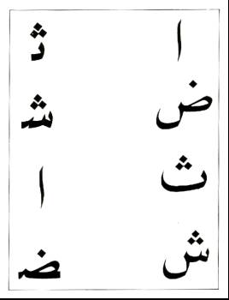
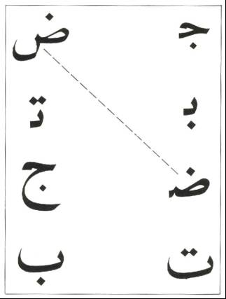

LESSON 2.9: JOINING HURUF (LETTERS) - BEGINNING:
Today you will learn of a group whose form does not change at the beginning of the word:
Letters look the same as Harf

     
Beginning of word | The Harf
○ | ○
 | 
 | 
 | 
 | 
 | 
These Huruf are look the same at the Beginning of the word.
WORKSHEET 2.9: JOINING HURUF (LETTERS) - BEGINNING:
Match the following letters in the 2 columns by drawing a line between them:
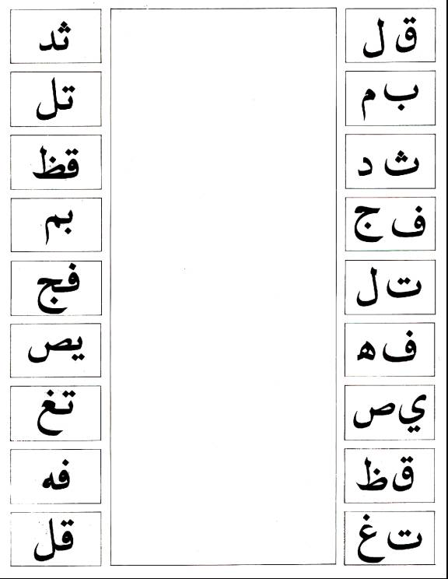
LESSON 2.10: JOINING HURUF (LETTERS) - BEGINNING:
Today you will learn of a group that do not join to the Harf following BUT want to join the Harf before it.
These Harf are called Stubborn Harf and there are 6 of them:
Stubborn Harf

     
Beginning of word | The Harf
 | 
 | 
 | 
 | 
 | 
 | 
These Huruf are Stubborn

WORKSHEET 2.10: JOINING HURUF (LETTERS) - BEGINNING:
a: Revise Suratul Ikhlas:

   
   
 
 
  
 •    

LESSON 2.11: HARAKA – FATHA (MAKHRAJ):
Makhraj = the place of origin of the sound of the harf.
When the harf has a Fatha – a line on top of it, then only the sound of the Harf is said.
A lot of huruf have very similar sounds, so you have to learn exactly where the sound must come from and how you must say it. Then the huruf will not all sound the same.
The following three huruf have similar sounds:     
As all these huruf have the same 'u' sound. You have to say them from different places in your mouth to make them sound a little bit different, so that people who are listening to you saying them know which one out of the three you are saying.
 - The tongue is placed flat in the mouth and the sound comes from the top of the throat.
 - The tongue is placed flat in the mouth and the sound comes from deeper in the throat.
 - Is a sound between  and 
WORKSHEET 2.11: HARAKA – FATHA (MAKHRAJ)
Practise reciting the following:
        

LESSON 2.12: HARAKA – FATHA (MAKHRAJ):
Revision of Makharij learnt last week.   
A lot of huruf have very similar sounds, so you have to learn exactly where the sound must come from and how you must say it. Then the huruf will not all sound the same.
The following three huruf have similar sounds:     
As all these huruf have the same 't' sound you have to say them from different places in your mouth to make them sound a little bit different, so that people who are listening to you saying them know which one out of the three you are saying.
 - The tongue is placed at the upper teeth.
 - The tongue is placed at the upper teeth and brought down with force.
 - The tongue is placed between the teeth and is said as 'th' in thumb, think.
WORKSHEET 2.12: HARAKA – FATHA (MAKHRAJ):
Practise reciting the following:
         

LESSON 2.13: HARAKA – FATHA (MAKHRAJ):
Revision of Makharij learnt last week.      
A lot of huruf have very similar sounds, so you have to learn exactly where the sound must come from and how you must say it. Then the huruf will not all sound the same.
The following three huruf have similar sounds:-     
As all these huruf have the same 's' sound you have to say them from different places in your mouth to make them sound a little bit different, so that people who are listening to you saying them know which one out of the three you are saying.
 - The tongue is flat in the mouth with a hissing sound.
 - The tip of the tongue, touching the upper front teeth with a small whistling sound.
 - The tip of the tongue, touching the upper front teeth with a small buzzing sound. It sounds the same as the English 'z' sound.

WORKSHEET 2.13: HARAKA – FATHA (MAKHRAJ):
Practise reciting the following:
       

LESSON 2.14: HARAKA – FATHA (MAKHRAJ):
Revision of Makharij learnt last week.         
A lot of huruf have very similar sounds, so you have to learn exactly where the sound must come from and how you must say it. Then the huruf will not all sound the same.
The following three huruf have similar sounds:     
As all these huruf have the same 'dh' sound you have to say them from different places in your mouth to make them sound a little bit different, so that people who are listening to you saying them know which one out of the three you are saying.
 - The tongue is kept flat in between the teeth as in the, this.
 - The whole tongue is raised to the roof of the mouth and the mouth is full.
 - The tongue is raised to the upper teeth on the right or left side.

WORKSHEET 2.13: HARAKA – FATHA (MAKHRAJ):
Practise reciting the following:

      

LESSON 2.15: HARAKA – FATHA (MAKHRAJ):
Revision of Makharij learnt last week.                         
A lot of huruf have very similar sounds, so you have to learn exactly where the sound must come from and how you must say it. Then the huruf will not all sound the same.
The following two huruf have similar sounds:   
Both all these huruf have the same 'h' sound you have to say them from different places in your mouth to make them sound a little bit different, so that people who are listening to you saying them know which one out of the three you are saying.
 - Said from the top of the throat as the English H.
 - Said from deeper in the throat while pushing air out.

WORKSHEET 2.15: HARAKA – FATHA (MAKHRAJ):
Practise reciting the following:
     

LESSON 2.16: HARAKA – FATHA (MAKHRAJ):
Revision of Makharij learnt last week.                           
A lot of huruf have very similar sounds, so you have to learn exactly where the sound must come from and how you must say it. Then the huruf will not all sound the same.
As all these huruf have the same 'k' sound you have to say them from different places in your mouth to make them sound a little bit different, so that people who are listening to you saying them know which one out of the three you are saying.
The following four huruf have similar sounds:       
 - The sound is from the top of the throat, as English K.
 - The sound is from deeper in the throat, as English Q.
 - The sound is as if you are clearing your throat, as in the name Khalil.
 - The sound is from the throat as if you are gargling.

WORKSHEET 2.16: HARAKA – FATHA (MAKHRAJ):
Practise reciting the following:
           

LESSON 2.17: HARAKA – FATHA (MAKHRAJ):
Revision of Makharij learnt last week.                                              
The huruf that have not been taught yet are the easy ones, because all you have to do is say the sound which the harf begins with.

Baa ☹ begins with the sound 'b'
Jiim  begins with the sound 'j'
Daal  begins with the sound 'd'
Raa  begins with the sound 'r'
Shiin  begins with the sound 'sh'
Faa  begins with the sound 'f'
Laam  begins with the sound 'l'
Miim  begins with the sound 'm'
Nuun  begins with the sound 'n'
Waw  begins with the sound 'w'
Yaa  begins with the sound 'y'.

WORKSHEET 2.17: HARAKA – FATHA (MAKHRAJ)
This whole lesson should be spent checking that the child knows all the Makharij of the Arabic alphabet, without any help whatsoever.
S/he should be able to read lines 4-6 on Pg. 12 from Yassarnal Qur'an individually. The pronunciation should be perfect, with the correct Makharij.
If the child has problems with any of the above then the letter below should be sent to the parents of that child specifying what the child needs help with.
Dear parent,
Your child has now been taught all the Makharij of the Arabic alphabet. But when he/she was tested, we found that he/she was still having problems with the following:
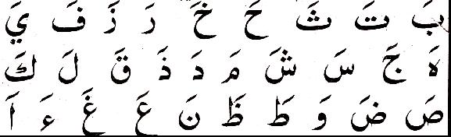
Lines 4 – 6
Page 12

Please can you ensure that by next week your child is confident with the whole alphabet, especially the ones named above. Jazakallah.

______________________ _________________
Signature of teacher: Date:
LESSON 2.18: KASRA:
The small line under the Harf is called a Kasra.
When you see this you should make a smiling face and say the sound of the Harf with an 'i' sound.
e.g. baa with kasra ☹ = 'b'+ 'i' = bi
Make sure that the sound is a short vowel
i.e. the 'i' in bit, fit, sit… and not elongated as 'ee' in feet, beet…

WORKSHEET 2.18: KASRA:
a: Let the children take turns to recite one Harf out aloud from Yassarnal Qur'an, Pg. 12, lines 1-3.
b: Remember when a Harf has a Kasra, you have to make a smiling face and say the sound of that Harf with an ' i ' sound.
Colour the smiling mouth and then write some Harf with Kasra.
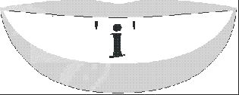

Remember to:

as you say them.

LESSON 2.19: DHAMMA:
The small circle with a tail on top of the harf is called a dhamma.
When you see this you should make a circle with your lips like the shape and say the sound of the harf with an 'u' sound.
baa with dhamma ☹ = 'b'+ 'u' = bu
Make sure that the sound is a short vowel:
i.e. the 'u' in full, pull... and not elongated as 'oo' in fool, pool ...

WORKSHEET 2.19: DHAMMA:
A: Let the children take turns to read one Harf out aloud from Yassarnal Qur'an, Pg. 12, lines7-9.
B: Remember when a Harf has a Dhamma, you have to make a round shape with your mouth and say the sound of that Harf with an ' u ' sound.
Colour Jameel showing you how to say a Harf with a Dhamma, then write some Huruf with Dhamma.
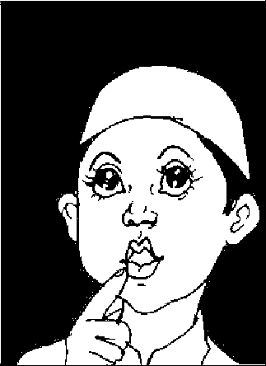

U

WORKSHEET 2.19: HARAKA – FATHA (MAKHRAJ):
Colour in the Stubborn Harf in Red:
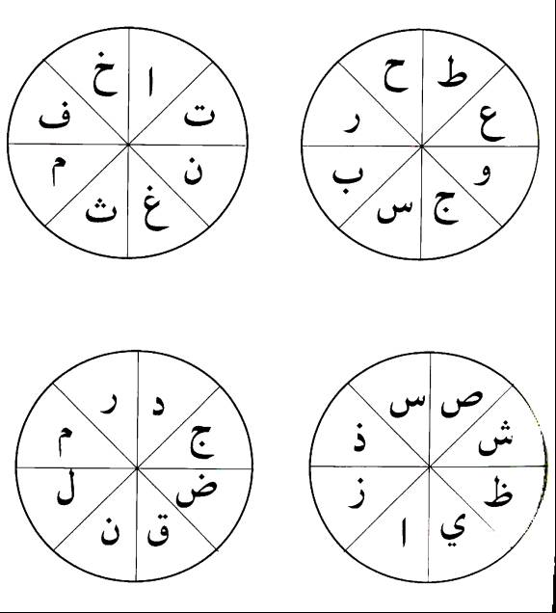

WORKSHEET 2.19: HARAKA – FATHA, KASRA, DHAMMA:

Put in the Haraka and read the words:

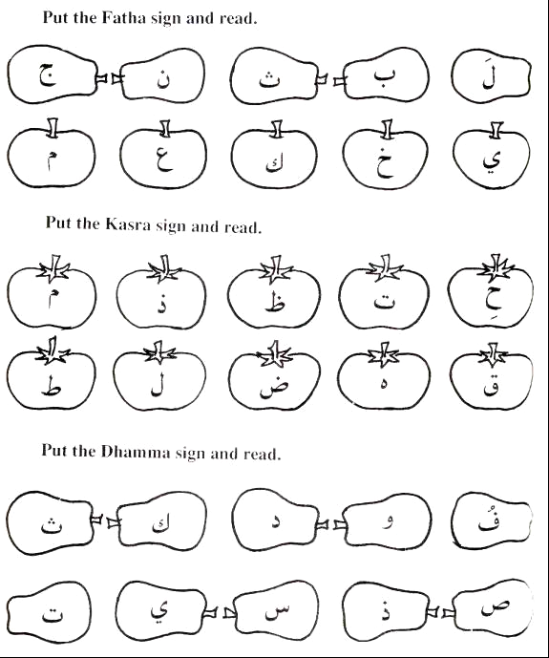
LESSON 2.20: REVISION:
This whole lesson should be spent checking that you know all the Makharij of the Arabic alphabet, with Harakaat, without any help.
S/he should be able to read Pgs. 13 - 17 from Yassarnal Qur'an. The pronunciation should be perfect, with the correct Makharij.
If the child has problems with any of the above then the letter below should be sent to the parents of that child specifying what the child needs help with.
Dear parent,
Your child has now been taught all the Makharij of the Arabic alphabet, with Harakaat.. But when s/he was tested, we found that s/he was still having problems with the following:

Please can you ensure that by next week your child is confident with the whole alphabet, especially the ones named above. Jazakallah.

______________________ _________________
Signature of teacher: Date:
LESSON 2.20: SURATUL FATIHA: MEMORISATION AND TAFSEER:

   
◻ ☹ 
 
  
◻   ☺◻ 
  
▪ ◻  
▪ ☹
 

This Surah was revealed to the Holy Prophet (s.a.w.) in Makka and also in Madina.
It has 7 verses

LESSON 2.20: SURATUL FATIHA – MEMORISATION AND TAFSEER:
It is said that the meaning of the Holy Qur'an as a whole has been mentioned in this Surah: i.e. The object of Islam.
The object of Islam:
- The belief and faith in the One and Only true Creator, Lord of the universe.
- The Day of Judgement, when everyone will have to account for their own deeds.
- To obey and follow Allah’s wishes, and to need no-one but Him.
- To follow the right path - His path for us.
- Learning from History, how the people who followed this right path were rewarded, and how those who went on the wrong path were punished.
The importance of this Surah is seen by the fact that:
- it was revealed both in Makka and Madina, AND
- every Muslim recites this Surah 10 times every day in their Salaat.
If you think about the meaning of this Surah as you recite it in your Salaat, it will make your Faith in the teachings of Islam strong.
It will also stop you from being proud, as you are nothing compared to Allah.

This Surah has many names, the most common ones being:
- Suratul Fatiha - The Opening (1st Sura of the Qur'an)
- Ummul Kitab - The mother of the book (Qur'an).
- As-Sab'a Mathani - The seven repeated verses.

WORKSHEET 2.20: SURATUL FATIHA - MEMORISATION AND TAFSEER:
Draw below what you have learnt from Suratul Fatiha:
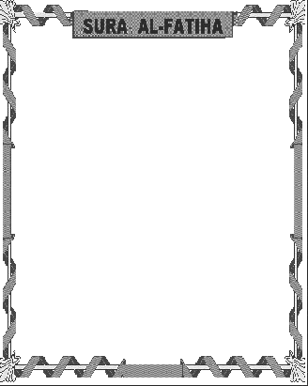

MEMORISATION SURAH FOR TERM 1: SURATUN NAAS:

   
 ☹ ▪ 
 
 
   
 ➢  
  

TERM 1: MEMORISATION SURAH FOR AZ-ZAHRA CERTIFICATE:
For the Az-Zahra Certificate, your child should know:
- Suratun Naas with proper Makhraj.
__________________ has been tested on the above requirements and has performed satisfactorily.

________________________ _________________
Signature of teacher: Date

If the child has not passed the test satisfactorily the teacher should fill in the letter below.
Dear Parent,
Your child __________________ was tested on Suratun Naas but s/he did not know it.
Please ensure that s/he knows the above for next week, so that s/he may receive their Az-Zahra Certificate.
__________________________ __________________
Signature of teacher Date
MEMORISATION SURAH FOR TERM 2: SURATUL FALAQ:

   
  ☹ ▪ 
    
 😐     
 ◻     
      

TERM 2: MEMORISATION SURAH FOR AZ-ZAHRA CERTIFICATE:
For the Az-Zahra Certificate, your child should know:
- Suratul Falaq with proper Makhraj.
__________________ has been tested on the above requirements and has performed satisfactorily.

________________________ _________________
Signature of teacher: Date

If the child has not passed the test satisfactorily the teacher should fill in the letter below.
Dear Parent,
Your child __________________ was tested on Suratul Falaq but s/he did not know it.
Please ensure that s/he knows the above for next week, so that s/he may receive their Az-Zahra Certificate.
__________________________ __________________
Signature of teacher Date
MEMORISATION SURAH FOR TERM 3: SURATUL KAFIROON:

   
   
 ☺◻  ☺▪ →
 ☺▪  ☺▪  →
 ☺▪  ▪  →
 ☺▪  ☺▪  →
    
TERM 3: MEMORISATION SURAH FOR AZ-ZAHRA CERTIFICATE:
For the Az-Zahra Certificate, your child should know:
- Suratul Kafiroon with proper Makhraj.
__________________ has been tested on the above requirements and has performed satisfactorily.

________________________ _________________
Signature of teacher: Date

If the child has not passed the test satisfactorily the teacher should fill in the letter below.
Dear Parent,
Your child __________________ was tested on Suratul Kafiroon but s/he did not know it.
Please ensure that s/he knows the above for next week, so that s/he may receive their Az-Zahra Certificate.
__________________________ __________________
Signature of teacher Date

