WORKSHEETS
FOR
MANUAL 00(R)
GIRLS’ MADRESA
(2007-2008)

NAME :_____________________________________________________

YEAR:______________________________________________________

GROUP:_____________________________________________________

WORKSHEET: BISMILLAH

Colour in all the pictures before which you should say Bismillah:

WORKSHEET: Woman’s Ring

Colour the picture. Can you see the ring?
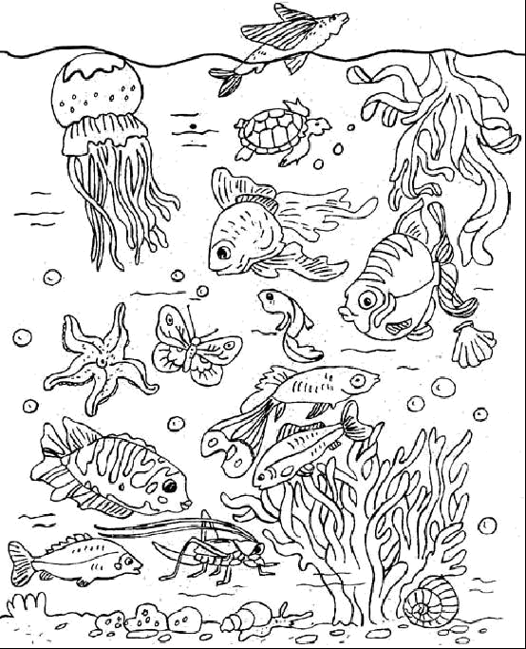

--------------------------------------------------------------------------------------------

WORKSHEET: Student Walks on Water
Draw 3 things you can start with:    
E.g.: Before starting your work:

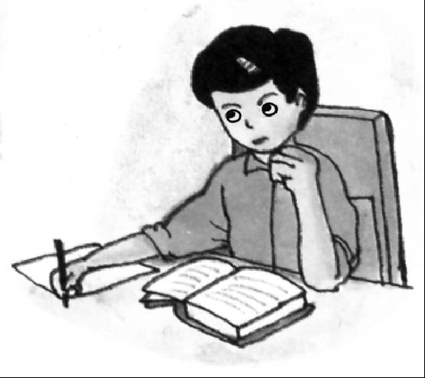

WORKSHEET # 1: Tawheed
Colour in the pictures:
Allah is the Creator of everything!
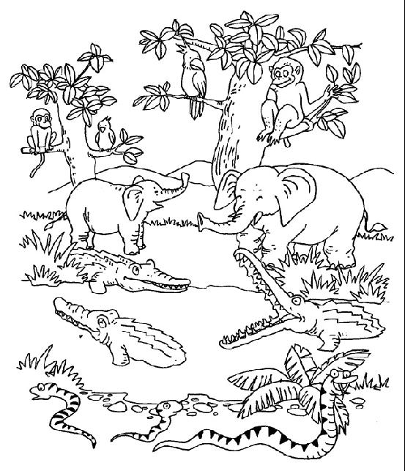



WORKSHEET # 2 : Tawheed

Who made the sun and the clouds and the mountains and the rain?

WORKSHEET # 1: Footprints of Tiger

Can you SEE the pain when you pinch yourself?

Although you can't see the pain you know it's there - don't you?

Colour the picture below; then cover the camel with your hands, so that you can't see it anymore.

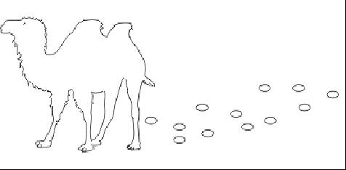
By seeing the footprints you know the camel has been there although you cannot see him.

Here are some creations of Allah so that you know He is there even though you cannot see Him.

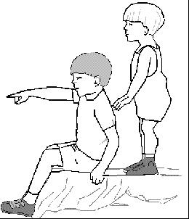

WORKSHEET # 2: Footprints of Tiger

Whose footprints made the guest of the farmer believe in Allah?

Draw the animal! (Refer to the story in your manual)

Colour the pictures

WORKSHEET : Allah Can See & Hear Everything

Who can see you everywhere? _______________________

Colour in the present Zainab’s mummy gave her.

Zainab’s mummy told her that she could open the present because she was such a clever girl.

Draw what you think was inside Zainab’s present:

WORKSHEET : Nabuwwat

Draw 3 things that Prophet Muhammad (s.a.w.) taught to do to make Allah happy:

E.g.: Helping Mummy:
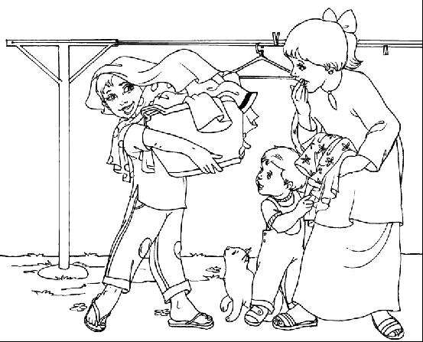

WORKSHEET #1: Twelve Imams

Colour the 12 stars remembering that there are 12 Imams (a.s.):

3
2
1
6
5
4
9
8
7
12
10

11

WORKSHEET # 2 : Twelve Imams

In the hand below, colour:

YELLOW = Prophet Muhammad (s.a.w.) BLUE = Imam Ali (a.s.)

PINK = Bibi Fatimah (a.s.) GREEN = Imam Hasan (a.s.)

RED = Imam Husain (a.s.)

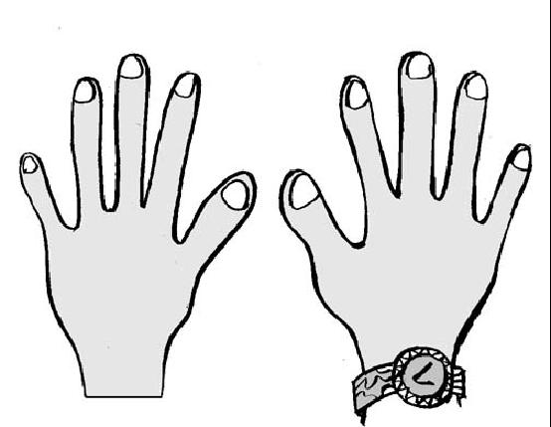
Prophetuhammad (s.a.w.)
Imam Ali (a.s.)
Bibi Fatimah (a.s.)
Imam Hasan (a.s.)
Imam Husain (a.s.)

WORKSHEET: Salawaat

    ▪  
Colour in the 14 beads that are on this special Tasbeeh of Salawaat for:
- the Holy Prophet (SAW)
- his daughter Bibi Fatima (AS) and
- the 12 Imams(AS)

1+1+12=14.

Remember to recite Salawaat as you colour each bead.

WORKSHEET: Qayamat

WORKSHEET : Angels

Draw wings around the names of the four special angels and a picture to show what they do.

Jibrail

------------------------------------------

Meekail

------------------------------------------

Izraail

------------------------------------------

Israfeel
WORKSHEET: SHAYTAN:

Put a big cross on the picture of fire-of-hell where Shaytan will be.

You are not going to go in there because you listen to Allah.

FIRE OF HELL:

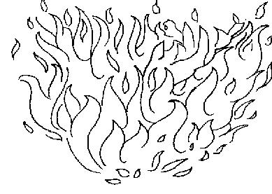

Because you listened to Allah you are going to heaven.

Draw what you are going to ask for in heaven when you get there.

HEAVEN:
E.g.: a bicycle:

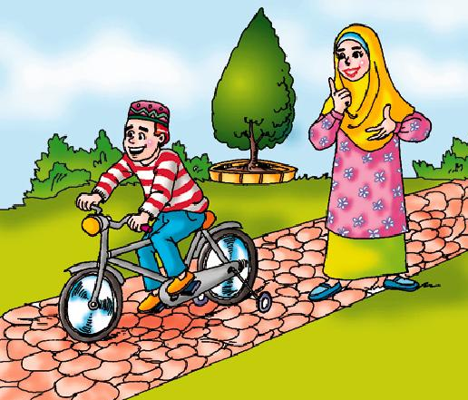

WORKSHEET : Salaam-un-Alaykum

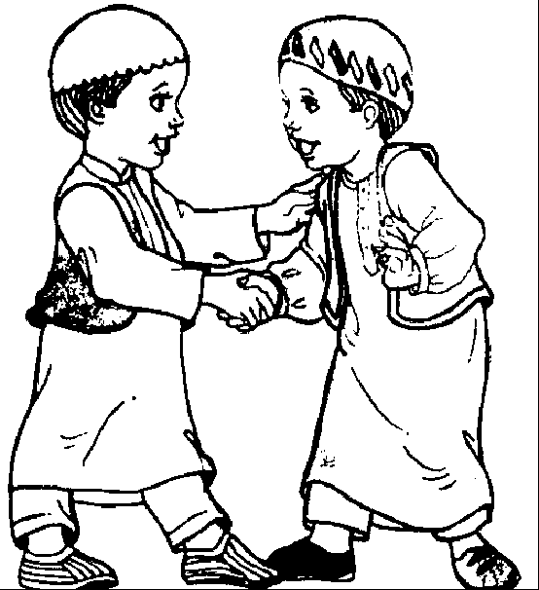
Say Salaam-un-alaykum and shake the hands of the person sitting on your right and then shake hands with the person on your left. Then Colour the picture:

WORKSHEET : Fi-Amanillah & Khuda Hafiz
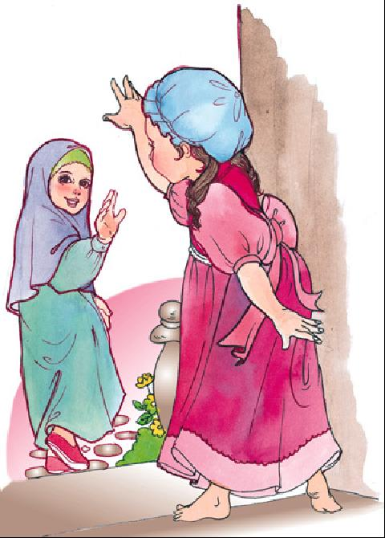

Colour in the picture of the friends saying Fi-Amanillah to each other.

WORKSHEET : Toilet Manners
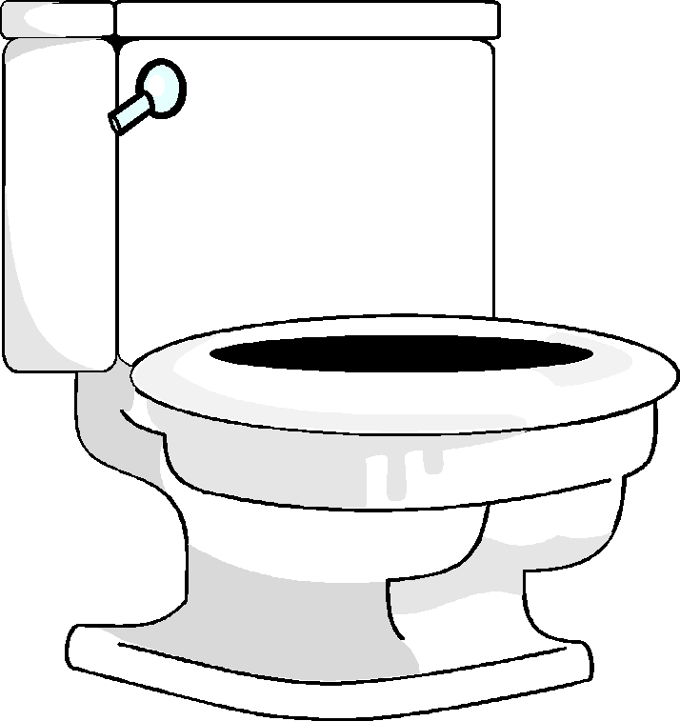

Number the following in the right order, and then colour them in:
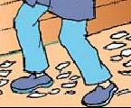
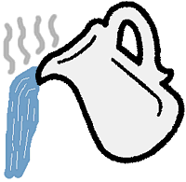

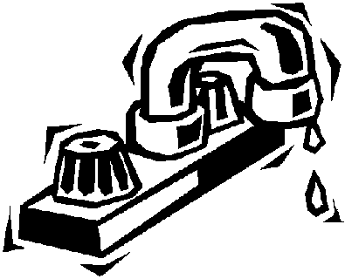

WORKSHEET : Table Manners

Look at the pictures below and put a cross on all the pictures that show bad table manners and a tick on all the pictures that show good table manners:

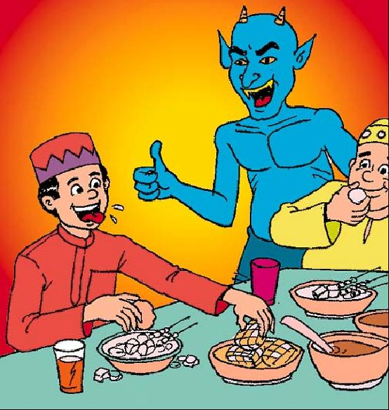
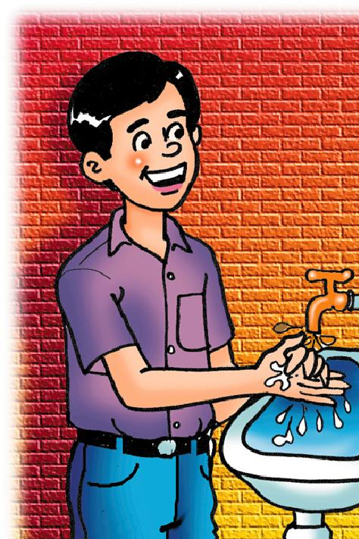
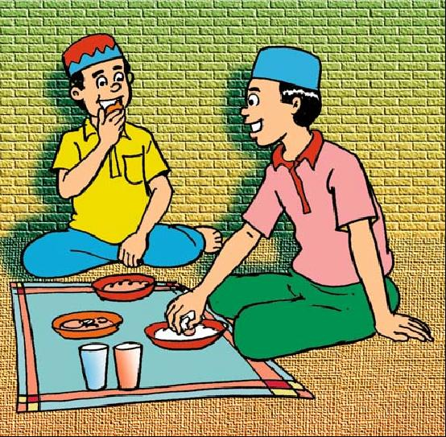
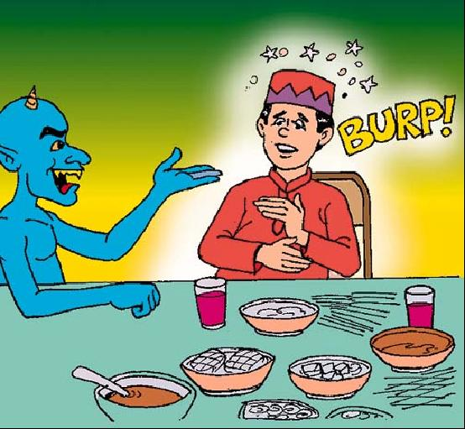
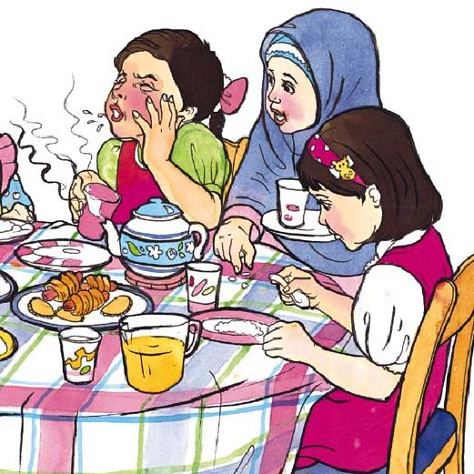

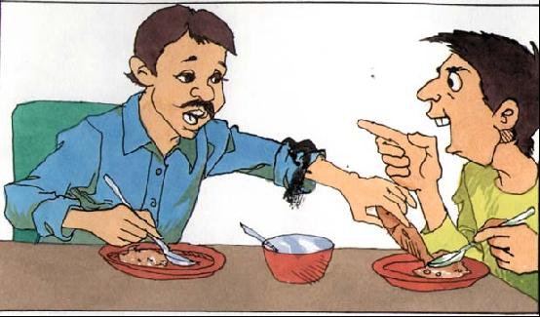
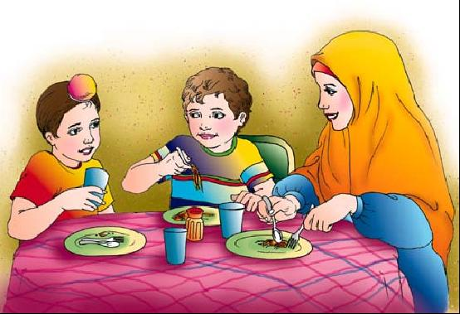
SALT

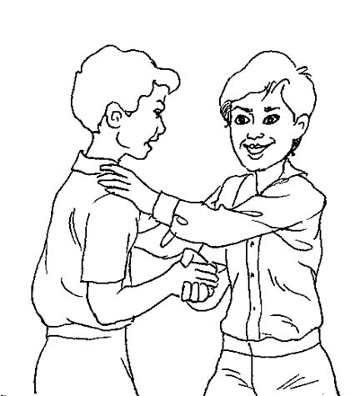
WORKSHEET : Manners in the Imambargah

Look at the pictures below and put a cross on all the pictures that show what you must not do in an Imambargah and a tick on all the pictures that show good Akhlaq in an Imambargah:




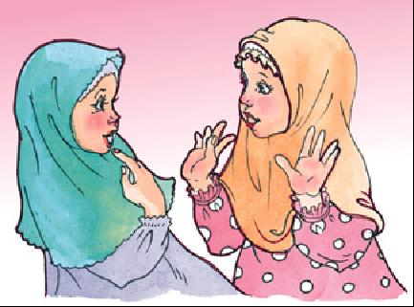
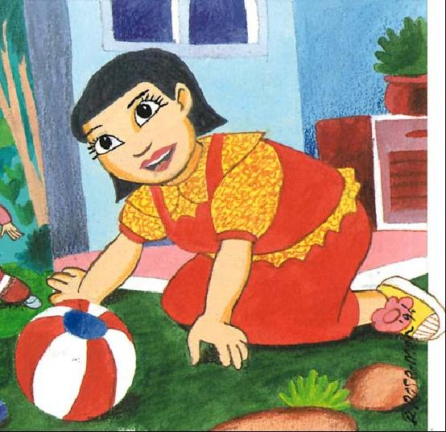
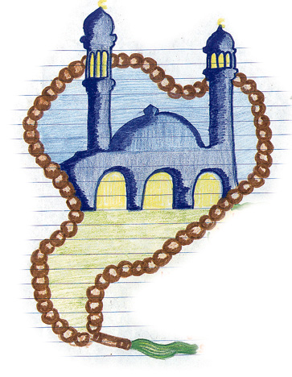
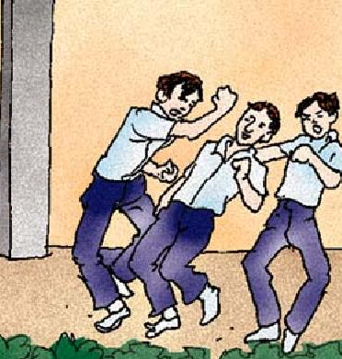
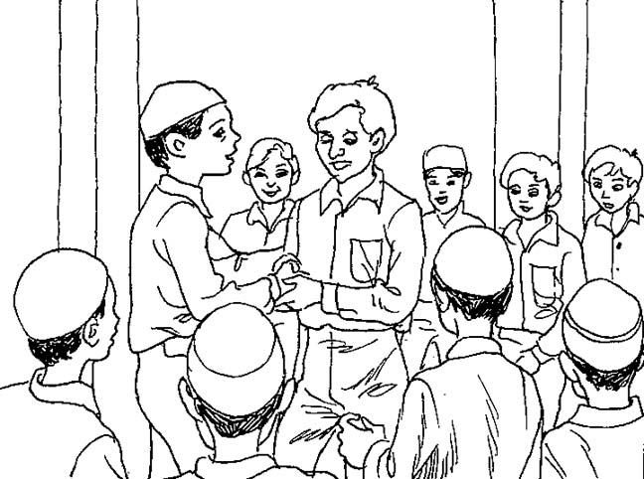
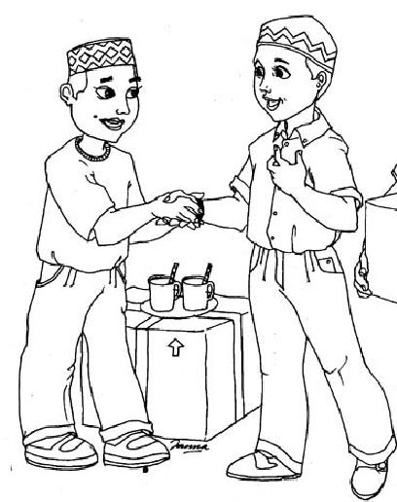
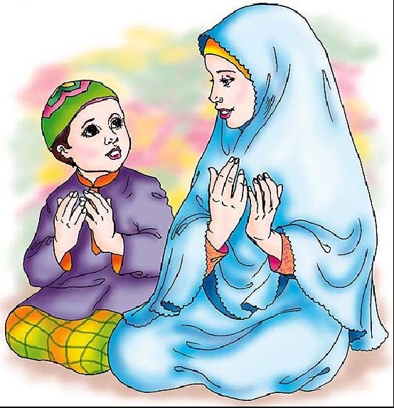

WORKSHEET : Respect of Parents

Can you think of different ways you can be kind and loving to your mother and father? Draw what you think would make them happy?

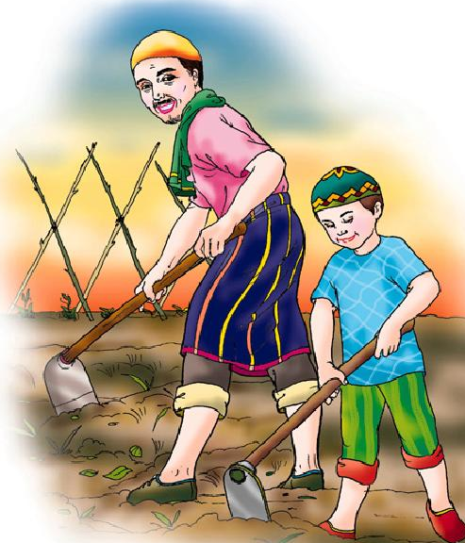
E.g.:

WORKSHEET : What we should do/should not do?

Ruqayya is packing to go to Janna.

Circle what she needs to pack in her suitcase.

Kalima Good akhlaq Salaa

Kafan Sunglasses Fasting

Hajj Naughty deeds Qur’an

Story books Duas Swimming
Costume

Sadaqa Shorts T shirts

WORKSHEET : Friday

WORKSHEET : Wuzu – Method

Number the actions in sequence (1st, 2nd etc.) and write how many times it has to be done
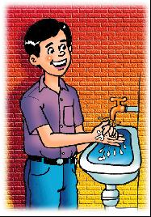
Colour them in and write how many times each one has to be done.

__________ times.
WORKSHEET : Prophet Muhammad (saw)

Tell your parents the story of Prophet Muhammad (s.a.w.) and the old woman.

Our Holy Prophet (s.a.w.) taught us to be kind to people and visit them when they are ill:

Draw how you can help other people:

E.g.: looking after them when they are ill:

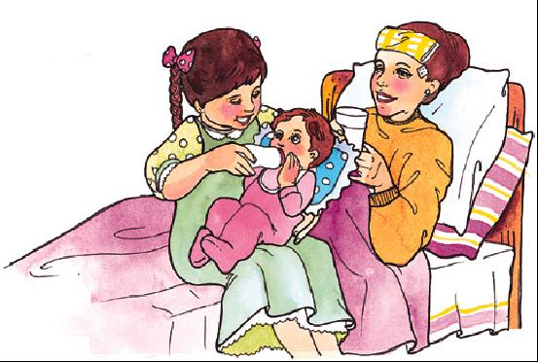

WORKSHEET: Bibi Fatimah (sa)

Colour the beads saying:
- Allahu Akbar 34 times,
- Alhamdulillah 33 times, and
- Subhanallah 33 times.


WORKSHEET : Imam Ali (as)

Tell your parents the story of where Imam Ali (AS) was born.
Tell your parents who was the first person whom Imam Ali (AS) saw
Now colour in the picture of the Ka'aba:

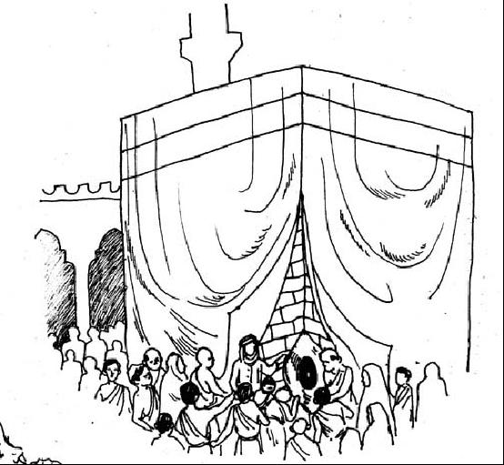

WORKSHEET : Imam Hasan (as)

Tell you Mummy and Daddy the story about Imam Hasan (a.s.) and the hungry dog:

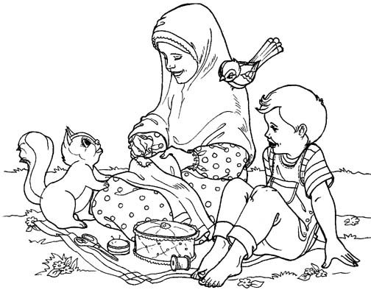
Colour in the picture below.

Draw below some animals that you usually see and

WORKSHEET : Imam Husain (as)

Tell your mummy and daddy the story of how the angel Fitrus got his wings back.

Now colour in the picture:
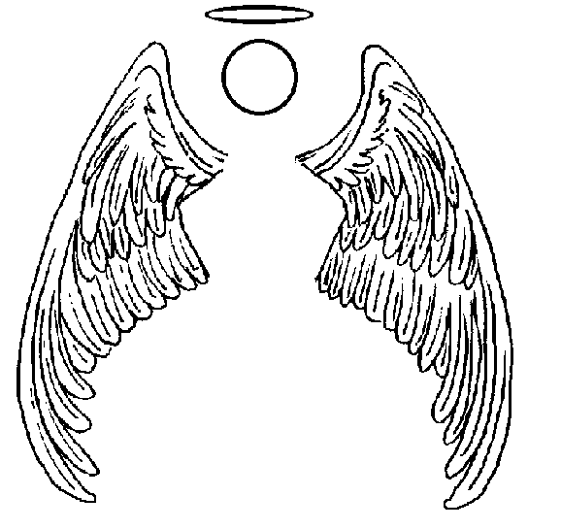
WORKSHEET : Imam Zainul Abideen (as)

Tell your mummy and daddy the story of what made our 4th Imam, Imam Ali Zainul Abideen (A) so angry.

Draw a picture of something you can do to help your mummy and daddy when you get home.

E.g.: help Mummy and Daddy put the grocery away:

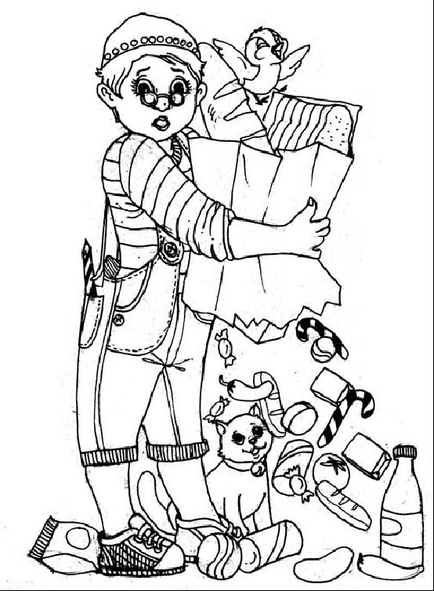

Other things you can do to help are:

Clean you room

Tidy your toys

Put you dirty plate in the sink after eating

Look after your little brother or sister

Put away your clothes when you change

WORKSHEET : Ariza(letter) To Imam Muhammad Al-Mahdi (atf)

Taking example from the above ariza, write an ariza to Imam-e-Zamana (ATF)
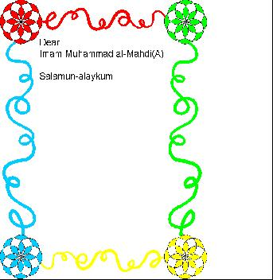

WORKSHEET: PROPHET ADAM:
Draw why Shaytan was taken out of heaven for not doing:

When Prophet Adam and Bibi Hawwa ate the fruit that Allah had told them not to eat, where did He send them?

WORKSHEET : Prophet Ibrahim (as)

Prophet Ibrahim (A.S.) and Prophet Ismail (A.S.) built the Ka’ba with the help of the angel Jibraail.

Draw the Ka’ba and colour it.

WORKSHEET : AZAAN

- It is narrated from the prophet(a.s)that:
one who recites azaan with true spirit will get reward from Allah equivalent to that for 40,000 martyrs and 40,000 men of piety.

- When muazzin says “ash-haduan la ilallah” ,
90,000 angels say durood for him.

- When muazzin says “ash-haduanna muhammedan rasoolallah”
40,000 angels record blessings for him

( ‘Ain Al-hayat’ by:Allama Mohammed Baqir Majlisi.)

ACTIVITY:

Tick(√ ) in the space provided if you have recited azaan for maghribain namaz.

Azaan recited befor maghribain namaz.
Friday
Saturday
Sunday
Monday
Tuesday
Wednesday
Thursday

Can you count the number of sawaab you have got?????

Mother’s signature:___________

Work Sheet: HIJAB

Colour all the people(na-mahrams) in front of whom you should do hijab:

Classmate | 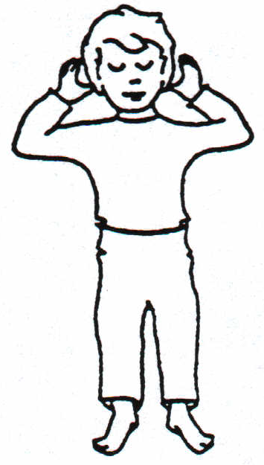  Brother | 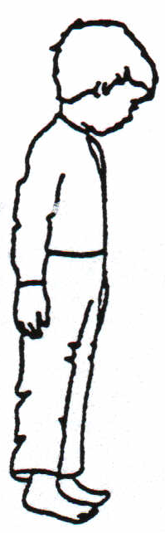  Brother’s Friend | Father’s Friend
Auntie’s husband(Khaloo) |  | Father’s brother(Chacha)
Mother’s brother(Mamoo) |  | Cousin

WORKSHEET : FRIENDSHIP

A friend need not be of your age. It could be family members/ teachers/ books.

Name a friend you have with these qualities:

      - Momin friend(s):________________________________________________
      - Those who have knowledge and patience:____________________________
      - Those who have good akhlaq:______________________________________
      - Those who try to improve your bad habits:____________________________
      - Those who help you as much as they can:____________________________

WORK SHEET: SLEEPING MANNERS

Tick() in front of every column before sleeping.(with the help of your mother)

 |  | fri | sat | sun | mon | tue | wed | thu
1. | visit toilet/ brush teeth/ wudhu
2. | Say fi amanillah to mummy/ pappa
3. | Recite kalmia/ suras/ tasbeeh.
4. | Think of good deeds you did and thank A…for it.
5. | Think of bad deeds you did and ask forgiveness (tawbah) .

Mother’s signature: __________

WORKSHEET : MANNERS OF WAKING UP
We remember Allah as soon as we wake up.
Draw / write / paste pictures of 3 other things you can do after you wake up:

WORKSHEET : Prophet Nuh (as)

Try to draw the Prophet Nuh’s Ark, which your teacher has shown. (overleaf)

WORKSHEET :THE ISLAMIC YEAR

(Lunar year/Qamri saal)
(Teacher will help to make the calender)

Muharram

Safar

Rabi ul Awwal

Rabi ul Aakher

Jamad ul Awwal

Jamad ul Aakher

Rajab

Sha'ban

Ramadhan

Shawwal

Dhulqa'ada

Dhul hijja

Month of RAJAB
Rajab is also called _________

RAJAB is the name of a river in jannah. It is whiter than milk and sweeter than honey. One who fasts in the month of RAJAB will surely drink from it.

- Tick each box after reciting “ ASTAGHFIRULLAHA RABI WA ATUBU ILAYH” every day before going to sleep.

1 | 2 | 3 | 4 | 5
6 | 7 | 8 | 9 | 10
11 | 12 | 13 | 14 | 15
16 | 17 | 18 | 19 | 20
21 | 22 | 23 | 24 | 25
26 | 27 | 28 | 29 | 30

Recite “ LAELAHA ILLALLAHO ” 1,000 times during the month of Rajab, So Allah (s.w.t) will write 1,000 good deeds in your aamal nama and will make 100 cities in Jannat!!! – Prophet Muhammad (s.a.w)
In this month also recite Astaghfirullaha rabbi wa atubu ilayh
MEERAJ is on ________ of Rajab.

