INDEX................... .........................................Manual M00(R)
(2007-2008)

- Bismillah 2
- Woman’s Ring 3
- Student Walks on Water 5
- Kalima 6
- My First Counting 7
- Usool-e-Deen 8
- Tawheed 9
- Why Can’t I See Allah 10
- Footprints of Tiger 11
- Allah Can See & Hear Everything 12
- Adal 13
- Nabuwwat 14
- Imamat 15
- Twelve Imams 16
- Salawaat 17
- Qayamat 18
- Our Treasure 19
- Angels 20
- Shaytan 21
- Salaam-un-Alaykum 22
- Fi-Amanillah & Khuda Hafiz 23
- Toilet Manners 24
- Table Manners 26
- Manners in the Imambargah 28
- Respect of Parents 29
- What we should do/should not do? 30
- Friday 31
- Furoo-e-Deen 32
- Why Should I Pray Namaz? 33
- Wuzu - Introduction 35
- Wuzu – Method 36
- Namaz & Rak’ats 37
- Namaz - Method 38
- Prophet Muhammad (saw) 41
- Bibi Fatimah (sa) 42
- Imam Ali (as) 43
- Imam Hasan (as) 44
- Imam Husain (as) 45
- Karbala & Muharram 46
- Imam Zainul Abideen (as) 47
- Imam Muhammad Al-Mahdi (atf) And Ariza to Imam(atf) 48
- Prophet Adam (as) 50
- Prophet Ibrahim (as) 52
- Introduction to Qur’an 53
- Suratul Fatiha 54
- Suratul Ikhlas 55
- Suratul Asr 56
- Suratul Kauthar 56
- Azaan 537
- Hijab 548
- Friendship 559
- Maners of sleeping 560
- Manners of wakingup 561
- Prophet Nuh(a.s) 62
- Prophet Ismail(a.s) 63
- Islamic year 564

Chapter 1

Bismillah

   
(I begin) in the name of Allah, the most Kind and the most Merciful.

We should say     before we do anything because we want Allah to help us in what ever we are doing.

If we say     then Allah keeps Shaytan away from us and he cannot come and try to spoil what we are doing.

   

Chapter 2

Woman’s Ring

A long time ago there lived a woman who always used to say     before she did anything.
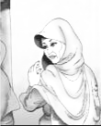

Now every night this woman, before she went to sleep would take off her ring and put it in her cupboard. And, as always, before she took off her ring she would say     

Her husband did not believe that just by saying     Allah would help you.

One night to show his wife that     did not make any difference, the husband took his wife's ring from the cupboard, where she had kept it safely, and threw it in the river.

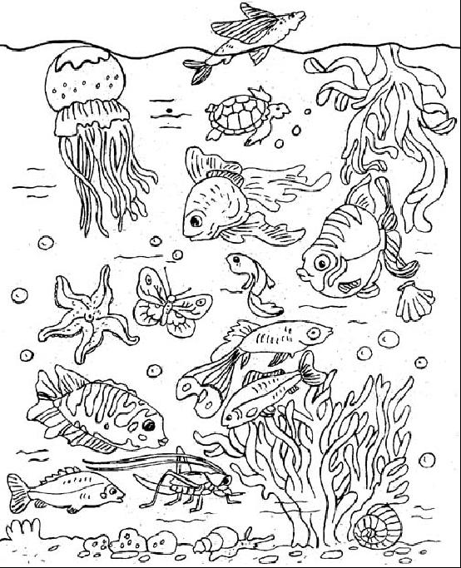
The next morning because the woman was late getting to the shops, she did not have time to get her ring, which she thought was still in the cupboard.

The woman went to the shops and bought a fish for their dinner that evening. When she got home, she began to cut the fish so that she could cook it and what do you think she found inside the fish?

Yes, there was her ring that her husband had thrown in the river. The fish had swallowed it.

The woman was very surprised to find her ring in the fish, and when her husband came home she told him all about it.

The husband was shocked. He then told her how he had thrown her ring in the river. He also told her how sorry he was and that now he truly believed that Allah looks after anyone who says:    

Moral:
Always say     before you do anything so that Allah will also look after you and when Allah looks after you then no-one can hurt you.

Chapter 3

Student Walks on Water

A long time ago, there lived a students who always came late to school.

One day, his teacher, Syed Murtaza, asked him why he was always late.

He replied that it was because he had to catch a boat to cross the river to get to school, and the boat was always late.

His teacher told him that he was giving him a piece of paper with something special written on it and with this paper in his hand the man would be able to walk on the water, but he must not look at what was written on the paper.

The next day the man went to the river and with the paper in his hand he stepped onto the water and began to walk on the water. The man reached his school in time.
It said:

Every morning the man walked on the water and reached his school on time, until one day when he looked at what his teacher had written on the paper.

The man thought to himself: "is that all it says". He then took the paper and went to walk on the water but this time he began to sink. He tried and tried but could no longer walk on the water.

That day he arrived to school late because he again had to wait for the boat to take him across the river.

When his teacher saw that he was late again he said to him that because he had thought what was written on the paper was not very important, he could no longer walk on water.

is very powerful if you truly believe in it.

Chapter 4

Kalima

   
There is no God but Allah

   
Prophet Muhammad (s.a.w.) is the messenger of Allah

  ▪ 
Imam Ali (a.s.) is the Wali of Allah.

   
Imam Ali (a.s.) is the successor of the Prophet (s.a.w.).

   
Imam Ali (a.s.) is the 1st Khalifah.
Chapter 5

My First Counting

Hindi/Urdu Version

Allah Aik
Panjetan Paanch
Imam Baara
Ma’sum Chowda
Nabi Aik lakh Chobees Hazar
Rasool Teen-so-Tera
Ulul Azm Rasool Paanch
Aasmani Kitabein Chaar
Karbala kay Shaheed Bahattar

English Version

Allah One
Panjetan Five
Imam Twelve
Ma’sum Fourteen
Nabi One hundred twenty-four thousand
Rasool Three Hundred Thirteen
Ulul Azm Rasool Five
Heavenly Books Four
Karbala’s Martyrs Seventy Two

Chapter 6

Usool-e-Deen

Hindi/Urdu Version

Usool-e-Deen, yani deen ki jadein

Usool-e-Deen paanch hain:

Awwal Tawheed

Doosrey Adal

Teesrey Nabuwwat

Chowthey Imamat

Panchwey Qayamat

English Version

Usool-e-Deen means roots of religion

Usool-e-Deen are Five:

First Tawheed

Second Adal

Third Nabuwwat

Fourth Imamat

Fifth Qayamat
Chapter 7

Tawheed
⬆

Tawheed means there is only one God

His name is ALLAH.

ALLAH looks after us and loves us very much.

ALLAH is the One whom we ask for help

ALLAH is the One whom we will go back to

ALLAH is the one we pray to.

ALLAH has made everything.
- He made the world.
- He made all of us, you, me, your mummy, daddy and everyone else.
- He made all the animals
- He made the trees and the flowers
- He made the sky with the sun and the moon.
- He made everything.

ALLAH is the strongest ever.
- He is stronger than any person.
- He is stronger than any animal
- He is stronger than anyone or anything

ALLAH is the cleverest
- He is cleverer than any one ever.

We have to listen to Him and do whatever He tells us to do.

ALLAH does not need anyone
We all need ALLAH
Chapter 8

Why Can’t I See Allah

One day Hasan asked his mummy, "Why can't I see Allah?"

His mummy said, "Allah is not a thing we can see. He has never been seen and will never be seen."

Hasan asked, "Mummy, if we can't see Allah, then how do we know He is really there?"

Hasan's mummy smiled and told him to pinch himself. Hasan did what his mummy told him to do

"Ouch! That hurt me" he said as soon as he pinched himself.

His mummy started looking all over Hasan looking for something.

"What are you looking for mummy?" Hasan asked.

"I'm looking for the pain" she replied.

Hasan looked puzzled "But mummy, you can't see the pain."

His mummy smiled and said "just as the pain is there even if you can't see it, Allah is also there although you can't see Him."

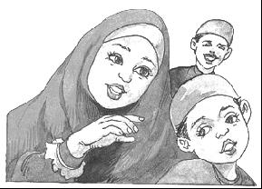
Then she continued "although you can't see Allah you can see all the things He has made - by looking at yourself and all around you."

I understand now Mummy. Thank you

Our Holy Prophet Muhammad (s.a.w.) has told us that:

When you see the footprints of a camel in the sand, then you know that a camel has passed by; even though you cannot seen the camel itself.

In the same way, when you see all the creations of Allah; you know He is there, even though you cannot see Him.

Chapter 9

Footprints of Tiger

Once there was a farmer who was a very good man. He worked hard on his farm and prayed namaz on time every day.

One day he saw a sick man lying on the roadside. He helped him up and took him home to look after him.

The next morning when the farmer woke up to pray salaa he woke up his guest who said he did not want to pray.

The man said that he could not see Allah so how could he pray to One whom he could not see. The farmer did not say anything.

The next day the man was feeling better and wanted to go home. The farmer walked with him across the fields. Suddenly they saw footprints. The man told the farmer that they were the footprints of a tiger.

"I don't believe that ! " said the farmer . "I can't see a tiger here !"

The man looked surprised and said "Are these footprints not enough to tell you that a tiger was here ?"

The farmer said "Dear brother! When you saw the footprints you believed that a tiger had passed here; so are not the moon, the sun, the flowers,and the trees signs enough to make you believe that there must be One who made them?"

The man thought for a while and said "You are right ! We cannot see Allah with our eyes but we can understand from the things he has made that He exists."

Chapter 10

Allah Can See & Hear Everything

Zainab’s mummy wanted to know if she really understood that Allah can see and hear everything.

So one day when Zainab came home from school, her mother gave her a big present and said: "Zainab you can only open this present in a place where no one can see you."

Zainab thought this would be very easy.

She took the present and ran upstairs, but her father was there. So, she ran into the garden, but the birds were there. Then, she ran into the bathroom, but there was a spider there.

Zainab thought for a moment then she ran into a store cupboard under the stairs and she looked around. At last there was no one there.

She was just about to open the present when suddenly she remembered what her mummy had told her: that Allah can see and hear everything.

Zainab went back to her mummy without opening the present.
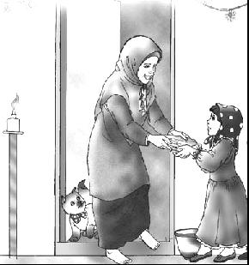
Why didn’t you open your present?

Because there is no place where Allah cannot see me.

Allah can see and hear everything, but He does not use eyes or ears like we do.

There is nowhere that you can hide where Allah cannot see you.

There is nothing that you can say which Allah cannot hear, even if you whisper it ever so softly.

Chapter 11

Adal

Adal means:

- Allah is fair to everyone

- He never does anything wrong.

- He never forces anyone to do bad things and them punish them.

- He will always reward those who obey Him.

Chapter 12

Nabuwwat

Nabuwwat means prophethood

Prophets are teachers that Allah sent to show us how to be good Muslims.

The Prophets know everything.

They never ever do anything that Allah does not like.

There are 124,000 Prophets.

The 1st Prophet is Prophet Adam (AS)

The last Prophet is Prophet Muhammad (s.a.w.).

Prophet Muhammad (s.a.w.) taught us what Allah wants us to do.

He taught us about the religion of Islam.

He taught us how to pray and to do good things that make Allah happy.

If we do everything that Prophet Muhammad (s.a.w.) taught us, then we will be good Muslims.

These are a few things our Holy Prophet Muhammad (s.a.w.) taught us:

- Looking after people when they are not feeling well

- Helping the poor

- Praying on time

- Reciting Qur’an.

Chapter 13

Imamat

Allah had told Prophet Muhammad (s.a.w.) to teach the people everything that Allah wanted them to know

After the death of Prophet Muhammad (s.a.w.), the Imams would be there to help people if they forgot anything.

Prophet Muhammad (s.a.w.) was the last Prophet

After him came the 12 Imams (a.s.).

The 1st Imam is Imam Ali (a.s.).

The last Imam is Imam Muhammad Mahdi (atfs).

Imam Muhammad Mahdi (a.s.) is still alive and is the Imam of our time.

Chapter 14

Twelve Imams

There are twelve Imams:

First Imam | Hazrat Ali (AS)
Second Imam | Hazrat Hasan (AS)
Third Imam | Hazrat Husain (AS)
Fourth Imam | Hazrat Zainul Abideen (AS)
Fifth Imam | Hazrat Muhammad Baqir (AS)
Sixth Imam | Hazrat Ja’fer Sadiq (AS)
Seventh Imam | Hazrat Musa Kazim (AS)
Eighth Imam | Hazrat Ali Raza (AS)
Ninth Imam | Hazrat Mohd Taqi (AS)
Tenth Imam | Hazrat Ali Naqi (AS)
Eleventh Imam | Hazrat Hasan Askari (AS)
Twelfth Imam | Hazrat Muhammad Mehdi (ATF)
AS means Alaihis Salam
ATF means Ajjalal-laho ta’ala farajohu
SAW means Sal-lal-laho Alaihe Wasallam

Twelfth Imam Hazrat Muhammad Mehdi (ATF) is the Imam of our time, and is alive

When we hear or say the name of our 12th Imam (a.s.) we should:
- put our right hand on our head
- bow down
- and recite Salawaat.

Ma’sumeen:

Ma’sumeen are:
- Prophet Muhammad (SAW)
- Bibi Fatimah (AS)
- Twelve Imams

12+1+1=14

Panjetans:

There are 5 Panjetans:

They are:
- Prophet Muhammad (SAW)
- Imam Ali (AS)
- Bibi Fatimah (AS)
- Imam Hasan (AS)
- Imam Husain (AS)
Chapter 15

Salawaat

Ahle-Bayt (AS): The family of the Prophet (SAW) are called his Ahle-bayt or Ahlul-Bayt

Whenever you hear the name of our Holy Prophet or his family, you should recite Salawaat.

    ▪  
O Allah!
Send Your blessings on Prophet Muhammad (SAW)
and his Ahle-bayt (family).

Salawaat is also known as Durood

When you are sitting in mosque and do not understand the lecture or Majlis, you should recite as many Salawaat as possible.

When you recite Salawaat you are asking Allah to send His blessings to the Holy Prophet and his family.

Inshallah on the day of Qayamat (Judgement) the Holy Prophet (SAW) and his family will ask Allah to forgive you in return for all the Salawaat you sent to them.

Chapter 16

Qayamat

One day everyone will die

After dying, all will be made alive again

Everyone will be gathered at a place, where he/she will be shown (as a film) what he/she has done in this life. He/She will be questioned about everything what he/she has done in this world

Whoever has done good deeds will get rewarded for this

Whowever has done bad deeds will be punished for this

This day is known as Qayamat (Day of Judgement)

WORKSHEET
Chapter 17

Our Treasure

Our God ALLAH

Our Prophet Hazrat Muhammad (SAW)

Our religion Islam

Our book Qur’an

Our Qibla Ka’ba

Our leaders Imams

Our first Imam Hazrat Ali (AS)

Our last Imam Hazrat Muhammad Mehdi (ATF)

Imam Mehdi is alive

Our religious symbol Alam

Our recognition (pehchaan) Love of Ahle Bayt (AS)

We are Shia Ithna Ashri

Chapter 18

Angels

Allah loves us so much that He takes care of us in ways that we cannot even see. Angels are one of these ways.

Allah created lots and lots of angels all doing different things. Some are in Qiyam all the time, some in Rukoo, and some in Sijda.. Some deliver His messages, whilst some have special jobs like looking after each one of us.

Each of us have two angels who write down everything we do. The one on the right side writes down all our good deeds whilst the one on the left side writes down all our bad deeds.

We cannot see angels but we know that they are there.

We are not sure what angels really look like but we know that they have wings.

Some of the very special angels are:

Jibrail | He delivers the commands of Allah to His Prophets. It was Jibrail who brought the ayaat of the Qur'an to Prophet Muhammad (SAW).
Meekaail | He distributes sustenance (rizq) to Allah's creation. Rizq is the essential things required for life. e.g. air, water, food, clothing, shelter
Izraail | He is the angel who is responsible for death. He takes us back to Allah
Israfeel | He will announce the end of the world just before the day of Qiyama

Chapter 19

Shaytan

Before Allah made human beings, He made everything else:
- the sun and the moon
- the sky
- the earth
- the animals
- the trees
- the angels
- the jinn

The jinn were like people:
- some were good and listened to Allah, and
- some were naughty and did not listen to Allah.

Shaytan was a very good jinn, so Allah let him come to the heavens to live with the angels.

Now Allah decided to make man.
Allah had made the jinn from fire.
He made man from clay.

The 1st man Allah made was Prophet Adam.

Allah told everyone in the heavens to bow down to Prophet Adam. All the angels listened to Allah and bowed to Prophet Adam but Shaytan did not listen to Allah.

He said that he was made from fire and was better than Prophet Adam so he would not bow down to him.

Shaytan had been very bad because he did not listen to Allah. So Allah told Shaytan that he was not allowed to live in the heavens anymore and that he would go to hell and burn in the fire.

We must always listen to Allah and be good Muslim children, so that we can go to heaven.

Chapter 20

Salaam-un-Alaykum
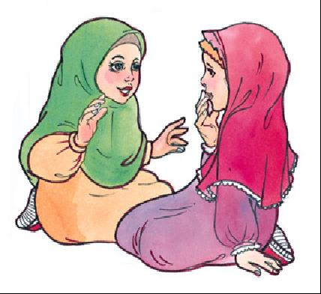

We are Muslims, which means that everything we do is for Allah.

Allah tells us that all Muslims are brothers and sisters and that we should care for each other.

By saying Salaam-un-alaykum you are not just saying hello, but you are telling the person that you care about them and you will not hurt them in any way because

Salaam-un-alaykum means "Peace be on you."

So before you talk to a Muslim you should first say Salaam-un-alaykum. It is also good to shake hands with them. (Boys with boys and girls with girls)

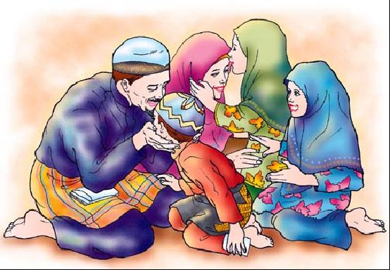
When you wake up in the morning the first thing you should do is say Salaam-un-alaykum to your mummy and daddy.

If someone says Salaam-un-alaykum to you then you should reply with Wa-alaykum-us-Salaam Wa Rahmatullahi Wa Barakatuhu.

Wa Alaykum-us-Salaam means “And Peace be on you.”

Wa Alaykum-us-Salaam Wa Rahmatullahi Wa Barakatuhu, Taqi
Salaamun Alaykum Javad
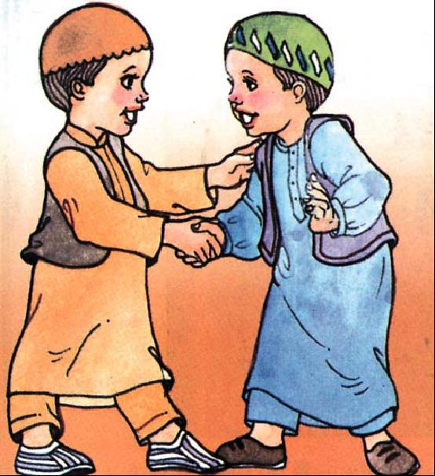

Allah does not like if you do not reply to Salaam.
Chapter 21

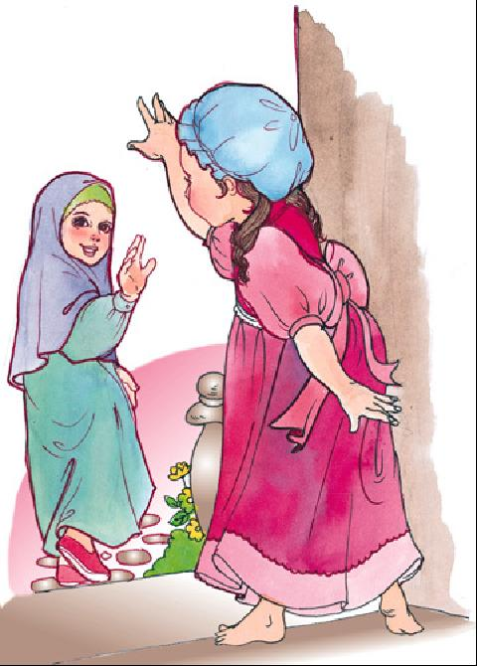
Fi-Amanillah & Khuda Hafiz

We are Muslims, which means that everything we do is for Allah.

Allah tells us that all Muslims are brothers and sisters and that we should care for each other.

By saying Fi-Amanillah, you are not just saying good-bye, but you are telling the person that you care about them because you are asking Allah to take care of them

Fi-Amanillah means: I leave you in the careof Allah.

Khudah-Hafiz means: May Allah take care of you.

Whenever you leave your mummy and daddy you should say Fi-Amanillah to them so that Allah may keep them safe.
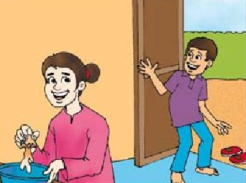
Fi-Amanillah Mummy
Fi-Amanillah Javad

Before you go to sleep you should say Fi-Amanillah.

Chapter 22


Toilet Manners

You should go to the toilet as soon as you need to, and not wait to finish what you are doing.

Wear some slippers, because the floor may be wet and Najis

When you go to the toilet, close the door

When you go to the toilet, SIT on the seat. DO NOT STAND and do wee-wee

If there is a pipe connected to the tap, use it, else fill the jug with water and use it. Using pipe is better than using jug

If you have done wee wee, make sure to pour water three times.

If you have done poo, then wash yourself with your left hand until you are clean.


If you cannot wash yourself, call someone to wash you.

Flush the toilet and wash your hands.

Thank Allah for having made the water which cleans us

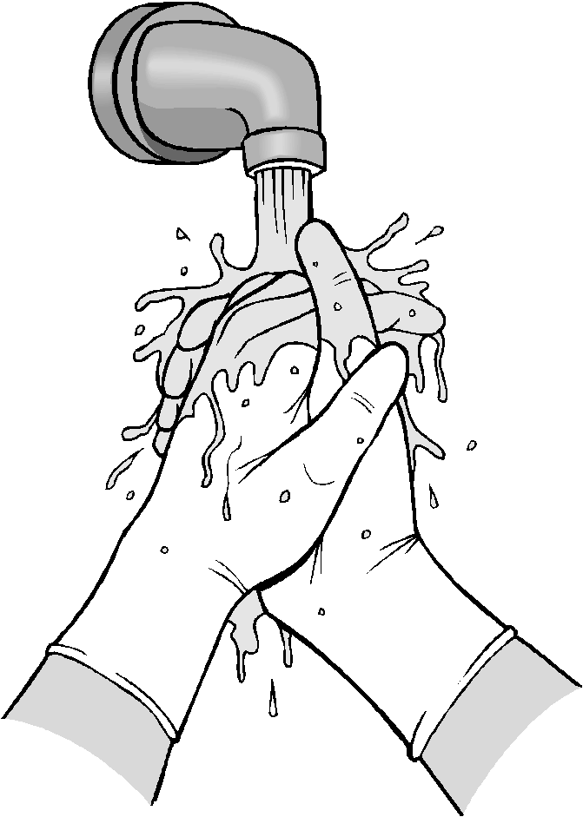
Say: Alhamdu lillah
⬇⬆⬇ 
(All praise is for Allah)

At school, if there is no pipe or jug, take some water in a cup. If there is no cup, then after you have done your wee-wee clean yourself with a tissue.

When you get home, tell your mummy that you used tissue and not water; so that she can help you become Pak again and also change your dress which may be Najis.

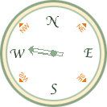
Remember that when you are sitting on the toilet you should not face or have your back to Qiblah.

If the toilet is facing Qiblah then sit a little sideways.

Enter the toilet with your left foot.

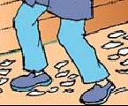
Leave the toilet with your right foot

Chapter 23

Table Manners

When Zahid went home from Madressa, his mummy asked what he learnt today. This is how he explained to his mum what he had been taught about table manners.
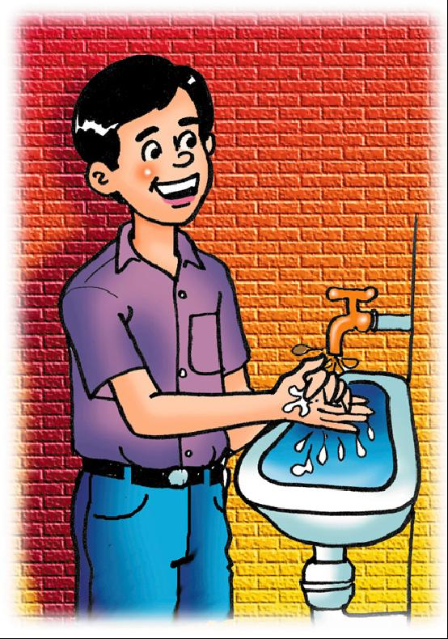

Always wash your hands before you start eating

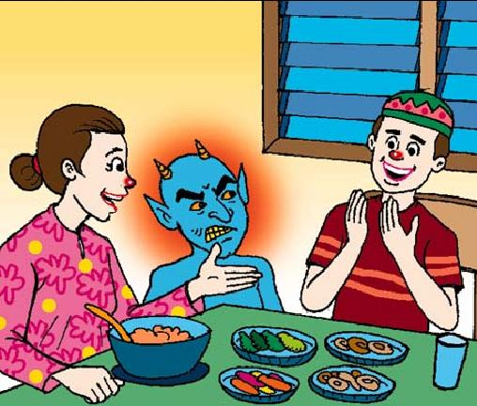

Begin by saying “Bismil laahir Rahmaanir Rahim”

SALT

Take a pinch of salt before starting to eat.

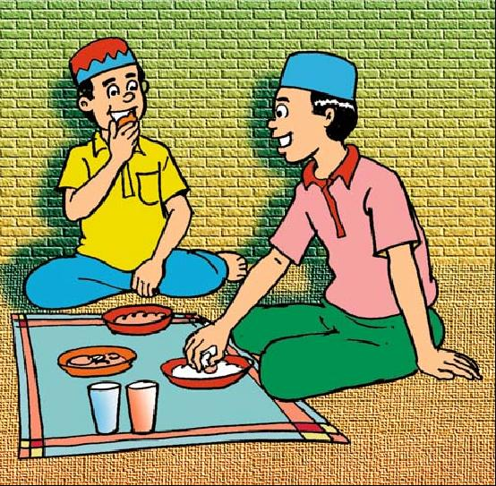

Always eat with your right hand, and take small bites and chew the food.
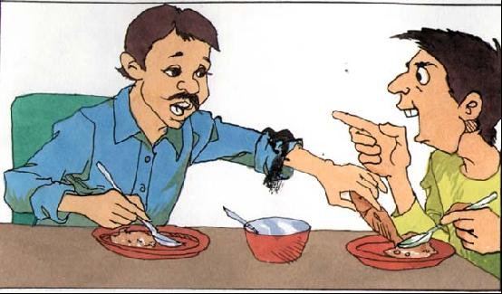

Never talk with your mouth full or
look at other people faces or plate while eating.

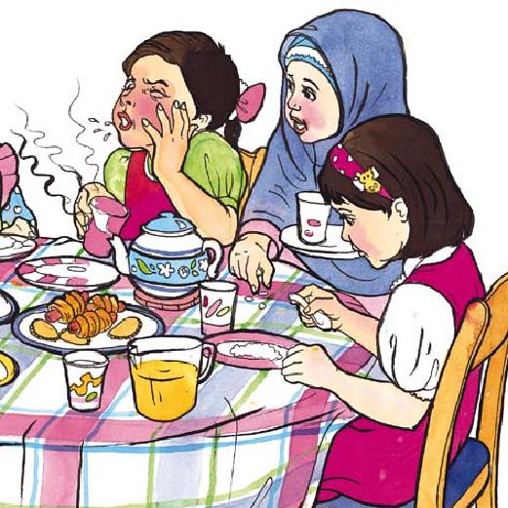

Don’t eat hot food or blow on it, and

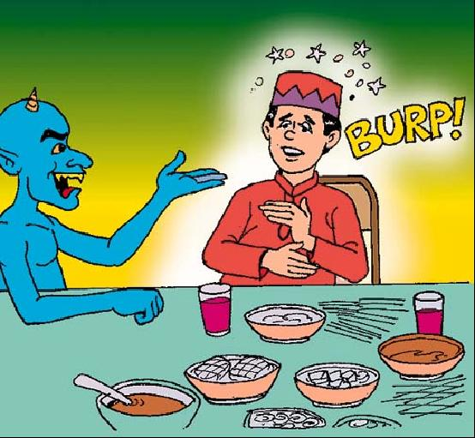
Always finish all the food on your plate.

Do not over eat. Always put a little food on your
plate and add more if you are still hungry

Finally thank Allah for the food he has given you by saying :
AL-HAMDU-LILLAH (All praise is for Allah).

Wait for everyone on the table to finish before you get up

When you go home today show your parents what you were taught about table manners.

Chapter 24

Manners in the Imambargah

A mosque is a place for Namaz.

An Imambargah is a place for Majlis and other functions.

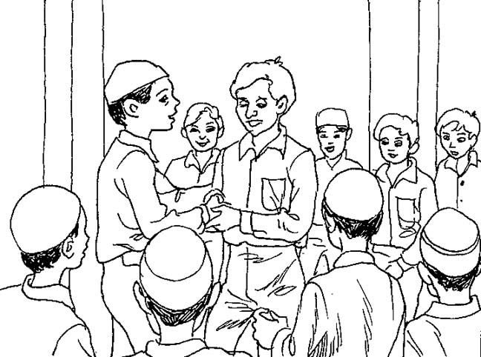
When you enter the Imambargah, remember to behave with respect:

Say Salaamun Alaikum to people as you see them

Remove your shoes


Do not talk during the Adhan, Namaz, Du'a or lecture

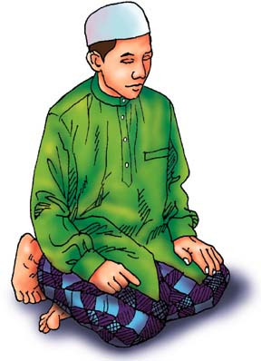
Find a place to sit. Do not squash anyone else around you

Listen carefully to the lecture


When ‘tabarruk’ is given, wait to be given one. Take only one

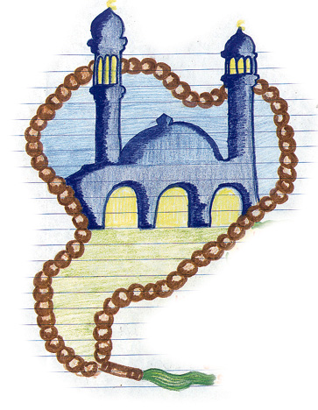

If you do not understand the lecture, recite Salawaat or Tasbeeh of Bibi Fatima (as)


Say khuda-hafiz to people as you leave
When leaving, leave slowly being careful not to push anyone

Chapter 25

Respect of Parents

Who do you think is most the most important person for you in the world?

Is it your best friend? OR Is it Superman?

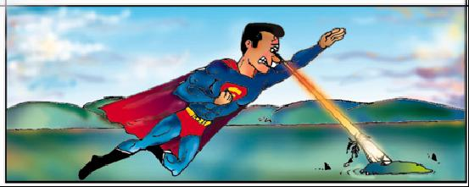

Of course you know it is not them but your parents who are the most special people on this earth for you.

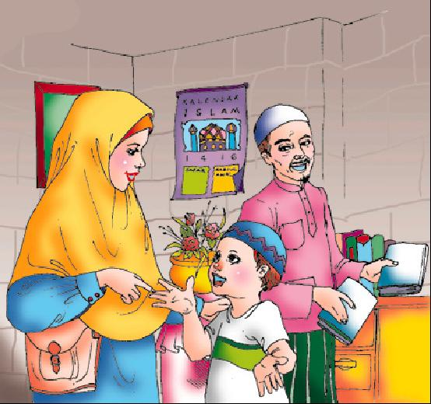
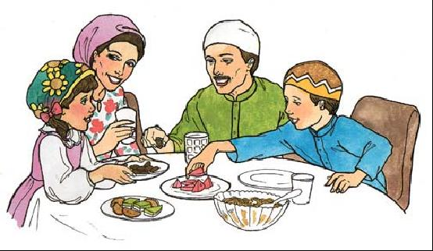

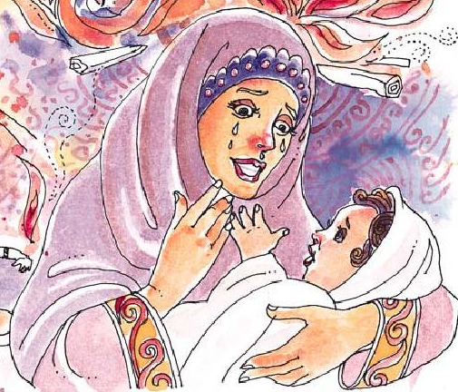
Your parents love you and take care of you.

When you were babies and your weren’t feeling well, your parents kept awake all night and made you comfortable.

They fed you and cuddled you when you were sad.

They always make you happy.

In the Holy Qur’an Allah tells us to respect our parents. We must:

- never talk to them in a loud voice
- never be rude to them
- always make them as happy as they make us.

Chapter 26

What we should do/should not do?

What we should do?

We should follow our ALLAH, Prophet (SAW) and Imams (AS)
We should make our parents happy
We should respect our elders
We should listen to our teacher
We should learn our lessons
We should greet everyone with Salaam
We should always speak the truth
We should offer our prayers on time
We should love people who love Allah, Rasool and Imam
We should hate people who hate Allah, Rasool and Imam

What we should not do?

We should not lie
We should not bother our parents, and shall not make them angry
We should not say bad words
We should not listen to songs / music
We should not use other’s things without their permission
We should not say bad things about someone in his absence
Chapter 27

Friday

Friday is the most important day of the week

Friday is the day of our Imam-e-Zamana (ATF)

We shall offer prayers, recite duas and do only those things on Friday by which Allah, Prophet and Imams get happy

We shall not spend Friday in games and play

WORKSHEET :
Chapter 28

Furoo-e-Deen

Hindi/Urdu Version

Furoo-e-Deen yani deen ki shakhein

Furoo-e-Deen Das (10) hain:

Awwal Namaz
Doosrey Roza
Teesrey Hajj
Chowthey Zakaat
Panchwein Khums
Chattey Jihad
Satvein Amar Bil Maroof
Athvein Nahi anil Munkar
Nawein Tawalla
Daswein Tabarra

English Version

Furoo-e-Deen means branches of religion

Furoo-e-Deen are 10:

First Namaz
Second Roza
Third Hajj
Fourth Zakaat
Fifth Khums
Sixth Jihad
Seventh Amar Bil Maroof
Eighth Nahi anil Munkar
Ninth Tawalla
Tenth Tabarra
Chapter 29

Why Should I Pray Namaz?

One day, Abid’s mother asked him: “Have you offered your prayers?”
Abid replied: “No mother”

Mother asked: “Why?”
Abid said: “Why should I offer prayers? I dont feel like”

His mother kept quiet

The next day, his mother gave him a gift (pencil)
Abid said “Thanks mom!”

His mother was very happy that Abid thanked him, and gave him another gift (eraser)
Abid said “Thanks again mom!”

His mother asked him: “Why did you thank me?”
Abid said: Because you gave me a gift

His mother asked: My gift (pencil) is more important or your eyes
Abid replied: “Of course my eyes. I cannot see without my eyes”

His mother again asked him: “My gift (pencil) is more important or ears”
Abid replied: “Of course my ears. I cannot listen without my ears”

His mother again asked him: “My gift (pencil) is more important or legs?”
Abid replied: “Of course my legs. I cannot walk without my legs”

Finally his mother said: “You are thanking me for giving you a pencil, but dont you think you should thank to who has given you the precious things like eyes, ears, and legs?”

Abid asked: “Yes mother. I did not think about that at all. Who has given all these things to me”
Mother replied: “ALLAH”

Abid said: “How do I thank him?”
Mother said: “By offering prayers”

Abid was shocked. “He thanked his mother for explaining him about the importance of prayers, and said “From today, I will never miss my prayers”

His mother said:
- Allah made us and looks after us
- He has given us everything. We love Allah.
- Allah loves us and He wants to talk to us
- But Allah wants us to talk to Him too. We talk to Allah through Namaz and dua. Namaz means “talking to Him the way He likes me to talk to Him”.

- Namaz also means thanking Allah for all the good things which he has given us

- We can talk to Allah anywhere about anything. He always hears and understands. He hears me if I whisper or if I shout or even if I think of something in my mind.

Abid thanked his mother for explaining him all this, and thanked ALLAH for giving him a mother who explains good things to him
Chapter 30

Wuzu - Introduction

Wuzu is the special way to wash yourself before you pray

Wuzu is needed for Namaz
Wuzu is also needed for:
- Touching the writing of the Holy Qur'an
- Touching the names of Allah and the 14 Ma'sumeen
It is very good to do Wuzu:
- before you go to sleep
- before you go to the Imambargah
- when you are angry (as it calms you down)
In fact, it is good to do Wuzu anytime

Chapter 31

Wuzu – Method
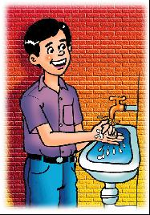

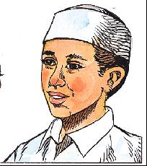
Washing Hands Gargling 3 times Washing Nose 3 times
I am doing Wuzu in obedience to Allah, Qurbatan ilallah
Niyyat
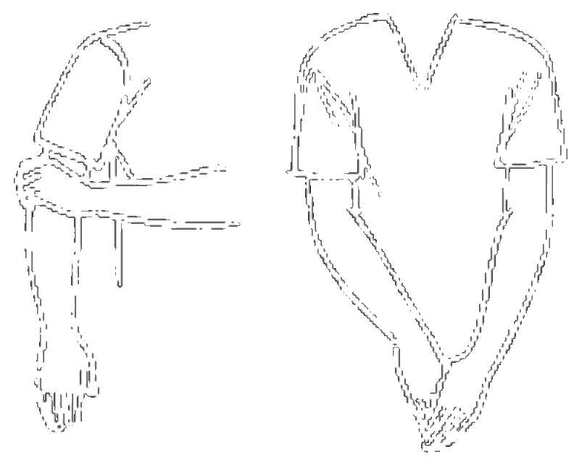
Washing of the face

Washing of the arms

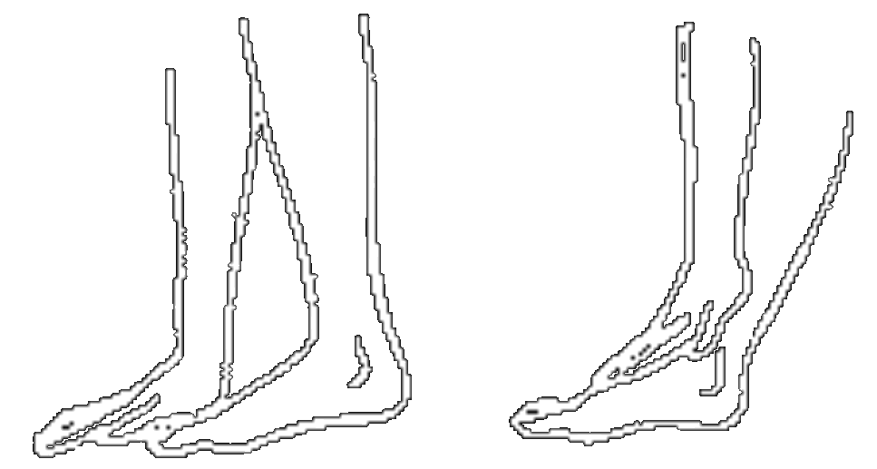
Masah of the head

Masah of the feet

Chapter 32

Namaz & Rak’ats

I pray five Namaz, three times a day.

Each namaz is divided into rak’ats. In each rak’at, I do qiyam, rukoo and two sijda

Fajar 2 Rak’ats

Zohr 4 Rak’ats

Asr 4 Rak’ats

Maghrib 3 Rak’ats

Isha 4 Rak’ats

Chapter 33

Namaz - Method

Following is the method of Fajr Prayers

1. Say niyyat “I am praying 2 rak’ats of Fajr Prayers, for Allah”
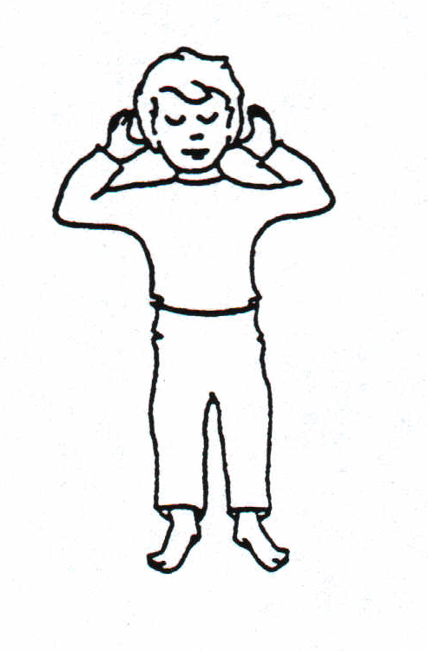
2. Raise hands up to and say “Allahu Akber”
☺• ⬆ 

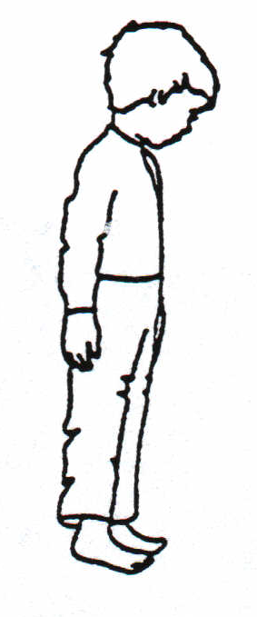
3. Stand still for qiyam and looking at the ground (mohr, turbat). Recite Suratul Fatiha and one other sura from the Qur’an

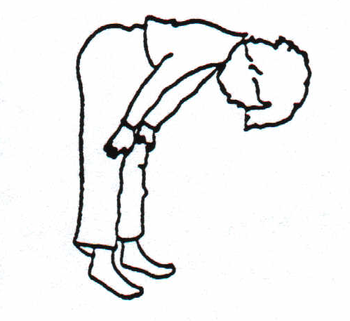
4. Say “Allahu Akber” and then go to rukoo. Looking between your feet, recite: “Subhana rabbiyal ‘azeemi wa bihamdih”
  ◻ ⇨ ☺

5. Stand up from rukoo and recite: “Sami’allahu liman hamida” 
   

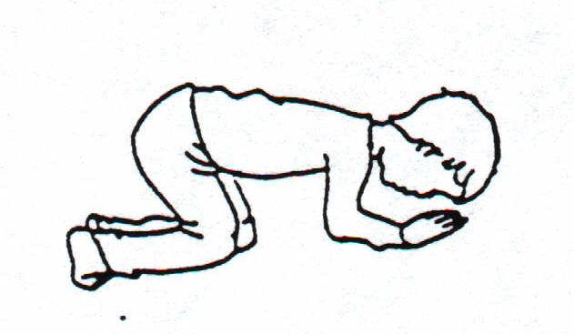
6. Say “Allahu Akber” and then go to sijda making sure that the seven parts of your body touch the ground – Forehead, two palms, two knees, and the two tips of toes. In sijda, I recite: “Subhana rabbiyal a’laa wa bihamdi”
  ▪ ⇨ ☺

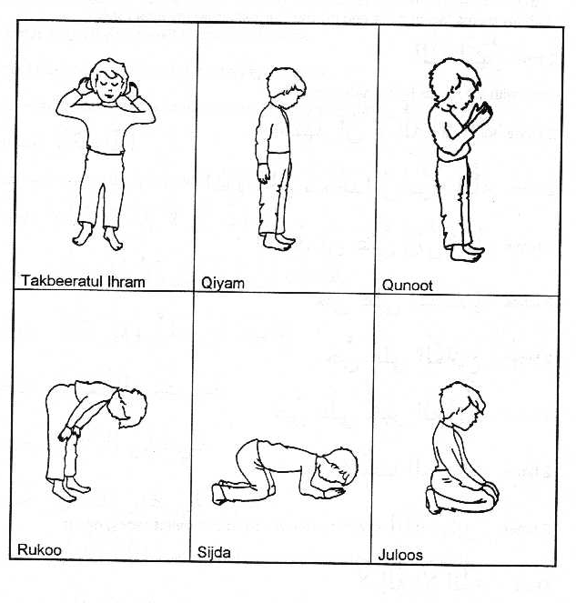
7. Sit up from sijda and looking at your lap, say: “Astaghfirullaha rabbi wa atubu ilayh
 ☹  ⇨  

8. Go back to sijda once more and recite: “Subhana rabbiyal a’laa wa bihamdi
  ▪ ⇨ ☺

9. Sit up from sijda and recite: “Allahu Akber”
☺• 

10. Now stand up for qiyam of the second rakaat. Whilst in the process of standing up, recite: “Bihawlillahi wa quwwatihi aqumu wa aq’ud”
◻      
11. Stand for qiyam and recite Suratul Fatiha and Suratul Ikhlas.

12. Raise hands for qunoot and recite: “Rabbanaa aatinaa fid dunya hasanataw wa fil aakhirati hasanataw waqinaa azaaban naar.
     
    
☹▪         

13. Then do rukoo and the two sijdas just like the first rak’at.

14. Sit after the second sijda, say Takbeer “Allahu Akber” and then recite Tashahhud: “Ash hadu al laa ilaaha illallahu wahdahu laa sharika lah, wa ash hadu anna Muhammadan ‘abduhu wa rasuluh, Allahumma salli ‘alaa Muhammadiw wa aali Muhammad - 
       →  
  ☺▪    
    ▪  

15. Then I say salaam: “Assalamu ‘alayka ayyuhan nabiyyu wa rahmatullahi wa barakatuh; Assalamu ‘alaynaa wa ‘alaa ibadillahis saaliheen; Assalamu ‘alaykum wa rahmatullahi wa barakatuh -
•     ☺  ▪ 
  ☺▪ ▪  ▪ 
 •     ▪  

Chapter 34

Prophet Muhammad (saw)
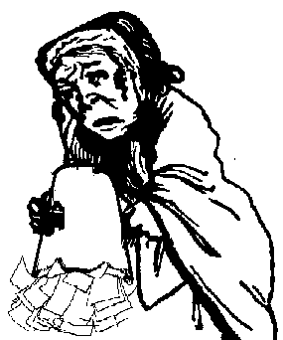
There was once an old woman who was very naughty.

She used to throw rubbish on the Holy Prophet (s.a.w.) everyday when he passed her house.

But he was a very patient man, and never got angry with her.

One day, when the Holy Prophet (s.a.w.) passed the old woman's house, she did not throw rubbish on him.

He stopped and asked a neighbour why the old woman was not there.
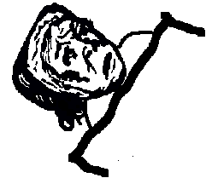
The neighbour told him the old woman was sick and in bed. So, the Prophet went to see her, because it is good to visit people who are ill.

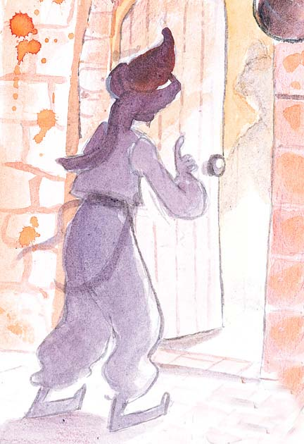
When the old woman saw him, she thought he had come to take revenge, when she was too ill to shout back at him.

Prophet Muhammad (s.a.w.) told the old woman that he had come to see her because Allah tells us to look after people who are ill.

The old woman was very surprised that the Prophet (s.a.w.) was so kind to her after she had been so mean to him. She decided right away to listen to him and she became a Muslim.

Prophet Muhammad (s.a.w.) taught us:
- To be kind to people even if they are mean to us.
- Go to see people who are ill and help them.

What happened on the 17th of Rabi ul Awwal?

Shaytan knew that something very important had happened on that day because he was not allowed to go to the heavens at all.
He came to the Ka'ba disguised as a little bird and saw the angels praising Allah.
Jibrail saw him and recognised him.
He asked Shaitan to go away !!
Shaitan asked Jibrail to tell him what had happened that day .
Jibrail told him that the best and the last of the messengers of Allah Muhammad (S.A.W.) was born.
Shaitan went away crying and wailing. It is said that he cried for forty days.

Chapter 35

Bibi Fatimah (sa)


Bibi Fatimah (AS) used to work very hard in her house.

Her father, Prophet Muhammad (SAW), could see how hard she was working.

One day, he gave her a Tasbeeh, and told her that after every Namaz she should say:
- Allahu Akbar 34 times
- Alhamdu-lillah 33 times
- Subhanallah 33 times

This is called the Tasbeeh of Bibi Fatimah (as).
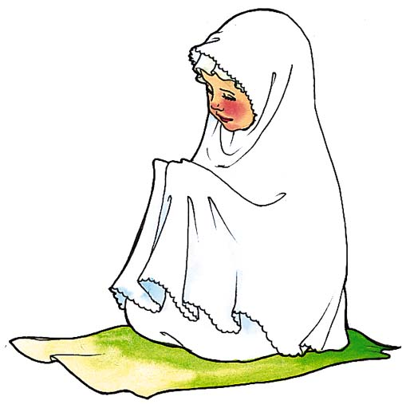

Namaz is like a beautiful flower and the Tasbeeh of Bibi Fatimah (as) gives that beautiful flower a beautiful smell.

Prophet Muhammad (saw) has said that this Tasbeeh is better than a helper or anything else in the world.

So after every Namaz remember to recite the Tasbeeh of Bibi Fatimah (a.s.).

Chapter 36

Imam Ali (as)
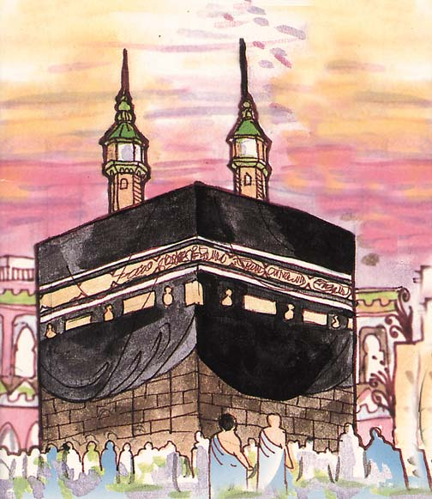
We have 12 Imams.

Today we are going to learn about Imam Ali (a.s.).

Bibi Fatimah binte Asad (the mother of Imam Ali) went to the Ka’ba to pray to Allah that her baby would be born safely.

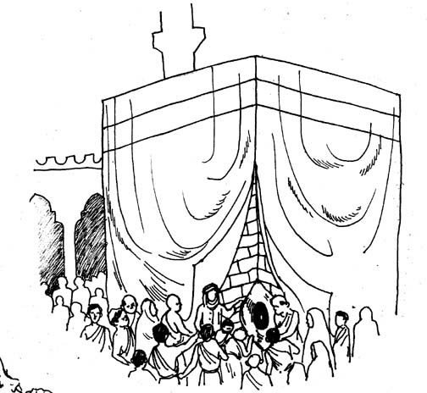
She was standing by the Ka’ba praying, when suddenly there was a crack in the wall of the Ka’aba near her.

The crack became bigger and bigger until it was big enough for her to go through.

As soon as Bibi Fatimah binte Asad entered the Ka’ba, the crack began to get smaller and smaller.
This crack is still there today on the wall of the Ka’aba.

People around the Ka’ba saw what had happened, and they wanted to look inside the Ka’ba.


So they went and got the keys of the door of the Ka’ba. But the door would not open.

Prophet Muhammad (s.a.w.) had been away when all this happened.

When he came back from his trip and went to the Ka’ba and the door of the Ka’ba opened on its own, and Bibi Fatimah binte Asad came out holding her new baby - Imam Ali (a.s.).

When Prophet Muhammad (s.a.w.) held Imam Ali (a.s.), he opened his eyes for the first time. So the first thing Imam Ali (a.s.) saw was the face of the Holy Prophet (s.a.w.).

Imam Ali (a.s.) is the only person ever to be born in the Ka’aba.
Chapter 37

Imam Hasan (as)


One day, our 2nd Imam, Imam Hasan (a.s.), was eating when a dog came and stood in front of him, looking at him hungrily.


Imam Hasan (a.s.) gave some of his food to the dog, who ate it up and again looked up at him.

Imam (a.s.) threw more food to the dog.

A man who was passing by came forward to “shoo” the dog away, so that Imam (a.s.) could eat in peace.

Imam Hasan (a.s.) told the man to leave the dog alone, as Allah had made the dog just as He has made all of us. Allah loves animals just as He loves us all.

Moral: Be kind to animals as they have been made by Allah

Chapter 38

Imam Husain (as)


When our 3rd Imam, Imam Husain (AS) was born, Allah sent down the angel Jibrail to congratulate Prophet Muhammad (s.a.w.) and his family.


On the way, Jibrail saw the angel Fitrus on an island.

Because Fitrus had been naughty, Allah had taken his wings away and sent him to this island.

Fitrus asked Jibrail where he was going, and Jibrail told him about the birth of Imam Husain (a.s.).

Fitrus wanted to go with Jibrail, and, with Allah’s permission, Jibrail carried Fitrus with him.

When they reached the Holy Prophet (s.a.w.) and congratulated him and his family, the Prophet (s.a.w.) told Fitrus to go to Imam Husain (a.s.).

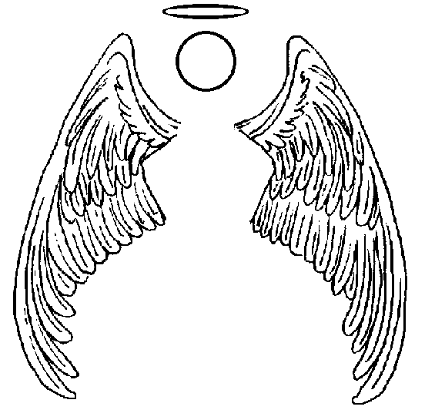
When Fitrus touched Imam Husain's (a.s.) cradle, Allah forgave him and gave him back his wings.

Moral: If you want something it is better to ask through our
Imams (AS) as they are closer to Allah than we are

Chapter 39

Karbala & Muharram

During the time of our third Imam, Imam Husain (AS), there was a ruler Yazid who was very bad, and he started spoiling the religion (Islam)

Hazrat Imam Husain (AS) felt that if he will not raise his voice against Yazid, then people will think that Yazid’s Islam is the correct Islam

Imam Husain (AS) therefore went to a place called Karbala, to fight with Yazid’s army

Imam Husain (AS) was having only 72 people whereas the enemy was having thousands of soldiers

In this war, Imam Husain (AS) and his Ashab (friends) got martyrdom (shahadad)

So did he lose the war? Not really

He fought with the ruler so that Islam and Namaz can be saved

If today Namaz is still saved, then it means that Imam Husain (AS) was successful in his mission, and it was due to his shahadat that Islam is safe

Every year, in the month of Muharram, we remember this tragedy of Karbala, and cry because:
- we want to inform others that we belong to Imam Husain (AS)’s side, not his enemy’s side
- we want to pay tribute to Imam Husain (AS) that because of his shahadat, today we are able to follow Islam
- we want to inform others that Imam Husain (AS) was successful, that is why many people around the world remember him
- we love Imam Husain (AS)

How do we remember the story of Karbala?
- by arranging majalises
- by explaining the tragedy of Karbala to each other
- by crying while listening to story of Karbala
- by doing ma-tam
- by distributing tabarruk
- by organizing ‘sabeel’ of water
- etc

Who were with Imam Husain (AS)?
- Hazrat Qasim, Ali Akbar, Ali Asghar who got martyrdom
- Hazrat Imam Sajjad (AS) and Bib Zainab (AS) who were alive, and conveyed the message of Karbala to near and far

Chapter 40

Imam Zainul Abideen (as)

Our 4th Imam, Imam Zainul Abideen (AS), was a very kind and patient person.

He usually had a smile on his face, and hardly ever got angry.
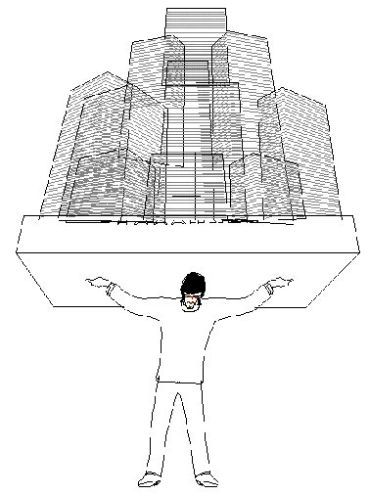
One day, when Imam (a.s.) was walking with some friends, he saw an old man carrying something very heavy, while his son walked next to him.


Imam (a.s.) lost his smile and became very angry.

All his friends were very surprised, and asked what had made him so angry.

Imam (a.s.) replied that he was angry to see a son walking next to his father without helping him.

Moral: You should always help your parents, even when they do not ask you to.

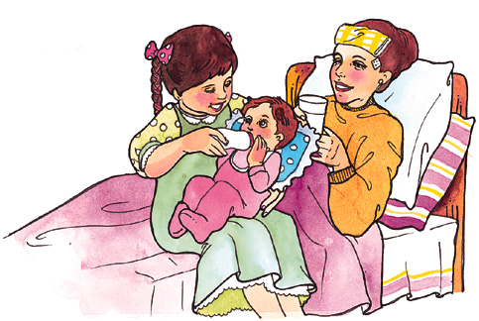
E.g.: you can help look after your younger brothers or sisters, or tidy up your toys after you have finished playing with them.



Chapter 41

Imam Muhammad Al-Mahdi (atf)

Our twelfth Imam, Imam Muhammad Al-Mahdi (ATF) is still alive. Ask your teacher what is his age today

He is OUR Imam. Every week he gets a report of what we do from the angels recording our deeds with Allah’s permission. He feels very sad when he sees if we have done something that is naughty or bad.

Imam Muhammad Al-Mahdi (ATF) is in ghayba. This means that although he is amongst us, we do not recognise him when we see him.

Whenever we need help we must ask Allah through Imam Muhammad Al-Mahdi (ATF)

Whenever we hear his name we should:
- bow down
- put our hand on our head
- recite salawaat.

When Allah orders, Imam will make himself known to us. We must pray to Allah to make this happen quickly and to keep Imam safe.

When he makes himself known to the world, he will want us to be his soldiers so that the world can be a better place. A world of justice.

We should prepare to be his soldiers by being the best of Muslims - by having taqwa (keeping away from all haram acts and doing all the wajib acts).

Whenever we have any problem, we shall write ariza (letter/request) to Imam-e-Zamana (ATF) and throw it in the sea

WORKSHEET

Draw what you would like our 12th Imam, Imam Muhammad al-Mahdi (ATF) to ask from Allah for you.

Ariza(letter) To Imam Muhammad Al-Mahdi (atf)

Chapter 42

Prophet Adam (as)
A long time ago, Allah made angels, the heavens and the earth.

Allah then told the angels that he was going to make a man and put him on the earth to take care of it.


He then made the first man, who was Prophet Adam, from clay. Prophet Adam is also our first Prophet.

Allah then made Bibi Hawwa, so that Prophet Adam would have a friend.

Allah told everyone in heaven to do sajdah to Prophet Adam.

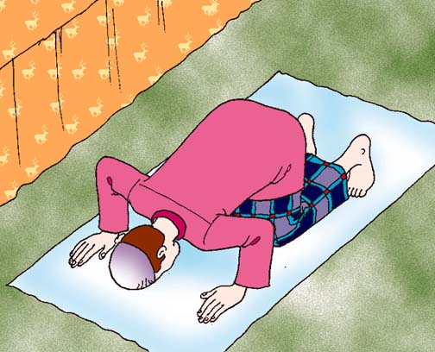
Shaytan, who had been a very good jinn so far, was also in heaven.


All the angels listened to Allah and did Sajdah but Shaytan did not.

He said that he was better than Prophet Adam because he was made of fire and Prophet Adam was made from clay, and fire melts clay.


Allah sent Shaytan away from heaven because he had not listened to Him.

Prophet Adam and Bibi Hawwa lived in heaven where they had everything.

They were only told not to eat the fruit of one tree.


Shaytan knew this and he was very jealous of Prophet Adam and Bibi Hawwa because Allah liked them very much.

So Shaytan tricked Prophet Adam and Bibi Hawwa into picking a fruit from that tree by lying to them.

Prophet Adam had never heard a lie before, so he believed Shaytan.

As soon as Prophet Adam and Bibi Hawwa ate the fruit they knew that they had done something wrong.

They were very sad and said sorry to Allah. Allah forgave them but did not forgive Shaytan.

Allah then sent Prophet Adam and Bibi Hawwa to live on the earth.

Chapter 43

Prophet Ibrahim (as)

Prophet Ibrahim (AS) was one of our many Prophets.

He had a son called Ismail, who was also a Prophet.

Allah ordered both Prophet Ibrahim (AS) and Prophet Ismail (AS) to build the Ka’ba.

They picked up heavy stones one by one and built the Ka’aba.

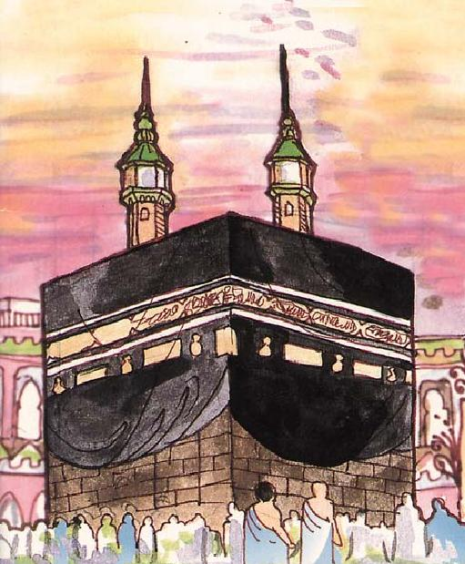
They worked very hard.

Prophet Ibrahim (AS) used to stand on a stone to see how the work was getting along.

Allah made that stone soft and it made a print of Prophet Ibrahim’s feet.

Today this stone can be seen near the Ka’aba, it is called Makame Ibrahim.

When the Ka’ba was nearly finished, Angel Jibrail brought a special black stone from heaven and showed them where to put it.
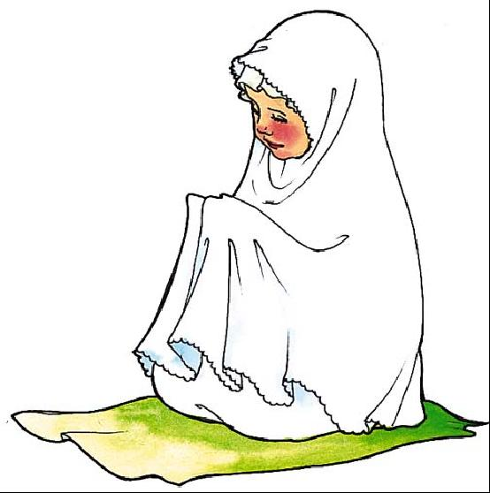
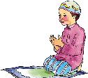
This black stone is called Hajrul Aswad.

During our Namaz, we turn ourselves towards the direction of Ka’ba.

Each year during Haj, which is a pilgrimage to Makka, many Muslims walk around the Ka’ba and pray to Allah together.

This is the time to remember Prophet Ibrahim (AS) and Prophet Ismail (AS) who followed Allah’s order to build this very special place.
Chapter 44

Introduction to Qur’an

Note for teachers
Introduce the Qur’an as a gift from Allah. Show the children a Qur’an wrapped up as a gift. Ask the children what they think is inside it. Tell them it is something precious and a gift they can keep for life. Open it and show them what the whole Qur’an looks like, what the Arabic is like, how it is read etc.

Qur’an is the last book of Allah. It is written in Arabic

Qur’an was revealed to Prophet Muhammad (SAW)

When we recite Qur’an, Allah gets pleased

Even seeing the wordings of Qur’an gives Sawaab

It is better to do wuzu and then recite Qur’an

Qur’an shall be respected, and should be handled with care. We should:
- hold it properly (show the child)
- never leave it open when no-one is reciting from it
- never touch the writing in it without wuzu (you can read it without teaching it but will get less sawab)

It is better to face the qibla while reciting the Qur’an

We should learn the correct makharij to recite the Qur’an

We shall follow Qur’an’s teachings

Allah tell us in the Holy Qur'an:
- true stories of the Prophets.
- how He wants us to act.
- about heaven and hell.

Before starting to recite the Holy Qur’an, you should say:

And

WORKSHEET 1.1: INTRODUCTION:
Learn the correct pronunciation and meaning of:

Chapter 45

Suratul Fatiha

   
  ◻ ☹  
 
  
◻   ☺◻ 
  
▪ ◻  
▪ ☹


Chapter 46

Suratul Ikhlas

   
   
 
 
  
 •    

Chapter 47

Suratul Asr


   
 ◻ 
    
 ▪    
 ☺      

Chapter 48

Suratul Kauthar


   
  ▪ 
   
    

Chapter 49

Azaan

Adhan(azaan) is the call for salaa (namaz). It is called in a loud voice. It can be called from the minaret of a masjid (mosque) or from where ever I pray. I always begin my namaz with azaan and iqama. After I have done wudhoo, I stand on my musalla facing the qibla. With the palms of my hand facing qibla and my thumbs just under my ears I recite;

4 times Allahu Akber
☺• ⬆
2 times Ash hadu anl laa ilaaha illallah
⬆ ⬇ ⬇   
2 times Ash hadu anna Muhammadar rasulullah
    
2 times Ash hadu anna Aliyyuw waliyullah
  ▪  
2 times Hayya alas salaa
 ▪ 
2 times Hayya alal falaah
 ▪ 
2 times Hayya alaa khayril ‘amal
◻  ▪ 
2 times Allahu Akber with my palms facing qibla and thumbs under my ears
☺• 
2 times Laa ilaaha illallah
   
If someone else is reciting Azaan loudly, I sit with respect and follow the recitations, reciting salawat after the names of the Prophet (S.A.W.) and Imam Ali (A.S.)

Chapter 50
HIJAB

The Prophet(s.a.w.) asked Janabe Fatima:
“What is the best thing for a woman?”
The Masuma(s.a.) replied:
“She should see no na-mahram and neither should any na-mahram see her”

It is Wajib for girls to cover one's head and body from a man who is na-mahram.
The face and the hands upto the wrists may be left uncovered.

Who is a na-mahram?
All men who are not mahram are na-mahram

The following are some men who are mahram:
Father and his father, grand-father , great grand-father.....
Brothers and their sons and sisters' sons
Fathers' brothers and mothers' brothers
Husband, his sons and his father..

Hijab is not just a scarf or head covering. It is no hijab if one wears beautiful clothes, wears make up and then just a scarf over the hair.

The covering of hijab must be such that it is:
- Not tight
- Not attractive
- Not see-through

Hijab should be done in any place where na-mahrams are present, be it house, school, park, shopping centre or any other place

Hijab provides the necessary dignity and self-respect.

Hijab is worn by women according to the orders of Allah and to please Allah.

Chapter 51

FRIENDSHIP

A friend is a very important person in one's life.

Prophet Muhammad (S.A.W.) has said:
"The behaviour of everyone will be according to the beliefs and principles of his/her friend".

Qualities one should look for in a friend:

Knowledge
Imam Ali (A.S.) has said:
"The best of companions (friends) are those who have knowledge and patience."
If you have friends who have knowledge or are interested in learning then, rather than waste time talking about worthless things or gossiping you will talk about events and ideas.

Good Akhlaq
Because the akhlaq of a friend affects and rubs off on you it is important to have and be friends with those having good akhlaq. There is a Spanish saying which says:
"If you go to the wolves, it is howling which you will learn from them."

A Muslim friend is a mirror for his friend.

Imam Ja'fer As-Sadiq (A.S.) has said:
"A friend is someone who:
- What he/she feels towards you and what he/she says about you must be the same.
- He/she should think your good qualities as his/her good qualities and your bad qualities as his/her bad qualities.....
- He/she should help you as much as he/she can.
- He/she should not leave you alone when you are in trouble."

Chapter 52
MANNERS OF SLEEPING
Before I go to sleep, I have a wash and change into my night clothes.
I visit the toilet and brush my teeth.
Then I do wudhoo.
I go to my mummy and pappa and the rest of my family and say:
Fiy amaanillah
   (May Allah keep you safe)
I give them a hug and a kiss.
I get into bed and recite Kalima, suras from the Qur’an that I know by heart, and a tasbeeh of Sayyida Fatma Zahra (A.S.)
I think to myself, which angel has done more writing today, the angel on the right shoulder, writing all good deeds or the angel on the left, writing all bad deeds.
I then say sorry to Allah for anything bad that I have done and promise not to do it again.
I thank Allah for anything good that I have done and pray to do much better.
I never sleep on my tummy because that is how Shaytan sleeps.
Prophet Muhammad (S.A.W.) used to sleep on his right side with his hand under his cheek.
I never sleep in total darkness. My mummy leaves a night light on for me – sometimes the light from the hall or the street shines through.

Chapter 53
MANNERS OF WAKINGUP
I am a Muslim. I wake up in the morning to pray Fajr Salaa (namaz). When I am getting out of bed, I say:
☺• ⬆                                     Alhamdulillahi wallahu akber
 (All praise is for Allah and Allah is greater than everything and everyone)
I send salaams to our 12th Imam (a.s.):
    ▪ 
( Assalamu ‘alayka ya Hujjatibnil Hasan (a.t.f) )
I run to my mum and dad’s room and knock on the door and greet them saying:
▪ 
Assalamu ‘alaykum
(Peace be upon you)
They reply saying:
 ⬄▪ 
Wa ‘alaykumus Salaam
(And peace be upon you)
I greet everyone else in the house, put on my slippers and go to the washroom.

Chapter 54

PROPHET NUH (A.S.)
The big ark

Prophet Nuh (A.S.) was sent by Allah to tell his people that there is only One god – Allah and to be good Muslims.
⬆ ⬇ ⬇ 

(There is no God except Allah)

Prophet Nuh (A.S.) tried hard for many years but his people just laughed at him. They would put their fingers in their ears when he started to talk to them. Sometimes they would throw stones at him. The angel Jibraail used to come and help Prophet Nuh(A.S.) get up from under the pile of stones that were thrown at him.

Prophet Nuh (A.S.) complained to Allah that his people would just not listen. Allah told him to build a big ark (boat).

When the people saw Prophet Nuh (A.S.) and some of his family and friends building the ark, they laughed at him and teased him. There was no water near there and the sea and rivers were far away. Prophet Nuh (A.S.) carried on as Allah had ordered him to.

When the ark was ready, Allah told Prophet Nuh (A.S.) to take in it all the believers, and two of every kind of animals and birds.
As soon as they had entered the ark and the doors were shut, water began to pour from the skies and gush out of the land. All those who did not believe in Allah were drowned.

One of the sons of Prophet Nuh (A.S.) refused to come into the ark. He climbed onto a high mountain thinking he would be saved but he too drowned.
The ark was tossed around the big waves. Prophet Nuh (A.S.) prayed to Allah to make them land safely. He asked all the people in the ark to say:
⬆ ⬇ ⬇ 
There is no God except Allah

Allah answered his dua and made the earth swallow all the water. It stopped raining and the ark came to rest on a mountain called Judi.

Chapter 55

PROPHET ISMAIL (A.S.)

Zam Zam

Prophet Ibraheem (A.S.) was an old man when Allah granted him a son called Ismail (A.S.). He too was a prophet.

The mother of Prophet Ismail (A.S.) was Sayyida Hajra (A.S.) She was a very good lady.

Prophet Ibraheem (A.S.) took Sayyida Hajra (A.S.) and his son Prophet Ismail (A.S.) to a place which is today called Makka. He left them there as Allah had ordered him to do and went away.

Soon Sayyida Hajra (A.S.) found that all their food and water had finished. She went to look for water. There were two mountains called Safa and Marwa in Makka. She climbed up on the mountain of Safa first and looked around. She saw water and ran towards it until she reached the mountain of Marwa. Then she looked back and saw water again. She ran towards it until she reached Safa. She was seeing a mirage. But she did not give up! She ran back and forth seven times.

As she ran backwards and forwards, she used to glance towards her baby son Ismail to keep an eye on him. Suddenly she saw her baby son Ismail (A.S.) with a spring of water near his feet. The spring is still there today and it is called Zam Zam which means - Stop! Stop! (As this is what Sayyida Hajra said when she saw the water for she feared that her baby would drown). It may also mean ‘lots of water’.

Because of the spring of Zam Zam many people came to live there and soon Makka became the central town of Arabia.

Chapter 56
THE ISLAMIC YEAR

There are 12 months in a year .

As a Muslim I follow the Islamic calendar (Lunar / Qamri calendar).

The Islamic/Lunar month is the time between two new moons. Lunar comes from the Latin word Luna which means moon. A Lunar month is either 29 or 30 days long.

The Islamic/Lunar year is approximately 11 days shorter than the Solar year (January to December).

The months are :

Muharram

Safar

Rabi ul Awwal

Rabi ul Aakher

Jamad ul Awwal

Jamad ul Aakher

Rajab

Sha'ban

Ramadhan

Shawwal

Dhulqa'ada

Dhul hijja

