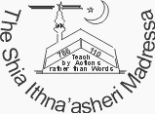

QUR’AN MANUAL - CLASS 1
M-00(R)
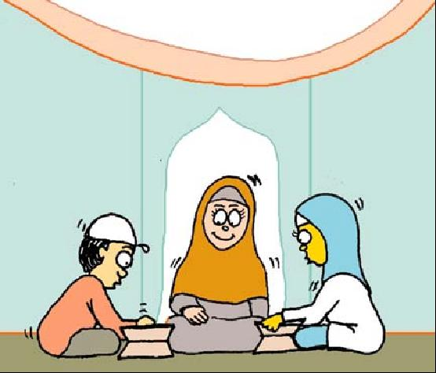
QUR’AN SYLLABUS CLASS 1 (4 YEARS OLD)
Lesson Topic Date Completed

LESSON 1: INTRODUCTION [ ]
LESSON 2: HURUF (LETTERS): ALIF [ ]
LESSON 3: HURUF (LETTERS): BAA, TAA, THAA [ ]
LESSON 4: HURUF (LETTERS): JIM, HAA, KHAA [ ]
LESSON 5: HURUF (LETTERS): DAAL, DHAAL [ ]
LESSON 6: HURUF (LETTERS): RAA, ZAA [ ]
LESSON 7: HURUF (LETTERS): SEEN, SHEEN [ ]
LESSON 8: HURUF (LETTERS):SAAD, DHAAD [ ]
LESSON 9: HURUF (LETTERS): TAA, ZAA [ ]
LESSON 10: HURUF (LETTERS): AIN, GHAIN [ ]
LESSON 11: HURUF (LETTERS): FAA, QAAF, KAAF [ ]
LESSON 12: HURUF (LETTERS): LAAM, MEEM, NOON [ ]
LESSON 13: HURUF (LETTERS): HAA, WAW, YAA [ ]
LESSON 14: HURUF (LETTERS): REVISION [ ]
LESSON 15: HURUF (LETTERS): AZ-ZAHRA CERTIFICATE
[ ]
LESSON 16: SURATUL FATIHA: MEMORISATION [ ]

MEMORISATION SECTION: FOR AZ-ZAHRA CERTIFICATE:
TERM 1: SURATUL IKHLAS [ ]
TERM 2: SURATUL KAWTHAR [ ]
TERM 3: SURATUN NASR [ ]
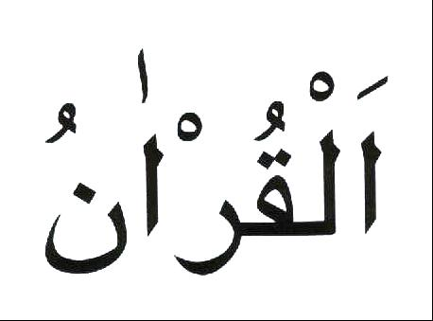
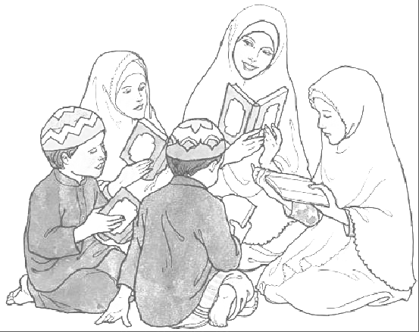

My name is _______________________________

This is how it is written in Arabic:

_________________________________________

LESSON 1.1: INTRODUCTION:
Qur’an as a Gift:
(Introduce the Qur’an as a gift from Allah. Show the children a Qur’an wrapped up as a gift. Ask the children what they think is inside it. Tell them it is something precious and a gift they can keep for life. Open it and show them what the whole Qur’an looks like, what the Arabic is like, how it is read etc.)
Ramadhan has just gone; this was the month the Qur’an was revealed. What presents did you get on Eid? Allah’s present to you is the Qur’an.
What is the Holy Qur'an?
It is a book that contains the words of Allah.
Who wrote the Holy Qur'an?
It was not written by anyone; Allah sent down the words to the Holy Prophet (s.a.w.) through the Angel Jibrail.
The Holy Prophet (s.a.w.) then recited the verses to the people. Most of the people would remember the verses by heart but the Holy Prophet (s.a.w.) chose some special people called scribes to write down the verses.
In which language is the Holy Qur'an written?
   ☹ 
It is written in Arabic.             

Arabic is read from right to left and back to front.
What does Allah tell us in the Holy Qur'an?
- He tells us true stories of the Prophets.
- He tells us how He wants us to act.
- He tells us about heaven and hell.
RESPECT OF THE HOLY QUR'AN:

We have to look after the Holy Qur'an because it is such a special book.

We should look after the Holy Qur’an by:
- holding it properly. (Show the child).
- never leaving it open when no-one is reciting it.
- Never touching the writing in it without first doing Wudhu.

You can read it without touching it, or put a plastic sheet on it.

When reciting the Holy Qur’an, it is Sunnat:
for boys to wear a cap

for girls to wear a scarf.

to face Qiblah (the Ka’aba)
Before starting to recite the Holy Qur’an, you should say:

And

WORKSHEET 1.1: INTRODUCTION:
Learn the correct pronunciation and meaning of:

I seek refuge from Shaitan the outcast
And

I begin in the Name of Allah, the Kind, the Merciful

LESSON 1.2: HURUF (LETTERS): ALIF
Just as "a, b, c...." are the LETTERS of the English Alphabet:
  ☹  are the HURUF of the Arabic alphabet.
The 1st harf that you will learn is called Alif = 

Alif is for Allah – No one but Allah

In our Kalima we say:
 ⬇ ⬇ 
There is no god but Allah

WORKSHEET 1.2: HURUF (LETTERS): ALIF:
Draw Alif from the dots using different colours.
Remember to say Alif each time you write it.
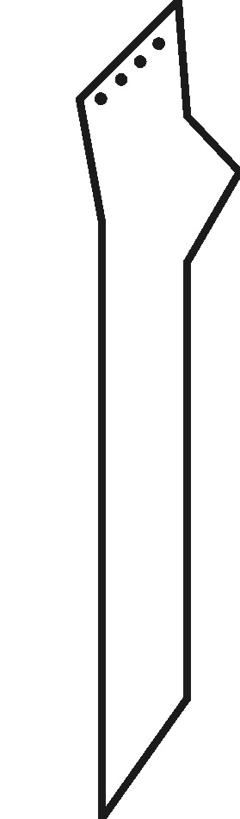
LESSON 1.3: HURUF (letters): BAA, TAA, THAA:
The harf you learnt last week was Alif = 
Today you will learn huruf that look like boats
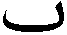
With this same shape you can make 3 different huruf in the Arabic alphabet using dots
By putting:
- 1 dot under the boat, you get BAA = ☹ 
- 2 dots above the boat, you get TAA. 
- 3 dots above the boat, you get THAA. 

      To say , you have to put your tongue out

   ☹

Baa is the beginning of Bismillah:

Taa is for Taqwa – coming closer to Allah,

Thaa is for Thawaab – a reward

…….
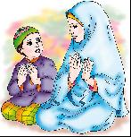
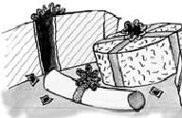
    
  
WORKSHEET 1.3: HURUF (LETTERS): BAA, TAA, THA
a: Learn the correct pronunciation of:

We say this when we finish something, or see something beautiful because Allah made it.
b: Draw Baa, Taa and Thaa from the dots using different colours.
Remember to say Baa, Taa and Thaa each time you write them.

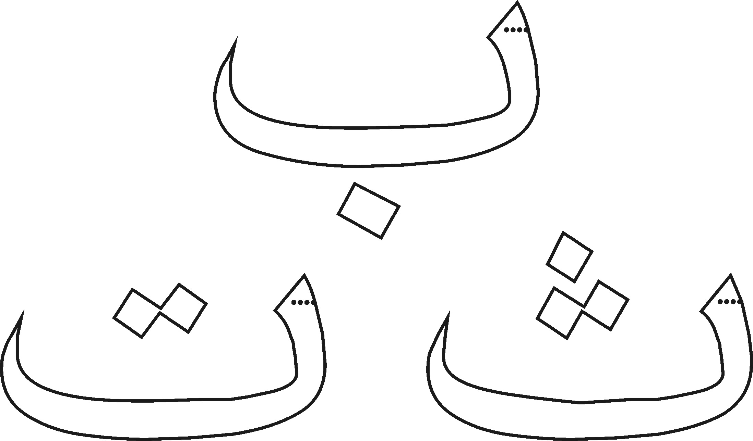
WORKSHEET 1.3: HURUF (LETTERS): BAA, TAA, THAA:
In each of the huruf put the correct number of dots in the right place to make the harf:
Teacher Assisted Activity:

THAA TAA BAA

TAA BAA THAA

BAA TAA THAA

BAA THAA TAA
LESSON 1.4: HURUF (LETTERS): JIM, HAA, KHAA:
The huruf you have learnt so far are:     ☹  
Today you will learn a harf that looks like a C - with a line on top.
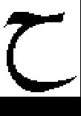
With this same shape you can make 3 different huruf in the Arabic alphabet using dots.

By putting:
- no dot at all, you get HAA = 
- 1 dot in its tummy, you get JIM = 
- 1 dot on its head, you get KHAA = 
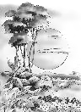
The sounds for  and , come from the throat
WORKSHEET 1.4: HURUF (LETTERS): JIM, HAA, KHAA:
a: Learn the correct pronunciation and meaning of:

b: Draw Jim. Haa and Khaa from the dots using different colours.
Remember to say Jim, Haa and Khaa each time you write them.

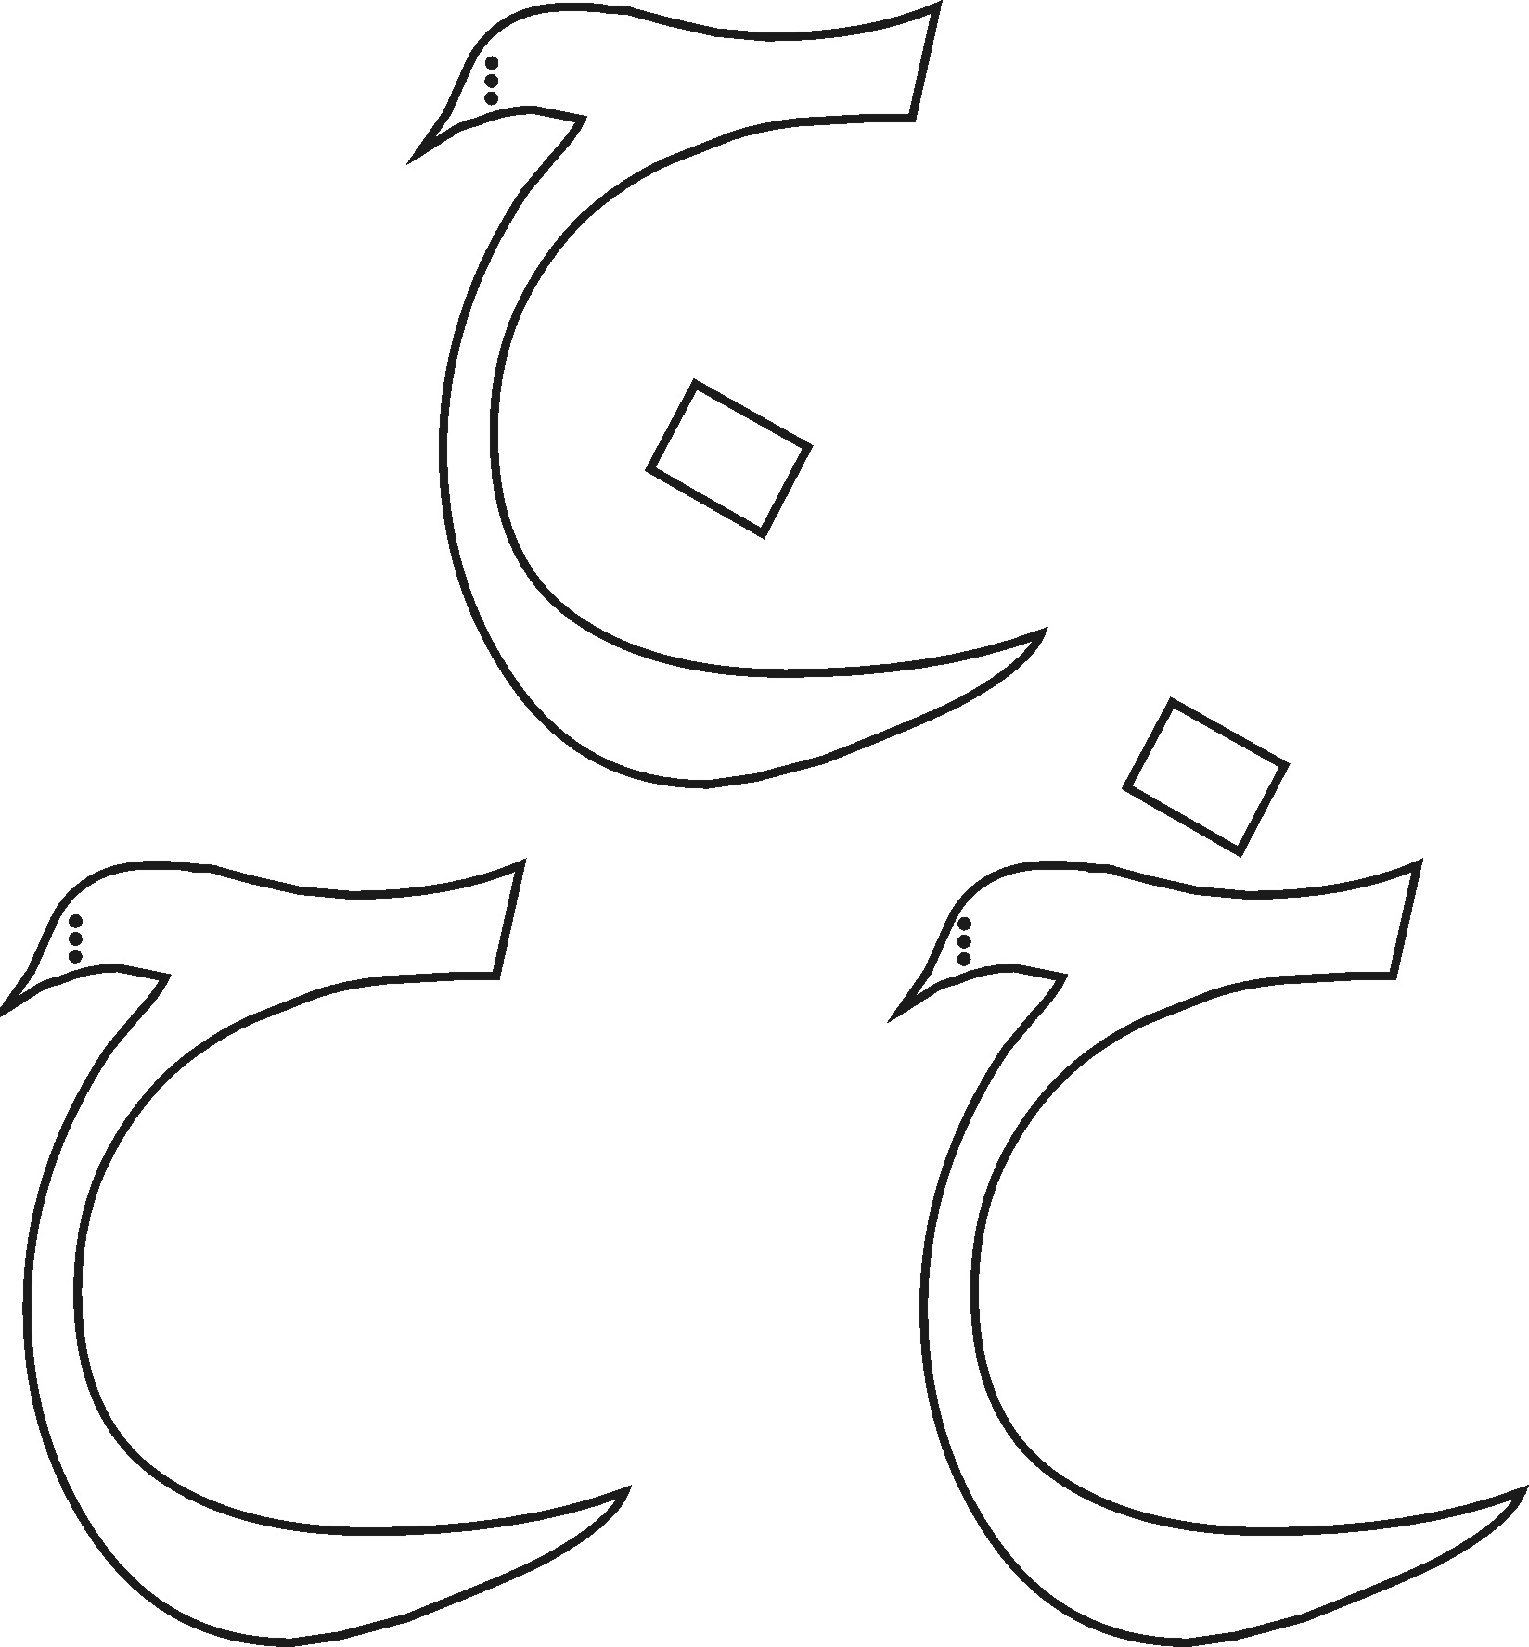
WORKSHEET 1.4: HURUF (LETTERS): JIM, HAA, KHAA:
In each of the huruf put the correct number of dots in the right place to make the harf.
Teacher Assisted Activity:

HAA JIM KHAA
KHAA HAA JIM

JIM HAA KHAA

HAA KHAA JIM

LESSON 1.5: HURUF (LETTERS): DAAL AND DHAAL:
The huruf you have learnt so far are:      ☹ 
Today you will learn huruf which are in pairs:

With this shape you can make 2 different huruf in the Arabic alphabet using a dot.
By putting:
- no dot at all, you get DAAL = 
- 1 dot on its head, you get DHAAL = 
The sound for  is made by pushing your tongue out

Daal is for deen – Al Islam, religion with Allah since time began
Dhaal is for Dhikr – remembering Allah

Al Islam

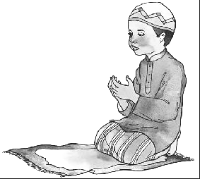

WORKSHEET 1.5: HURUF (LETTERS): DAAL AND DHAAL:
a: Learn the correct pronunciation of:
       

b: Draw Daal and Dhaal from the dots using different colours.
Remember to say Daal and Dhaal each time you write them.

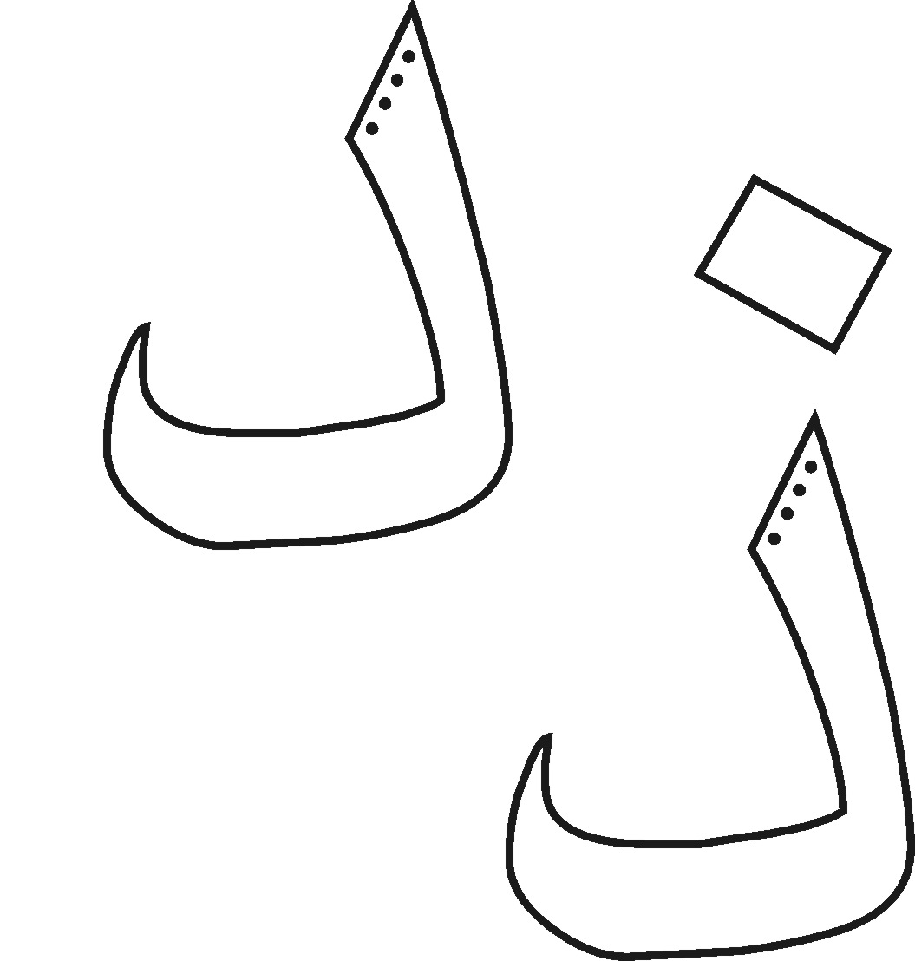
LESSON 1.6: HURUF (LETTERS): RAA AND ZAA:
The huruf you have learnt so far are:        ☹ 
Today you will learn more huruf that are in pairs:
With this shape you can make 2 different huruf in the Arabic alphabet using a dot.
By putting:
- no dot at all, you get RAA = 
- 1 dot on its head, you get ZAA = 

Raa is for the month of Ramadhan – Holy Ramadhan
Zaa is for Zakat to cure our greed when we give our money to those in need

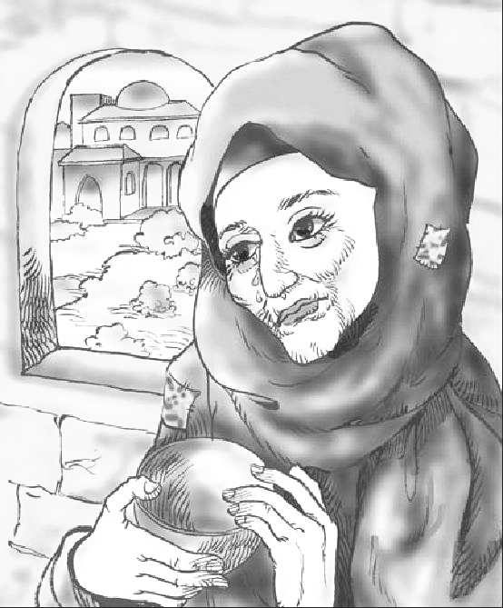
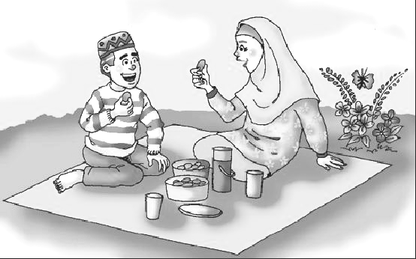

WORKSHEET 1.6: HURUF (LETTERS): RAA AND ZAA:
a: Revise the correct pronunciation of:
       

b: Draw Raa and Zaa from the dots using different colours.
Remember to say Raa and Zaa each time you write them.
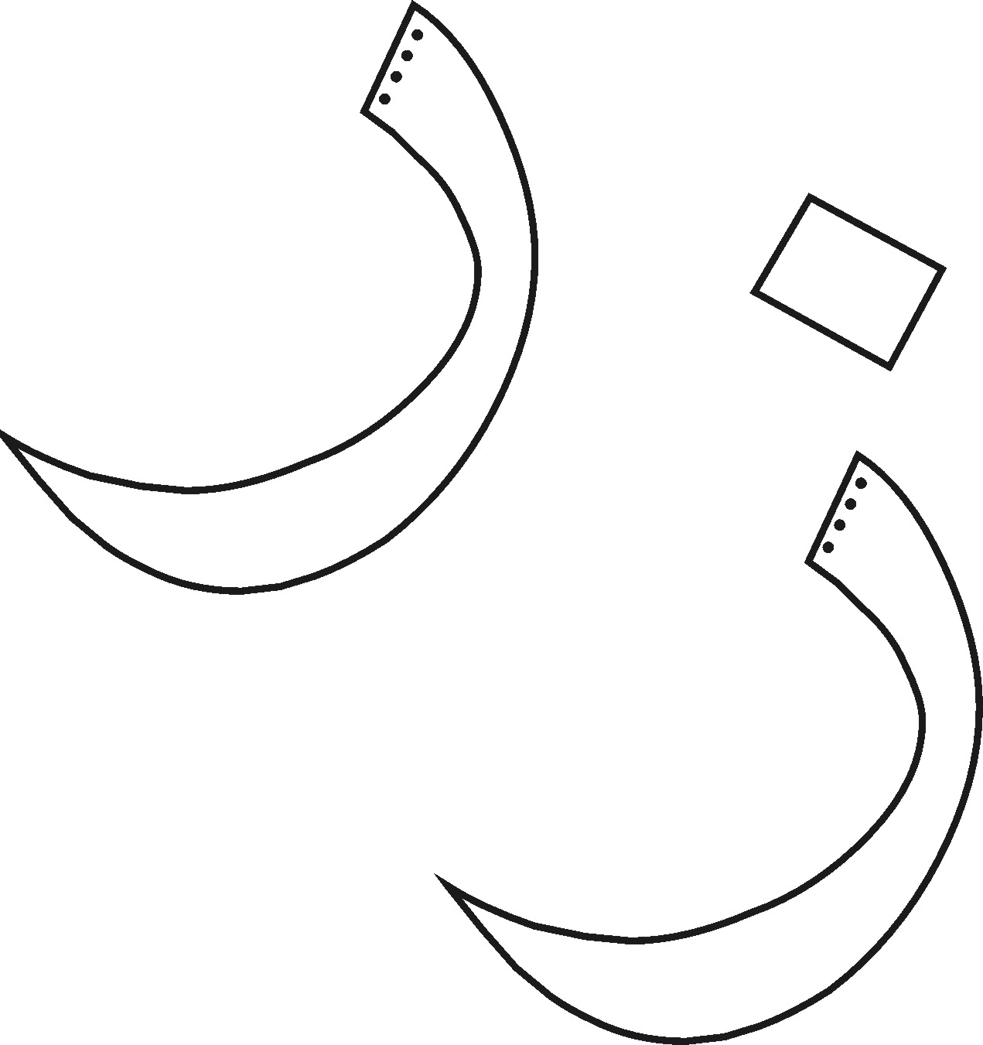
WORKSHEET 1.6: HURUF (LETTERS): DAAL, DHAAL, RAA AND ZAA:
Colour the vans: RED = DAAL YELLOW = DHAAL

BLUE = RAA GREEN = ZAA
Teacher Assisted Activity:
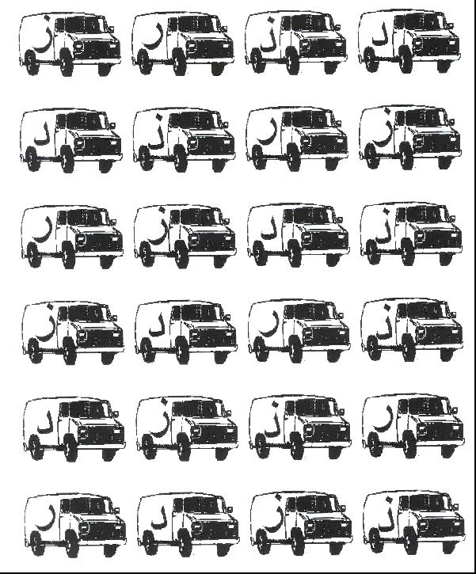

LESSON 1.7: HURUF (LETTERS): SEEN AND SHEEN:
The huruf you have learnt so far are:
         ☹ 
Today you will learn more huruf that are in pairs:
The following harf looks like it has 2 teeth:

With this shape you can make 2 different huruf in the Arabic alphabet using dots.
By putting:
- no dot at all, you get SEEN = 
- 3 dots on its head, you get SHEEN = 

Seen is for Salaamun Alaikum – peace be with you – Wa Alaikum Salaam
Sheen is for Shams – the shining sun that Allah blessed for everyone.

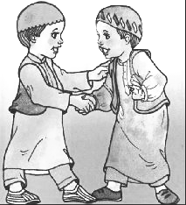


WORKSHEET 1.7: HURUF (LETTERS): SEEN AND SHEEN:
a: Learn the correct pronunciation of:
   ⬇◻ ⬇ ☺◻ ⬇

b: Draw Seen and Sheen from the dots using different colours.
Remember to say Seen and Sheen each time you write them.

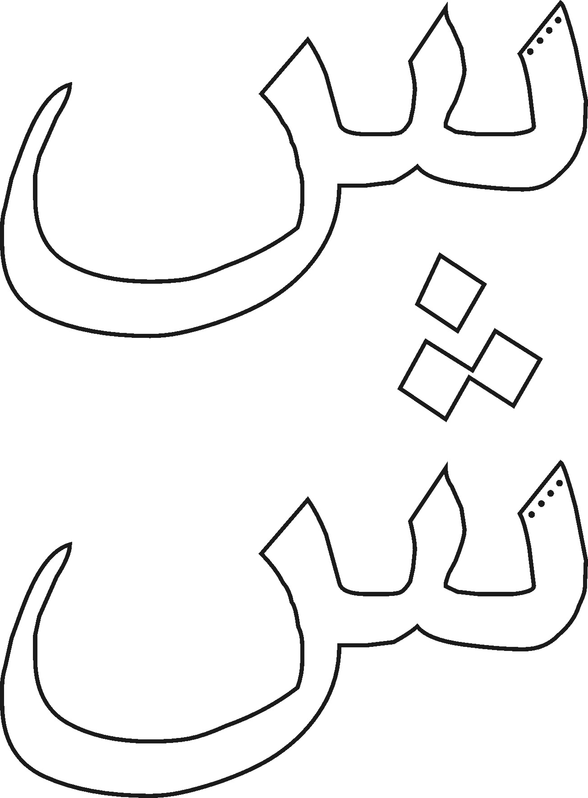
LESSON 1.8: HURUF (LETTERS): SAAD AND DHAAD:
The huruf you have learnt so far are:
⧫          ☹ 
Today you will learn more huruf that are in pairs:

With this shape you can make 2 different huruf in the Arabic alphabet using dots.
By putting:
- no dot at all, you get SAAD = 
- 1 dot on its head, you get DHAAD = 
Saad is for Salaat – for when we pray facing Him, everyday facing Him, till we meet our Lord.

ALLAH – THERE IS ONLY ONE GOD AND MUHAMMAD IS HIS MESSENGER – LA ILAHA ILLALAH

Dhaad is for Dhuha -the morning light – the sun has turned from red to white

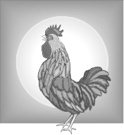
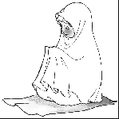

WORKSHEET 1.8: HURUF (LETTERS): SAAD AND DHAAD:
a: Revise the correct pronunciation of:
   ⬇◻ ⬇ ☺◻ ⬇

b: Draw Saad and Dhaad from the dots using different colours.
Remember to say Saad and Dhaad each time you write them.

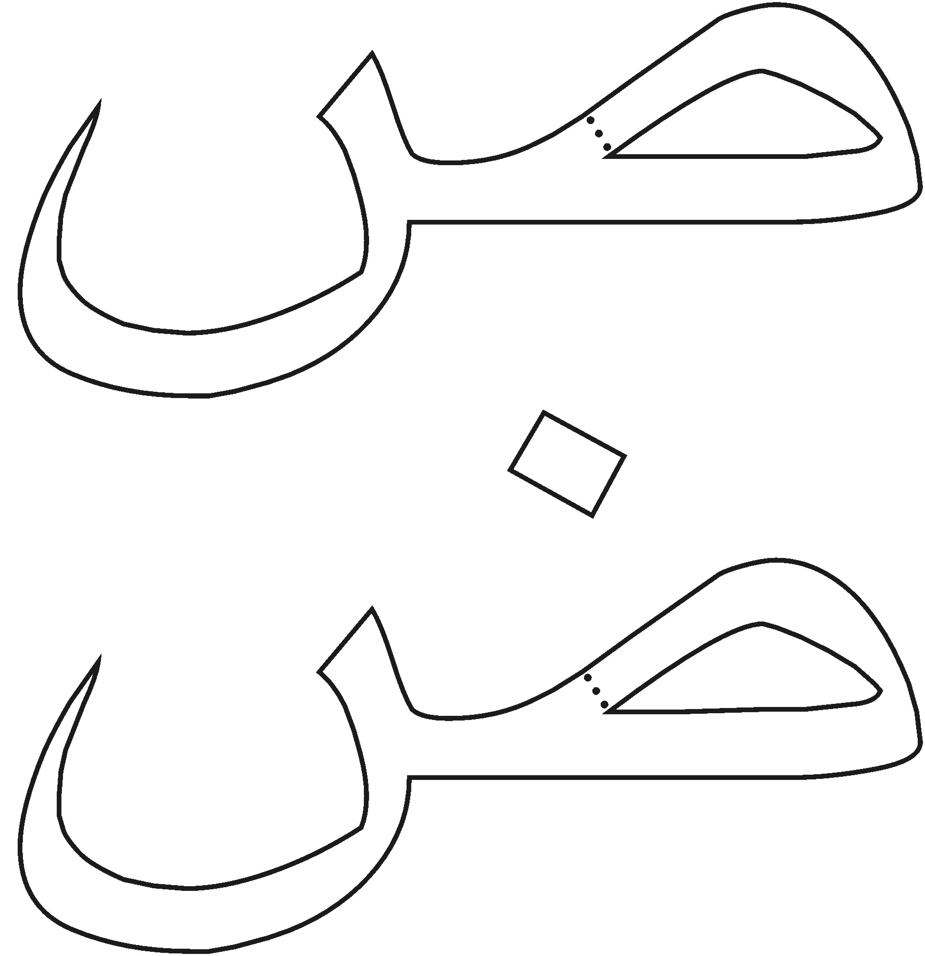
WORKSHEET 1.8: HURUF (LETTERS): SEEN, SHEEN, SAAD, DHAAD:
Colour the balloons: RED = SEEN YELLOW = SHEEN

BLUE = SAAD GREEN = DHAAD
Teacher Assisted Activity:

⧫   

❐   

   

   

LESSON 1.9: HURUF (LETTERS): TAA AND ZAA:
The huruf you have learnt so far are:
            ☹ 
Today you will learn more huruf that are in pairs:

With this shape you can make 2 different huruf in the Arabic alphabet using dots.
By putting:
- no dot at all, you get TAA = 
- 1 dot on its head, you get ZAA = 
The sounds for  and  come from the throat

Taa is for tareeq – a path to walk upon
Zaa is for zill – a shadow



WORKSHEET 1.9: HURUF (LETTERS): TAA AND ZAA:
a: Learn the correct pronunciation of:
     

b: Draw Taa and Zaa from the dots using different colours.
Remember to say Taa and Zaa each time you write them.

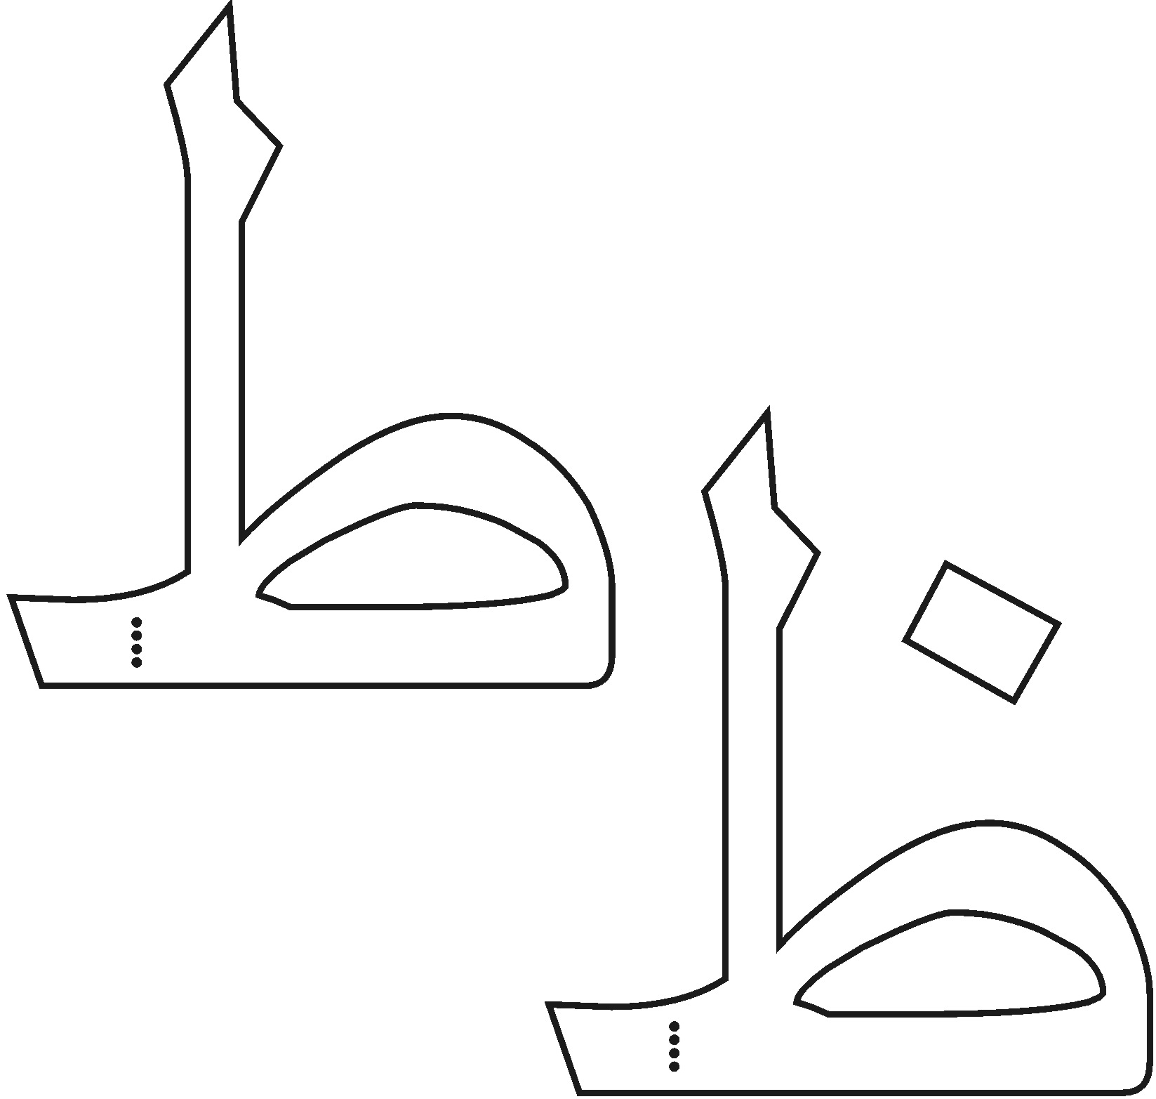

LESSON 1.10: HURUF (LETTERS): AIN AND GHAIN:
The huruf you have learnt so far are:
              ☹ 
Today you will learn more huruf that are in pairs:

With this shape you can make 2 different huruf in the Arabic alphabet using dots.
By putting:
- no dot at all, you get AIN = 
- 1 dot on its head, you get GHAIN = 
The sounds for  and  come from the throat
Ain is for ilm – the thing to know to make our knowledge grow in Islam
Ghain is for ghaib – a world unseen – and that we know is not a dream

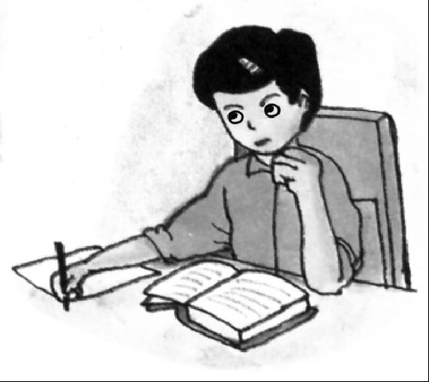

DREAM
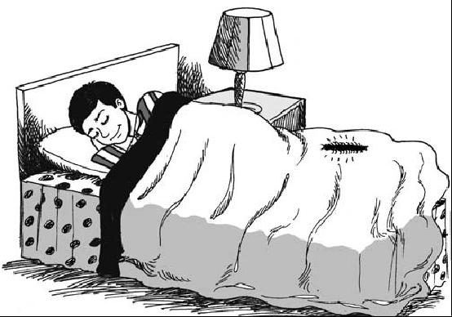

WORKSHEET 1.10: HURUF (LETTERS): TAA AND ZAA:
a: Revise the correct pronunciation of:
     

b: Draw Ain and Ghain from the dots using different colours.
Remember to say Ain and Ghain each time you write them.
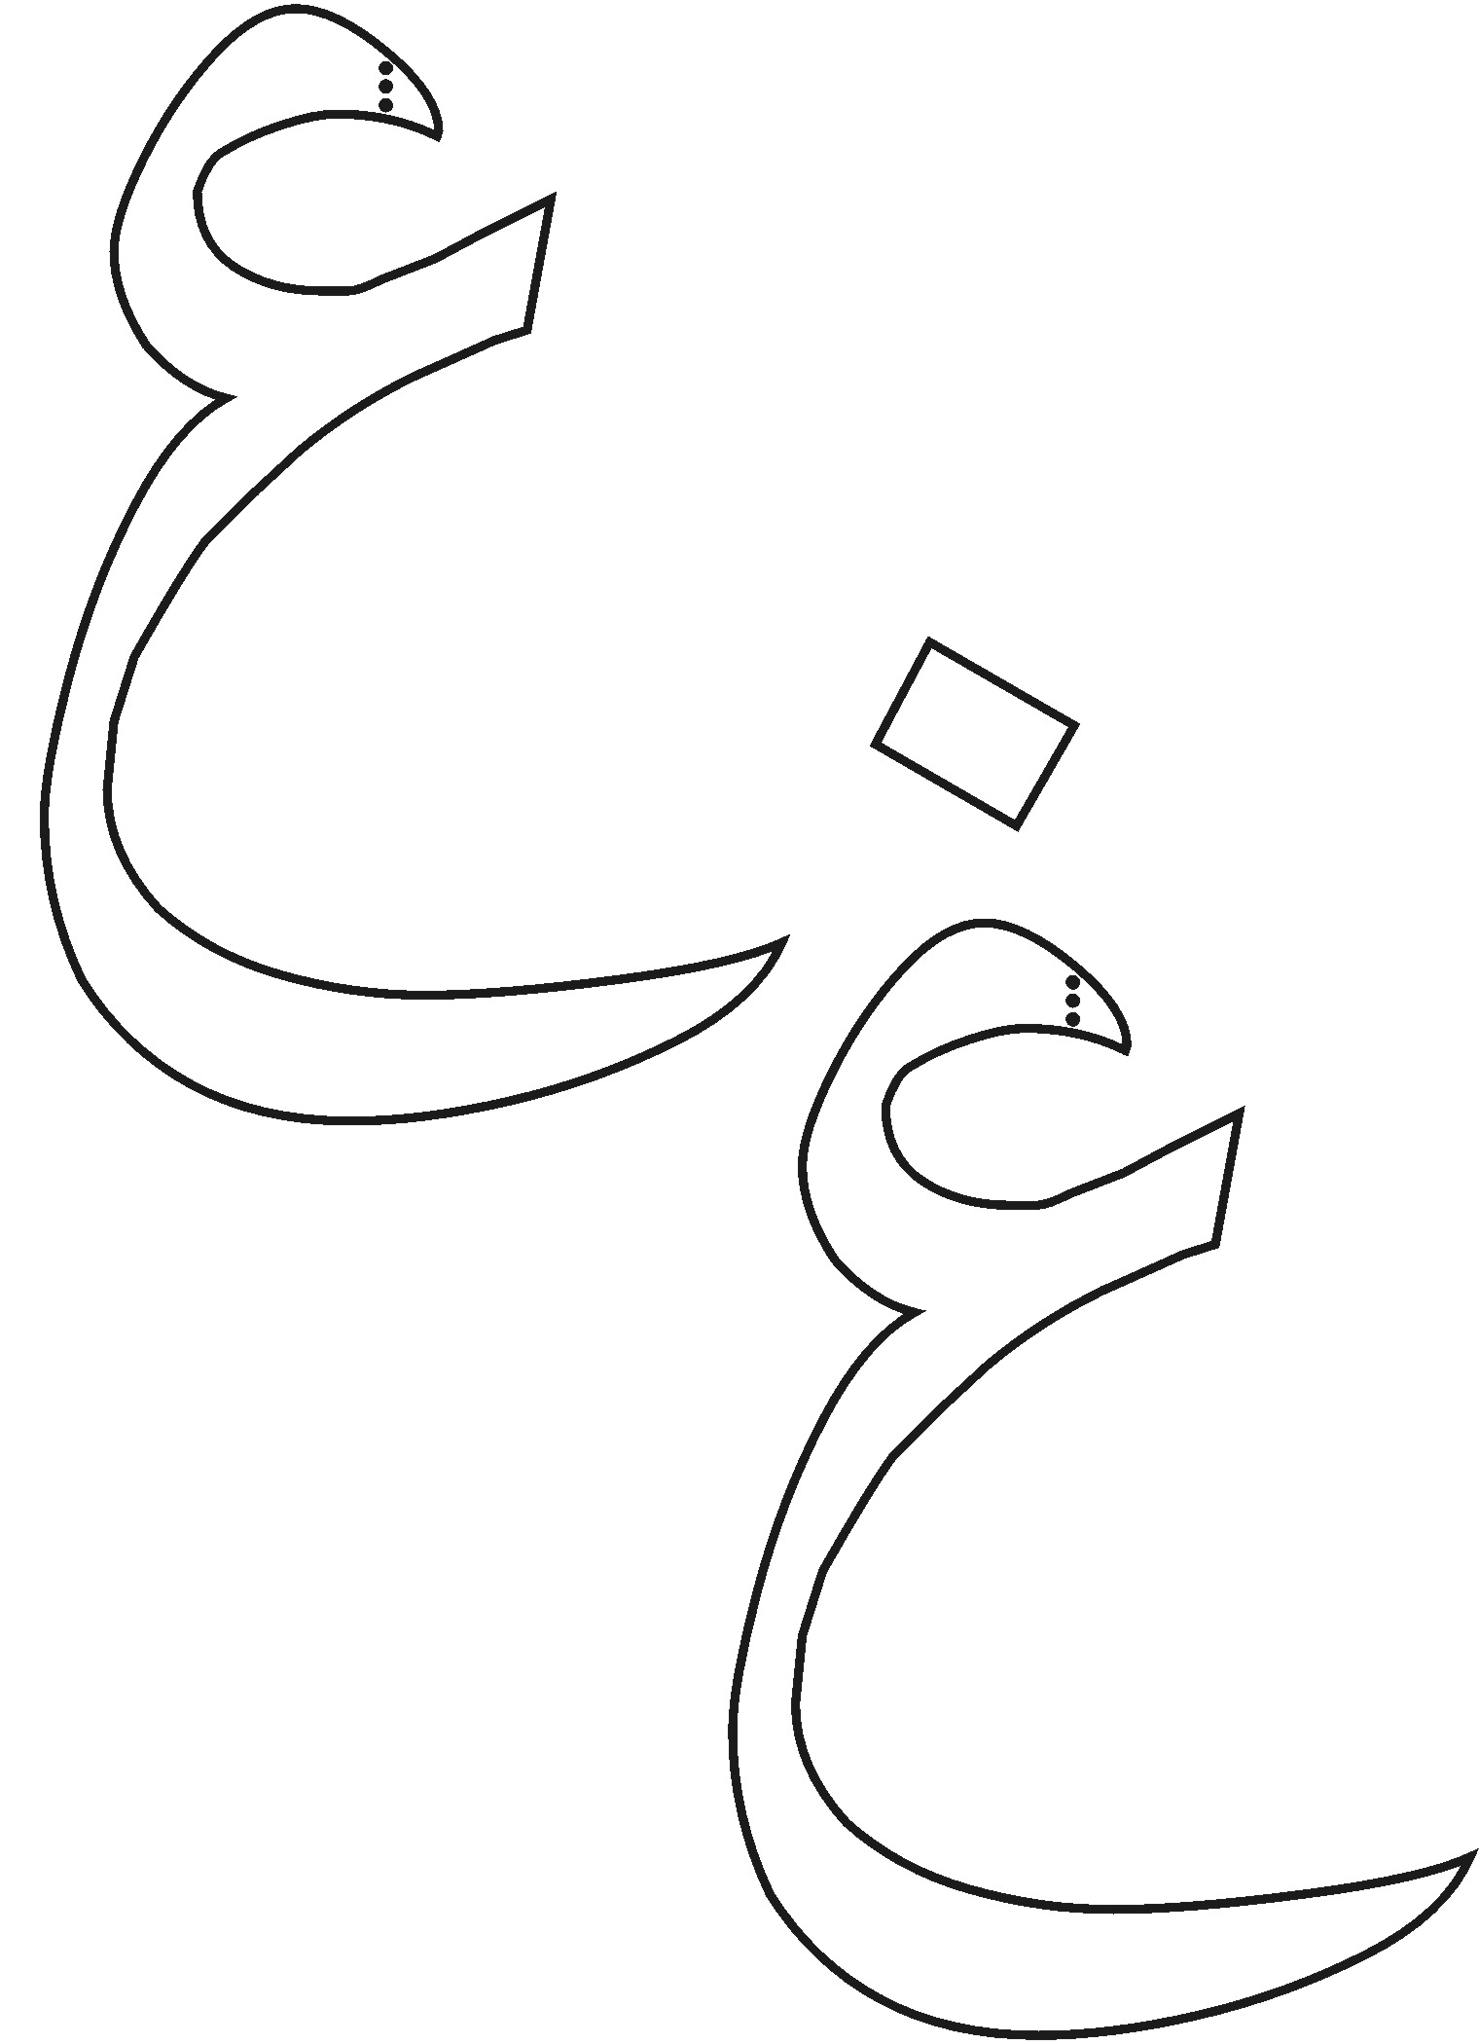
WORKSHEET 1.10: HURUF (LETTERS): TAA, ZAA, AIN AND GHAIN:
Colour the hearts: RED = TAA YELLOW = ZAA

BLUE = AIN GREEN = GHAIN
Teacher Assisted Activity:

○   

   

✦   

✦   

LESSON 1.11: HURUF (LETTERS): FAA, QAAF AND KAAF:
The huruf you have learnt so far are:
→                ☹ 
Today you will learn huruf that look like the boat family but have a loop:
With 1 dot, you get FAA = 

Then a slightly deeper boat:
With 2 dots, you get QAAF = 

The next one makes a similar sound to QAAF but is much lighter KAAF.
A lighter qaaf , is KAAF = 

Faa is for the Opening – Al Fatiha and
Qaaf is for Qur’an – the book of God and
Kaaf is for Kalima – a word with thought to teach us what is good and what is not

      
      
 
          
There is no god but Allah

Suratul Fatiha
Kalima

Holy Qur’an

WORKSHEET 1.11: HURUF (LETTERS): FAA, QAAF AND KAAF:
a: Learn the correct pronunciation of:
   ▪ ◻  

b: Draw Faa, Qaaf and Kaaf from the dots using different colours.
Remember to say Faa. Qaaf and Kaaf each time you write them.

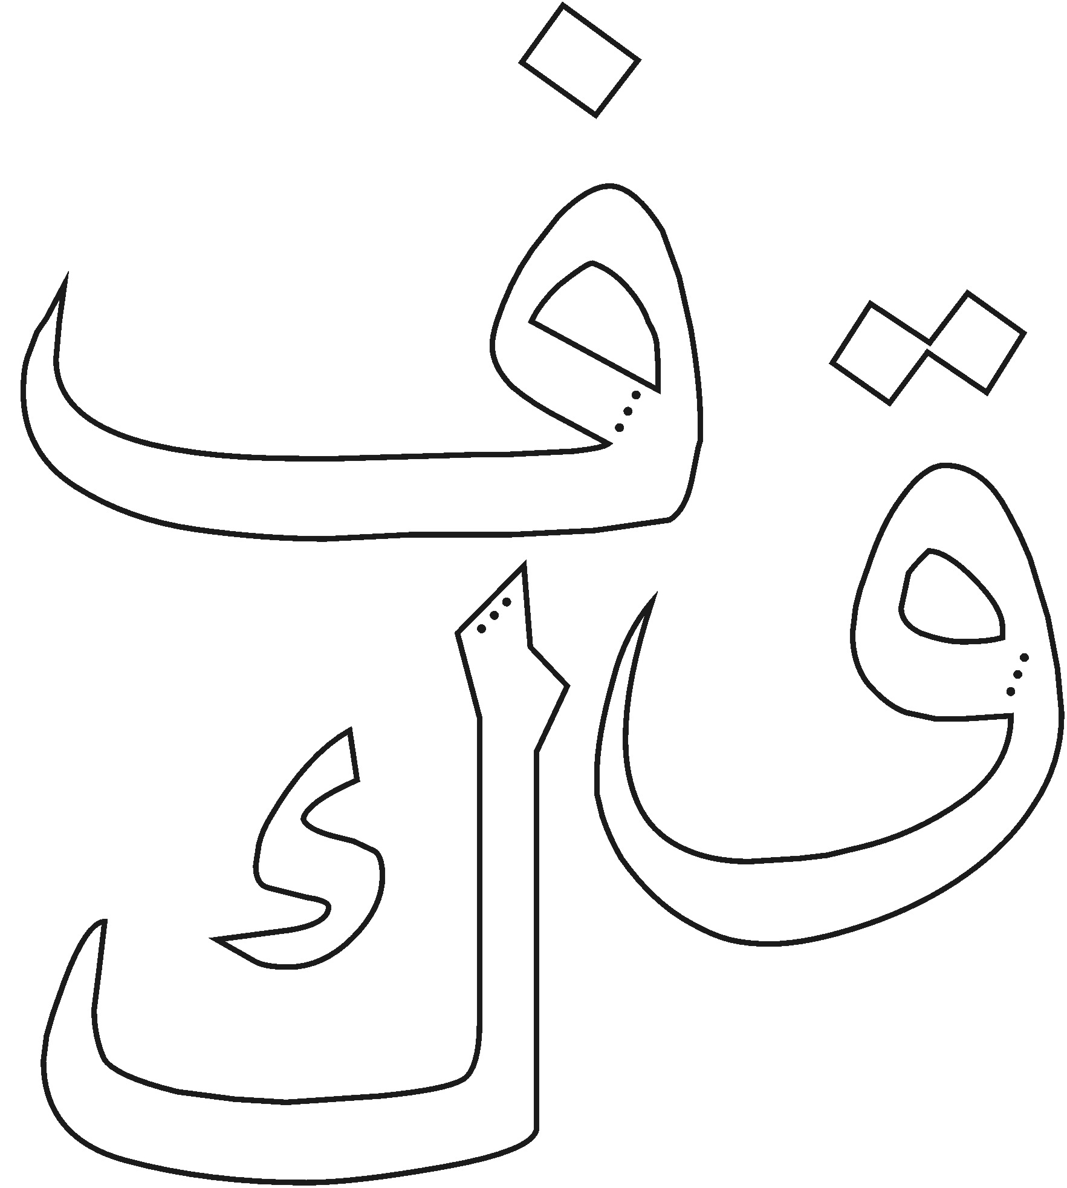
WORKSHEET 1.11: HURUF (LETTERS): FAA, QAAF, AND KAAF:
Colour the diamonds: RED = FAA BLUE = QAAF

GREEN = KAAF
Teacher Assisted Activity:

   

   

   

✰   

✰   

LESSON 1.12: HURUF (LETTERS): LAAM, MEEM, NOON:
The huruf you have learnt so far are:
              ☹ 
    
Today you will learn 3 huruf:
LAAM = 

MEEM = 
A deeper boat shape, is NOON = 
Laam is the beginning of La ilaha ilallah
Meem if for messenger – Muhammadur Rasulullah
La ilaha Ilallah – Muhammadur Rasulullah

ALLAH – THERE IS ONLY ONE GOD AND MUHAMMAD IS HIS MESSENGER – ALLAH – LA ILAHA ILALLAH

Noon is for Naum – sleep. God gave to give us rest after the day.
            

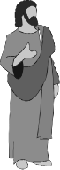


Beginning of our Kalima

WORKSHEET 1.12: HURUF (LETTERS): LAAM, MEEM AND NOON:
a: Learn the correct pronunciation of:
     ▪ ☹

b: Draw Laam, Meem and Noon from the dots using different colours.
Remember to say Laam, Meem and Noon each time you write them.
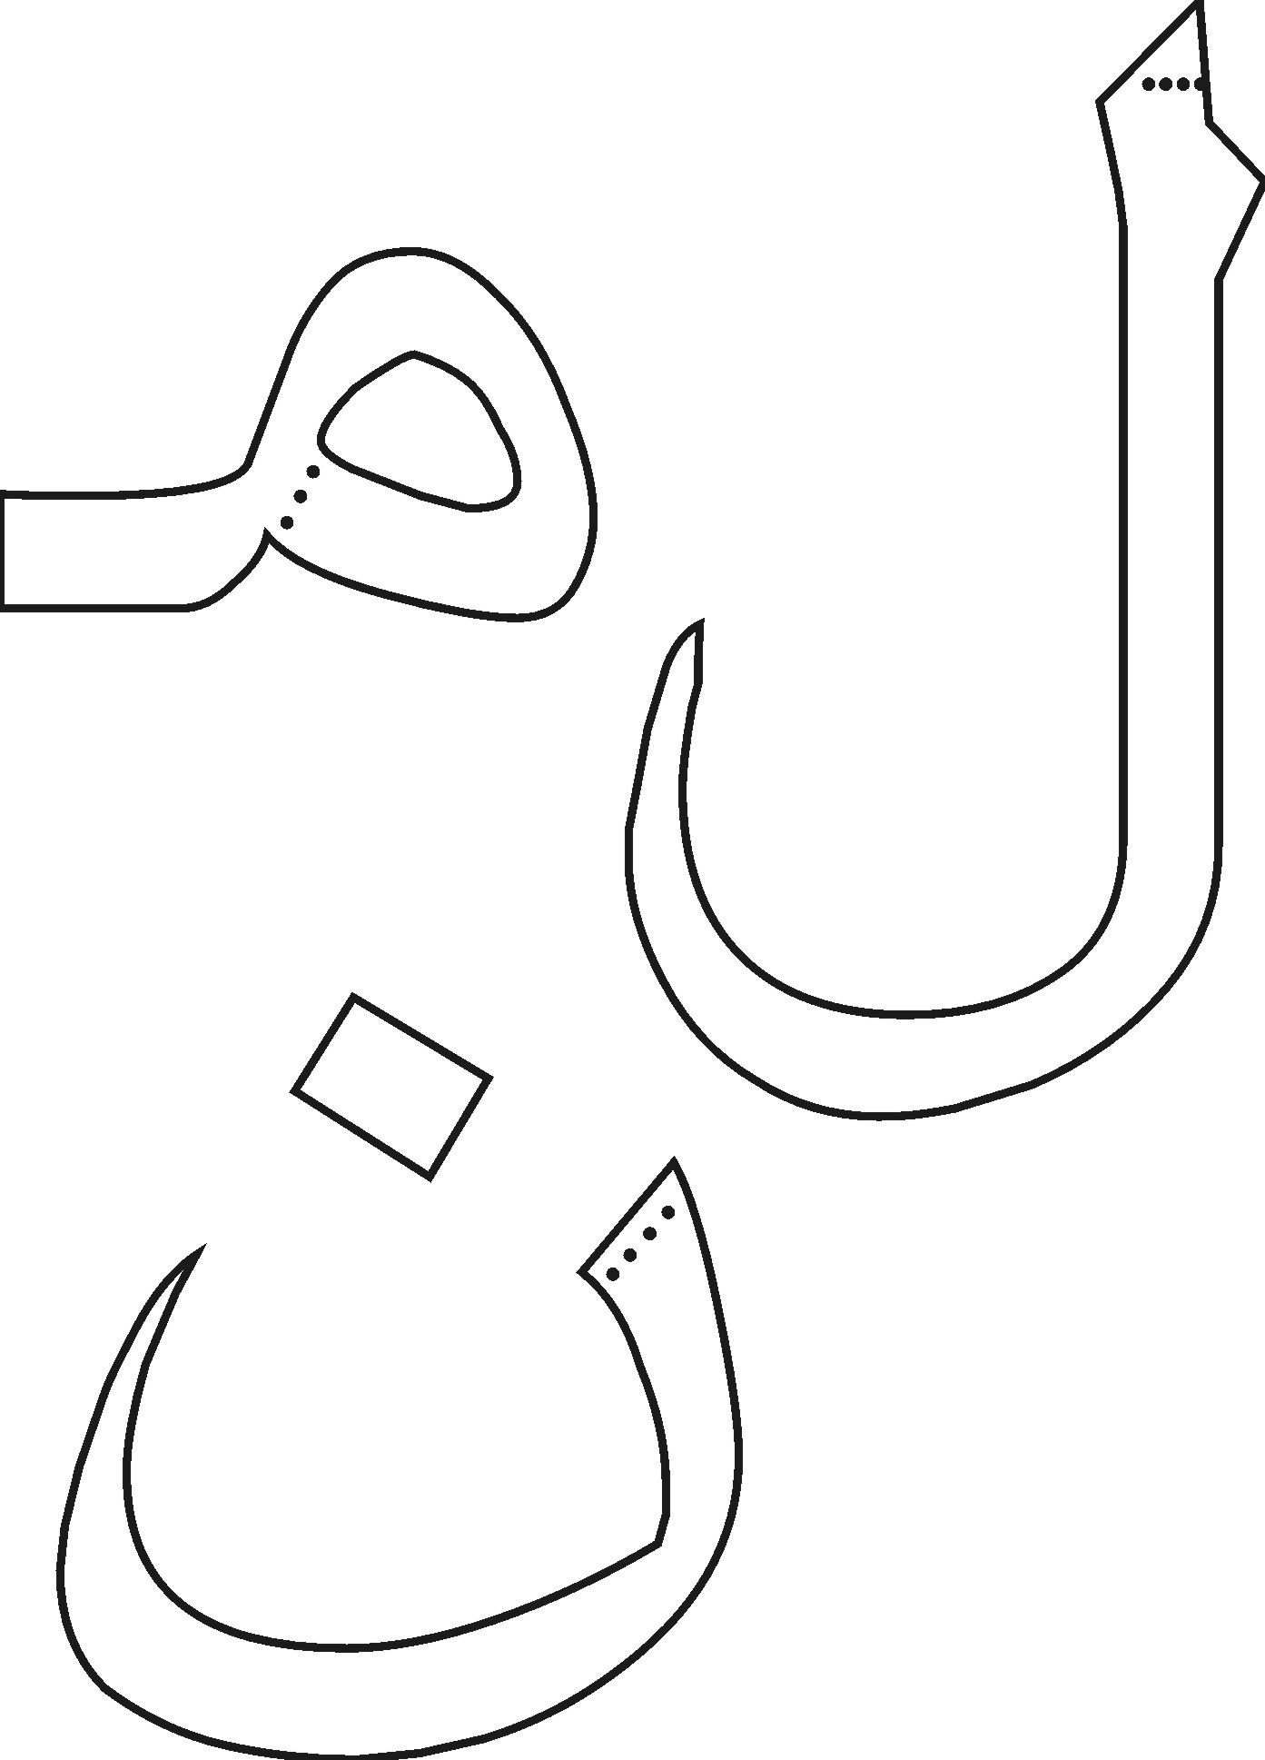
WORKSHEET 1.12: HURUF (LETTERS): LAAM, MEEM AND NOON:
Colour the stars: RED = LAAM YELLOW = MEEM

BLUE = NOON
Teacher Assisted Activity:
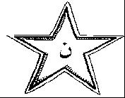
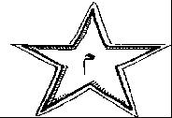
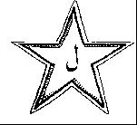

LESSON 1.13: HURUF (LETTERS): WAW, HAA, YAA:
The huruf you have learnt so far are:
              ☹ 
       
Today you will learn 3 huruf:
WAW = 

A lighter sound HAA = 
YAA = 
Waw is for Wudhu – before we pray to help us wash our sins away
Haa is for Hijra – the journey that the Muslims make, and
Yaa is for Yaumid Deen

ALLAH – THERE IS ONLY ONE GOD AND MUHAMMAD IS HIS MESSENGER – ALLAH – LA ILAHA ILALLAH

Day of Judgement

WORKSHEET 1.13: HURUF (LETTERS): WAW, HAA AND YAA:
a: Learn the correct pronunciation of:
        

b: Draw Waw, Haa and Yaa from the dots using different colours.
Remember to say Waw, Haa and Yaa each time you write them.

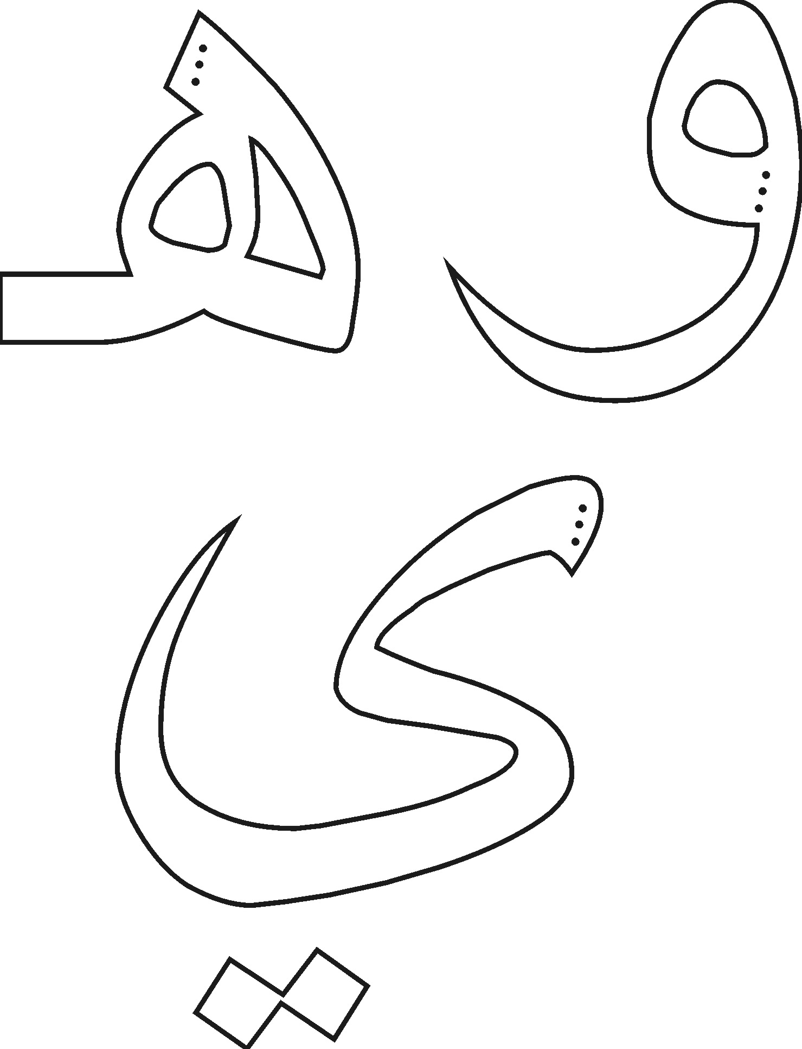
WORKSHEET 1.12: HURUF (LETTERS): LAAM, MEEM AND NOON:
Teacher Assisted Activity:
Catch the correct fish:

WAW
HAA

YAA





LESSON 1.14: HURUF (LETTERS): REVISION:

Can you read all the huruf now?

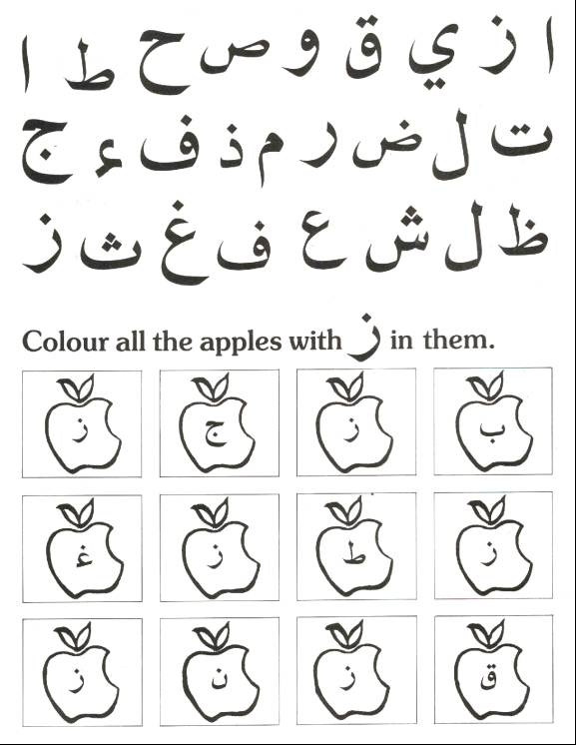

LESSON 1.15: HURUF (LETTERS): AZ ZAHRA CERTIFICATE:
For the Az Zahra Certificate, your child should know:
- All the Huruf (Letters) of the Arabic Alphabet
- AND
- Should be able to recite Lines 8-10 of Pg. 4 of Yassarnal Qur’an
__________________ has been tested on the above requirements and has performed satisfactorily.
________________________ _________________
Signature of teacher: Date

If the child has not passed the test satisfactorily the teacher should fill in the letter below.
Dear Parent,
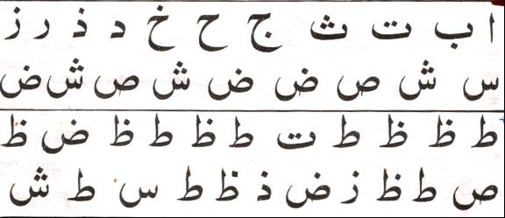
Your child __________________ was tested on the Arabic Alphabet but s/he did not know:
Lines 8 – 10 Page 4

- some of the Huruf (Letters)
- Lines _______ Pg 4 of Yassarnal Qur’an.
Please ensure that s/he knows the above for next week, so that s/he may receive their az-Zahra Certificate.
__________________________ __________________
Signature of teacher Date
LESSON 1.16: SURATUL FATIHA: MEMORISATION:

   
  ◻ ☹  
 
  
◻   ☺◻ 
  
▪ ◻  
▪ ☹


MEMORISATION SURAH FOR TERM 1: SURATUL IKHLAS:

   
   
 
 
  
 •    

TERM 1: MEMORISATION SURAH FOR AZ-ZAHRA CERTIFICATE:
For the Az Zahra Certificate, your child should know:
- Suratul Ikhlas with proper Makhraj.
__________________ has been tested on the above requirements and has performed satisfactorily.

________________________ _________________
Signature of teacher: Date

If the child has not passed the test satisfactorily the teacher should fill in the letter below.
Dear Parent,
Your child __________________ was tested on Suratul Ikhlas but s/he did not know it.
Please ensure that s/he knows the above for next week, so that s/he may receive their Az-Zahra Certificate.
__________________________ __________________
Signature of teacher Date
MEMORISATION SURAH FOR TERM 2: SURATUL ASR:


   
 ◻ 
    
 ▪    
 ☺      

TERM 2: MEMORISATION SURAH FOR AZ-ZAHRA CERTIFICATE:
For the Az Zahra Certificate, your child should know:
- Suratul Asr with proper Makhraj.
__________________ has been tested on the above requirements and has performed satisfactorily.

________________________ _________________
Signature of teacher: Date

If the child has not passed the test satisfactorily the teacher should fill in the letter below.
Dear Parent,
Your child __________________ was tested on Suratul Asr but s/he did not know it.
Please ensure that s/he knows the above for next week, so that s/he may receive their Az-Zahra Certificate.
__________________________ __________________
Signature of teacher Date
MEMORISATION SURAH FOR TERM 3: SURATUL KAUTHAR:


   
  ▪ 
   
    

TERM 3: MEMORISATION SURAH FOR AZ-ZAHRA CERTIFICATE:
For the Az Zahra Certificate, your child should know:
- Suratul Kauthar with proper Makhraj.
__________________ has been tested on the above requirements and has performed satisfactorily.

________________________ _________________
Signature of teacher: Date

If the child has not passed the test satisfactorily the teacher should fill in the letter below.
Dear Parent,
Your child __________________ was tested on Suratul Kauthar but s/he did not know it.
Please ensure that s/he knows the above for next week, so that s/he may receive their Az-Zahra Certificate.
__________________________ __________________
Signature of teacher Date

