Akhlaq Chapter 1
THE MEANING AND ORIGIN OF AKHLAQ:

The word Akhlaq is the plural for the word Khulq which means BEHAVIOUR.

Our Behaviour is that ability (malakah) of the soul which is the source of all activities that we perform spontaneously without thinking about them. Malakah is a property of the soul which comes into existence through exercise and repetitive practice and is not easily destroyed.
A particular behaviour (malakah) may appear in us because of one of the following reasons:
Natural and physical make up: It is observed that some people are patient while others are touchy and nervous. Some are easily disturbed and saddened while others show greater resistance and resilience.

Habit: This is formed because of continual repetition of certain acts and leads to the emergence of a certain behaviour.
Practice and conscious effort: If continued long enough will eventually lead to the formation of certain behaviour.
Even though the our physical make-up produces certain behaviour patterns in us, it is by no means true that we have no choice in the matter and are absolutely compelled to abide by the dictates of this physical make-up. On the contrary, since we have the power to choose, we can overcome the dictates of our physical nature through practice and effort, and can acquire the behaviours of our choice.
Of course, it should be admitted that those behaviour patterns caused by the mental faculties such as intelligence, memory, mental agility, and the like, are not alterable. All other behavioural patterns, however, may be changed according to our will.
We can control our anger and other emotions and desires, and channel them to improve and move ourselves along the path of perfection and wisdom.
When we speak of our ability to bring about changes in our behaviour, we do not mean that we should destroy our instincts of reproduction or self-preservation; because we could not exist without these instincts. What we mean is that one should avoid going to either extremes in regard to them, and maintain a condition of balance and moderation so that we may perform our duties properly.
Just as the seed of a date grows into a fruitful tree through proper care, or a wild horse is trained to serve his master, or a dog is trained to be the lifelong friend and a help to man, so also can man attain perfection and wisdom through self-discipline and intelligent perseverance.
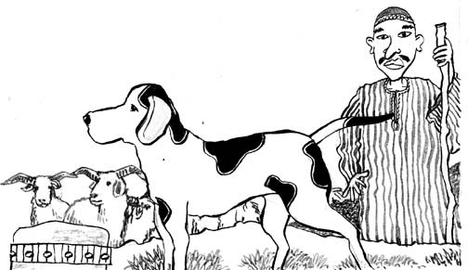
Human perfection has many levels. The greater the amount of self-discipline and effort on our part, the higher the level of perfection we would attain.
In other words, we stand between two extreme points, the lowest of which is below the level of beasts and the highest of which surpasses even the high station of angels.
Our movement between these two extremes is discussed by `ilm al-akhlaq or the science of moral values. It is the goal of moral values to raise and guide us from the lowest animal state to that high position superior to that of the angels.
In a hadith from Imam Ali (A), he is related as saying:
Surely God has characterized the angels by intellect without sexual desire and anger, and the animals with anger and desire without reason. He exalted man by bestowing upon him all of these qualities. Accordingly, if man's reason dominates his desire and ferocity, he rises to a station above that of the angels; because this station is attained by man in spite of the existence of hurdles which do not trouble the angels.
So? Where are we now?
Here?

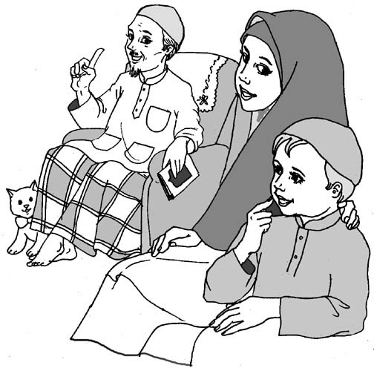
or
or

Akhlaq Chapter 2

DEEDS WHICH INVITE UNHAPPINESS

We have done those deeds, which invite happiness before, but there are also deeds, which are bad, and if you do them, they will lead to unhappiness.

Allah has made certain deeds wrong either because they are bad for us, i.e. our health, or they hurt or harm other people.

Some of these are listed below:

Not praying on time:
Salaat is one of the most important acts of Worship, performing it is Wajib.
Not praying on time without a good reason; e.g. If you are watching your favourite football match the FA cup between Manchester United and Crystal Palace, and it is time for Salaat, you should go to pray first, and then come back to watch the rest of the match.
Our 6th Imam (a.s.) has said:
"Whoever does not pray on time is not of us."



Eating even after you are full:


Eating when you are already full is bad because you spoil your appetite, make yourself overweight and put extra pressure on your body to look after the extra weight.

Sleeping more than is required:


Sleeping too much is bad for you because the more you sleep, the more tired you get. This means that you become lazy and lay in bed for longer than you need.

Time is very precious, and Allah has given it to you to spend usefully. Try not to waste it.

Telling Lies:
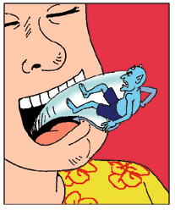
To tell lies. Lying is very bad, and can become a habit very easily. Lying is also like a key, which opens the door to other bad deeds.

Prophet Muhammad (S) has said:
"Leave falsehood and make speaking the truth a habit."

To be rude to others and also to be stubborn:

Being rude to people is bad because you hurt their feelings; also you will lose your self-respect and you friends if you make a habit of being rude.

Being stubborn means that you think only you are right and that everybody else is wrong and you refuse to listen to anyone else. You should listen to others and think about what they are saying before you decide what is right and wrong.

To laugh at other people’s mistakes:

Laughing at other people's mistakes is rude and also shows you as being proud. Everybody is human, and everybody makes mistakes. To laugh at other people is bad because you can hurt their feelings. Just think, how would you like it if other people laughed at you?

Sulking:

Sulking means to make a face when you don't get what you want. This is bad because you are being a spoilsport.

If your parents refuse you something, they are only doing it for your own good.

To think you are better than everyone else:
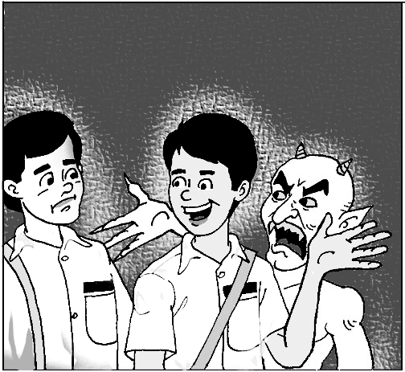
Thinking that you are better than others, is one of the worst deeds and is called pride.

This is why Shaytan was removed from the mercy of Allah, because he thought he was better than Prophet Adam (A).

However good you are, or however well you do, just remember Allah and thank Him, and you will stop yourself from becoming proud.

To be in the state of Najasat (unclean):

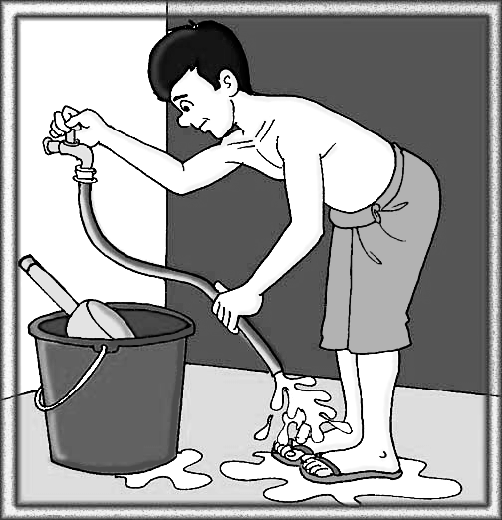
You should always try and remain clean and Pak.

This means that you should wash yourself properly every time you go to the toilet, and make sure that your clothes do not get Najis. If they do, then you should clean them as soon as you come home.

It is said that to be clean and Pak (Tahir) is from the habits of the prophets.

Akhlaq Chapter 3
ACQUIRING KNOWLEDGE

This means to try and LEARN and UNDERSTAND what people say to you and use it in the future. This is a very good habit.

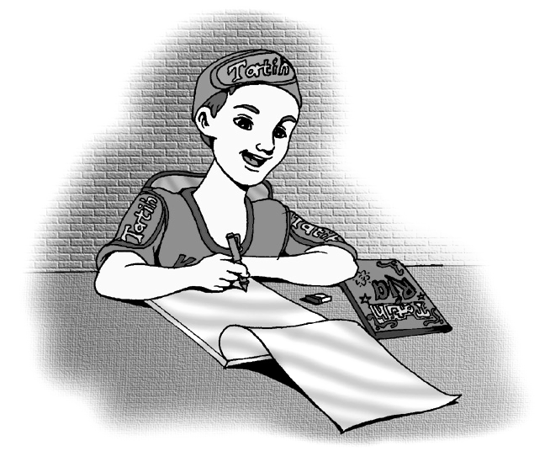
You can always gain knowledge by:
- watching what other people do;
- learning from their mistakes;
- picking up their good habits;
- picking up good points from books, television when you watch.

ALWAYS BE CAREFUL THAT YOU NOTICE BAD HABITS AND AVOID PICKING THESE UP

If someone says something to you, you should do three things

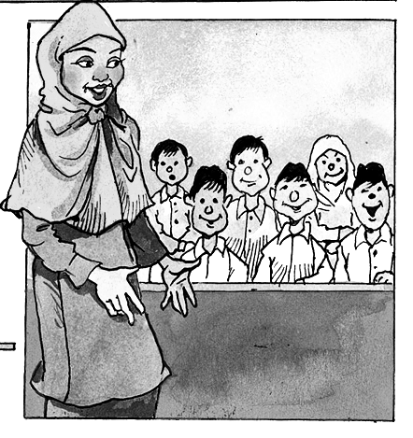
LISTEN
LEARN
UNDERSTAND
Never become proud of having Knowledge. No matter how much you know there is always many times more that you do not know
Places where we learn are:

HOME SCHOOL MOSQUE MADRESSA





We should always respect these places, by acting properly and trying not just to learn, but also to enjoy learning e.g., at school, we should respect the teacher, and at the same time try and enjoy doing the work. That way we will progress and have fun at the same time.
Once the Prophet (s.a.w.) entered the Mosque, BEFORE THE PRAYER TIME and he found two groups in the Mosque.

In one group, some were reading from the Qur'an while others were praying. The other group was in a corner busy learning. They learnt how the read and write and discussed the teachings of Islam and their application to their daily lives.

Looking at both, the Prophet (s.a.w.) said: "They are both engaged in useful pursuits. But I am a teacher. I shall join the group assembled to learn."

And so he sat with the group of students.

No matter how much you know there is always many times more that you do not know.

There was a King in days long gone by, who was very famous. One reason for his fame was that he had a wise old man for his councilor.

The councilor was walking down the road when he was stopped by an old lady, who said "I have a question for you."

The wise old man said "How can I help you?"

The old lady asked her question and the wise old man sat down and started to think. He scratched his head and moved one way and then another. Finally he said, "I don't know the answer."

The old lady said, "Huh, you are supposed to be the King's wise man, and you can not even answer an old woman's question!"

The wise old man laughed and replied "The King pays me for the answers that I DO know, if he was to pay me for the answers that I DO NOT know, all the kingdoms on the earth would not suffice."

This shows us that no matter how clever a person is, there is always room for him to improve.

Knowledge can be of different kinds, we must always seek knowledge to improve our understanding of things around us.

Abu Abdullah (a.s.) has said:

"The seekers of (sacred) knowledge are of three kinds, so recognize them by their specific qualities and characteristics.
- One kind of them seeks it for the sake of ignorance and dispute.
- Another kind seeks it for the sake of domination and deceit.
- Yet another kind seeks it for the sake of (improving) understanding and intellect.

Akhlaq Chapter 4
PATIENCE - SABR

Patience means to be able to wait quietly in times of difficulty and hardship. It also means to be tolerant.

This can be compared to a mountaineer who, in order to reach the peak of a mountain has to face internal and external obstacles and barriers. The internal obstacles, like the love of comfort, the fear and despair are within his inner self while the external ones, like falling rocks, wolves, thieves are outside beyond his control. Each of them in their own ways interfere with his climbing efforts.

Someone faced with these kinds of barriers will have the option to either drop his journey on this road that is full of hardships and dangers, or to go ahead by resisting against them and overcoming every barrier with his power of determination. The second case is defined as PATIENCE.


Accomplishment of a goal requires action, and action requires patience and staying power.

Our Holy Prophet Muhammad (s.a.w.) has said that:
“Patience is half of faith”

This means that if a person can stay patient even after hardship, then that person has taken a BIG step towards understanding their faith.

Allah says in the Holy Qur’an:


Suratul Baqarah
Ayat
156-157
"....and give glad tidings to the PATIENT ones who, when misfortune befalls them, say, "Verily we are God's and to Him shall we return." Those are the ones upon whom are blessings from their Lord and His mercy; and they are the ones that are rightly guided."

Patience is a virtue.

This shows that in Islam, BEING GOOD BY YOURSELF is not enough to please Allah. You should teach others what you believe, and you should have patience, which is an EXCELLENT QUALITY.

Akhlaq Chapter 5
AWARENESS OF ALLAH'S DISPLEASURE (TAQWA)

People often translate Taqwa as "fearing God". This is not a proper translation, and can be taken to mean the Allah makes his creation afraid and scared, which is not true at all.

In Islam the concept of fearing God is NOT to be scared of HIM, but to be ashamed, scared or sad at doing something which would "displease HIM".

There is no English translation for this idea, which is known as TAQWA.
We all know that the most important duty of a Muslim is to believe in Allah and to have total submission to Him, i.e. His wishes are our commands. We also know that if we displease Him, then on the Day of Judgment we will have to answer for it.



The important thing is that if we ever do anything either accidentally or on purpose, we should be "aware" of what we have done and its consequences, and so should ask forgiveness from Allah
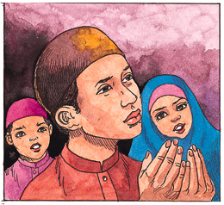
.

To reach this state of awareness is very difficult and we human beings would never have been able to reach it without Allah's help and guidance. Allah says in Suratul Baqarah "Worship me to ward off evil". This shows the concept of worship i.e. total submission and love of Allah is very important to keep away evil.

Imam Ali (a.s.) says in the Nahjul Balagha that: “… O creatures of Allah, the best advise for himself is he who is the most obedient to Allah, and the most deceiving advise to himself is he who is most disobedient to Allah.”

In Surah an-Nur, Allah says he will guide those who wish to be guided. This shows us that it is only through the love and worship of Allah that we will be guided on the "right path" to heaven.

Isn't that our main goal in life?

Akhlaq Chapter 6
FORGIVENESS

Forgiveness means to "let someone off the hook". It means to pardon someone for their mistakes towards you.

Forgiveness is a very good deed and shows that you have a big heart.

Allah tells us in Qur'an, Surah 64 ayat 14:

Suratut Taghabun
Ayat
14
“…. And if you forgive, and over look and cover up (their ills) then verily God is Oft forgiving, The Most Merciful.”

This shows us that if you are kind enough to forgive someone who has done something against you, Allah, who is The Kindest of all will also forgive you.
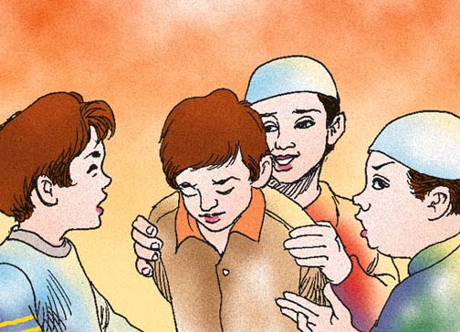
Imam Ali (A) has said:
Prophet Isa (A) said that you should do to others what you would like them to do to you. This means that if you want someone to forgive your sins towards them, you should first forgive their sins towards you.
"A person who has asked forgiveness from Allah, that person is like a new born baby."

When a baby is born, it is pure and sinless. Everyone loves it because it has done no wrong, and it has harmed no one.

When Allah forgives a person, then that person becomes pure as well. Allah makes his heart and soul as clean as that of a new born baby.

Imam Musa al-Kadhim (A) has said that:
"Your activities are like business with God. If one begs forgiveness for a deed before 7 hours have passed, it is better for you."

If you treat your actions as if Allah counts them, then the minute you make a sin, you should seek forgiveness for it before you finish the day.

That way, when you go to sleep, at least you know that you have settled all accounts with Allah, and so you can sleep happy and at peace with yourself.

Akhlaq Chapter 7
VISITING THE SICK

If you visit someone who is not well, you make them feel happy.

Why do they feel happy?
The reason they feel happy is that they know you care.
This means that the sick person knows that he/she has not been forgotten, and that there is somebody who worries about how they are feeling.
There was once an old woman who used to throw rubbish on Prophet Muhammad (s.a.w.) everyday when he passed her house on his way to the mosque, but he never ever got angry with her.

One day when the Prophet (s.a.w.) passed the old woman's house, any rubbish did not hit him.
He stopped and asked the old woman's neighbour if she was all right because she was not there to throw rubbish on him.


The neighbour told him that the old woman was not well and she was in bed.
So the Prophet (s.a.w.) went to visit the old woman because it is good to go and see people who are not well.
The old woman thought the Prophet (s.a.w.) had come to tell her off, and she said:

"Why did you wait until I was ill to tell me off. Why didn't you come when I was well and strong?"
Prophet Muhammad (s.a.w.) replied to the old woman:
“I have not come to tell you off, but to visit you because Allah tells us to look after people who are not well.”


This shows how important it is to visit sick people, you can make them feel very happy and when they get better, they will remember you and like you even more.
The old woman was so surprised that the Holy Prophet (s.a.w.) was being so kind to her, after she had been so mean to him, that she decided to listen to him and she became a Muslim.

Have you ever been sick, and sent to hospital?

If so, how did you feel when people came to visit you. What did you feel when they brought you presents and gifts?

Why did you feel like that?

Akhlaq Chapter 8
FULFILLING PEOPLE’S NEEDS
A need is when a person wants something, or has to have something so that he can live. Food and water are basic needs of all living creatures.
When we have something that others do not, then we should try and share what we have so that other peoples' needs are also met.
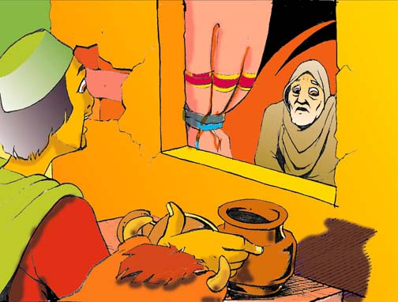
There are many different types of needs. If a person is poor, we should help them by giving them some money.
There are people who are disabled in some way. They might not be able to do things as easily as we can. They don't need money, but they need friendship and consideration. We should not laugh at these people, or make fun of them, but should go out of our way to be friendly with them and to make them feel that they are one of us, and not different.



Then there are people who are not very sure of themselves, and make mistakes often. Instead of laughing at them, we should help them and encourage them. When they make a mistake, do not tease them, but tell them how to improve. All they need are some true friends to help them.
There are also some people who are not lucky enough to have parents, friends or family who care for them, or to bring them up understanding Islam. They have parents, but they don't teach Islam properly.
What should we do when these friends ask us to do things wrong, like listening to music, or watching films which are not good, or eating food which we should avoid?
We should explain to them properly why we should not do these things, and guide them to the way of Islam, so that they can live happily with the pleasure of Allah.
This shows that we should help everyone we know in one way or another. When we see the faults or problems in other people, we should also make sure that we look at ourselves and see that we do not suffer from the same faults. If we do, we should try and make ourselves become better people as well.
Akhlaq Chapter 9
HAQQ-UN-NAAS:
Haq = right, i.e. a person's right to have or own something, and
Naas = which means person, or human beings.
It can be seen from this, that Haqq-un-naas means the rights of people. Every person has certain rights which are vital, and should not be taken away.
If I am holding the estate of an orphan, then it is the right of the orphan to inherit the estate when he comes of age. I should not consume it for my self, taking advantage of my position as the custodian.
Allah who is Just and Merciful, will (Inshallah) forgive us for the sins which we commit against Him, provided we repent for them sincerely; but how can He forgive you for the sins which you commit against others. That would be going against His justice. We can never be forgiven for breaking Haqq-un-naas, the rights of others, unless the person whom we have wronged forgives us himself.
The next question is "What actions break Haqq-un-naas?"
A person has a right over you even when he is not there. Imagine you were at a gathering, and were discussing with others. If you are not at that gathering, you still have a right that your name isn’t insulted, nor your reputation spoilt. This means that if someone does Gheebat, or Tohmat, or Fitna in which your name is mentioned then a sin has been committed against you.
Such a sin cannot be forgiven unless you have forgiven it. It is because of these high consequences that we should avoid committing actions which breach the rights of others. This shows that Islam is a religion that not only benefits a person directly, but helps the community in general. Where else can you find a law that commands you not to insult others, and to guard their reputation in public and private.
You are answerable for Haqq-un-naas even after death.
Islam advises that we should seek forgiveness from the person whom we have wronged before one of the parties dies. If person dies before forgiving the other, then there is no direct way of obtaining forgiveness, and that sin will carry forward until the day of Judgement.
Consider the danger of this sin! Allah cannot forgive us for crimes against Haqq-un-naas. He Himself has told us that He will only forgive the sin after the person who has been wronged forgives us. This does not matter whether the person is a Muslim, or a non Muslim, whether he is a sinner, or a believer.

Akhlaq Chapter 10
GOOD INTENTIONS

When you make an intention, it means to know what you are about to do and why you are doing it.

In Islam, intention plays a very important part in all our duties, because without a clear intention, almost any act is useless.

Imagine that someone was praying Salaat, he could be praying correctly and still his prayer might not be accepted. This is because when we pray, we can be praying for many reasons, some of them are:

a. So that Allah will be pleased with us.
b. So that people will see how good we are.
c. Because if we don't, our parents will get angry.

Obviously, our prayer will only be accepted if we have the first intention.

The Arabic word for intention is NIYYAT. Every act we do should have a good Niyyat. There is a hadith by our Prophet (S) that:

"Actions are governed by their intentions."

This means that the sins or blessings we get for doing something depends on WHY WE DID IT.

Another example is that suppose you gave a lot of money to charity in front of many people. There is nothing wrong in doing that depending on your Niyyat. If you give the money so that everyone will see how rich and kind you are, then that action is not worth anything in the "eyes" of Allah; however if you give the money in front of people so that they can see you and so that they might follow your example, then that action is looked upon very highly by Allah.

So, no matter what we do, we should always have a good Niyyat (intention) about it. We don't have to say anything as long as we know in our mind why we are doing something.

Whatever we do, there should always be one Niyyat that should be in our minds, THE NIYYAT THAT WE ARE DOING SOMETHING FOR THE PLEASURE OF ALLAH.

Akhlaq Chapter 11
TAHARAT AND UNCLEANLINESS

To be clean means to be free from dirt. To be Tahir (Pak) means to be pure according to Islam. There is a big difference between these two words.


If you dress in new clothes, take a shower and put on some perfume or cologne, you will be clean. Then imagine you go to the toilet and do not wash yourself properly.

You might still be clean, but now you are Najis. When we go to the toilet, we should wash ourselves twice better 3 times to make sure that we are Tahir. It is no good using tissue paper BY ITSELF, because this may make us clean, but it will not keep us Tahir.

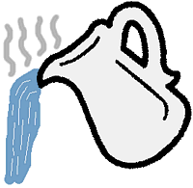


It is always a good habit to try and be Tahir (or pure) all the time. Our 8th Imam (A) said:

"To be pure and clean is amongst the habits of the Prophets."

Also, Prophet Muhammad (S) has said

"Cleanliness and purity are part of faith."

The opposite of being Tahir is being Najis, and the opposite of Cleanliness in Uncleanliness. One should always try to avoid being both Najis and unclean. There are certain ways Islam explains us to be both Tahir and clean at the same time. These are shown below.

Wudhu.
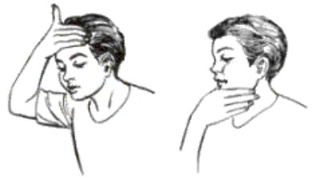
Islam tells us to wash ourselves with a special method before praying. This washing is known as Wudhu.

Ghusl.

Means to clean the body with a special method, with the Niyyat of cleaning it spiritually.
There are times when Ghusl becomes Wajib, i.e. when you touch a dead body. This means that you have to do Ghusl before you can pray Salaat.

Daily Bath.

.
Islam is a religion, which not only tells you to keep your soul clean, but to also keep your body clean. You should take a regular bath or shower to keep your body clean


Washing of Face and Brushing Teeth.


In the morning when you wake up, you should wash your face and brush your teeth. This makes you feel fresh as well as cleaning the dirt that forms overnight.

Prophet Muhammad (S) has said,
"Upon you is the brushing of the teeth, for surely it purifies the mouth, and pleases Allah, and brightens the eyesight. Indeed the angels hate the odour from a mouth not cleaned after eating food."


Clean Clothing.

A Muslim should never dress with dirty clothes. This does not mean that you wear your best and most expensive clothes. It means that even if you have one piece of cloth to wear, you should keep it clean.

When you wear clothes, you should wear it for yourself, and not for others to look at.

Cutting Nails.
You should always cut your nails because they grow very long and can get very dirty.

If you have long nails, dirt can get trapped underneath. When you eat, you will be putting that dirt in your food and swallowing it. This is very bad for your health and can lead to many illnesses.

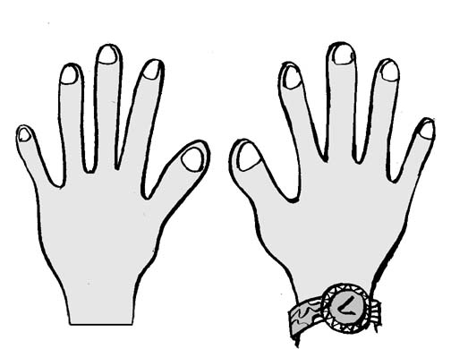

Looking After Hair.

One should always comb his hair with a proper parting. You should never leave your hair messy and unkempt.
Prophet Muhammad (S) has said that if you can not look after your hair properly, you should shave it off!

This shows the importance of caring for your hair. This does not mean that you spend all your time making sure that each hair is in place. You should make sure that your hair is clean and tidy.

One important point about the above is that Islam has told us to keep our bodies clean because a clean body leads to a healthy body. If we do not look after our bodies we will get all sorts of illnesses. If you keep your body clean you will feel good, and fresh.

The same way we are told to keep our souls Tahir, since a clean soul also leads to a healthy soul.
Akhlaq Chapter 12
HARD WORK

Hard work means to concentrate and strive at something until you achieve it.
You must have all heard the English saying,

If at first you don't succeed, then try, try again

Islam believes in working hard. If you work hard at something, than you will almost always succeed. Another common English saying is

It is better to have tried and failed, than not to have tried at all.

A believer has to work harder than most people. This is because most people work only for this life, i.e. food, house, money, family etc...

However, the believer has to work for BOTH this life and the next life.

The way to work for the next life is to be fair in this life, to pray on time and to help those in need.

One of our Imams was once working on a field. It was hot and sunny, and Imam was digging the ground. He was working very hard.

A person passed by and saw Imam sweating and working away at the ground. He said to Imam, "Oh son of the Prophet, have you no shame!"

Imam looked up from his work and asked, "Why, what have I done?"
The man answered, "You are working so hard for this world, and are forgetting your God."
Imam replied, "Doing hard work which is Halaal is one of the best forms of worship."

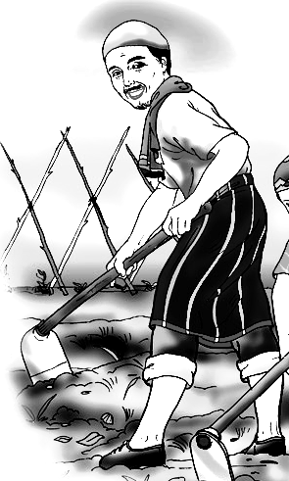

This shows that Islam is a religion which helps us lead a well-balanced life. Its rules are not just on recitation and Salaat, but also work and livelihood.
Akhlaq Chapter 13

INJURING OTHER PEOPLES FEELINGS

All people have feelings. There is nothing worse than a person who has his feelings hurt, because it takes a long time to recover.

If you throw a stone at someone, you will hurt them. The bigger the stone, the more they will be hurt. If you hurt their legs, then they won't be able to walk, or if you hurt their eye then they won't be able to see.


The tongue throws out words, and sometimes these words hurt more than stones. The stones hurt the body, but the tongue hurts the feelings.

There is a saying: "The tongue is sharper than the sword."

This means that sometimes, when you say something it can hurt someone even more than a sharp sword.

If you call someone names, or insult them, or make fun of something about them then you hurt their feelings. This makes them sad, and then they feel that no one cares for them.

Think for a moment. Pretend that you were them. Would YOU like someone calling you names all the time, making life miserable for you. Would YOU like some laughing when you fell down, or someone telling tales at you. Would YOU like people making fun of your family, or the colour of your skin, or at the way you are.

NO YOU WOULD NOT.

Then why do it to others?

Allah has created us all equal. Some are good at one thing, and some are good at others.
So next time you say something to someone else, even if it is only a joke. It might not be a joke to them. Think how it will affect their feelings before you say it.

Akhlaq Chapter 14
BLABBERING

Blabbering means to talk too much about things which are of no use or importance, without stopping.

You will notice that no one pays attention to a person who talks too much. As a result he loses his respect. He will not have any close friends since people will try to avoid him. In general, he will be thought of as a child.

When a person talks too much, he is giving away all his secrets, and he does not even realise. This explains why Imam Ali (A.H.) has said:

"The heart of a fool lies behind his tongue."

This shows that the secrets (heart) of a fool is revealed when he speaks.

On the contrary the person who is wise will only talk when it benefits him, which is why Imam Ali (A) also said:

"The tongue of a wise man lies behind his heart."

Blabbering is something which many people do often. Certain people, when they get together start talking about useless things, talk about other people, talk about who is doing what and who is going where. All this just turns out to be Gheebat and Fitna. You should always try to avoid these types of meetings or groups, since you will come out without any benefit, and in the meantime, someone’s name and honour would have been damaged.

Prophet Isa has explained us to treat our words as if they were gold. Would you throw away gold to anyone, and just treat it like sand. Well you should not throw your words away either. They are too expensive and important to be treated as dust, to throw away.

Akhlaq Chapter 15
REBELLING AGAINST AND DISOBEYING PARENTS

This is one of the most common problems in today's world, and is the cause of a lot of violence, bad behaviour and vandalism amongst today's youth.

Allah tells us in Qur'an (Surah 17, ayat 23)

Suratul Bani Israil
Ayat
23
"Thy lord has commanded that you worship none but Him, and that you be kind to your parents."

This shows how important it is to obey your parents and shows us that it is definitely not good to disobey them.

Question: Why should we obey our parents?

Answer : Our parents are older than us and so have had a lot of experience. They have given up so much for us. They also have our best interests at heart, so when they tell us something, they are telling us for our own good.

Allah said to one of His prophets:
"I swear by My Honour that anyone who does not obey his parents, even if he comes with the deeds of the Prophets in front of Me, I will never accept him."

If we disobey our parents, we are disobeying Allah and so we will not obey anyone. This means that there are no rules for us to follow, so we can do whatever we want!

This is what has happened to the western world today. The children do what they want and become spoilt and violent. Since today's children rebelled against their parents, they did not learn how to behave, and as a result will make bad parents in the future when they have children.

This shows that if we disobey our parents, we are ruining our own lives because we will bring our children up to disobey us.

Ayatullah Khomeini (may Allah rest his soul) said that,
"Looking at the face of your mother or father with respect is like looking at the Kaa’ba, the reward is the same."
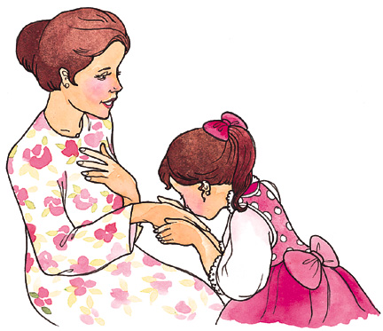

Imam Ali (A) has said:
"Respect your father and your son will respect you."
Akhlaq Chapter 16
LYING

To lie means to say something that you know is wrong, on purpose.

We all know that lying is a great sin. The bad thing is that we do not realise how often we are doing it.

Our Sixth Imam said that it is more difficult to repent for many small sins than for one big sin. Remember the story of the two men who came to Imam to repent for their sins.

Prophet Muhammad (S) has said,

"Leave falsehood and make speaking the truth a habit."

"If a person has a habit of speaking lies, he is a hypocrite until he rids himself of the habit."

To lie is Haraam because you are deceiving others. There are many reasons why people lie, some of them are,

a. as an excuse to get yourself out of trouble,
b. to cheat somebody out of something you want,
c. to get someone else into trouble.

As you can see, all the above reasons are bad. If you have done something which gets you into trouble, then you should face it, and not lie your way out of it because that is being very irresponsible.

Qur'an also tells us not to lie,

Suratul Baqarah
Ayat
42
“And cover not Truth with falsehood, nor conceal the Truth when you know (what it is).”

Prophet Muhammad (S) has also said,
"Beware of association with the liar for he is like a mirage which draws the far one nearer to you and the nearer far from you."

If you make the habit of lying, then you will lie very often without realising. You will lie to your family, your friends and everybody you meet. Then one day you will be caught out because you will have trapped yourself in a corner, and there will be no escape.
Akhlaq Chapter 17
FOR THE SAKE OF ALLAH ONLY
Your actions should be for the sake of Allah only. Only then will you get the result you deserve.
In the time of Prophet Musa (A) there lived a pious man, who used to remember Allah day and night.
One day this man heard about a tree which was being worshipped by some people. This news made him so angry that he went to find the tree and chop it down.
As the man reached the tree Shaytan appeared in front of the man disguised as an old man.
Shaytan asked the old man what he was going to do.
The old man said that this tree was being worshipped by some people, so he was going to chop it down.
Shaytan asked the old man that if Allah wanted the tree to be chopped, would He not have sent a Prophet to do it.
The pious man did not listen.
They began to argue and shout at each other until finally they began fighting.
The pious man managed to knock Shaitan down on to the floor and sat on him.
Shaytan begged him to let him go and told him that he had thought of a solution which would help the man in this world and the next. The man listened.
Shaytan continued that he would pay the man 2 Dinars everyday, of which the man could partly spend on himself and partly on the poor. In exchange the man should leave the tree uncut till Allah commanded whether it was right or wrong to cut it.
The pious man was misled by Shaytan. He thought the suggestion was a good one and agreed.
The next day when the pious man woke up he found 2 Dinars under his pillow. He was delighted and spent some on himself and some on the poor.
But the following day there was no money to be found. This made him very angry, so he again took his axe and went to cut the tree.
On reaching the tree he again met Shaytan disguised as an old man, who asked him what he had come to do.
The pious man replied that he had come to chop down the tree. To which Shaytan answered that he had no power to do this and it was better for him to go back home.
They again fought but this time Shaytan succeeded in overpowering the pious man and knocked him down.
The pious man was very surprised and asked Shaytan why it was that last time they fought he managed to overpower him but this time he could not.
Shaitan replied that it was because the first time they fought the man had come for the sake of Allah only, but the second time the man had come for the sake of money.
Moral: If you do something for the sake of Allah only, then Allah will give you special strength to carry it out.
(Anecdote from the life of Imam Ali (A))
WORKSHEET
Write what happened each time and why.
FOR THE SAKE OF ALLAH:


FOR THE SAKE OF MONEY:
Akhlaq Chapter 18
SELF-ACCOUNTING
Allah says in the Holy Qur'an,

Suratul Qiyamah
Ayat
42
"And I swear by the self-accusing soul."

In the above ayat we are told that there is a part of our soul which is called the self-accusing soul and that this is such an important part that Allah swears by it.
What is the self-accusing soul?
The self-accusing soul is our conscience; it is the part of us that makes us feel guilty when we do something wrong
Self - accounting is to listen to this conscience. If you ignore your conscience enough times then you will no longer hear it and then the next time you do something wrong, you will not feel guilty.
Once our Holy Prophet (S) was travelling with his followers when he stopped at a deserted place where there was nothing growing.
The Holy Prophet (S) told his followers to go and collect wood. They replied that they would not be able to find any wood in such a deserted place. The Holy Prophet (S) told them that they should still go and try to find some.
So they went and brought back whatever little they could. In a short while there was a big heap of wood laid before the Holy Prophet (S).
The Holy Prophet (S) then told them that their sins could just as easily be searched for and collected.
The Holy Prophet (S) was teaching them about self - accounting. In the same way that the wood was collected although it could not be seen before collecting, people's sins are not easily seen or remembered. But when they are looked for and accounted, they make a long list.
Is it not better to self - account and find that long list now while you can still ask for forgiveness rather than on the Day of Judgement when it will be too late.
You should get into the habit of self - accounting every day (at night, or after Salaat) where you think of the whole day and everything that you have done in that day.
What good thing have you done? If none then think of something good that you can do the next day.
What bad things have you done? How are you going to put them right (do Tawbah).
WORKSHEET
Why did the Holy Prophet (S) stop at such a deserted place?


What did he ask his followers to collect and why?
What was he trying to teach his followers?
Why is it important to self-account?

