Fiqh Chapter 01
USEFUL EXPLANATIONS 1

Wajib
Wajib means compulsory, we must do it. Allah has given us so many blessings. In return, when He tells us to do something, we must obey Him.
IF YOU DO A WAJIB ACT

IF YOU DO NOT DO A WAJIB ACT

YOU GET THAWAAB
YOU GET THAWAAB
YOU GET GUNAAH


Examples of Wajib acts
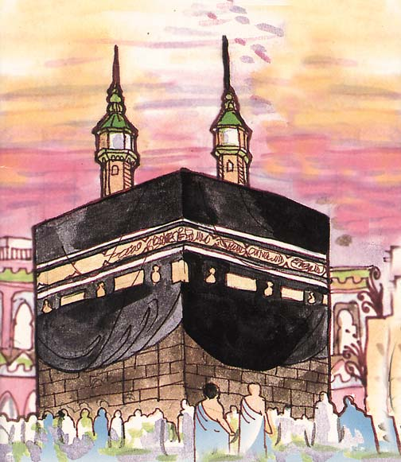


Mustahab
A Mustahab act is one that is good to do because it makes Allah happy. However, it is not Wajib.
IF YOU DO A MUSTAHAB ACT
YOU DON’T GET GUNAAH
IF YOU DO NOT DO A MUSTAHAB ACT


Examples of Mustahab acts

Haraam
Haraam means forbidden, we must never do it. This is because it makes Allah angry.
IF YOU DO A HARAAM ACT

IF YOU DO NOT DO A HARAAM ACT

YOU GET GUNAAH

YOU GET THAWAAB


Examples of Haraam acts
No you haven’t!! Look, you’ve not filled in all the answers!!

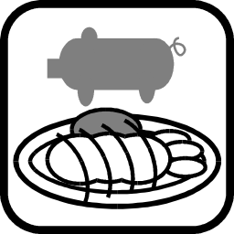

But I have done my homework!!

Makruh
A Makruh act is one that we should try not to do because it is not liked by Allah. However, it is not Haraam.
IF YOU DO A MAKRUH ACT

IF YOU DO NOT DO A MAKRUH ACT

YOU DON’T GET GUNAAH
YOU GET THAWAAB

Examples of Makruh acts

Mubah
Mubah acts are those that we are allowed to do. Another word for Mubah is Jaiz, which means allowed. We can get Thawaab for Mubah acts if we do them in the way Allah likes.

IF YOU DO A MUBAH ACT
YOU DON’T GET THAWAAB
IF YOU DO NOT DO A MUBAH ACT
YOU DON’T GET GUNAAH

Examples of Mubah acts






WAJIB – WE MUST DO THEM
MUSTAHAB – ARE GOOD TO DO THEM AS IT MAKES
ALLAH HAPPY
HARAAM – WE MUST NEVER DO THEM
MAKRUH – WE SHOULD TRY NOT TO DO THEM
MUBAH– WE ARE ALLOWED TO DO THEM & WE GET
THAWAAB IF WE DO THEM IN THE WAY ALLAH
LIKES

Fiqh Chapter 02
USEFUL EXPLANATIONS 2

Muslim
A Muslim is a person who believes in:
- Tawhid (Presence & Oneness of Allah)
- Nabuwwat (the Prophethood & the Prophets)
- Qiyamat (the Day of Judgement)

Mu’min
Mu’min is a person who believes in:
- Tawhid (Presence & Oneness of Allah)
- Adl (Justice of Allah)
- Nabuwwat (the Prophethood & the Prophets)
- Imamat (12 Imams)
- Qiyamat (the Day of Judgement)

Allah says in the Holy Qur’an (Simplified meaning of Ayat 15, Surah al-Hujaraat):

“The Mu’mins alone are the true believers in Allah and His Prophet. Once they believe, they never doubt again. They give up their wealth and even their lives for Allah. They are always truthful.”

Zahid
This is the person who does not love the things of this world too much.

Allah says in the Holy Qur’an (Simplified meaning of Ayat 23, Surah al-Hadeed):

“Do not grieve (too much) at what you missed or rejoice (too much) at what He has given to you. Allah does not like proud people.”

Muttaqi
This is a person who is pious. This means that he always remembers what Allah’s wishes are. He never does what Allah has forbidden, and always does what Allah wants him to do. We should all try to be Muttaqi.

Allah says in the Holy Qur’an (Simplified meaning of Ayat 183, Surah al-Baqarah):

“You should fast so that you become Muttaqi.”

Fiqh Chapter 03
USEFUL EXPLANATIONS 3

Kaafir
This is a person who is not a Muslim.

Allah says in the Holy Qur’an (Simplified meaning of Ayat 161, Surah al-Baqarah):

“The people who are Kaafirs, and die while they remain Kaafirs, are cursed by Allah, His angels and all mankind.”

I AM A KAAFIR. I DO NOT BELIEVE IN ONE GOD, PROPHETS, DAY OF JUDGEMENT OR 12 IMAMS

Mushrik
A Mushrik believes that Allah has a partner.

Allah says in the Holy Qur’an (Simplified meaning of Ayat 107, Surah al-An’aam):

“Follow only what has been commanded by Allah, there is no god except Him, and turn away from the Mushriks.”


I AM A MUSHRIK. I BELIEVE THAT THERE ARE DIFFERENT GODS FOR DIFFERENT THINGS. THERE’S A GOD FOR RAIN, FOOD, MONEY, ETC…
KAAFIR IS A PERSON WHO IS NOT A MUSLIM

MUSHRIK BELIEVES THAT ALLAH HAS A PARTNER
Munaafiq
A Munaafiq is a person who says that he is a Muslim, but in his heart he does not follow Islam. He is a hypocrite. Such a person is a liar and makes Allah very angry.

Allah says in the Holy Qur’an (Simplified meaning of Ayat 138, Surah an-Nisaa):

“Inform the Munaafiqs that there will be a painful punishment for them (in the next world).”
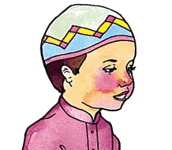
I AM A MUSLIM……..HAH!! HAH!! HAH!! THAT’S WHAT YOU THINK RIGHT??

Faasiq
TRUTH IS, I AM NOT. I DON’T PRAY OR FAST, JUST SAY THAT I AM A MUSLIM SO THAT PEOPLE THINK OF ME AS A GOOD PERSON!! HAH! HAH! HAH!!!!!
This is a person who disobeys Allah openly. He sins in public. A person who defies Allah in front of everyone is the worst kind of sinner and follows the way of Shaytan.

Allah says in the Holy Qur’an (Simplified meaning of Ayat 40, Surah al-Kahf):

“Allah said to the angels to bow down in front of Aadam, they all obeyed, except Shaitan. He was a jinn and a Faasiq, and did not obey the command of his Lord.”

I LOVE TO DO WHAT I LIKE IN PUBLIC. I DON’T HIDE IT. I DO IT WHERE EVERYBODY CAN SEE ME!!


THIS IS FUN!! HAH! HAH! HAH!

MUNAAFIQ IS A PERSON WHO SAYS HE IS A MUSLIM BUT IN HIS HEART HE DOES NOT FOLLOW ISLAM

FAASIQ IS A PERSON WHO DISOBEYS ALLAH OPENLY
Fiqh Chapter 04
BRIEF INTRODUCTION TO TAQLEED

In every sphere of life, we need advice of the experts in that field. Likewise, in the matter of Islamic laws, we must obey the rulings of the experts of that law.

A Mujtahid is an expert in the ruling of Islamic Laws. He studies the Qur'an and the Ahadeeth (sayings) of the Ma'sumeen (Ahlul Bayt) and gives Fatawa (plural of Fatwa: religious verdict)

The fatawa of our present Mujtahid can be found in a book called Tauzeehul masail or Islamic Laws.

Taqleed means obeying Islamic Laws according to the ruling of a Mujtahid.

Muqallid is a person who does Taqleed, that is, follows the orders of the Mujtahid.

Every Baligh male and female has to follow (WAJIB) the rules regarding Furoo-e-deen if s/he is not him/herself a mujtahid

You cannot do Taqlid of someone on the aspects of Usul-e-Din and follow him because this must come from your heart ^{e.g.} Believing in One God.

Upon becoming Baligh, you should make Niyyat (intention) that you will act or follow him in accordance with verdicts when ever the need arises.

BULOOGH

Boys become Baligh upon completionof their fifteenth lunar year (according to Islamic Calendar) OR for boys, other signs also there which will be taught in
higher classes

Girls become Baligh upon completion of their ninth lunar year (according to the Islamic calendar).

After that all Wajibaat become applicable upon them.

THE FIRST THING TO DO IS THE NIYYAT OF WHOSE MUQALLID YOU BECOME.

Your teachers will guide you about who are the current Marja’ (Those Mujtahid’s who are followed, whose taqleed is done by majority of people)

Fiqh Chapter 05
INTRODUCTION TO NAJASAAT

Najasaat means those things which are considered unclean by Shariat.

Najasaat are unclean by themselves and make other things unclean by contact. A thing becomes Najis (unclean) by coming into contact with another Najis thing, but only if either one or both the things are wet or moist.

Thus a dry Najasaat does not make another dry thing Najis.

The following things are Najis
Urine   |  | Stool |  |  | Blood  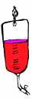 |  | Dead body   |  |  | Dog  
Pig   | Kafir |  |  | Liquor   |  |  |  | Fuqaa (mild beer)   |  |  | Semen  ♂

Toilet Etiquette
- When entering the toilet one should enter with the left foot first. 
Left foot
- It is Haraam to face the Qibla, or to have your back to Qibla, when sitting on the toilet. (If your toilet faces Qibla, then sit slightly sideways on it).

- After urinating, the part of the body concerned must be washed twice (better thrice) with water.
- It is makruh to urinate whilst standing. There are severe punishments after death due to this act.
- After relieving the bowels, the part of the body concerned may be cleaned with water.
Fiqh Chapter 06
WUDHU

Wudhu is a special way of washing that makes us spiritually clean. Wudhu is made up of washing the face and arms, and wiping the front of the head and upper part of the two feet.

Wudhu is Wajib [required] for:

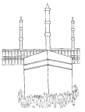

Wudhu is Mustahab [recommended] for:



Conditions Of Wudhu
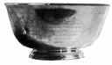


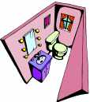
I am doing Wudhoo for the pleasure of Allah, Qurbatan Ilallah


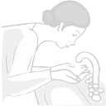

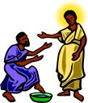

STEP-BY-STEP EXPLANATION OF HOW TO PERFORM WUDHU

Wudhu is divided into

WAJIB ACTIONS
MUSTAHAB ACTIONS

NIYYAT
WASH HANDS

WASH FACE

GARGLE

WASH ARMS
WASH NOSE

MASAH OF HEAD
MASAH OF FEET

THESE ACTIONS HAVE TO DE DONE, OTHERWISE WUDHU IS BATIL [WRONG]
IF YOU DO THESE ACTIONS YOU GET THAWAAB, BUT IF NOT DONE YOUR WUDHU IS SAHIH [RIGHT]

STEP – BY – STEP EXPLANATION OF HOW TO PERFORM WUDHU

While performing wudhu, it is Mustahab to recite Du’as during each action.

1. | Niyyat - | Wajib Action

The first action of wudhu is Niyyat i.e. you say what you are going to do and for whom. The Niyyat must be of Qurbatan ilallah.
I am doing Wudhu in obedience to Allah, Qurbatan Ilallah

2. | Washing your hands - | Mustahab Action

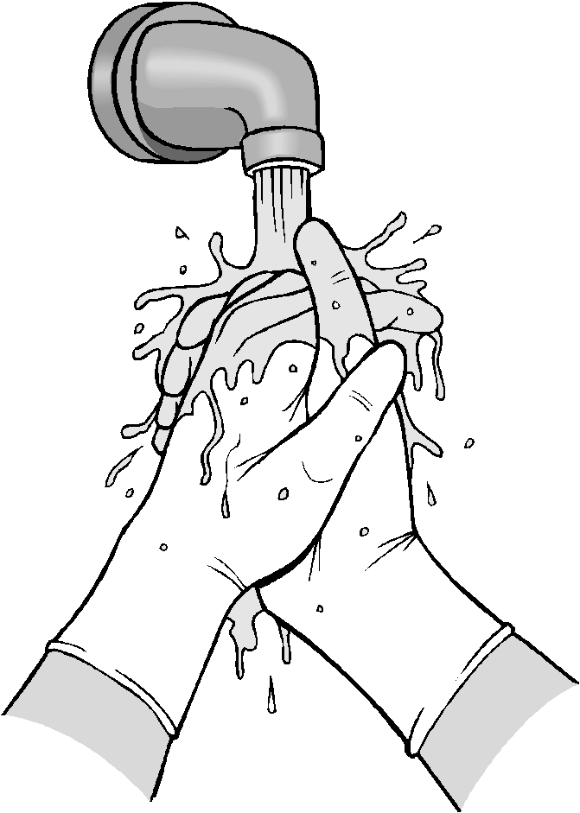
Wash your hands two times

3. | Gargling - | Mustahab Action
Oh Allah! Please help me speak the truth.

Gargle i.e. wash your mouth three times

4. | Washing your nose - | Sunnat Action
Oh Allah! Please help me to smell the fragrance of paradise.

Wash your nose [take water into the nostrils] three times

5. | Washing your face - | Wajib Action

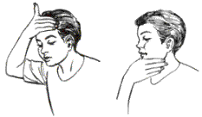
Oh Allah! Let my face shine on the day of judgement.

First get some water in your right hand and then pour it onto your forehead, where the hair grows.
You have to wash the whole length of your face, beginning from your forehead (where the hair grows) and ending at the bottom of the chin.
You have to wash the whole width of your face. You do this by stretching your hand out (from your thumb to your middle finger). To make sure that the whole width has been washed, you should pass your wet hand on either side of your face.
Washing of the face once is Wajib, two times is Mustahab, and three or more times is Haraam

6. | Washing your arms - | Wajib Action

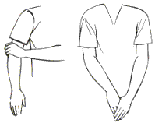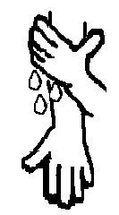
Oh Allah! Please give my a’amal in my right hand
Oh Allah! Please do not give my a’amal in my left hand

The washing of the arms is from the elbow to the fingertips. First the right arm is washed with the left hand, then the left arm is washed with the right hand. THE WASHING OF THE ARMS IS A LITTLE DIFFERENT FOR BOYS AND GIRLS.
BOYS - BETTER IF THE WATER IS POURED ABOVE THE BACK PART OF THE ELBOW.
GIRLS – BETTER IF THE WATER IS POURED ABOVE THE FRONT PART OF THE ELBOW.
Washing of the arms once is Wajib, two times is Mustahab, and three or more times is Haraam. In case of washing three times, if you use the same water for masah, then the wudhu will become void (batil)

7. | Masah of the head - | Wajib Action
Oh Allah! Please decrease the heat of the sun on the day of judgement.

8. | Masah of the feet - | Wajib Action
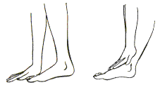
Oh Allah! Please help me pass pul – e – siraat with ease
This is done by wiping the wet three fingers of the right hand from the middle of the head up to the edge of the hair, without touching the forehead.

The water of the face and head should not join.

This is done once only.
This is done by wiping the wet fingers of the right hand over the upper part of the right foot from the tip of the toes to the ankle.

Then the same is done with the left hand for the left foot.

This is done once to each foot.
Things that make Wudhu Batil

- Going to the toilet; whether to pass urine or faeces.
- Passing wind from the rear. (stomach wind)
- Sleeping.
- Becoming unconscious
- etc.

Fiqh Chapter 07
ADHAN AND IQAMAH

ADHAN
The Call to Salaat

☺• ⬆ - (4 times)
Allah is the Greatest
           
  ⬆ ⬇ ⬇    - (2 times)
I bear witness there is no god but Allah.
          
   ⬆ ⬄ ⬅   - (2 times)
I bear witness Muhammad is the messenger of Allah
            
   ▪   - (2 times)
I bear witness Ali is the Wali of Allah.

 ▪  - (2 times)
Hasten to prayer.

 ▪  - (2 times)
Hasten to success.

◻  ▪  - (2 times)
Hasten to the best deed.

☺•  - (2 times)
Allah is the Greatest.

    - (2 times)
There is no god but Allah.

IQAMAH

The Recitation Just Before Salaat

☺• ⬆ - (2 times)
Allah is the Greatest

             ⬆ ⬇ ⬇    - (2 times)
I bear witness there is no god but Allah.

             ⬆ ⬄ ⬅   - (2 times)
I bear witness Muhammad is the messenger of Allah

               ▪   - (2 times)
I bear witness Ali is the Wali of Allah.

 ▪  - (2 times)
Hasten to prayer.

 ▪  - (2 times)
Hasten to success.

◻  ▪  - (2 times)
Hasten to the best deed.

   - (2 times)
Indeed the prayer has begun.

☺•  - (2 times)
Allah is the Greatest.

    - (1 time)
There is no god but Allah.

ADHAN AND IQAMAH COMPARED
ADHAN - call for Salaat |  | IQAMAH-call to start Salaat
X4 | ☺• ⬆ | X2 | ☺• ⬆

Allah is the greatest
X2 | ⬆ ⬇ ⬇    | X2 | ⬆ ⬇ ⬇   

I bear witness there is no God but Allah
X2 | ⬆ ⬄ ⬅   | X2 | ⬆ ⬄ ⬅  

I bear witness Muhammad is the messenger of Allah
X2 |   ▪   | X2 |   ▪  

I bear witness Ali is the Wali of Allah
X2 |  ▪  | X2 |  ▪ 

Hasten to prayer
X2 |  ▪  | X2 |  ▪ 

Hasten to success
X2 | ◻  ▪  | X2 | ◻  ▪ 

Hasten to the best deed
Not to be recited in Adhan |  | X2 |   

Indeed the Salaat has begun
X2 | ☺•  | X2 | ☺• 

Allah is the greatest
X2 | ⬆ ⬇ ⬇  | X1 | ⬆ ⬇ ⬇ 

There is no god but Allah
Conditions of Adhan and Iqamah

- It is Mustahab for every person that they should recite Adhan and Iqamah before offering their daily Wajib Salaat.
- They should be recited after the time of Salaat has set in, and not before.
- They should be recited in correct Arabic, with proper pronunciations. It should not be recited in a musical voice like singing - that makes it Batil.
- There should not be an unusual gap between sentences of Adhan and Iqamah.
- It is Mustahab that if a person hears Adhan or Iqamah recited by someone else, he himself should also utter, in a low voice, the part he happens to hear.
- It is Mustahab that while pronouncing Adhan a person should be standing with his face towards Qibla and should have performed Wudhu. He should place his hands on his ears and raise his voice. He should leave a short gap between the sentences and should not talk with anyone during the recital of Adhan.

Fiqh Chapter 08

PREPARATION FOR SALAAT

Before you start your Salaat you must prepare yourself. This is known as
MUQADDIMATUS-SALAAT.
There is mnemonic checklist to remember this. It goes QWPTC (pronounced kweepts) and stands for:
Q | = | QIBLAH
W | = | WUDHOO
P | = | PLACE
T | = | TIME
C | = | CLOTHES

Before Starting Salaat, We Must Prepare Ourselves In The Following Manner
OUR BODY MUST BE CLEAN
TAHARAT – WUDHOO MUST BE PERFORMED
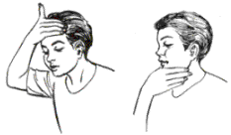

CLOTHES OF SALAAH MUST BE TAHIR
QIBLAH – WE MUST KNOW IN WHICH DIRECTION TO FACE
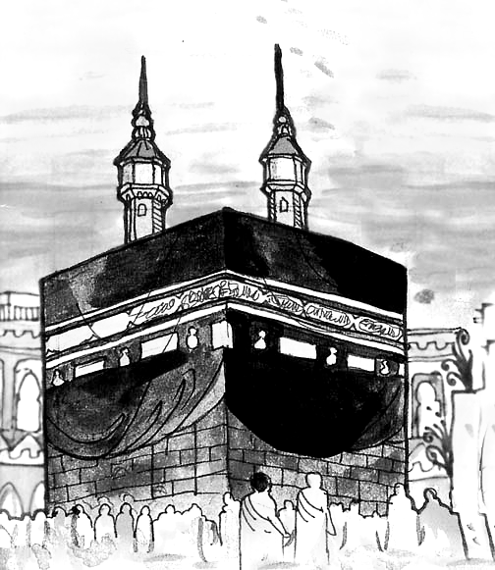

TIME OF SALAAH – WE MUST KNOW THE RIGHT TIME FOR OFFERING OUR SALAAH
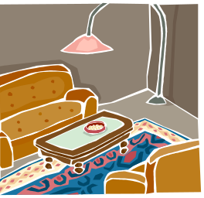
PLACE OF PRAYER MUST BE PAAK AND NOT GHASBI

Fiqh Chapter 09
THE CLOTHES FOR PRAYER

The following condition must be observed in the clothes for Salaat
- The clothes must be TAHIR.

- The clothes must be MUBAH.
- Mubah means that the clothes must be lawfully yours. Either you are the owner or you have permission to use it.
- A dress bought from money from which Zakaat and Khums has not been paid, is regarded as GHASBI. Ghasbi is the opposite of Mubah.
So a prayer offered in such clothing is Batil.
- The clothes must not be made from any part of a Haraam animal. Therefore, for example a coat made of Lion’s hair is not allowed to be worn in Salaat.
- If the clothes are made from any part of a Halaal animal which was slaughtered in the Islamic way, then there is no problem with it at all.
- If the clothes are made from an Halaal animal which died by itself or was slaughtered in an un-Islamic way then there are two rules:

- If the clothes are made from those parts of such an animal which have feeling during lifetime (like, fat, meat, skin, hide), then such clothing are not allowed in Salaat.
- If the clothes are made from those parts of such an animal which have no feeling during lifetime (like, hair, horn, teeth, bone, nails), then such clothing are allowed in Salaat.
FOR MEN ONLY
- The clothes should not be made of gold (whether pure or mixed). Wearing any gold is Haraam for men at all times, not only during Salaat.
- The clothes should not be made of pure silk. Wearing pure silk is Haraam for men at all times, not only during Salaat.

For a female, it is required to cover whole body except face, hands upto wrist and feet upto ankles
For male, it is required to cover the private parts, but better to cover from the navel (bellybutton) to at the least below the knees.
Fiqh Chapter 10
THE PLACE OF SALAAT

Islam teaches us that we have to respect the things which belong to others, and that we should not use them without the owner’s permission.

The above rule has to be remembered at all times especially when you want to perform your Salaat.

The place where you intend to pray must either be yours or you must have the permission of the owner to use it

If the place does not belong to you and you do not have the permission of the owner to use it then your Salaat is Batil.

Of course, if you go to Masjid (mosque), you do not need anyone’s permission to perform your Salaat in there.

WHY? Because……
MASJID IS THE HOUSE OF ALLAH,
IT IS BUILT FOR PRAYING TO ALLAH

Also remember that Allah wants us to pray in a clean place. Therefore always keep your room clean and Tahir. If you have a musalla in your room, always fold it after praying and keep it in a place where it will remain Tahir and clean.

The following conditions must be observed for the Place of Salaat

- Salaat can only be offered in someone's place with their permission. (Mubah)
- The place where you perform your Sajdah must be Tahir. Where you stand or sit while performing Salaat can be Najis, as long as there is no possibility that this Najasat will effect your body or clothes.
- You cannot offer your Salaat in a place where you are not sure you will be able to complete your Salaat or that there is a possibility of danger to your life, for example on a busy road in the rush hour.
- The place where you pray must not be unstable, like on a bed or a couch.
- There should be enough space to stand and perform Rukuu and Sajdah properly.
- If women and men are praying in the same room, then the women must stand behind the men. The minimum difference should be that her place of Sajdah be at least in line with his thighs during Sajdah. It is better that there be a curtain or wall in between.
- The place where the head is kept for Sajdah must not be 4 fingers (joint together) above or below the place where the knees and toes are put.
Fiqh Chapter 11
THE TIME OF SALAAT (Fazilat and Qadha)

It is better to pray in the time of Fazilat, when the prayers are rewarded
with more Thawab.

By regular offering of Salaat at its fixed timings, the spirit of punctuality is developed.


When the time of a Salaat ends, it becomes Qadha. If you have not prayed your Salaat before it becomes Qadha, you will then pray with the Niyyat of Qadha (rather than ‘ada’)

THERE ARE SEVERE PUNISHMENTS AND DISADVANTAGES OF DELAYING THE WAJIB SALAAT, MAKING THEM QADHA OR MISSING THEM COMPLETELY.

NAME OF SALAAT | START TIME | QADHA TIME
FAJR (Subh) | Subh-e-Sadiq | SUNRISE
DHUHR | Zawal-e-Aftab | SUNSET
ASR | After DHUHR prayer | SUNSET
MAGHRIB | Maghrib-e-Sharai | MIDNIGHT
ISHA | After MAGHRIB prayer | MIDNIGHT

Explanation
- Subh-e-Sadiq: The last part of night, in which a white line starts appearing on the sky, from east, known as Subhe Kazib (False Dawn). After a while, this line starts spreading on both sides, known as Subhe Sadiq (True Dawn).
- Zawal-e-Aftab: The sun after extending from east reaches mid sky. Now when it starts moving further towards west, this time is known as Zawal-e-Aftab
- Maghrib e Sharai: After the sun sets, a red cover starts extending in the sky. When this reddishness reaches mid sky, and starts extending towards west, this is known as Maghrib-e-Sharai. It is recommended not to start Maghrib prayers before this

Fiqh Chapter 12

INTRODUCTION TO SALAAT (NAMAAZ)

Salaat (prayer) is Wajib on a Muslim five times a day. The Salaat is wajib on those who have become ‘BALIGH’.

Boys become ‘Baligh’, at the latest, by the age of 15 and girls become ‘Baligh’ at the age of 9.

Salaat is one of the main pillars of Islam. It is the first and foremost duty of every Muslim. In the Holy Qur’an Allah has mentioned it again and again in more than 80 places. Allah has given more importance to Salaat than any other act of worship. Salaat keeps us away from evil things and helps us live a clean and pure life.

How many kinds of Salaat are there?

The following Prayers are Wajib

1. The five daily Prayers
FAJR 2 RAKAATS
ZUHR 4 RAKAATS
ASR 4 RAKAATS
MAGHRIB 3 RAKAATS
ISHA 4 RAKAATS
TOTAL 17 RAKAATS WAJIB EVERYDAY

2. The Prayer of Aayat - Prayer recited when an eclipse takes place or an earthquake or any other event which causes fear in people.


3. The Prayer of Mayyit - Prayer recited before a dead body before it is buried.

4. The Prayer after completing Wajib Tawaf of Ka’aba

5. Deceased father’s qaza salat which is Wajib on elder son

6. Those salaats which become Wajib due to ijara (rent), mannat, qasam and/or ahed

What is wajib in Salaat?

As you already know, Salaat is made up of different parts. In this section, you will come to know the list of the Wajib acts of Salaat.
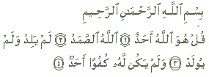
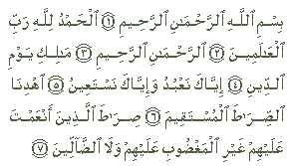
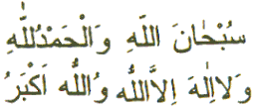
There are 10 things which are wajib in the Salaat:
NIYYAT  Qurbatan Ilallah…    The intention to perform a particular Salaat, ‘Qurbatan ilallah’ | TAKBIRATUL EHRAM    The first ‘Allahu Akbar’ in Salaat.
QIYAM  Standing for recitation | QIRA’AT  Recitations during the Qiyam
RUKU  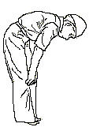  Bending from the waist | TWO SAJDAHS  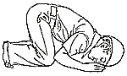  Prostration with knees, palms and toes touching the ground
DHIKR  Subhana Rabbi………  ……………………….  The recitations during Ruku and Sajdah | TASHAHHUD    The recitation while sitting down after the two sajdahs in the second and final rakaats of salaat
SALAAM  The final recitation of Salaat while sitting down | TARTIB AND MUWALAT  Tartib means to pray in the order prescribed by the Shariah  Muwalat means to pray without interruption or gap

The Salaat is like a building which is made up of many parts: Some of these parts form the foundation of the building, while others are just built upon the foundation. If the foundation gives way, then the whole building will collapse.

In the same way, the wajib acts of Salaat are divided into two categories: Rukn and Ghayr Rukn.

Rukn means those parts of the Salaat which are its foundation.

Ghayr Rukn means these parts of the Salaat which are not considered as its foundation.
Fiqh Chapter 13
QIBLAH - KA'ABA IS THE QIBLAH

WHEN YOU HAVE DONE YOUR WUDHU AND ARE READY TO PRAY, WHAT DIRECTION SHOULD YOU FACE?

You should face the direction of the Ka'aba, which is in Makka.

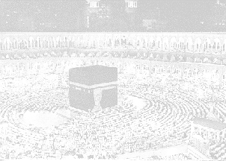
BUT WHY SHOULD WE FACE KA'ABA?
Allah has said that:
- all the Muslims are brothers and sisters.
- all are the same in their relationship to Allah.
- all believe in ONE and the same Allah.

So, Allah has commanded that, all the Muslims should face in one direction at the time of prayers and Allah has selected the Ka’aba, as the direction for prayers.

Just imagine how funny it would look if four Muslims in a single room were to pray facing four different directions!

So, facing the direction of Ka'aba is Wajib for all Muslims.

It is also a sign of Muslim UNITY and BROTHERHOOD.



S SE

THE KA'ABA IS THE HOUSE OF ALLAH

THE KA'ABA IS OUR QIBLAH

QIBLAH IS THE DIRECTION WE FACE IN SALAAT

FINDING THE QIBLAH

The mosque that surrounds the Holy Ka’aba is called Masjidul Haram. Because the mosque circles the Ka’aba all the way around, if you are outside you just have to face the mosque and you will automatically be facing Qiblah.

It is Wajib to face the Qiblah while praying all the Wajib Prayers

The Three Ways Of Finding Qiblah
- any convincing means of knowledge
- mihrab of a Mosque
- grave of a Muslim


- Any Convincing Means Of Knowledge

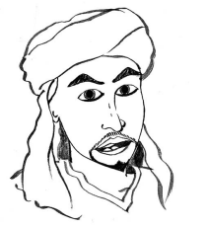
This means that something or
someone makes you sure that
Qiblah is in a certain direction.
This would include asking a
trustworthy person or using a compass.

- Mihrab Of A Mosque

Mihrab is a place in the mosque specially

built for the person who leads the prayers.
It is like an arch that has been carved into
the wall and is also built in the direction
of the Qiblah.

3. Grave Of A Muslim

When Muslims dies, they are laid down Qiblah
in their grave on their right side, with
HEAD
their face towards the Qiblah. If you
know which side the dead person’s head
is, then you can easily know the direction
of the Qiblah.

Uncertainty Of Qiblah
Ali and Zainab at a school trip abroad

DAY 1
I have no idea at all about which direction to pray and my Namaaz is becoming Qadha! Help! What should I do?


Don’t panic! Just pray in any direction. However, for your next Namaaz, if there is enough time, it is better to pray in all 4 directions.

DAY 2

I have been looking around and I am now sure Qiblah is either towards the North or the South. What should I do?
Then you must pray twice, facing both directions.

DAY 3

I am still not sure which direction Qiblah is but I have a strong feeling that it is North East, so now what should I do?

Well, if you have a strong feeling about it, then you should pray facing that direction.

REMEMBER
If you have no idea which direction to pray in then
pray in any direction if there isn’t enough time.
better to pray in all 4 directions if there is enough time.

If you think it is one of two directions
- you will pray in both directions.

If you do not know the Qiblah & there is no way of finding out
you should pray facing the direction you have a strong feeling about.

.
Fiqh Chapter 14
FUROO-E-DEEN - PART 1

Furoo-e-deen are the branches of religion. They are the acts of worship that we do when we have understood the Usool-e-deen. There are 10 Furoo-e-deen altogether.

- Salaat (Daily Prayers)
Allah says in the Holy Qur’an: “Seek assistance through patience and Salaat… “(2:45)
There are 17 Raka’ats in the Daily Prayers:
Fajr has 2;
Zuhr has 4;
‘Asr has 4;
Maghrib has 3 &
‘Isha has 4.
- Sawm (Fasting in the Month of Ramadhan)
Allah says in the Holy Qur’an: “O you who believe, Sawm is prescribed for you… so that you may become pious. “(2:183)
Fasting is Wajib for every Muslim for the whole lunar month of Ramadhan every year. It starts at Subhe Sadiq and ends at the time of Maghrib.
- Haj (Pilgrimage to Makka)
Allah says in the Holy Qur’an: “And go for Haj for the pleasure of Allah…” (2:196)
Every Muslim has to go to Makka once in their life-time for Pilgrimage when they can afford to go.
- Zakaat

Allah says in the Holy Qur’an: “And surely those who believe and do good deeds and keep up Salaat and pay Zakaat shall have their reward with their Lord…” (2:277)
Zakaat is a charity that is paid on certain items and is given to needy Shia Muslims.
- Khums (Islamic Tax)
Allah says in the Holy Qur’an: “And from everything you gain, Khums is for Allah and His Prophet…”(8:41)
Everyone has to pay 1/5th of their year's savings. The money is divided between Saadaat (descendants of the Prophet (S) and our 12th Imam (A); during his Ghaybat it is given to the Mujtahid.
Fiqh Chapter 15

FUROO-E-DEEN - PART 2

- Jihad (To Fight for Allah)
Allah says in the Holy Qur’an: O Prophet! Encourage the believers to go for Jihad. If there are twenty patient ones amongst you, you will overcome 200… (8:65)
Jihad means fighting in the path of Allah in response to the call from the Prophet (S) or the Imam (A) of the time. It is not just with a weapon, it can be with your writing and speech also.
- Amr-bil-Ma'roof (Guide others to the Good)
- Nahi-‘anil-Munkar (Stop others from doing evil)
Allah says in the Holy Qur’an: And among you there should be a group who invite to do good and do Amr-bil-Ma’roof and Nahi-‘anil-Munkar. These will be the successful people. (3:104)
If we see someone who is not doing a good action, we should encourage him to do it. This is called Amr-bil-Ma’roof.
If we see someone doing a bad action, we should try to stop him from doing it. This is called Nahi-‘anil-Munkar.

- Tawalla (To be the friends of the friends of Ma’sumeen (A)
The Prophet (S) has said: “Whoever pleases my family, has pleased me, and whoever annoys them, has annoyed me.
Tawalla means to love and follow the teachings of the 14 Ma’sumeen (A) and to keep friends with their followers.
- Tabarra (To be the enemies of the enemies of Ma’sumeen (A)

FUROO E DEEN ARE BRANCHES OF RELIGION. THERE ARE 10.

THESE ARE SALAAT, SAWM, HAJ, ZAKAAT, KHUMS, JIHAD, AMR BIL MA’ROOF, NAHI ‘ANIL MUNKAR, TAWALLA & TABARRA

Fiqh Chapter 16

Practical Wuzu - Assessment

For M01

- Washing
  - Washes hands
  - Rinses mouth
  - Rinses nose
  - Washes face from top to bottom
  - Washes face – From beginning of forehead to end of chin
  - Washes face – Full width
  - Washes hands from elbow to fingers completely
  - Washes hands from elbow to fingers direction
  - Washes right hand first, then left hand
- Wiping
  - Wipes head with correct side of fingers
  - Wipes head from behind to front
  - Wipes feet from fingertips to mound
  - Wipes right feet first, then left hand
  - Wipes from the water which remains while washing left hand
  - Wipes while water is not dired
- General
  - Not much gap between different actions
  - Does not waste water

Fiqh Chapter 17
Practical Namaz – Assessment

Rak’at 1- Actions

Niyyat
  - Does niyyat before starting namaz
  - Says and understand Qurbatan Ilallah

Takbiratul Ahram
  - Says correct words
  - Straight, and calm

Qir’at
  - Recites Suratul Hamd
  - Recites Suratul Ikhlas
  - Straight, and calm
  - No rhythmic movement

Ruku’
  - Waits for a while, straight, before going to Ruku
  - Starts zikr after getting calm
  - Recites zikr
  - After reciting zikr, waits for a while, then stands up

Samiallah
  - Recites ‘Samiallah’
  - Recites ‘Samiallah’ standing straight and calm
  - After ‘Samiallah’, waits for a while, then goes to sajda

Sajda
  - Seven parts on the floor
  - Starts zikr only after becoming calm
  - Recites zikr
  - Stays calm during zikr
  - Correct part of thumb on the floor
  - After reciting zikr, waits for a while, then sits

Astaghfirullah
  - Recites ‘Astaghfirullah’
  - Recites ‘Astaghfirullah’ sitting straight and calm
  - After ‘Astaghfirullah’ , waits for a while, then goes to sajda

Sajda No. 2
  - Seven parts on the floor
  - Starts zikr only after becoming calm
  - Recites zikr
  - Stays calm during zikr
  - Correct part of thumb on the floor
  - After reciting zikr, waits for a while, sits for a while, and then stand up for second rak’at
  - Recites Bihawl

Rak’at 2

Qir’at
  - Recites Suratul Hamd
  - Recites Suratul Ikhlas
  - Straight, and calm
  - No rhythmic movement

Qunoot
  - Raises hand
  - Recites Qunoot

Ruku’
  - Waits for a while, straight, before going to Ruku
  - Starts zikr after getting calm
  - Recites zikr
  - After reciting zikr, waits for a while, then stands up

Samiallah
  - Recites ‘Samiallah’
  - Recites ‘Samiallah’ standing straight and calm
  - After ‘Samiallah’, waits for a while, then goes to sajda

Sajda
  - Seven parts on the floor
  - Starts zikr only after becoming calm
  - Recites zikr
  - Stays calm during zikr
  - Correct part of thumb on the floor
  - After reciting zikr, waits for a while, then sits

Astaghfirullah
  - Recites ‘Astaghfirullah’
  - Recites ‘Astaghfirullah’ sitting straight and calm
  - After ‘Astaghfirullah’ , waits for a while, then goes to sajda

Sajda No. 2
  - Seven parts on the floor
  - Starts zikr only after becoming calm
  - Recites zikr
  - Stays calm during zikr
  - Correct part of thumb on the floor
  - After reciting zikr, waits for a while, then sits

Tashahhud
  - Recite tashahhud
  - Recited tashahhud sitting straight and calm

Salam
  - Recite all 3 salams
  - Recited salam sitting straight and calm

Closing
  - Recite Allahu Akbar three times

Recitation Assessment

Note for teacher: At this age, the student should be able to recite correctly, with accurate talaffuz, and with correct makharij, and also take care of waqf ba harkat and wisl ba sukun

  - Takbiratul Ahram
  - Suratul Hamd
  - Suratul Ikhlas
  - Zikr-e-Ruku’
  - Samiallah
  - Zikr-e-Sajda
  - Astaghfir
  - Bihawl
  - Qunoot
  - Tashahhud
  - Salam 1
  - Salam 2
  - Salam 3

Appendix A

Wuzu – Method

- Before I go to the wash basin I roll up my sleeves and take off my socks. If I am wearing a watch, ring or glasses, I take them off too. If the floor is najis, I wear slippers
- At the water tap I first thank Allah for having made the water available and so clean.
⬇⬆⬇  All praise is for Allah
- I do Niyyat. I am doing Wuzu Qurbatan Ilallah ⬇⬆ ⬇ ⬅ 
In obedience to Allah and to get closer to Him

- I wash my hands twice.
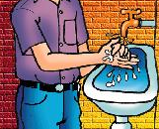

- I rinse my mouth three times


- I rinse my nose three times.

- I take some water in my right hand and pour it on my forehead from where the hair grows. I then wipe my face with my hand stretching from thumb to the middle finger. I always wipe downwards from the forehead to the chin. Then I wipe on either side of my face downwards. I make sure that water reaches every part of my face.
- I take some water in my left hand and pour it just above the right elbow back and front. Then I wipe my right arm with my left hand from the elbow to the fingertips making sure that the water reaches everywhere.

- Then I take some water in my right hand and wash my left arm in the same way as I washed my right arm.

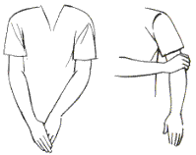

- With three fingers of my right hand I wipe the middle part of my head with my finger tips making sure that I do not touch my forehead.

- Then I wipe my right foot with my right hand from the toes to the mound at the joint of the foot and leg. In the same way I wipe my left foot with my left hand

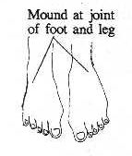

Appendix B

Namaz – Method (Fajr Namaz)

Following is the method of Fajr Namaz

1. Say niyyat “I am praying 2 rak’ats of Fajr Prayers, Qur-batan Ilallah (for Allah)”
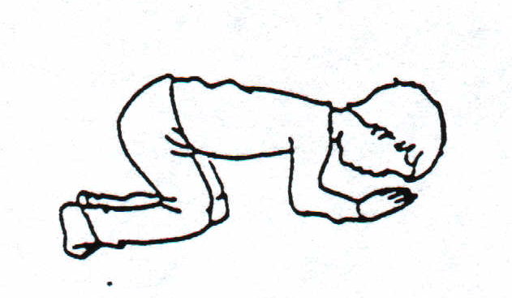
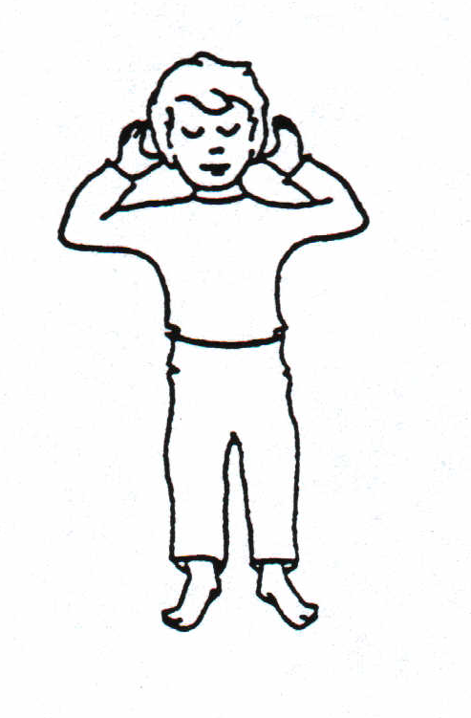
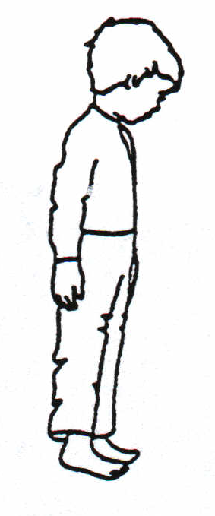
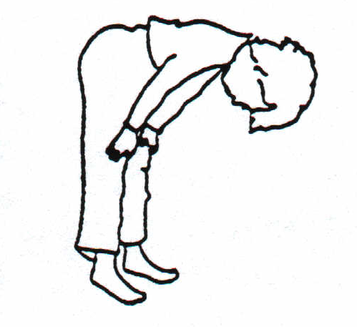
2. Raise hands up to ear and say “Allahu Akbar”
☺• ⬆ 

3. Stand still for qiyam and looking at the ground (mohr, turbat). Recite Suratul Fatiha and Sura Ikhlas (or any other sura from the Qur’an) (Refer to Quran section of this manual for these surahs)

4. Say “Allahu Akbar” and then go to ruku’. Looking between your feet, recite: “Sub-hana rabbiyal ‘azeemi wa biham-dih”
  ◻ ⇨ ☺

5. Stand up from ruku’ and recite: “Sami’allahu liman hamidah” 
   

6. Say “Allahu Akbar” and then go to sajda making sure that the seven parts of your body touch the ground – Forehead, two palms, two knees, and the two tips of toes. In sajda, recite: “Sub-hana rabbiyal a’laa wa bihamdi”
  ▪ ⇨ ☺

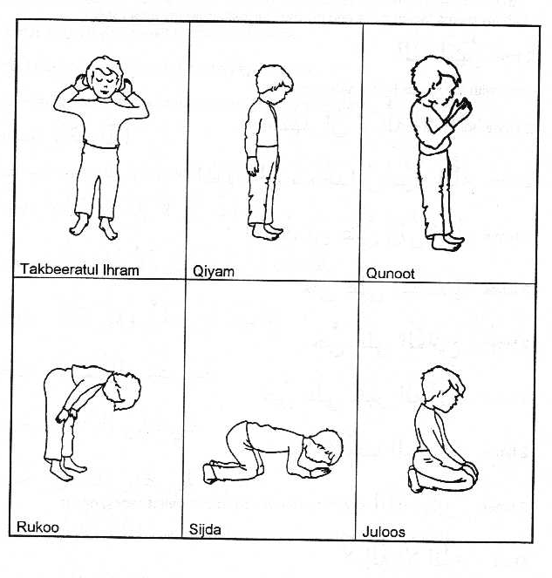
7. Sit up from sajda and looking at your lap, say: “Astaghfirullaha rabbi wa atubu ilayh
 ☹  ⇨  

8. Go back to sajda once more and recite: “Sub-hana rabbiyal a’laa wa bihamdi
  ▪ ⇨ ☺

9. Sit up from sajda and recite: “Allahu Akbar”
☺• 

10. Now stand up for qiyam of the second rak’at. Whilst in the process of standing up, recite: “Bihawlillahi wa quwwatihi aqumu wa aq’ud”
◻      
11. Stand for qiyam and recite Suratul Fatiha and Suratul Ikhlas.

12. Raise hands for qunoot and recite: “Rabbanaa aatinaa fid dunya ‘hasanataw wa fil aakhirati ‘hasanataw waqinaa ‘azaaban naar.
    
    
☹▪         

13. Then do ruku’ and the two sajdas just like the first rak’at.

14. Sit after the second sajda, say Takbeer “Allahu Akbar” and then recite Tashahhud: “Ash hadu al laa ilaaha illallahu wahdahu laa sharika lah, wa ash hadu anna Muhammadan ‘abduhu wa rasuluh, Allahumma salli ‘alaa Muhammadiw wa aali Muhammad - 

       →  
  ☺▪    
    ▪  

15. Then say salaam: “Assalamu ‘alayka ayyuhan nabiyyu wa rahmatullahi wa barakatuh; Assalamu ‘alaynaa wa ‘alaa ibadillahis saaliheen; Assalamu ‘alaykum wa rahmatullahi wa barakatuh -
•     ☺  ▪ 
  ☺▪ ▪  ▪ 
 •     ▪  

16. Then three times (raising your hands each time) say Allahu Akbar:
  ☺• ⬆

