History Chapter 1
THE AHLUL BAYT – TITLES:

The Ahlul Bayt have many titles given to them because of the special qualities they have.
The most common title of each Imam is:

IMAM | TITLE | MEANING
1st | Ameerul Mu'mineen | Commander of the Faithful
2nd | Al-Mujtaba | The Chosen One
3rd | Sayyedush Shuhada | King of Martyrs
4th | Zainul Abideen | Best of Worshippers
5th | Al-Baqir | The Giver of knowledge
6th | As-Sadiq | The Truthful One
7th | Al-Kadhim | The Patient one
8th | Ar-Ridha | The Accepted One
9th | At-Taqi | The Pious One
10th | An-Naqi | The Pure One
11th | Al-Askari | He who lived at ‘Askar’, a place
12th | Al-Mahdi | One who guides

WORKSHEET

Unscramble the following words to make the titles of the Ahlul Bayt:






NIQ ANA
HA MUM SAYS YES HUHU
History Chapter 2
BIBI KHADIJA:

Bibi Khadija was the first wife of Prophet Muhammad (s.a.w.), and the mother of Bibi Fatimah (a.s.).


Her father was a wealthy trader.
When he died, Bibi Khadija continued his business. Soon, she was the richest trader in Makka.

Prophet Muhammad (s.a.w.) worked for Bibi Khadija, but she was impressed with him and soon they were married.
They soon had two sons, Qasim and Abdullah. But, both boys died while still very young. This made the Holy Prophet very sad, and when his cousin Imam Ali (a.s.) was born, he brought him up in his house as his own son.

The Holy Prophet (s.a.w.) and Bibi Khadija then had a daughter, Bibi Fatimah (a.s.).

Prophet Muhammad (s.a.w.) used to spend a lot of time in a cave on Mount Hira near Makka. There, he would think about Allah and wonder at His creations.


Sometimes he would stay on Hira for many days at a time.
Bibi Khadija would regularly visit him, bringing food and water and making sure he was comfortable.
When Prophet Muhammad (s.a.w.) was finally commanded by Allah to begin teaching Islam, Bibi Khadija was the first woman to accept his message and become a Muslim. She gave all her money to help spread Islam.

Bibi Khadija was married to the Holy Prophet (s.a.w.) for many years before she died. She is buried in Makka.
The Prophet’s uncle, Abu Talib also died in this year that has been named the “Year of Grief” or “Aamul Huzn” in Arabic.
While Bibi Khadija was alive, the Holy Prophet (s.a.w.) did not marry another woman, and later said that she was the best of his wives.
He also said that she was one of the 4 perfect women who had ever lived. The other three are:
- Bibi Asiya (wife of Firaun),
- Bibi Maryam (mother of Prophet Isa), and
- Bibi Fatimah (a.s.).

WORKSHEET
Crossword on Bibi Khadija:

1 2 3

5
4

6

ACROSS
- The name of the daughter of Bibi Khadija.
- The name of the wife of the Holy Prophet (s.a.w.) who is known as one of the four perfect women in the world.
- The name of the year in which Bibi Khadija died.
DOWN
- The burial place of Bibi Khadija.
- The name of the mountain where the Holy Prophet often went to meditate.
- The name of one of her sons who died while still young.
History Chapter 3
BIBI FATIMAH (a.s.):
Once, when Imam Hasan (a.s.) and Imam Husain (a.s.) were children they both fell ill. Their parents, Imam Ali (a.s.) and Bibi Fatimah (a.s.), made a nazr that they would fast three days if their children became well.

Nazr is a promise that you make to Allah to do something extra for His pleasure if your wish comes true.

Both Imam children recovered from their illness very soon. Their parents decided to fast the next day. The young Imams (a.s.) also decided to fast, as well as their maid Bibi Fizza.

On the first day of the fasting, Bibi Fatimah (a.s.) prepared some bread to break their fast with.


In the evening, they all prayed then sat down to break their fast. Just as they were about to eat their bread, a poor man knocked at the door and asked for something to eat.

They all gave their bread to the beggar, and broke their fast with water only.

The next day, they fasted for a second time. Again, Bibi Fatimah (a.s.) made bread for their Iftar.


This time, as they were about to break their fast, an orphan came to their door asking for food.
Although Bibi Fatimah (a.s.) and her family had not eaten for two days, they all happily gave their loaf of bread to the orphan and again slept without any food.



On the third day of their fasting, as they sat down to break their fast, a prisoner knocked at the door asking for food.
Without hesitating, they again gave away their bread.


Allah revealed Sura Ad-Dahr in the Holy Qur'an, in praise of the sacrifice made by this holy family.

Moral: Always think of others before yourself. It is not how much you give but the intention with which you give.

WORKSHEET
What was the nazr the family kept and why did they make this nazr?

Who did they give their food to on each of the three days?

What was the sacrifice that this family made for which a Surah of the Holy Qur’an was revealed and what was the name of this Surah?
History Chapter 4
THE FIVE EIDS – INTRODUCTION:

Eid means an event which happens again and again. In Islam, we celebrate Eid as the happy festival which occurs every year.
In Sura Al Maidah , Prophet Isa asked Allah for food from Heaven because his followers wanted a miracle to increase their faith, and to always celebrate the occasion with joy.
We are lucky that we have five types of Eids in a year:
- Eid ul-Juma’
- Eid ul-Haj
- Eid ul-Fitr
- Eid-e-Gadheer
- Eid-e-Mubahila

WORKSHEET
Write in each cake the 5 Eids that we celebrate each year:



What does the word Eid mean?
The word Eid means ____________________________________
History Chapter 5
JUM’A (Friday):
Juma’ means Friday, and for all Muslims it is a very religious day.
The Holy Prophet (s.a.w.) has said that prayers and worship on Juma’ are many times better than any other day.

In the Islamic calendar, the night comes before the day. So, Friday begins at the time of Maghrib Salaat on Thursday.
There are certain A’amaal recommended for Juma’.
For the night of Juma’ (Thursday night):
Recite Sura Fatiha for those who have gone back to Allah
Recite Suratul Yasiin & Dua Kumail




For the day of Juma’ (Friday):
Do ghusl for Juma’
Cut your nails, wear nice clothes and apply perfume
Visit the graves of our loved ones
Gather in mosque and pray Salaat together





WORKSHEET

What day is Jum’a?
The Day of Jum’a is: ___________________________

On one page write all the A’amal you can do on the night of Jum’a and on the other page write all the A’amaal you can do on the day of Jum’a:


Night of Juma’ Day of Juma’

History Chapter 6
EID-UL-HAJ:
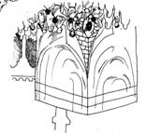
Eid ul-Haj is also known as Eid ul-Ad-ha (Eid of Sacrifice).

It takes place on the 10th of Zilhaj (Dhul-Hijja), and marks the end of Haj of Muslims to Makka.
This Eid honours the sacrifice of Prophet Ismail by his father, Prophet Ibrahim.

One day, Prophet Ibrahim dreamt that he was sacrificing his young son, Prophet Ismail. This day is called Yawme Tarwiyah which means, the Day of the First Dream.
Allah’s commands


Prophet Ibrahim often received Allah's commands in his dreams, but because he was being asked to actually kill his son, he wondered whether it was real.
He had the same dream the next day, and was now sure it was a true command. So, the 9th of Zilhaj is known as Yawme Arafaat, which means the Day of Knowledge

So, Prophet Ibrahim took his son into the desert.



On the way, Shaitan, disguised as an old man, tried to convince Prophet Ibrahim that he was making a terrible mistake in killing his son.

Three times Shaitan came, and each time Prophet Ibrahim made him go away by throwing seven small stones at him.

When they reached Mina, Prophet Ibrahim laid his son on the ground and took a knife.


Prophet Ismail saw how upset his father was, and asked him to blindfold himself so that he would not have to see his son die.
Prophet Ibrahim did as his son requested, and then cut the throat of his son.

But when he removed the blindfold, he was surprised to see that he had slaughtered a male sheep instead, and that his son was standing safe beside him.

Allah was so pleased with Prophet Ibrahim that he has made this sacrifice of a sheep wajib for Muslims as the last stage of Haj.
WORKSHEET
Crossword on Eid ul-Haj.
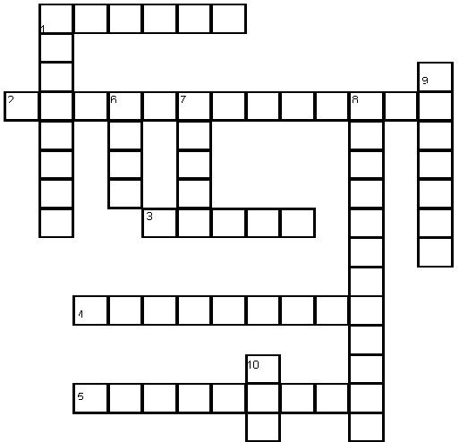

ACROSS
- The Prophet who was taken to be sacrificed on Eid ul-haj.
- The day of the first dream - in Arabic.
- What was found sacrificed in place of the Prophet.
- The name of the month in which Eid ul-haj occurs.
- The other name given to Eid ul-haj.
DOWN
- The father of the Prophet who was taken to be sacrificed.
- The place where the sacrifice took place
- Which day in the month does Eid ul-haj occur
- The day of Knowledge - in Arabic
- Who tried to mislead the Prophet on his way to sacrifice.
- What does this Eid mark the end of?
History Chapter 7
EID-UL-FITR:

Eid ul-Fitr is the first day after the Holy month of Ramadhan. It is on the 1st of Shawwaal.
Fitr means to break, and it marks the end of the fasting period.

It is a happy occasion because:
During Ramadhan we are in the habit of committing few or no sins
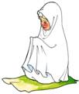

By fasting in Ramadhan, we have shown our obedience to Allah
Through our prayers in Ramadhan, Allah may have forgiven our sins
Allah has made a Wajib charity of Zakat ul-Fitr for every family at the end of Ramadhan. This charity helps poor people who do not have the money to feed themselves.

WORKSHEET


Write in each organ what you should NOT do with it, especially while fasting.




History Chapter 8
EID-E-GHADEER:
On the 18th of Zilhaj , Allah commanded Prophet Muhammad (s.a.w.) in the Qur’an to stop at a place called Ghadeer-e-Khum (the pond of Khum).

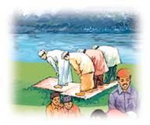
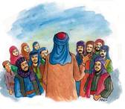
A friend of the Prophet called all the people to gather around.
The Holy Prophet (s.a.w.) led the Salaat.

Then, he stood so that all the people could see him. He told everyone that when he died, he would leave behind two special things:
the Book of Allah (the Qur’an)
the Ahlul Bayt (his family)


BIBI FATIMAH & 12 IMAMS (a.s.)

The Prophet (s.a.w.) explained that if the people follow BOTH the Qur’an AND the Ahlul Bayt, Allah will always be happy with them.
But if the people follow only the Qur’an, and don’t listen to the Ahlul Bayt, then Allah will NOT be happy with them.

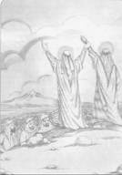
Then Prophet Muhammad (s.a.w.) held up Imam Ali (a.s.) hand, showing him to all the people, and said whoever considered the Prophet (s.a.w.) their leader must also consider Imam Ali (a.s.) their leader.

Then, he prayed to Allah to love those people who love Imam Ali (a.s.), and hate those who do not love him.
Allah then said that the religion of Islam had been completed that day.
This day is known as Eid-e-Ghadeer.

WORKSHEET
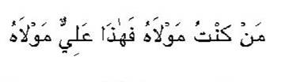
Write the meaning of the following ayat, then learn it.

It means:

Write what 2 things the Holy Prophet (s.a.w.) said he was leaving behind.

History Chapter 9
EID-E-MUBAHILA:

The Holy Prophet (s.a.w.) had sent letters to many different countries inviting them to Islam. One letter was sent to the Christians of Najran.
The Christians wanted to meet the Holy Prophet (s.a.w.)


When they arrived in Madina, the Holy Prophet (s.a.w.) was sad to see them dressed in silk and gold, and he ignored them.
Imam Ali (a.s.) asked them to change into simple clothes, and the Holy Prophet (s.a.w.) was then happy to see them.

They talked, but the Christians would not listen to the Prophet (s.a.w.).
They believed in Prophet Isa as the son of God, because he had no father.
Allah sent down a verse from Sura Aali Imran, saying that if they called Prophet Isa the son of God (as he has no father), then they should also call Prophet Adam the same, because he was born without a father or mother.

The Christians did not have an answer to this, but they still argued because they did not want to say they were wrong.
Allah ordered the Holy Prophet (s.a.w.) to do "Mubahila" with the Christians.
Mubahila means to curse one another.
The next day, on the 24th of Zilhaj, the Holy Prophet (s.a.w.) came out for Mubahila with Imam Hasan (a.s.), Imam Husain (a.s.), Bibi Fatimah (a.s.) and Imam Ali (a.s.).
The Christians, on seeing the shining faces of the Panjatan began to tremble and shake.
They backed away and realised that they had failed.
WORKSHEET
On what date did Mubahila occur?
Mubahila occurred on: ___________________________________

For the challenge of Mubahila, the Holy Prophet (s.a.w.) came out with the following people. Why and who did they represent?
Imam Hasan (a.s.)
Imam Husain (a.s.)

Prophet Muhammad (s.a.w.)

Imam Ali (a.s.)
Bibi Fatimah (a.s.)

History Chapter 10
NAMES OF ISLAMIC MONTHS:

In Islam we follow the Lunar (moon) calendar as opposed to the Solar (sun) calendar.

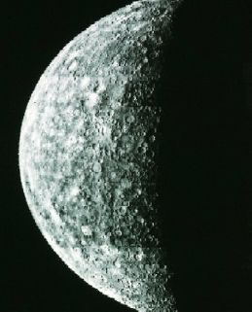
To follow the Lunar calendar, we use the shape of the moon to work out which day of the month it is.

The Islamic month has 29 or 30 days, while the calendar month has 30 or 31 days.
The Islamic months are:
MUHARRAM
SAFAR
RABIUL AWWAL
RABIUL AKHAR
JAMAAD UL AWWAL
JAMAAD UL AKHAR
RAJAB
SHABAN
RAMADHAN
SHAWWAAL
DHULQA'ADA
DHULHIJJA
WORKSHEET
Make your own Islamic calendar.
Your Teacher will give you a sheet with the names written on it
Cut along the dotted line, then stick it on some cardboard.
Then slide the card with the slits cut through the months card.



