Akhlaq Chapter 1
AL-HAMDO-LILLAH
Alhamdulillah = a way of thanking Allah.

Alhamdulillah means all praise is for Allah

Why do we thank Allah?
We thank Him because of all the lovely things He has given us:
Eyes to see with
Hands to hold things hingsth
A brain to understand things
A family to care for us
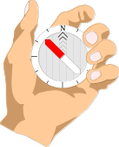
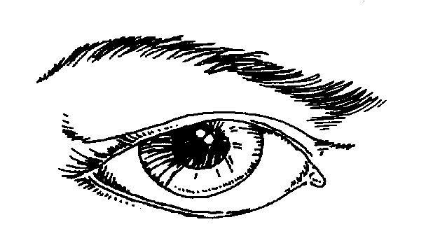

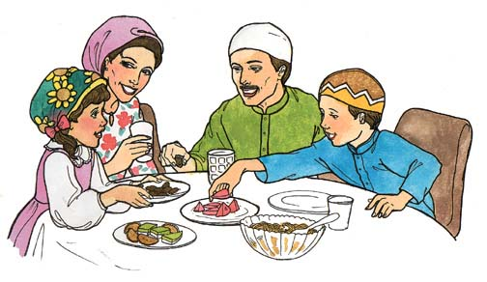

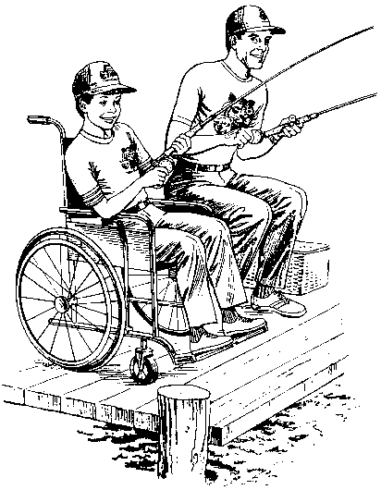
Some people are blind or deaf or don’t have legs. Allah may have created people with disabilities to help those of us who have everything be thankful for what we have.
So let us remember to do only good things which Allah likes, and say Alhamdulillah for all the things he has given us.

WORKSHEET :
Draw something else for which you can say Alhamdulillah:
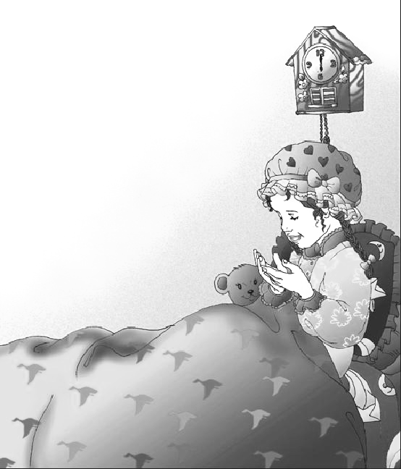
E.g.: To be thankful for a bed to sleep in
Akhlaq Chapter 2
JAZAKALLAH
We are Muslims, which means that every thing we do is for Allah. Allah tells us that all Muslims are brothers and that we should care for each other.
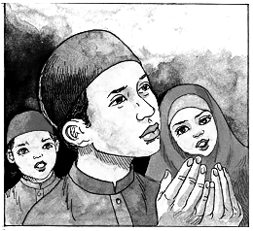
Jazakallah = May Allah reward you.
This tells a person that you care about them because you are asking Allah to reward them for what they have done for you.

By saying Jazakallah to someone, you are asking Allah to give them more thawaab so that they may go to heaven. In return, Allah also gives you more thawaab.

You should say Jazakallah when someone is kind to you, helps you in any way or gives you something.
WORKSHEET
When someone helps you or gives you something you say Jazakallah.
Draw 2 pictures of when someone would say Jazakallah:
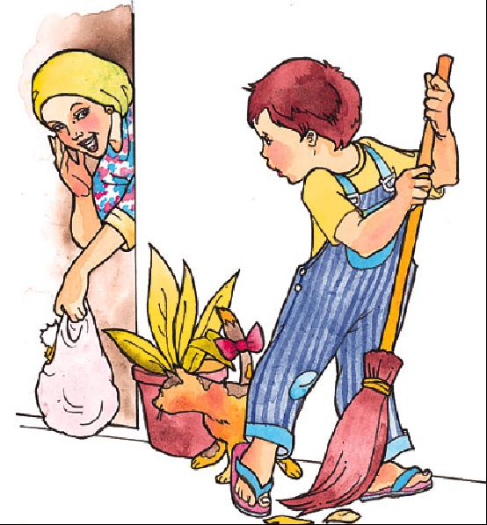
E.g.: Helping Mummy to sweep up the leaves:
Jazakallah
Akhlaq Chapter 3
INSHALLAH

Inshallah means that no matter how much we plan something, if Allah does not want it to happen, it will not happen.

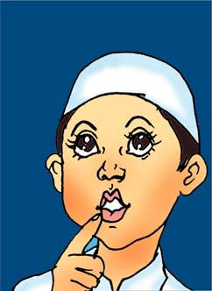
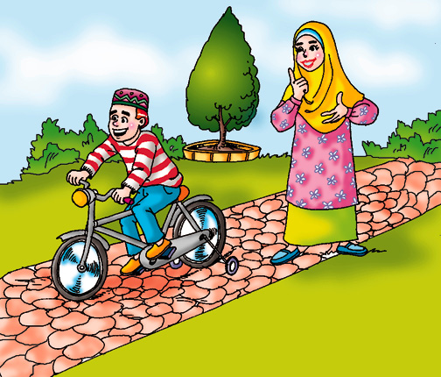
Little Ali’s mummy had told him again and again to say Inshallah after he said he was going to do something. But Ali usually didn’t say Inshallah.

One day, Ali decided he wanted to go to the park to play. He looked out of the window and the sun was shining.

It was a nice day!
He asked his mummy if she would drive him to the park later. She said she would Inshallah take him that afternoon.

Ali called his friends to tell them that he was going to the park that afternoon. Ali's mummy heard him and told him that he should have said that he was going to go to the park Inshallah.

Ali replied that that he was going for sure because the day was so nice.
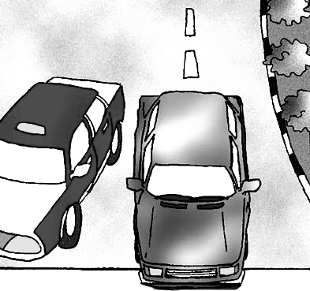
That afternoon, when it was time to go to the park, the sky had become less sunny and much more cloudy, but Ali was still happy about driving to the park.


But just before he reached the park, it started to rain. Very soon, it was raining very heavily, and Ali’s mummy said he could not play in the park in the rain, so they drove back home. Ali was very sad.

The next day Ali made sure he said Inshallah after everything he was planning to do
Inshallah means if Allah wants you to do something, then you will do it. So always make sure you say Inshallah when YOU PLAN TO do something.

But remember, you should not say Inshallah when you are talking about something you do not intend to do.
WORKSHEET
You should always say Inshallah when you decide to do something.
Draw a picture of something you should say Inshallah after you decide to do it:
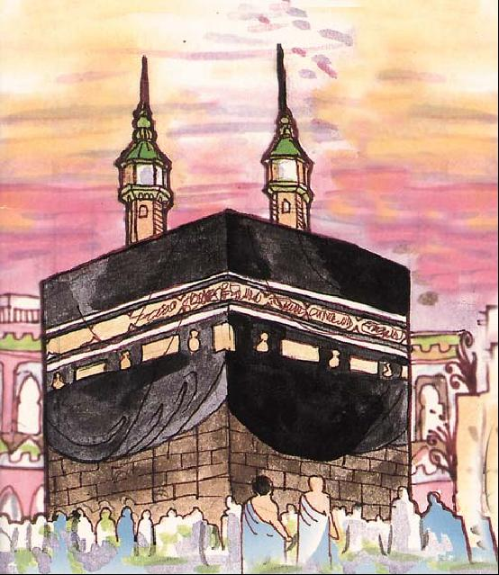
E.g. I will go for Umrah in the Summer, INSHALLAH:

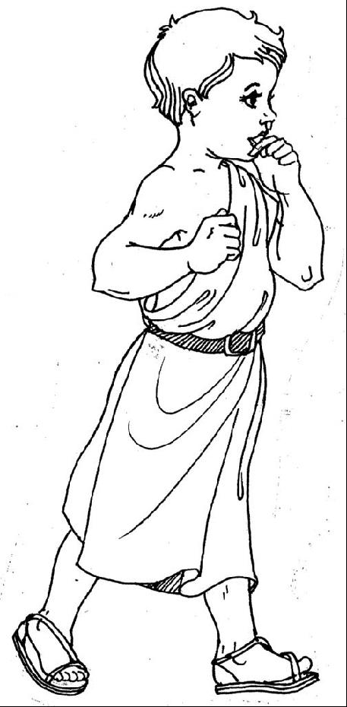
Akhlaq Chapter 4
ALL CREATURES OF ALLAH ARE IMPORTANT

All creatures of Allah are important. He listens to the prayers of all His creatures, no matter how big or small, or rich or poor they are. Allah loves them all.


A long time ago, in the time of Prophet Sulaiman , there had been no rain for a long time. All the plants were dying and the people had very little food.



The people asked Prophet Sulaiman to pray to Allah for them.
Prophet Sulaiman came out with his people to pray for rain.
Suddenly he noticed an ant standing on its two legs, raising it’s hands up to the sky and saying:
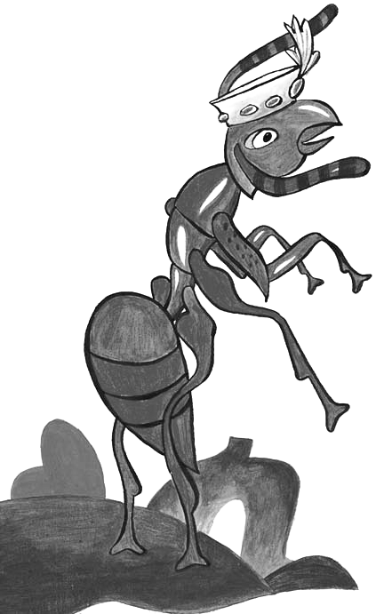
"Oh Allah! We are very small. We cannot survive without Your help. Please send rain so that we have food to eat."

Prophet Sulaiman , who understood the language of the animals, told his people that they could all go home as the prayer of that one little ant was enough.
It then rained heavily and all the land became green.
Moral: No matter who or what you are. Allah loves you and always listens to your prayers (Du'a) if they are from your heart.

Worksheet
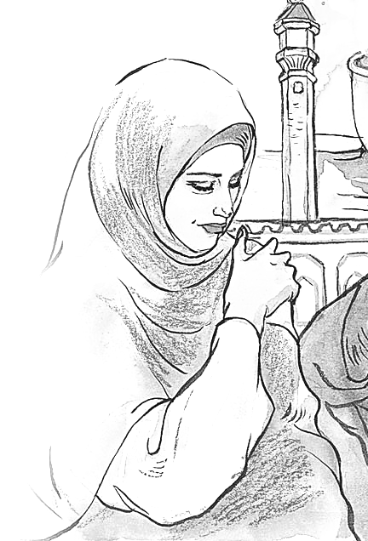

Colour the creatures whose prayers Allah will answer.
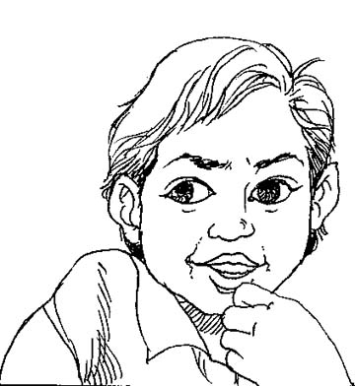
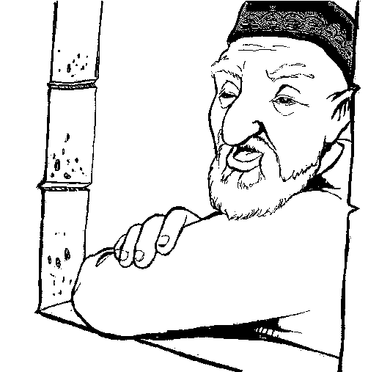
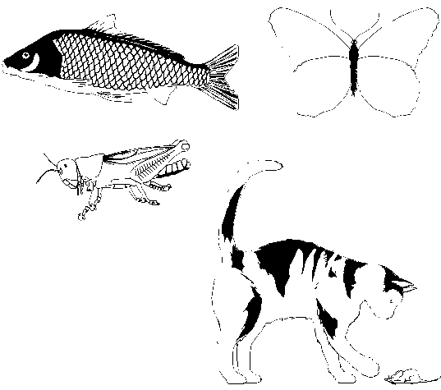

Akhlaq Chapter 5
BEING NICE TO OTHERS:
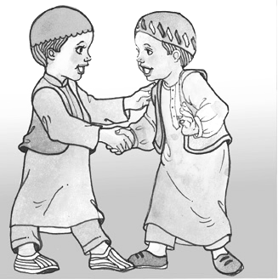
The Holy Prophet has said that the act most liked by Allah is making other Muslims happy.
Allah will give lots of Thawaab to a person who smiles when s/he meets another Muslim
By you smiling you are telling people that you are happy to see them.

If you are happy, people will want to be with you and they will also be happy, but if you are sad then people will leave you on your own because they do not want to be sad as well.

Whenever anyone was rude to Our Holy Prophet or the Imams, they used to just smile and be nice to them. The people being rude would immediately feel bad about what they had done.
There was once an old, naughty woman who used to throw rubbish on Prophet Muhammad (s.a.w.) everyday when he passed by her house on his way to the mosque, but he never ever got angry with her.
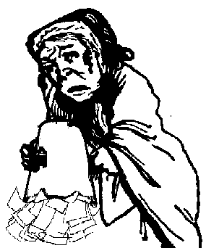
One day when the Prophet (s.a.w.) passed by the old woman's house, any rubbish did not hit him.
He stopped and asked the old woman's neighbour if she was all right because she was not there to throw rubbish on him.

The neighbour told him that the old woman was not well and she was in bed.
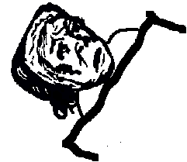
So the Prophet (s.a.w.) went to visit the old woman because it is good to go and see people who are not well.
The old woman thought the Prophet (s.a.w.) had come to tell her off, and she said:
"Why did you wait until I was ill to tell me off. Why didn't you come when I was well and strong?"
Prophet Muhammad (s.a.w.) replied to the old woman:
“I have not come to tell you off, but to visit you because Allah tells us to look after people who are not well.”
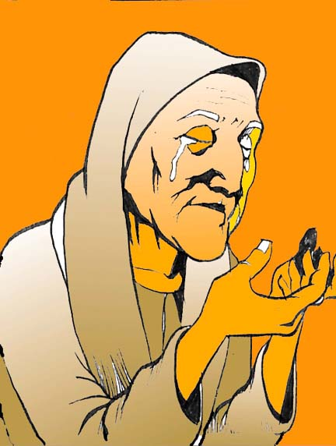
The old woman was so surprised that the Holy Prophet (s.a.w.) was being so kind to her, after she had been so means to him, that she decided to listen to him and she became a Muslim.

WORKSHEET

Draw the kind of face that Allah is pleased with.
Akhlaq Chapter 6
SHARING WITH SIBLINGS:
Allah likes us to share our things, especially with our brothers and sisters.
Remember that everything we have is from Allah, and if we share Allah will give us more.
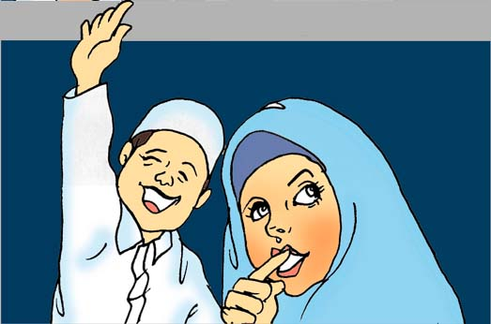
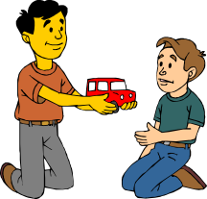
One day a woman came to Kazim's house to see his mummy. She brought her son, Raza.
Kazim's mummy told him to play with Raza.
So, they played in Kazim’s room with his toys.




Soon, Kazim’s younger brother Adam came, and he, too, wanted to play with his brother’s toys.

But Kazim did not want to play with his brother, in case Adam broke his toys.


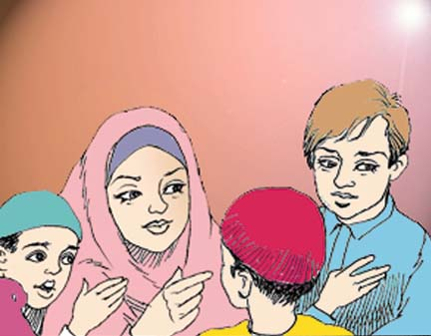
Adam was very upset and started crying.
Kazim's mummy asked Kazim to share his toys with his brother, but Kazim would not.


A few days later, Kazim went to Raza’s house, but Raza was being mean, and would not let Kazim play with his toys. Kazim was very sad.
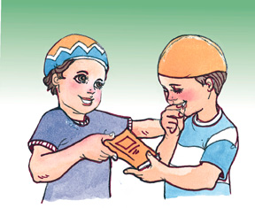
When Kazim got home he told his mummy how mean Raza had been. His brother Adam heard him, and told Kazim he could have his (Adam’s) favorite book to colour in.


Kazim realised how much his brother loved him, and was very sorry for not sharing with Adam and making him sad.
He promised that from then on he would always share all his things with his brother.

Brothers and sisters are very special. If we fight with a friend, they will go away, but even if we fight with our brother or sister they will always be there with us.

WORKSHEET
Colour the pictures below and draw how many of your bunny sweets you will share:
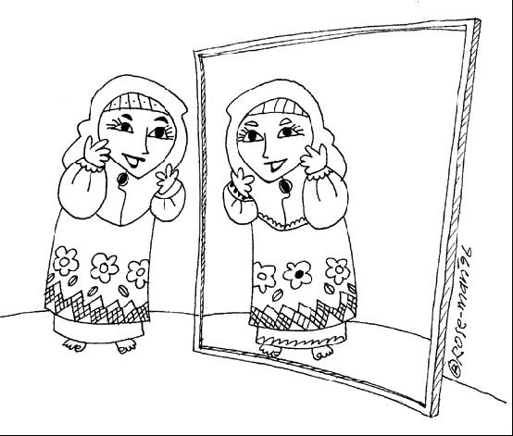
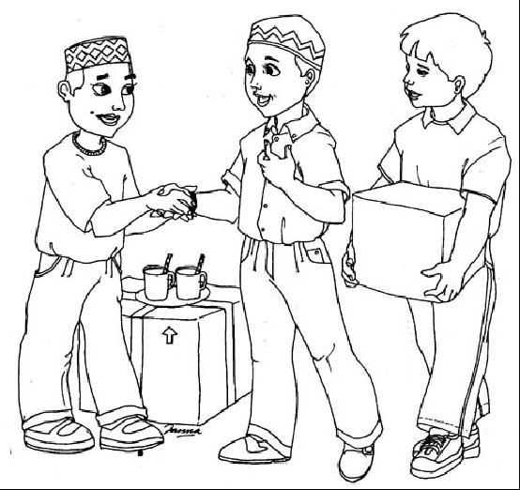



Bunny sweets

Akhlaq Chapter 7
SALAWAAT:
Allah has asked us in the Qur’an to recite Salawaat for the Holy Prophet (s.a.w.) and his family, because of His great love for them.
When you are reciting Salawaat you are asking Allah to send His blessings to the Prophet Muhammad and his family.

The Prophet’s family are:
- Bibi Fatimah (a.s.), AND
- the 12 Imams (a.s.)
Whenever you hear the name of our Holy Prophet (s.a.w.) or his family you should recite Salawaat.
When you hear the name of our 12th Imam, Imam Muhammad Al-Mahdi (a.s.), you should:
- stand up
- put your right hand on your head
- bow down your head
This is because our 12th Imam is still alive.
When you are sitting not knowing what to do (E.g.. when you do not understand the majlis in mosque), you should recite as many Salawaat as you can.
Inshallah on the Day of Judgement the Holy Prophet and his family will ask Allah to forgive you, in return for all the Salawaat you sent to them.

WORKSHEET 2.7
Below is the name Our Holy Prophet (s.a.w.) in Arabic. Remember to recite Salawaat as you colour it in:

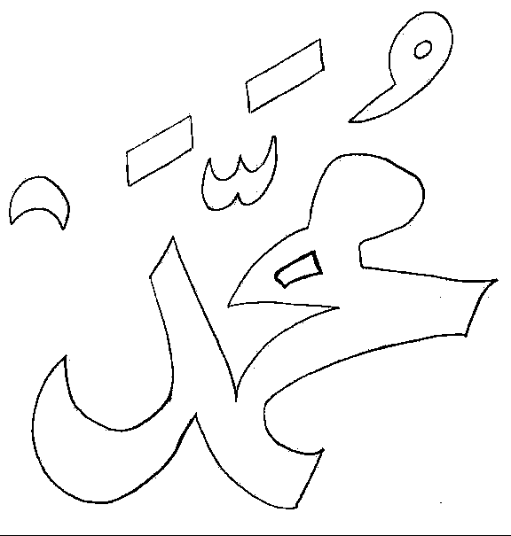

Akhlaq Chapter 8
SNEEZING:
When you sneeze you should say Alhamdulillah

When you sneeze you should put your hands or a tissue in front of your mouth so that you do not pass your germs to anyone else and give them your cold.

When someone else sneezes you should say Yarhamukallah, because Islam teaches us to care for each other.
WORKSHEET 2.8

Below is a game you can play in the class with your friends:

Your teacher will give you a big spinner:

How to play:

Spin the arrow

Take it in turn to sneeze (pretending)

Who has to say the word the spinner lands on? the person who sneezed or the friend?
Alhamdulillah
Alhamdulillah
Alhamdulillah
Yarhamukullah
Yarhamukullah
Yarhamukullah

Akhlaq Chapter 9

MANNERS BEFORE A LESSON:

It is every Muslim's duty to gain knowledge, and learn as much as you can.

Knowledge is what you learn and what you know.
You can learn new things at home, at mosque, in Madressa, at school, and many other places. We will concentrate on learning in Madressa.
There are some important things you must do when you are learning something:
Do not talk in class!
Remember Allah before you start
Sit up straight in your chair
Listen carefully to the lesson




Bismillah

Remember to thank the person who is teaching you.
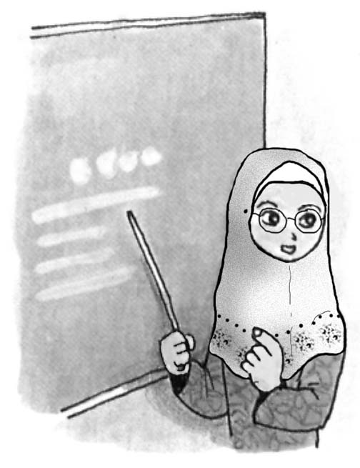
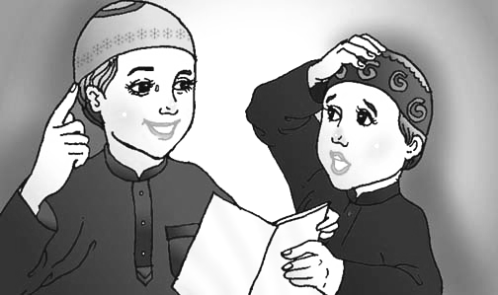
Use that knowledge to make yourself a better person and also teach others (your younger brothers or sisters, and your friends) what you have learnt.

WORKSHEET
Remember always to concentrate on your lesson completely:
Learn the little poem!
Work while you work,
Play while you play,
One thing each time,
That is the way,
All that you do,
Do with your might,
Things done by halves,
Are not done right.

Draw a picture of something you should NOT do in your lesson:
Akhlaq Chapter 10
MANNERS OF SLEEPING:
Before going to bed, you should do the following things:
brush your teeth
do Wudhu
Say Khuda-Hafiz to your family
Recite a Surah from the Qur’an

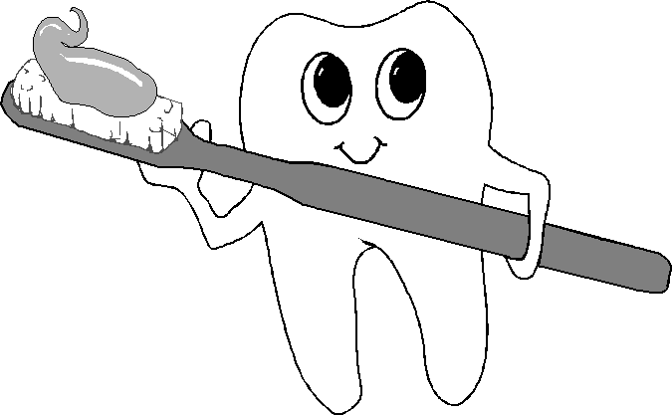
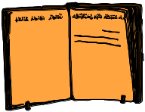

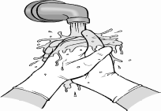

Before going to sleep you should think of all good and bad deeds you have done in the day.
More good or bad deeds?

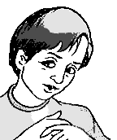

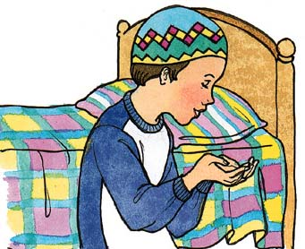

Which angel has done more writing: the angel on your right shoulder writing good deeds, or the angel on your left writing bad deeds.

Say sorry to Allah for anything bad that you have done, and promise that you will not do it again.
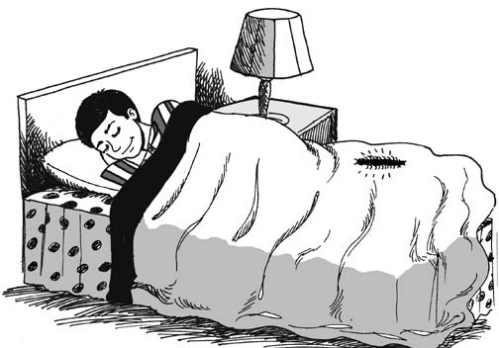
If you have been mean to anyone, tell yourself that tomorrow you will say sorry to them.

You should then sleep on your back or your right side. It is not good to sleep on your tummy.

WORKSHEET
Draw all the things you should try and do before you go to sleep:
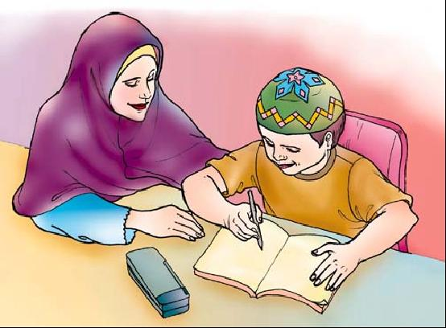
E.g. Finish your howework:
Akhlaq Chapter 11
MANNERS OF WAKING UP:

You should remember to do the following when you wake up in the morning:
Remember Allah first
Say Salaam to our 12th Imam
Greet, hug & kiss your parents

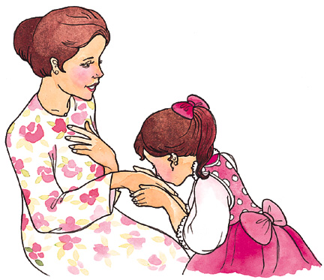
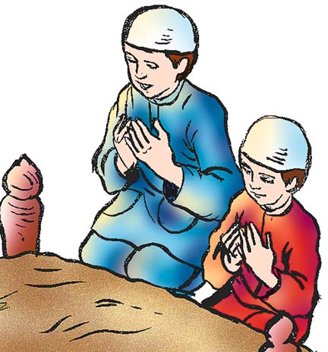
Bismillah
Remember, knock on your parents door and wait for permission before you enter.
You should then put on your slippers and go to the toilet.

WORKSHEET
We remember Allah as soon as we wake up, then send Salaams to our 12th Imam (a.s.) and then go and greet out parents.
Draw 2 other things you can do after you wake up:
E.g.: Put on our clothes:
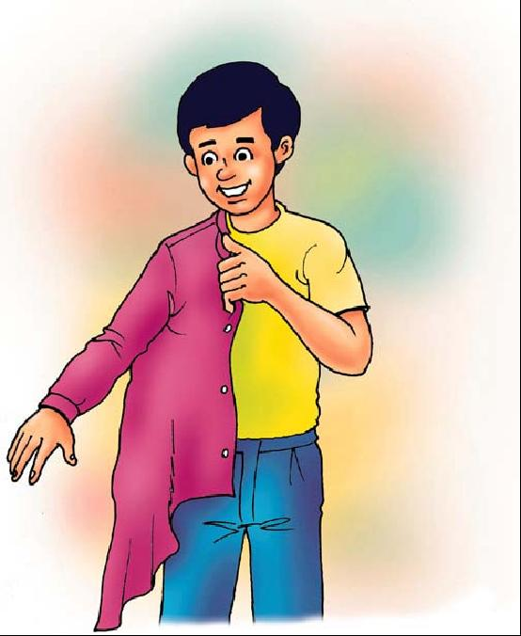

Akhlaq Chapter 12
RESPECT OF PARENTS:

Allah Says in the Holy Qur'an: "..Do not worship anyone except Allah and be kind to your parents.."
Allah is telling us in the same sentence to worship only Him, and to be good to our parents. This shows us how important being kind to our parents is in Islam.

The Holy Prophet (s.a.w.) has also said that when we please our parents we are pleasing Allah, and when we upset them we are upsetting Allah.
Your mother fed you, clothed you and looked after you since your birth
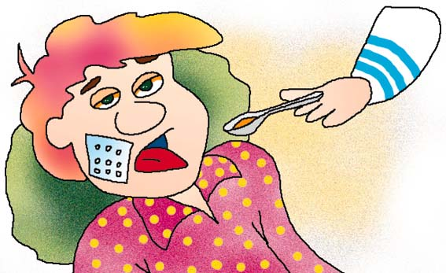
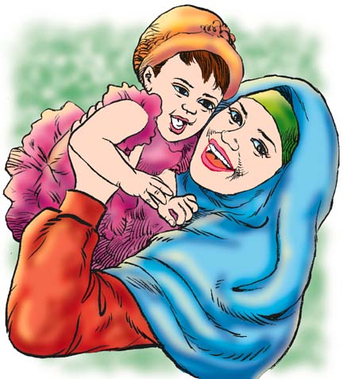
This is why in Islam we are told that Heaven lies under the feet of your mother.
When you are ill, your parents look after you.
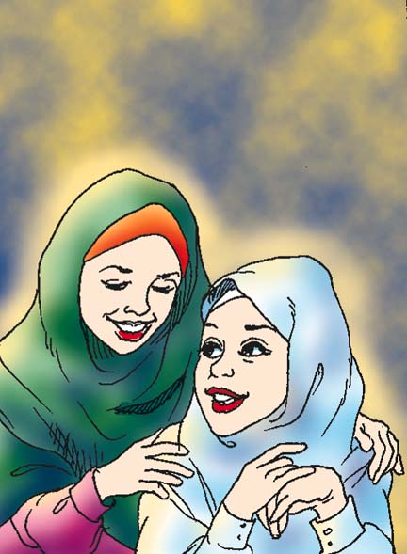
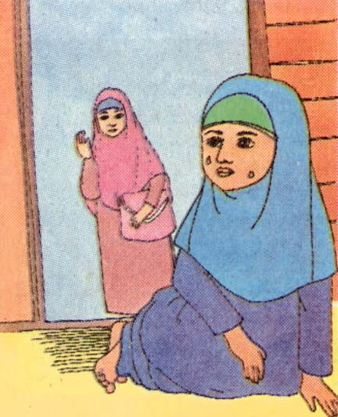
When you are sad they are sad. When you are happy, they are happy.

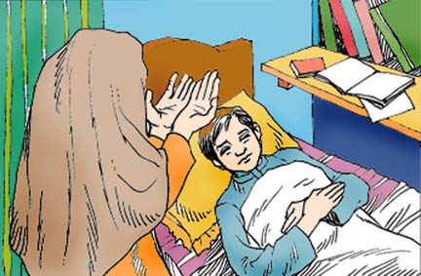
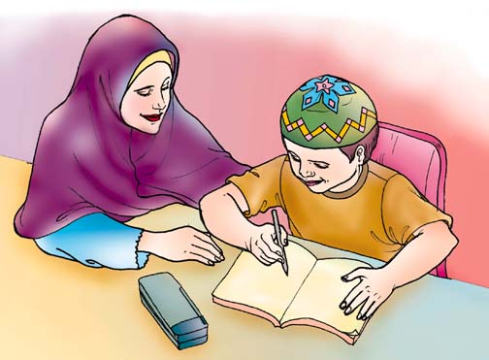
When you need help they are there for you.
They pray for you, without you asking or even knowing.

You can never repay your parents for everything they have done for you, but you can thank them by respecting them:
Remember to treat your grandparents with the same respect that you treat your parents. They cared for your parents just like your parents cared for you

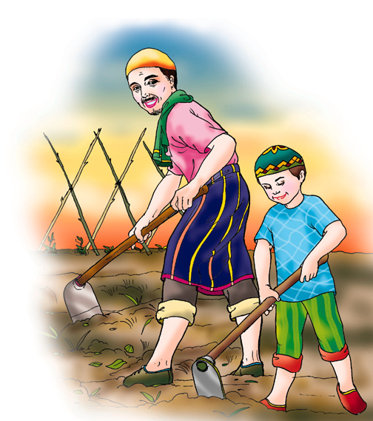
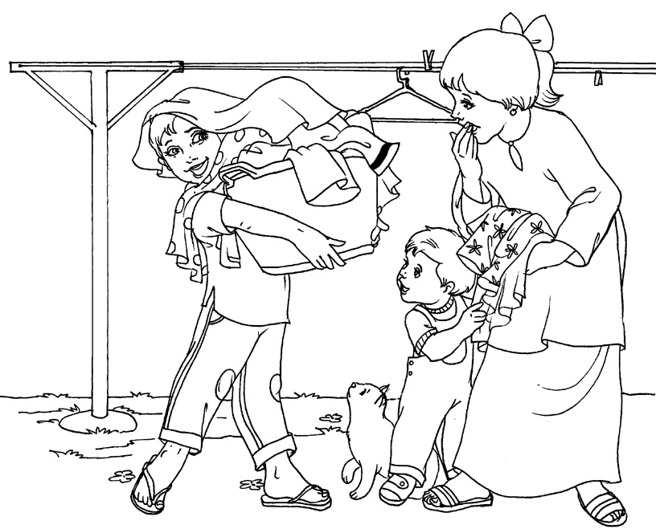
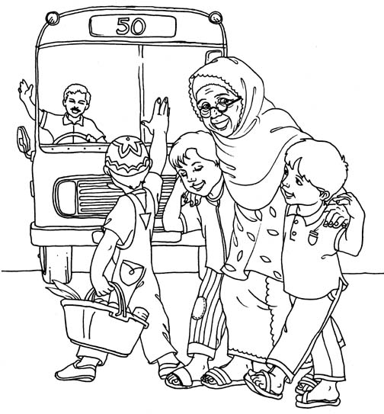

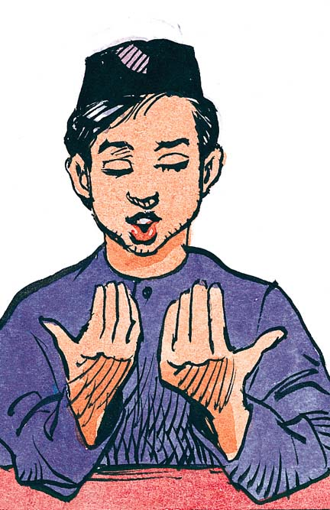
Doing things for them, without being told to
Never raising your voice when you are talking to them
Thanking them and praying for them
WORKSHEET 2.12: RESPECT OF PARENTS:
Allah wants us to be kind to our parents.
Draw 2 pictures of how you can be kind to you parents:
E.g. By playing quietly when they are resting:


