Fiqh Chapter 01

Furoo-e-Deen

Hindi/Urdu Version

Furoo-e-Deen yani deen ki shakhein

Furoo-e-Deen Das (10) hain:

Awwal Namaz
Doosrey Roza
Teesrey Hajj
Chowthey Zakaat
Panchwein Khums
Chattey Jihad
Saatvein Amar Bil Maroof
Aathvein Nahi anil Munkar
Nawein Tawalla
Daswein Tabarra

English Version

Furoo-e-Deen means branches of religion

Furoo-e-Deen are 10:

First Namaz (Prayers)
Second Roza (Fasting)
Third Hajj (Pilgrimage)
Fourth Zakaat
Fifth Khums
Sixth Jihad
Seventh Amar Bil Maroof
Eighth Nahi anil Munkar
Ninth Tawalla
Tenth Tabarra
WORKSHEET

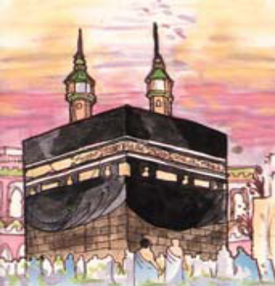
Number the following
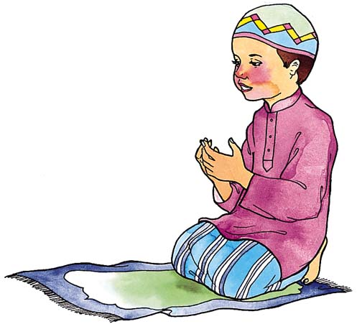

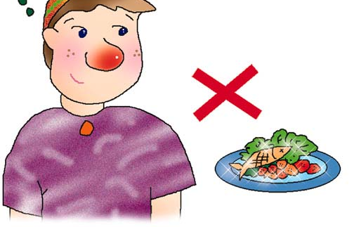
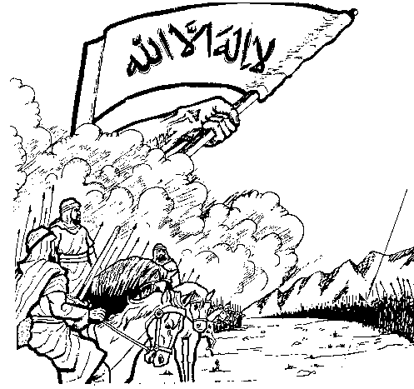


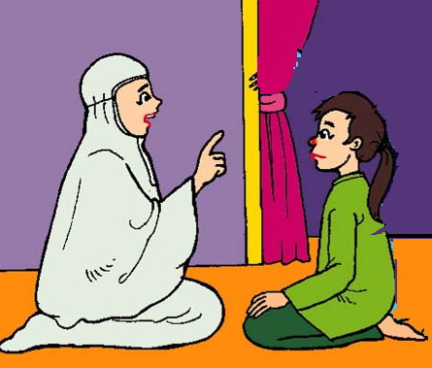
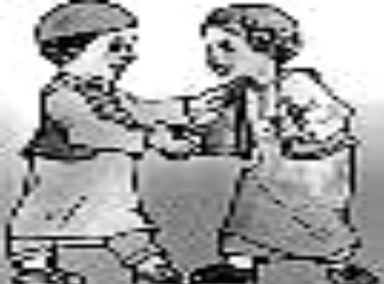
Nahi Anil Munkar



WORKSHEET

Colour the pictures
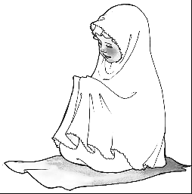
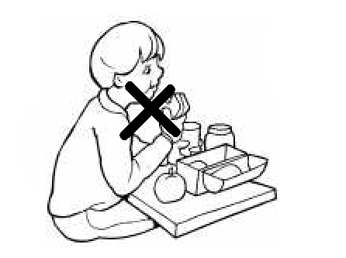
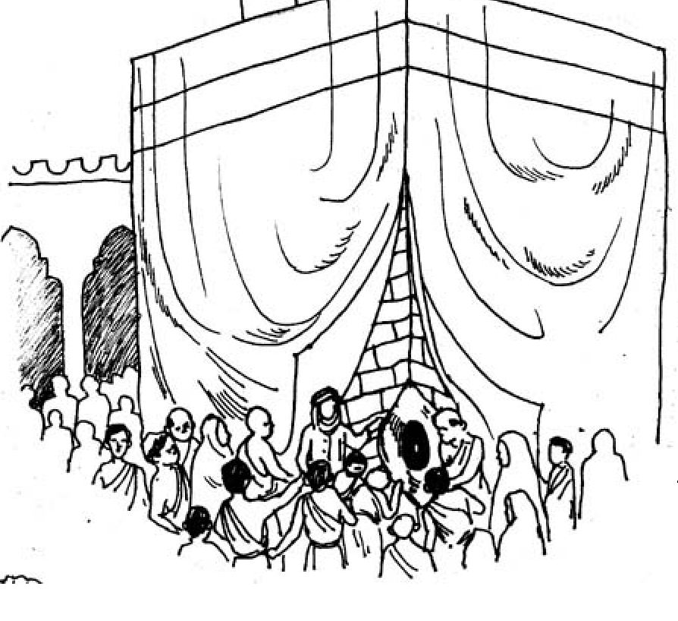
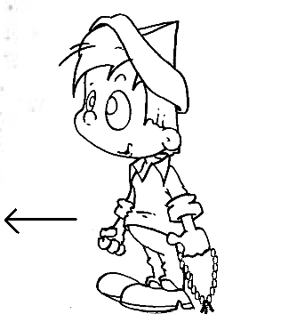
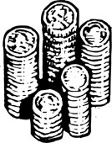
WORKSHEET

Colour the pictures
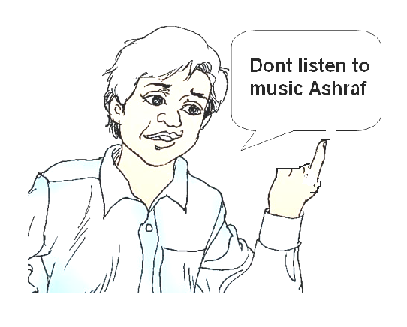
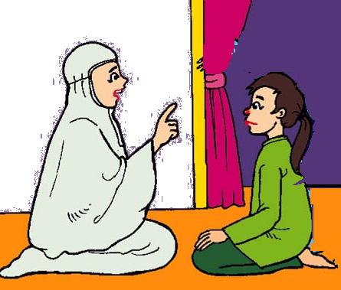
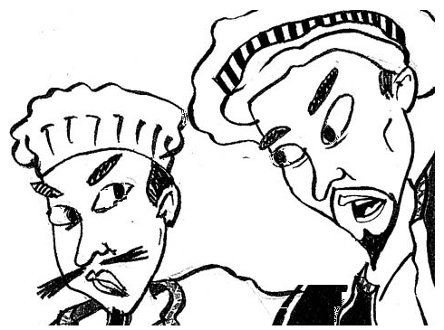
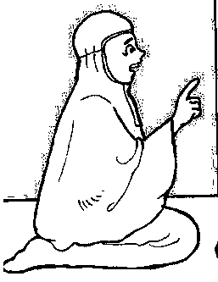
Fiqh Chapter 02

Why Should I Pray Namaz?

One day, Abid’s mother asked him: “Have you offered your prayers?”

Abid replied: “No mother”

Mother asked: “Why?”

Abid said: “Why should I offer prayers? I don’t feel like”

His mother kept quiet

The next day, his mother gave him a gift (pencil)

Abid said “Thanks mom!”

His mother was very happy that Abid thanked him, and gave him another gift (eraser)

Abid said “Thanks again mom!”

His mother asked him: “Why did you thank me?”

Abid said: Because you gave me a gift

His mother asked: My gift (pencil) is more important or your eyes

Abid replied: “Of course my eyes. I cannot see without my eyes”

His mother again asked him: “My gift (pencil) is more important or ears”

Abid replied: “Of course my ears. I cannot listen without my ears”

His mother again asked him: “My gift (pencil) is more important or legs?”

Abid replied: “Of course my legs. I cannot walk without my legs”

Finally his mother said: “You are thanking me for giving you a pencil, but don’t you think you should thank to who has given you the precious things like eyes, ears, and legs?”

Abid asked: “Yes mother. I did not think about that at all. Who has given all these things to me?”

Mother replied: “ALLAH”

Abid said: “How do I thank him?”

Mother said: “By offering prayers”

Abid was shocked. “He thanked his mother for explaining him about the importance of prayers, and said “From today, I will never miss my prayers”

His mother said:
- Allah made us and looks after us
- He has given us everything. We love Allah.
- Allah loves us and He wants to talk to us
- But Allah wants us to talk to Him too. We talk to Allah through Namaz and Dua. Namaz means “talking to Him the way He likes me to talk to Him”.
- Namaz also means thanking Allah for all the good things which he has given us

- We can talk to Allah anywhere about anything. He always hears and understands. He hears me if I whisper or if I shout or even if I think of something in my mind.

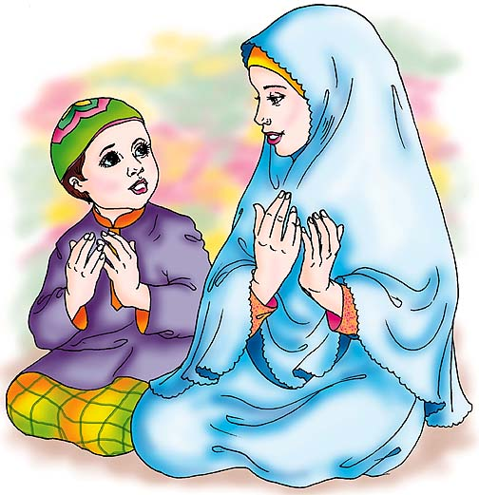
Abid thanked his mother for explaining him all this, and thanked ALLAH for giving him a mother who explains good things to him
WORKSHEET

Colour the things which Allah has created

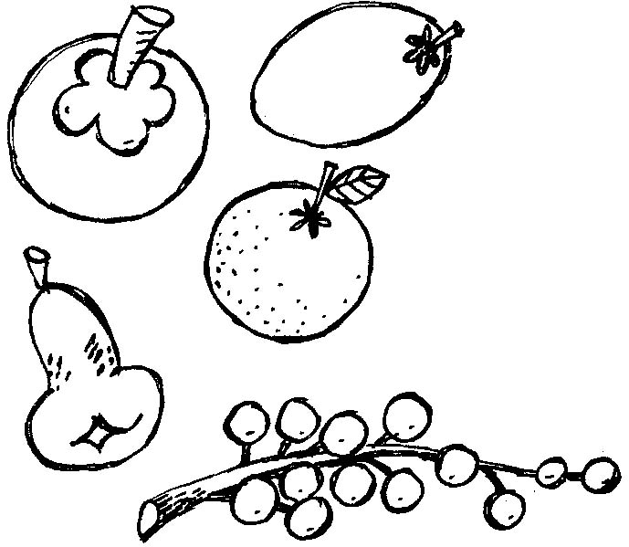


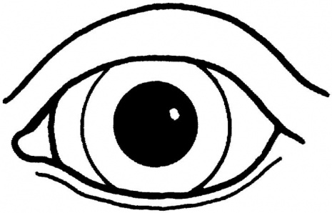

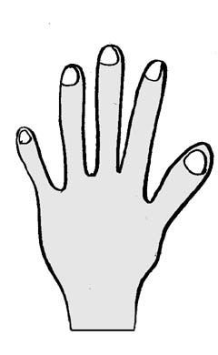
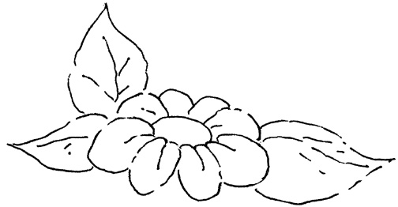

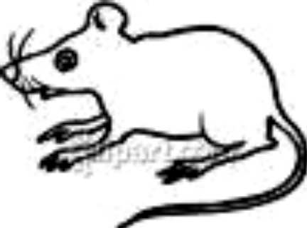
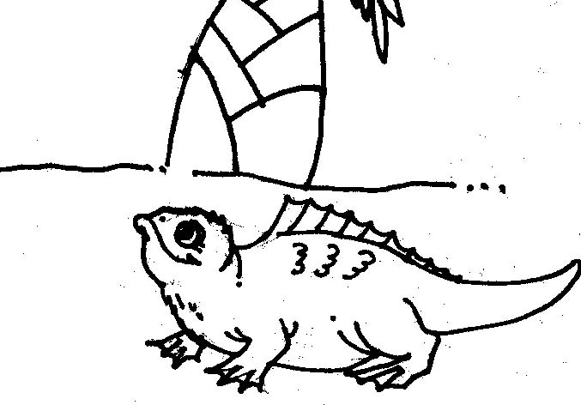

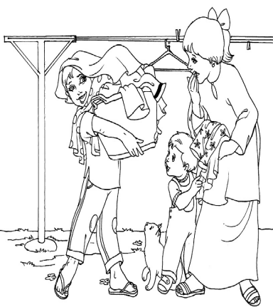
Join the dots
Which position of namaz is he in?

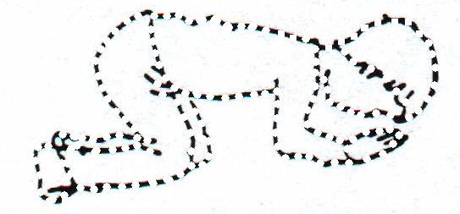
Fiqh Chapter 03

Wuzu - Introduction

Wuzu was taught, by our Holy Prophet Muhammad (SAW), after he came back from Me'raj.

In Me'raj the Holy Prophet (SAW) did Wuzu with the water from the river in Heaven.


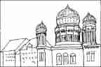


Wuzu is the special way to wash yourself before you pray

Wuzu is needed for Namaz

Wuzu is also needed for:

- Touching the writing of the Holy Qur'an
- Touching the names of Allah

It is very good to do Wuzu:

- To recite the Quran
- To recite Duas
- Before you go to sleep
- Before you go to the Imambargah
- When you are angry (as it calms you down)
- When touching the names of 14 Ma'sumeen
- Before going to sleep
- Entering a mosque
- Visiting graveyard
- When you are angry

In fact, it is good to be with Wuzu all the time

Before doing Wuzu you should make sure that:

- the parts of Wuzu (face, arms, head, feet) are all Pak, AND
- there is nothing on them which would stop the water reaching it, e.g. Plaster, nail varnish, rings, etc

WORKSHEET
Draw a circle round those things that you have to do Wuzu for AND
A square around those things it is good to do Wuzu for.
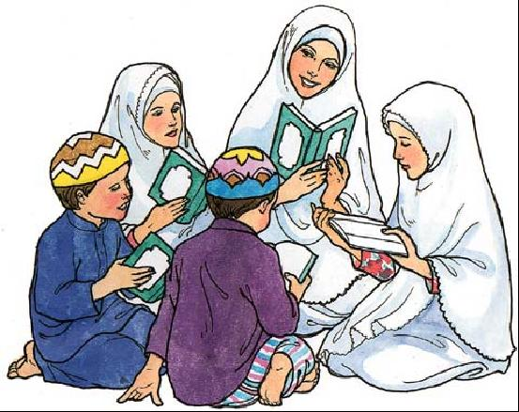
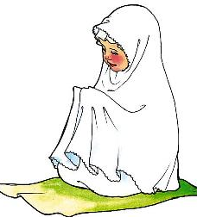

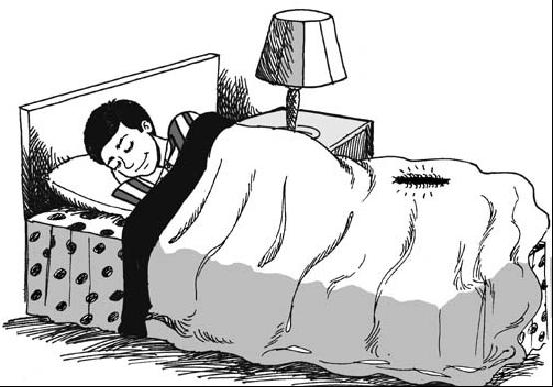
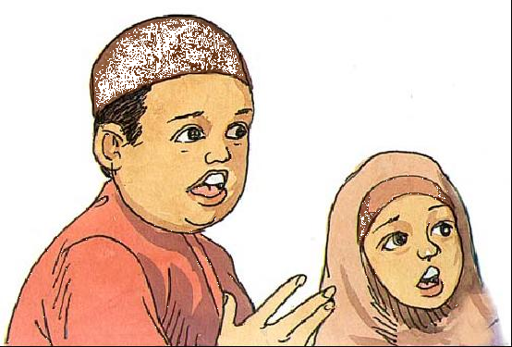
Before reciting Qur’an
Before going to sleep
Before offering Namaz
Before going to the Mosque
Entering Graveyard
When you become angry

WORKSHEET

Can Jabir do wuzu?

If not what should he do?

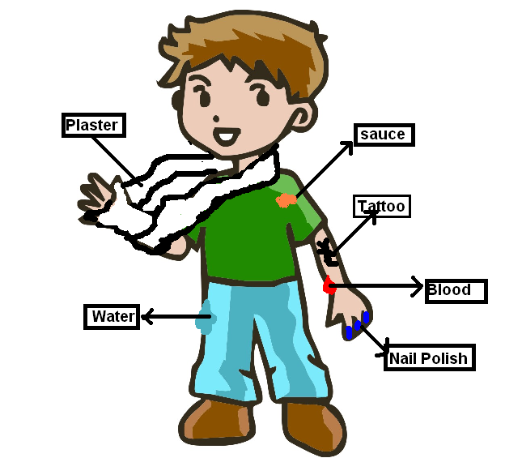
Fiqh Chapter 04

Wuzu – Method

We have to do Wuzu for Namaz
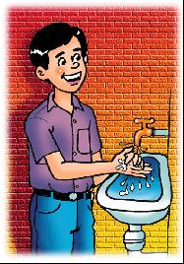


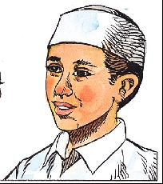
2. Washing Hands 3. Gargling 3 times 4. Washing Nose 3 times
I am doing Wuzu in obedience to Allah, Qurbatan ilallah
Niyyat
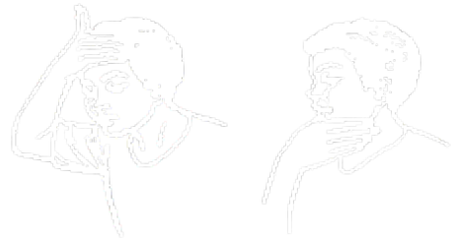
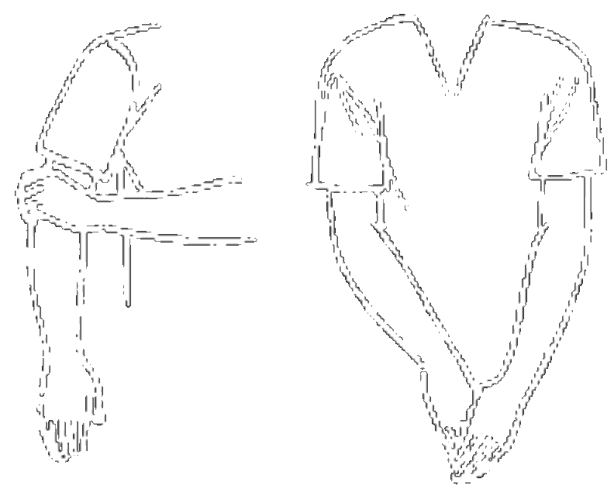
5. Washing of the face
From Top to Bottom

6. Washing of the arms, from elbow to fingertips, First Right, then Left

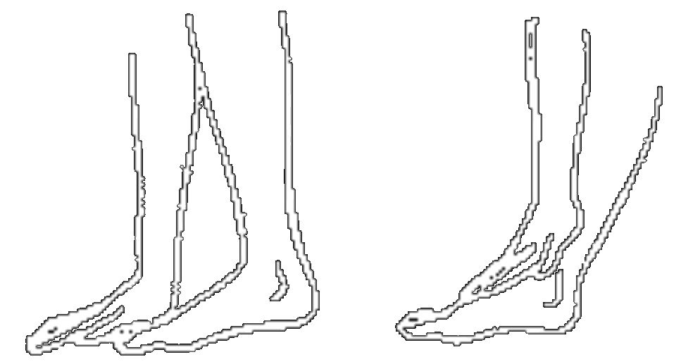
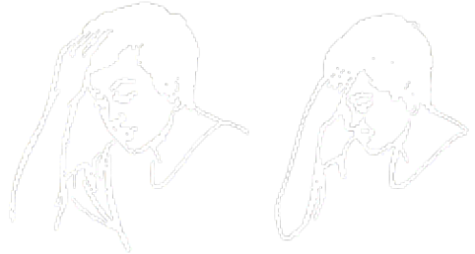
7. Masah of the head
From back to Front

8. Masah of the feet, from fingertips to mound, First Right, then Left

WORKSHEET
- Number the actions in sequence (1st, 2nd etc.)
- Write how many times it has to be done
- Colour them in
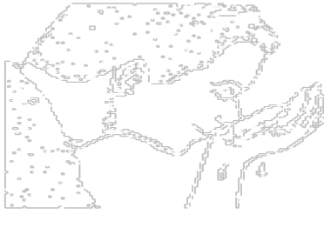

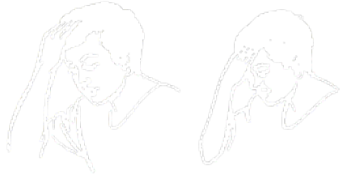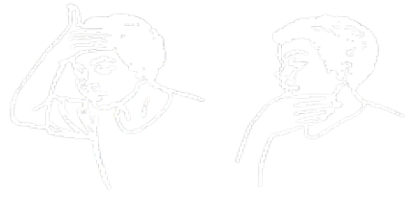

__________ times.
Fiqh Chapter 05

Namaz: Names, Rak’ats, Timings

I pray five Namaz, three times a day.

Each namaz is divided into rak’ats

In each rak’at, I do one ruku and two sajda

Each Namaz has to be prayed in its own time. If I don’t pray Namaz in its timings, it will not be accepted

When the Namaz time comes, it is better to offer the Namaz immediately without delay

Name | Rak’ats | Time
Fajar | 2 Rak’ats | Early in the morning just as the night ends, I pray Fajr Namaz
Zohr | 4 Rak’ats | At midday (halfway through the day), I pray Zuhr Namaz
Asr | 4 Rak’ats | After Zuhr Namaz, I pray Asr Namaz
Maghrib | 3 Rak’ats | Just as the day ends and the night begins, I pray Maghrib Namaz
Isha | 4 Rak’ats | After Maghrib Namaz, I pray Isha Namaz

These timings are indicative timings. When I grow up, I will learn about exact timings of Namaz

Although Allah has given us so much time in which to pray we should try to pray as soon as the time sets in for that Namaz. We should not wait to thank Allah in the way He likes us to, for all the wonderful things He has given us

So remember: Each Namaz in its own time, and as early as possible

WORKSHEET: Namaz: Names, Rak’ats, Timings

In the chart below, mark in the time for each Namaz

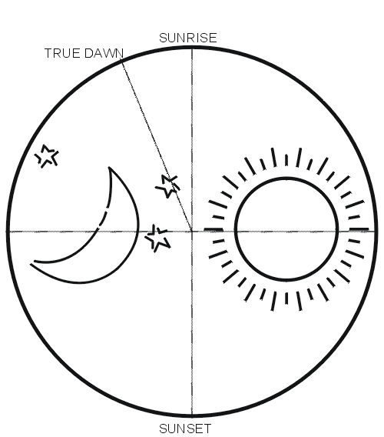
Worksheet
Match the following salaats to their timings :

Early in the morning
just as the night
ends

At midday

After zuhr

just as the
day ends

After maghrib

Zohr

Maghrib

Asr

Ishaa

Ishaa
Fiqh Chapter 06

Namaz – Method (Fajr Namaz)

Following is the method of Fajr Namaz

1. Say niyyat “I am praying 2 rak’ats of Fajr Prayers, Qur-batan Ilallah (for Allah)”
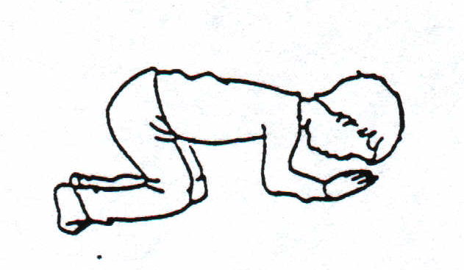
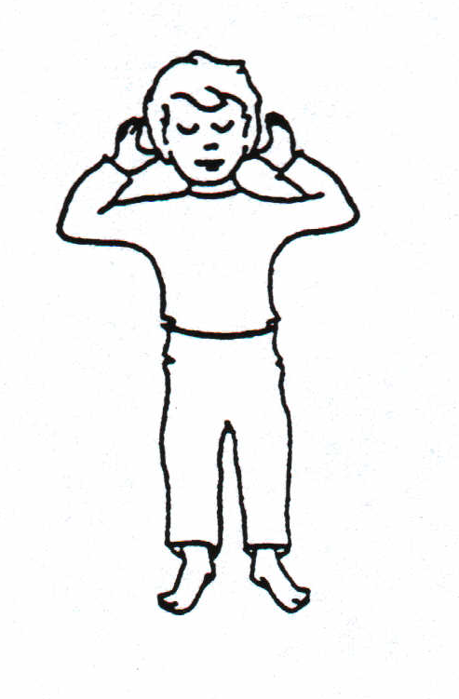
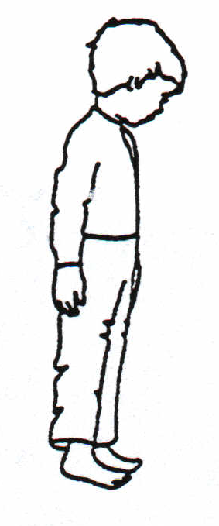
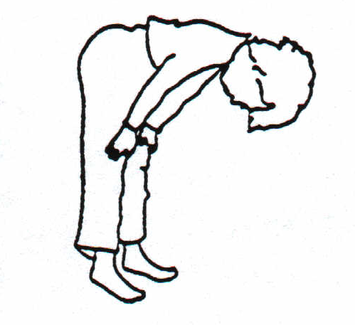
2. Raise hands up to ear and say “Allahu Akbar”
☺• ⬆ 

3. Stand still for qiyam and looking at the ground (mohr, turbat). Recite Suratul Fatiha and Sura Ikhlas (or any other sura from the Qur’an) (Refer to Quran section of this manual for these surahs)

4. Say “Allahu Akbar” and then go to ruku’. Looking between your feet, recite: “Sub-hana rabbiyal ‘azeemi wa biham-dih”
  ◻ ⇨ ☺

5. Stand up from ruku’ and recite: “Sami’allahu liman hamidah” 
   

6. Say “Allahu Akbar” and then go to sajda making sure that the seven parts of your body touch the ground – Forehead, two palms, two knees, and the two tips of toes. In sajda, recite: “Sub-hana rabbiyal a’laa wa bihamdi”
  ▪ ⇨ ☺

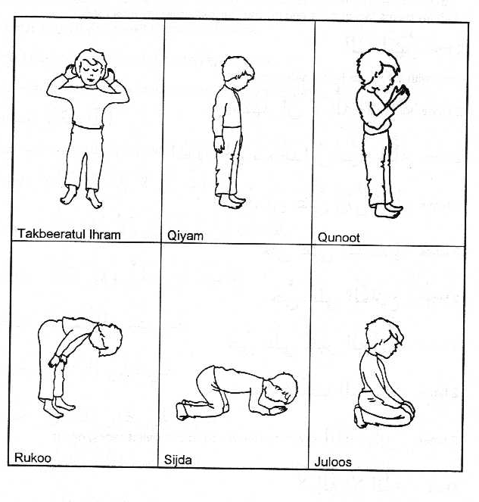
7. Sit up from sajda and looking at your lap, say: “Astaghfirullaha rabbi wa atubu ilayh
 ☹  ⇨  

8. Go back to sajda once more and recite: “Sub-hana rabbiyal a’laa wa bihamdi
  ▪ ⇨ ☺

9. Sit up from sajda and recite: “Allahu Akbar”
☺• 

10. Now stand up for qiyam of the second rak’at. Whilst in the process of standing up, recite: “Bihawlillahi wa quwwatihi aqumu wa aq’ud”
◻      
11. Stand for qiyam and recite Suratul Fatiha and Suratul Ikhlas.

12. Raise hands for qunoot and recite: “Rabbanaa aatinaa fid dunya ‘hasanataw wa fil aakhirati ‘hasanataw waqinaa ‘azaaban naar.
    
    
☹▪         

13. Then do ruku’ and the two sajdas just like the first rak’at.

14. Sit after the second sajda, say Takbeer “Allahu Akbar” and then recite Tashahhud: “Ash hadu al laa ilaaha illallahu wahdahu laa sharika lah, wa ash hadu anna Muhammadan ‘abduhu wa rasuluh, Allahumma salli ‘alaa Muhammadiw wa aali Muhammad - 

       →  
  ☺▪    
    ▪  

15. Then say salaam: “Assalamu ‘alayka ayyuhan nabiyyu wa rahmatullahi wa barakatuh; Assalamu ‘alaynaa wa ‘alaa ibadillahis saaliheen; Assalamu ‘alaykum wa rahmatullahi wa barakatuh -
•     ☺  ▪ 
  ☺▪ ▪  ▪ 
 •     ▪  

16. Then three times (raising your hands each time) say Allahu Akbar:
  ☺• ⬆

Worksheet

Color the following
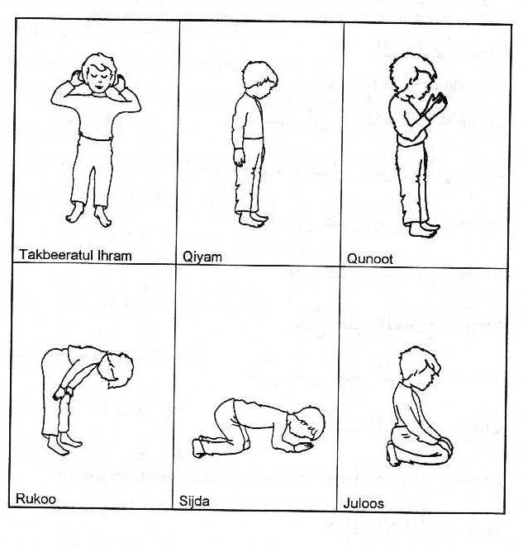

Worksheet
Boys: Colour in and learn the actions of Salaat:
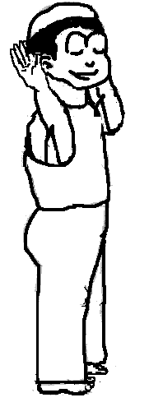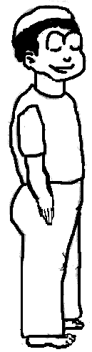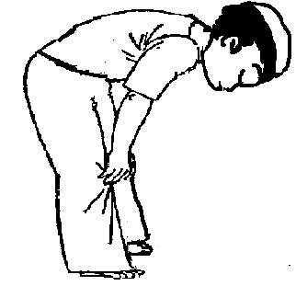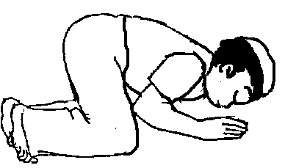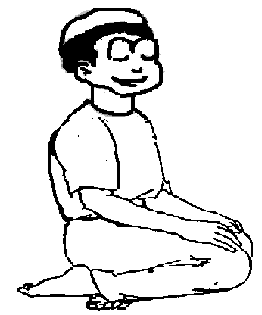
Takbiratul Qiyam Ruku Qiyam Sajdah Sitting Sajdah Sitting
Ihram
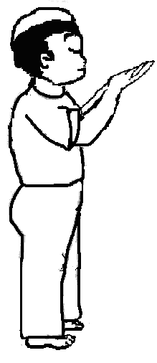
Qiyam Qunoot Ruku Qiyam Sajdah Sitting Sajdah Sitting
Girls: Colour in and learn the actions of Salaat:
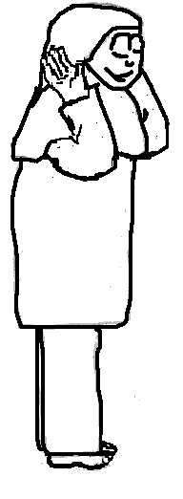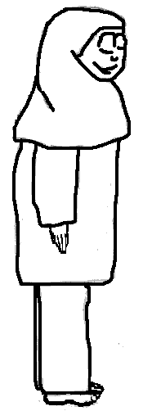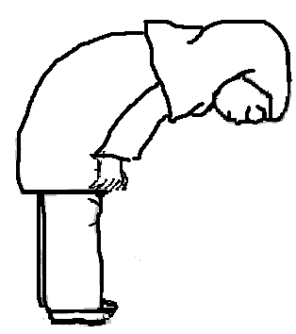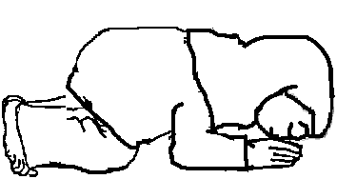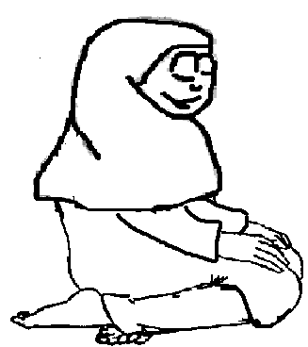
Takbiratul Qiyam Ruku Qiyam Sajdah Sitting Sajdah Sitting
Ihram

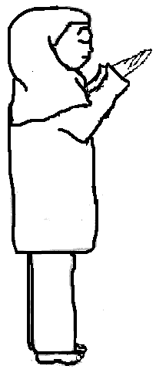
Qiyam Qunoot Ruku Qiyam Sajdah Sitting Sajdah Sitting
Fiqh Chapter 7

Toilet Manners

Dear Children

Allah (SWT) has created us, and loves us

He has asked us to be clean, and loves clean people

Remember:

- Urine and stool are najis, and you must clean yourself from them when you go to toilet

- If urine or stool touches other parts of body, or cloth, they make them najis also, so you have to clean them also. It is therefore better to be careful

Remember:

- Dont face qibla or back qibla while passing urine or stool
- Use tahir (pak) water to wash yourself
- First remove the najis items and then pour water at least twice, better still thrice
- Dont urinate whilst standing
- Dont hold your want to visit the toilet
- It is better to urinate before namaz, and before going to sleep
- Enter the toilet with your left foot and come out with your right foot
- Don’t wash with the right hand
- Wear slippers in the toilet
- Wash hands after coming out of toilet
- Take care of the droplets of urine. If you get it on your body, wash it with water. If you got it on your clothes, tell your parents to help you clean them
- Ask permission to use the toilet if it does not belong to you.
- Cover your private parts from others all the time

WORKSHEET

Tick the things you should do and cross in the things you should not do.

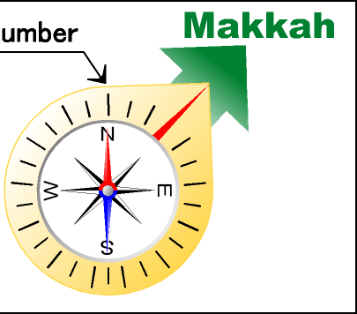



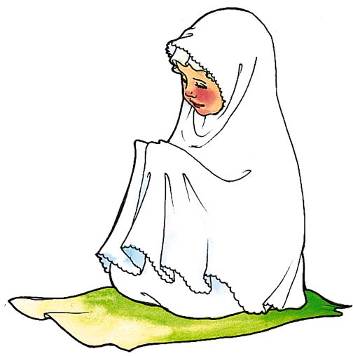

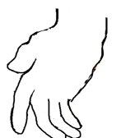

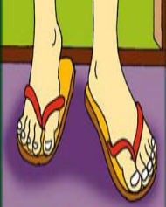
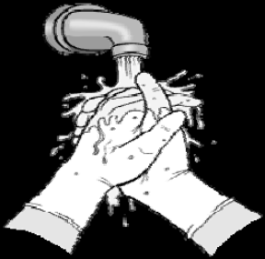




WORKSHEET

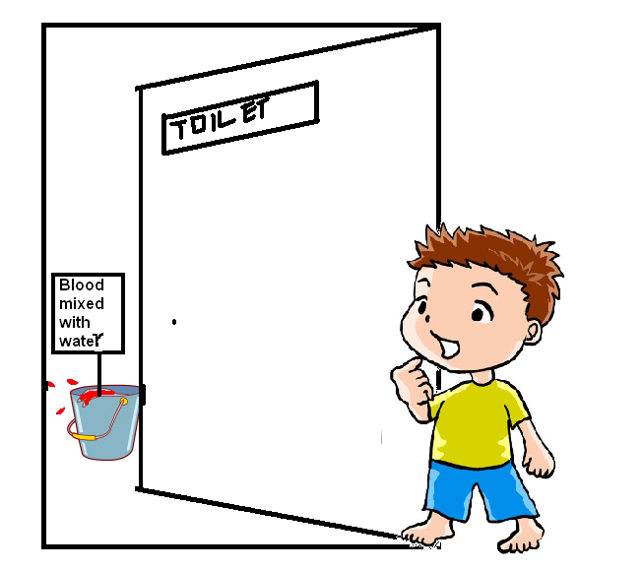
Circle the things which hamed shouldn’t do
Fiqh Chapter 8
Hijab

Nizam was at home, when the door-bell ring

“I think it is the electrician whom you have called for some repairs. I will open the door”, said Nizam

“Wait!” His mother screamed

Nizam was surprised. He asked his mom “Why mom?”

“Because I have to get my chadar and socks”, his mother replied

“Why mom?”, Nizam was not able to understand. “When your brother came yesterday, you did not run for chadar”

“Because my brother is Mahram and the electrician is Namahram”, replied his mother

Well, of course Nizam was not satisfied, but he waited till the electrician did his work and went back

He asked his mother then, “Can you explain me more. What is Mahram, Namahram and why do you take chadar”

“Yes of course”, said his mother. “It is necessary for girls & women to cover their full body except the face and hands from some people, known as ‘Namahram’

However they can show the head, feet etc. to those who are ‘Mahram’. This act of covering is known as Hijab

This is because Allah (SWT) has instructed us to do so, and our Ma’sumeen (AS) told us about this. Since Allah (SWT) has created us and loves us so much, we must obey Him, and I am sure He asks us anything for our benefit only, not for His own”

She continued: “The Prophet (SAW) once asked Janabe Fatima (SA): “What is the best thing for a woman?” The Masuma (SA) replied: “She should see no Na-mahram and neither should any Na-mahram see her”

Hijab is not just a scarf or head covering. It is no Hijab if one wears beautiful clothes, wears make up and then just a scarf over the hair.

The covering of hijab must be such that it is:
- Not tight
- Not attractive
- Not see-through

Hijab should be done in any place where Na-mahrams are present, be it house, school, park, shopping centre or any other place

Hijab provides the necessary dignity and self-respect.

Hijab is worn by women according to the orders of Allah and to please Allah

It is also not allowed for women to touch Namahram”

Nizam nodded “OK I got it. Can you tell me who is Mahram and Namahram?”

“Yes”, said mother. “For a boy or man, some of the Namahrams are:
- mother, grandmother
- sister, father’s sister (phuppi) and mother’s sister (khala)
- daughter

All those who are not mahram are Namahram, such as:
- father’s brother’s wife (chachchi) and his mother’s brother’s wife (mumani)
- female classmates and female cousins

For a girl or woman, some of the Namahrams are:
- father, grandfather
- brother, her father’s brother (chacha/taya) and her mother’s brother (mamoon)
- her son

All those who are not mahram are Namahram, such as:
- father’s sister’s husband (phuppa) and mother’s sister’s husband (khaloo)
- male classmates and male cousins

Husband and Wife are mahram for each other”, said his mom

“It is your responsibility:
- To respect women who are in Hijab
- Not to see Namahram women when they are not in Hijab
- Not to touch Namahram women”
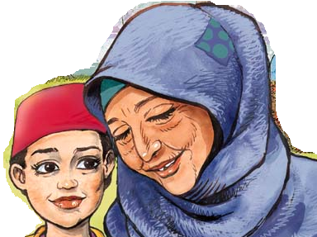
“I got it mom” said Nizam. “I will make sure to follow this, so that my Allah (SWT) and my Ma’sumeen (AS) are happy with me”

“That’s like a good boy”, said his mother, while she hugged him.

WORKSHEET

Colour in the boxes of all the na-mahrams who should do hijab in front of you
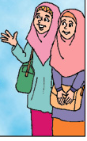




mother’s friend
Classmate Sister Sister’s friend

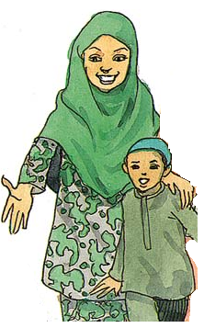
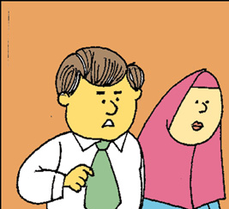
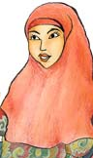

Uncle’s wife (mami) Father’s sister (phuppo) Mother’s friend

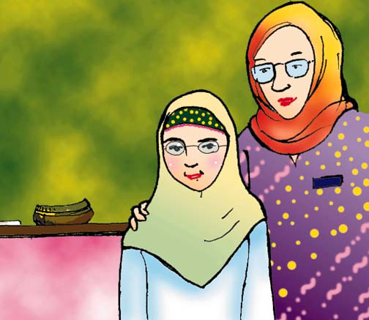


Cousin Mother’s sister (khala)
WORKSHEET

Is maryam’s hijab correct? Why?
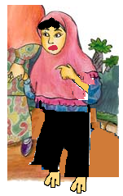
Fiqh Chapter 9

Practical Wuzu - Assessment

For M00

- Washing
  - Washes hands
  - Rinses mouth
  - Rinses nose
  - Washes face from top to bottom completely
  - Washes hands from elbow to fingers completely
  - Washes right hand first, then left hand
- Wiping
  - Wipes head with correct side of fingers
  - Wipes head from behind to front
  - Wipes feet from fingertips to mound
  - Wipes right feet first, then left hand
  - Wipes from the water which remains while washing left hand
  - Wipes while water is not dried
- General
  - Not much gap between different actions
  - Does not waste water

Fiqh Chapter 10
Practical Namaz – Assessment (M00)

Rak’at 1- Actions

Niyyat
  - Does niyyat before starting namaz
  - Says and understand Qurbatan Ilallah

Takbiratul Ahram
  - Says correct words
  - Straight, and calm

Qir’at
  - Recites Suratul Hamd
  - Recites Suratul Ikhlas
  - Straight, and calm
  - No rhythmic movement

Ruku’
  - Waits for a while, straight, before going to Ruku
  - Starts zikr after getting calm
  - Recites zikr
  - After reciting zikr, waits for a while, then stands up

Samiallah
  - Recites ‘Samiallah’
  - Recites ‘Samiallah’ standing straight and calm
  - After ‘Samiallah’, waits for a while, then goes to sajda

Sajda
  - Seven parts on the floor
  - Starts zikr only after becoming calm
  - Recites zikr
  - Stays calm during zikr
  - Correct part of thumb on the floor
  - After reciting zikr, waits for a while, then sits

Astaghfirullah
  - Recites ‘Astaghfirullah’
  - Recites ‘Astaghfirullah’ sitting straight and calm
  - After ‘Astaghfirullah’ , waits for a while, then goes to sajda

Sajda No. 2
  - Seven parts on the floor
  - Starts zikr only after becoming calm
  - Recites zikr
  - Stays calm during zikr
  - Correct part of thumb on the floor
  - After reciting zikr, waits for a while, sits for a while, and then stand up for second rak’at
  - Recites Bihawl

Rak’at 2

Qir’at
  - Recites Suratul Hamd
  - Recites Suratul Ikhlas
  - Straight, and calm
  - No rhythmic movement

Qunoot
  - Raises hand
  - Recites Qunoot

Ruku’
  - Waits for a while, straight, before going to Ruku
  - Starts zikr after getting calm
  - Recites zikr
  - After reciting zikr, waits for a while, then stands up

Samiallah
  - Recites ‘Samiallah’
  - Recites ‘Samiallah’ standing straight and calm
  - After ‘Samiallah’, waits for a while, then goes to sajda

Sajda
  - Seven parts on the floor
  - Starts zikr only after becoming calm
  - Recites zikr
  - Stays calm during zikr
  - Correct part of thumb on the floor
  - After reciting zikr, waits for a while, then sits

Astaghfirullah
  - Recites ‘Astaghfirullah’
  - Recites ‘Astaghfirullah’ sitting straight and calm
  - After ‘Astaghfirullah’ , waits for a while, then goes to sajda

Sajda No. 2
  - Seven parts on the floor
  - Starts zikr only after becoming calm
  - Recites zikr
  - Stays calm during zikr
  - Correct part of thumb on the floor
  - After reciting zikr, waits for a while, then sits

Tashahhud
  - Recite tashahhud
  - Recited tashahhud sitting straight and calm

Salam
  - Recite all 3 salams
  - Recited salam sitting straight and calm

Closing
  - Recite Allahu Akbar three times

Recitation Assessment

For this age, the student should be able to recite fairly well, but may not be fully accurate

  - Takbiratul Ahram
  - Suratul Hamd
  - Suratul Ikhlas
  - Zikr-e-Ruku’
  - Samiallah
  - Zikr-e-Sajda
  - Astaghfir
  - Bihawl
  - Qunoot
  - Tashahhud
  - Salam 1
  - Salam 2
  - Salam 3

