Aqaid Chapter 01

Kalima

⬆   
There is no God but Allah (SWT)

   
[Prophet] Muhammad (SAW) is the messenger of Allah

  ▪ 
[Imam Ali] (AS) is the ‘Wali’ of Allah.

   
And is the ‘Wasi’ of the Prophet (SAW) of Allah

   
And is the immediate successor of
him [Prophet Muhammad (SAW)]
WORKSHEET

COLOUR MOSQUE

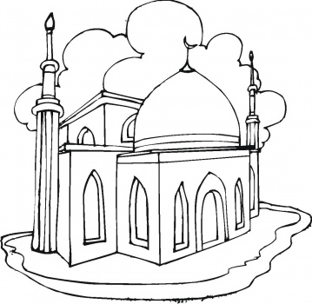

Aqaid Chapter 02

My First Counting

Hindi/Urdu Version

Allah Aik
Panjetan Paanch
Imam Baara
Ma’sum Chowda
Nabi Aik lakh Chobees Hazar
Rasool Teen-so-Tera
Ulul Azm Rasool Paanch
Aasmani Kitabein Chaar
Karbala kay Shaheed Bahattar

English Version

Allah One
Panjetan Five
Imam Twelve
Ma’sum Fourteen
Nabi One hundred twenty-four thousand
Rasool Three Hundred Thirteen
Ulul Azm Rasool Five
Heavenly Books Four
Karbala’s Martyrs Seventy Two

WORKSHEET
In front of each name, write how many are thay?



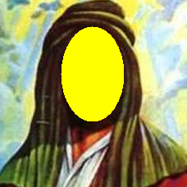
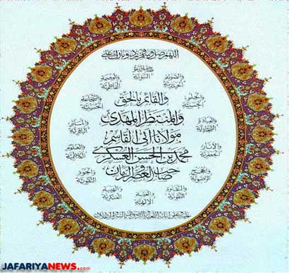
Imam
masoom

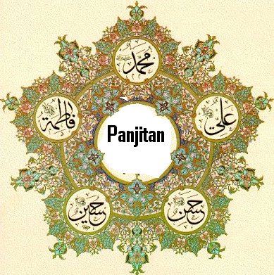

Aqaid Chapter 03

Usool-e-Deen

Hindi/Urdu Version

Usool-e-Deen, yani deen ki jadein

Usool-e-Deen paanch hain:

Awwal Tawheed

Doosrey Adal

Teesrey Nabuwwat

Chowthey Imamat

Panchwey Qayamat

English Version

Usool-e-Deen means roots of religion

Usool-e-Deen are Five:

First Tawheed

Second Adal

Third Nabuwwat

Fourth Imamat

Fifth Qayamat
WORKSHEET
Number the following


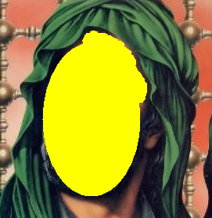

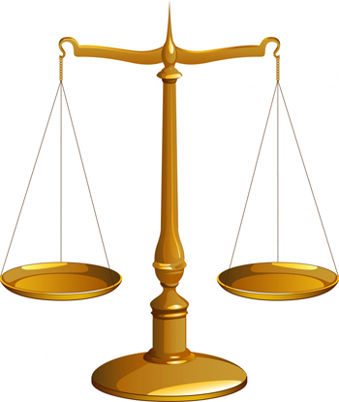

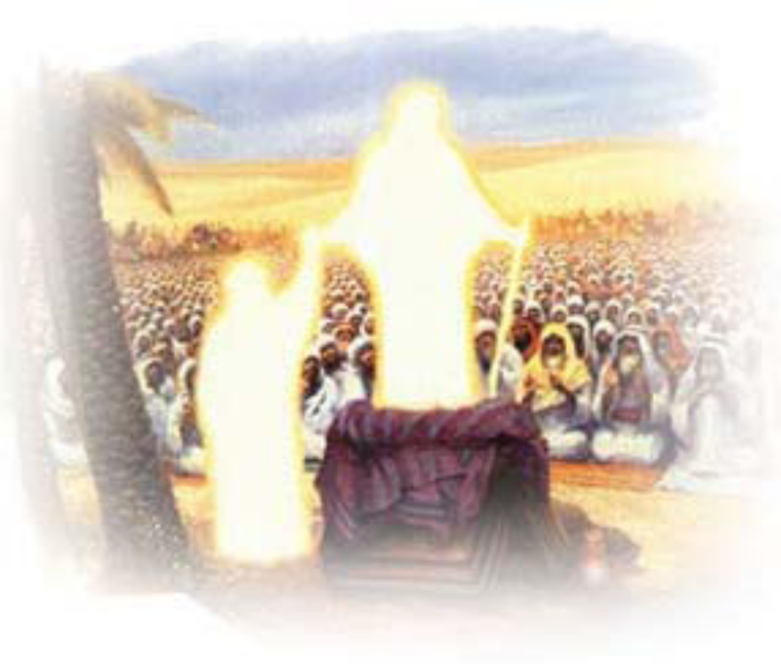

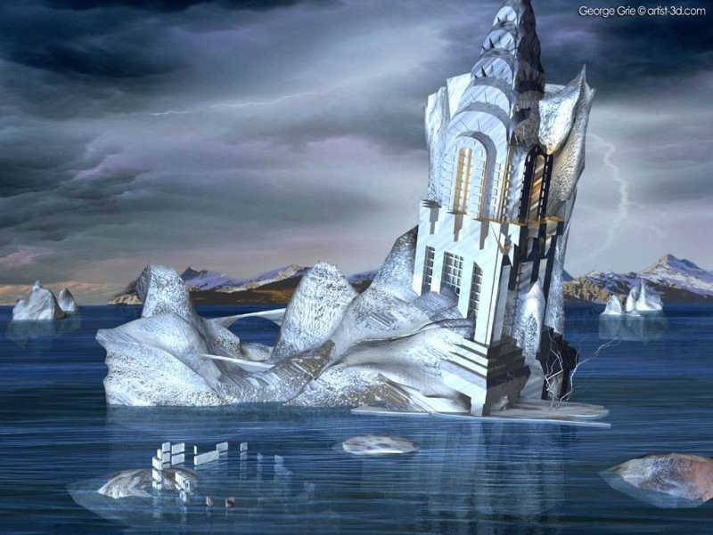

Aqaid Chapter 04

Tawheed
⬆

Tawheed means there is only one God

His name is ALLAH.

ALLAH looks after us and loves us very much.

ALLAH is the One whom we ask for help

ALLAH is the One whom we will go back to

ALLAH is the one we pray to.

ALLAH has made everything.
- He made the world.
- He made all of us, you, me, your mummy, daddy and everyone else.

- He made all the animals
- He made the trees and the flowers
- He made the sky with the sun and the moon.
- He made everything.

ALLAH is the strongest ever.
- He is stronger than any person.
- He is stronger than any animal
- He is stronger than anyone or anything

ALLAH is the cleverest
- He is cleverer than any one ever.

We have to listen to Him and do whatever He tells us to do.

ALLAH does not need anyone
We all need ALLAH

WORKSHEET


Colour the pictures:
Allah is the Creator of everything!


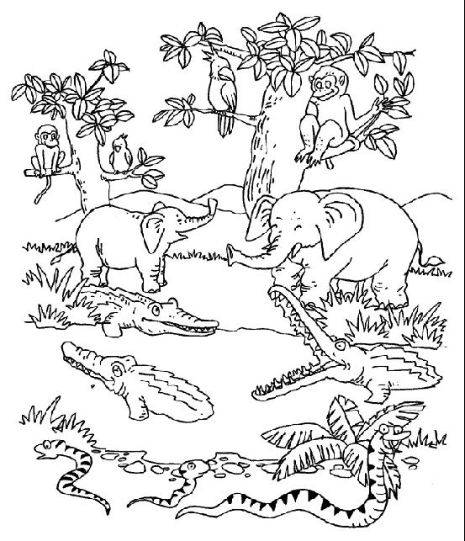
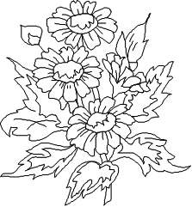


WORKSHEET

Who made the sun and the clouds and the mountains and the rain?
Darken the lines, and colour the picture

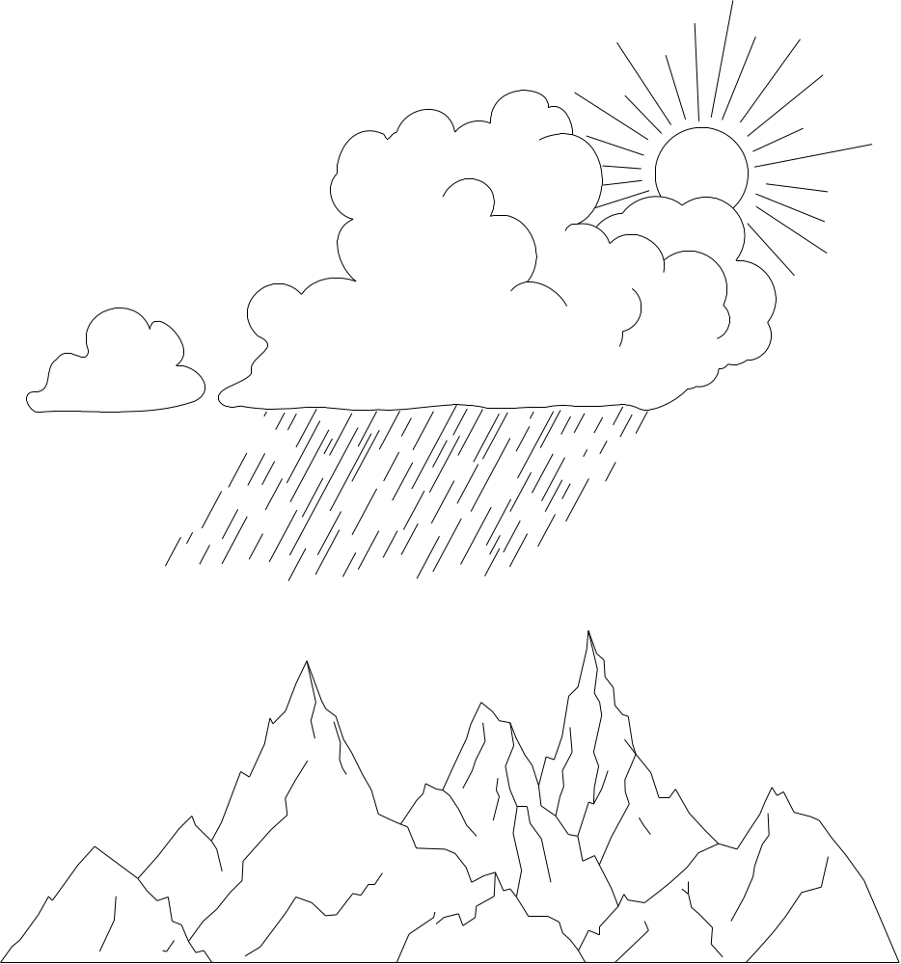

WORKSHEET

JOIN THE DOTS AND COLOUR IN THE PICTURE AS YOU SAY:

            ⬆ ⬇ ⬇ 
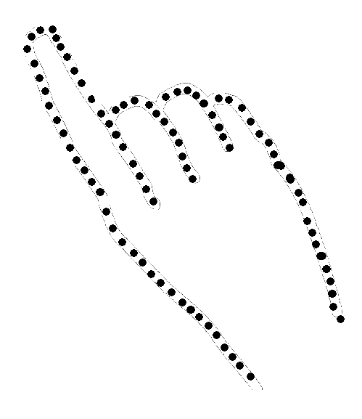

Aqaid Chapter 05

Why Can’t I See Allah

One day Hasan asked his mummy, "Why can't I see Allah?"

His mummy said, "Allah is not a thing we can see. He has never been seen and will never be seen."

Hasan asked, "Mummy, if we can't see Allah, then how do we know He is really there?"

Hasan's mummy smiled and told him to pinch himself. Hasan did what his mummy told him to do

"Ouch! That hurt me" he said as soon as he pinched himself.

His mummy started looking all over Hasan looking for something.

"What are you looking for mummy?" Hasan asked.

"I'm looking for the pain" she replied.

Hasan looked puzzled "But mummy, you can't see the pain."

His mummy smiled and said "just as the pain is there even if you can't see it, Allah is also there although you can't see Him."

Then she continued "although you can't see Allah you can see all the things He has made - by looking at yourself and all around you."

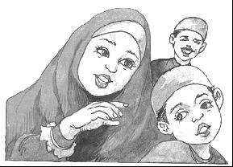
I understand now Mummy. Thank you

WORKSHEET

Colour the pictures below
Always keep in mind what Hassan’s mother told him
Can you see hunger? Then how do you know that you are hungry?
In the same way although you can’t see Allah, HE exists

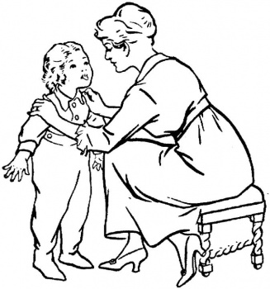

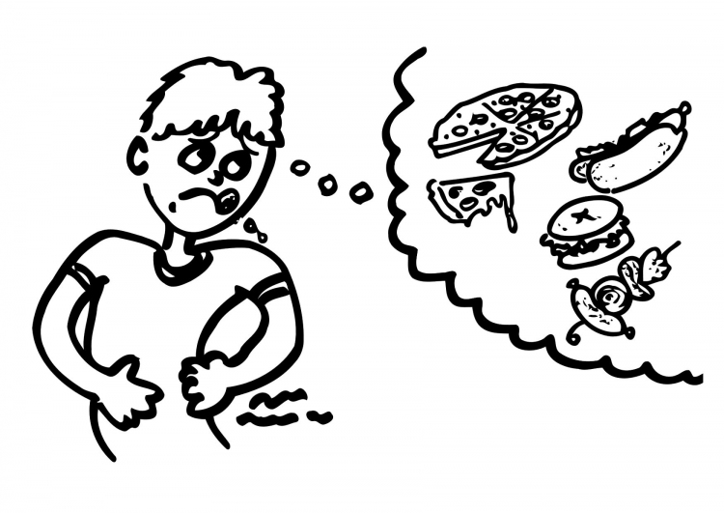

Aqaid Chapter 06

Footprints of Tiger

Once there was a farmer who was a very good man. He worked hard on his farm and prayed Namaz on time every day.

One day he saw a sick man lying on the roadside. He helped him up and took him home to look after him.

The next morning when the farmer woke up to pray Namaz he woke up his guest who said he did not want to pray.

The man said that he could not see Allah so how could he pray to One whom he could not see. The farmer did not say anything.

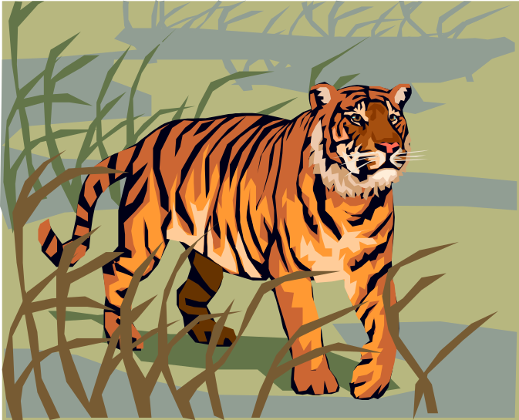
The next day the man was feeling better and wanted to go home. The farmer walked with him across the fields. Suddenly they saw footprints. The man told the farmer that they were the footprints of a tiger.

"I don't believe that ! " said the farmer . "I can't see a tiger here!"

The man looked surprised and said "Are these footprints not enough to tell you that a tiger was here?"

The farmer said "Dear brother! When you saw the footprints you believed that a tiger had passed here; so are not the moon, the sun, the flowers,and the trees signs enough to make you believe that there must be One who made them?"

The man thought for a while and said "You are right ! We cannot see Allah with our eyes but we can understand from the things he has made that He exists."

Our Holy Prophet Muhammad (SAW) has told us that:

When you see the footprints of a camel in the sand, then you know that a camel has passed by; even though you cannot seen the camel itself.

In the same way, when you see all the creations of Allah; you know He is there, even though you cannot see Him.

WORKSHEET

Can you SEE the pain when you pinch yourself?

Although you can't see the pain you know it's there - don't you?

Colour the picture below; then cover the camel with your hands, so that you can't see it anymore.

By seeing the footprints you know the camel has been there although you cannot see him.

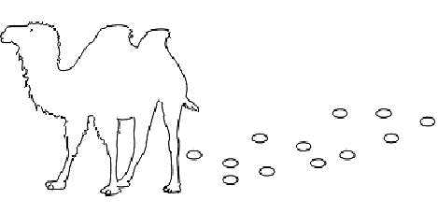

WORKSHEET

Here are some creations of Allah so that you know He is there even though you cannot see Him.






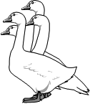
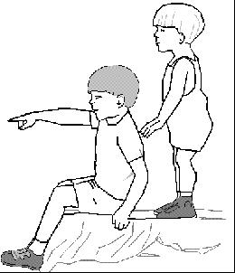


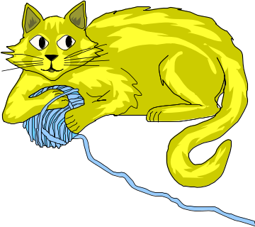

WORKSHEET

Darken the lines and colour the pictures below

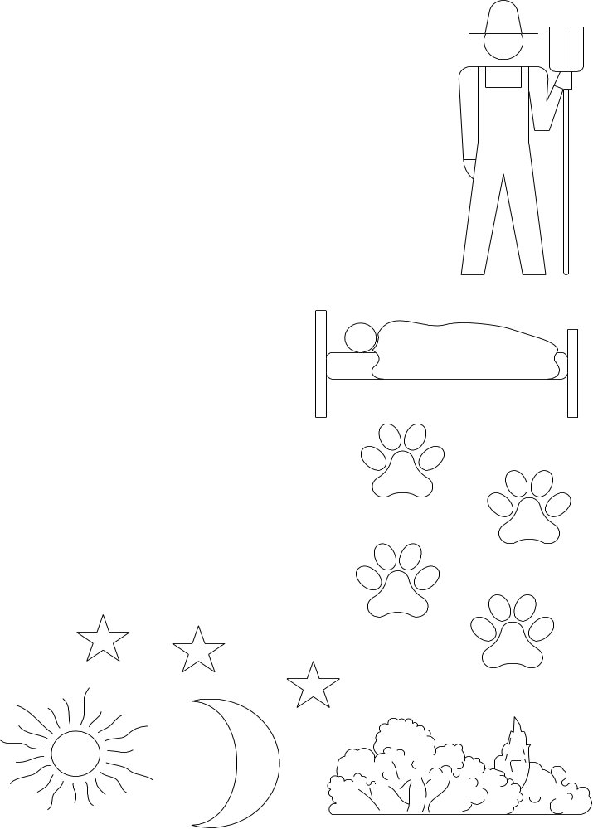
Aqaid Chapter 07

Allah Can See & Hear Everything

Zainab’s mummy wanted to know if she really understood that Allah can see and hear everything.

So one day when Zainab came home from school, her mother gave her a big present and said: "Zainab you can only open this present in a place where no one can see you."

Zainab thought this would be very easy.

She took the present and ran upstairs, but her father was there. So, she ran into the garden, but the birds were there. Then, she ran into the bathroom, but there was a spider there.

Zainab thought for a moment then she ran into a store cupboard under the stairs and she looked around. At last there was no one there.

She was just about to open the present when suddenly she remembered what her mummy had told her: that Allah can see and hear everything.

Zainab went back to her mummy without opening the present.
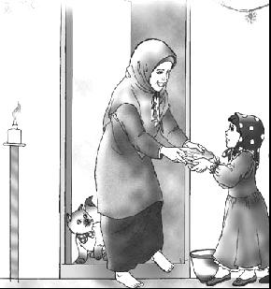
Why didn’t you open your present?

Because there is no place where Allah cannot see me.

Allah can see and hear everything, but He does not need eyes or ears like we do.

There is nowhere that you can hide where Allah cannot see you.

There is nothing that you can say which Allah cannot hear, even if you whisper it softly.

WORKSHEET

Who can see you everywhere? _______________________

Colour in the present Zainab’s mummy gave her.


Zainab’s mummy told her that she could open the present because she was such a clever girl.

Draw what you think was inside Zainab’s present:

Aqaid Chapter 08

Adal

Adal means:

- Allah is fair to everyone

- He never does anything wrong.

- He never forces anyone to do bad things and then punish them.

- He will always reward those who obey Him

Sometimes we see people that some people are rich and some are poor. Some are dark and some are fair. Some are intelligent and some are not so.

At first it looks like Allah (SWT) is not fair with them, but when we know Allah (SWT) more and more, we realize that Allah (SWT) does not need anything, so why would he be unfair. It is for our own benefit that the difference is there

Once day a person was going in a car, when suddenly someone else hit his car. He thought that why Allah (SWT) is unfair with him? When he drove further, some thiefs were waiting for him, and asked him to vacate the car, as they wanted to rob him of the car. But when they noticed that the car is damaged, they decided to let go of him. This person was now very happy and understood that a little damage of the car actually saved him from worse which could have come

Always believe that Allah (SWT) is fair to every one. If he has promised Jannat for those who do good deeds, he will surely give sawab and Jannat.

WORKSHEET

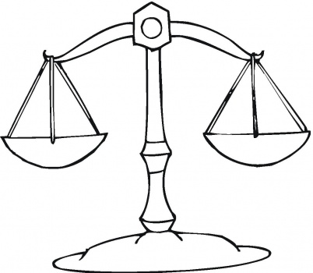
Colour the following:





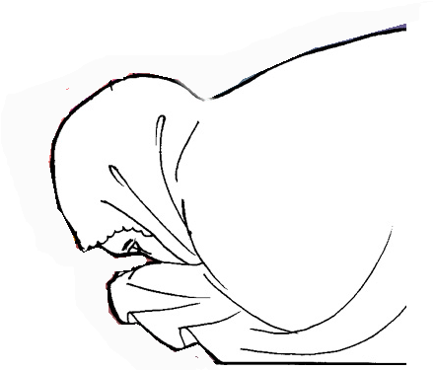

Aqaid Chapter 09

Nabuwwat

Nabuwwat means prophethood

They teach us how to be good believers and followers of Allah (SWT)

Allah wants us to live a good life. For this we need guidance, hence Allah (SWT) has sent 124,000 Prophets for our guidance

Prophet gets knowledge from Allah (SWT) and he is ma’sum (infallible)

There are 124,000 Prophets.

The 1st Prophet is Prophet Adam (AS)

The last Prophet is Prophet Muhammad (SAW).

Prophet Muhammad (SAW) taught us what Allah wants us to do.

He taught us about the religion of Islam.

He taught us how to pray and to do good things that make Allah happy.

If we do everything that Prophet Muhammad (SAW) taught us, then we will be true Muslims and good human beings

These are a few things our Holy Prophet Muhammad (SAW) taught us:

- Being kind to others
- Obeying our parents
- Praying on time
- Reciting Qur’an.

WORKSHEET

Draw 3 things that Prophet Muhammad (SAW) taught to do to make Allah happy:

E.g.: Helping Mummy:
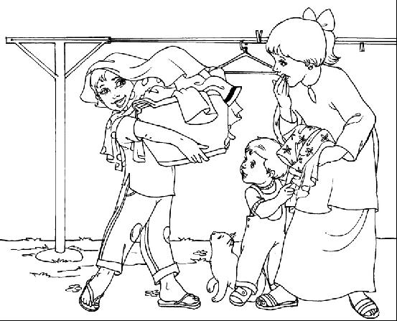

Aqaid Chapter 10

Imamat

Allah had told Prophet Muhammad (SAW) to teach the people everything that Allah wanted them to know

Prophet Muhammad (SAW) is the last prophet of Allah (SWT) and after him, no prophet will come

After the last prophet (Prophet Muhammad SAW), Allah has appointed Imams for our guidance and safeguarding of the religion Islam

There are 12 Imams, and they are also ma’sum, like prophets
After the death of Prophet Muhammad (SAW), the Imams would be there to help people if they forgot anything.

The 1st Imam is Imam Ali (AS).

The last Imam is Imam Mahdi (ATFS).

Imam Mahdi (ATFS) is still alive and is the Imam of our time.

We also call him as:
- Imam-e-Zamana
- Sahib-uz-Zaman

WORKSHEET

Match the following and color the pictures

last imam
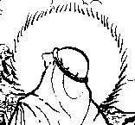

last prophet

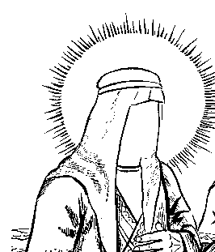

1st imam

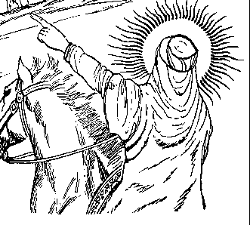

Aqaid Chapter 11

Twelve Imams

There are twelve Imams:

First Imam | Imam Ali (AS)
Second Imam | Imam Hasan (AS)
Third Imam | Imam Husain (AS)
Fourth Imam | Imam Ali Zainul Abideen (AS)
Fifth Imam | Imam Muhammad Baqir (AS)
Sixth Imam | Imam Ja’fer Sadiq (AS)
Seventh Imam | Imam Musa Kazim (AS)
Eighth Imam | Imam Ali Raza (AS)
Ninth Imam | Imam Muhammad Taqi (AS)
Tenth Imam | Imam Ali Naqi (AS)
Eleventh Imam | Imam Hasan Askari (AS)
Twelfth Imam | Imam Mehdi (ATFS)
AS means Alaihis Salam
ATFS means Ajjalal-laho ta’ala farajohu shareef
SAW means Sal-lal-laho Alaihe Wa Alehi Wasallam

Twelfth Imam Hazrat Mehdi (ATFS) is the Imam of our time, and is alive

When we hear or say the name of our 12th Imam (ATFS) it is better to:
- put our right hand on our head
- bow our head in respect
- and recite Salawaat.

Ma’sumeen:

Ma’sumeen are:
- Prophet Muhammad (SAW)
- Bibi Fatimah (AS)
- Twelve Imams

1+1+12=14

Panjetan:

Penjetan include the following 5 people:

- Prophet Muhammad (SAW)
- Imam Ali (AS)
- Bibi Fatimah (AS)
- Imam Hasan (AS)
- Imam Husain (AS)
WORKSHEET:

Colour the 12 stars remembering that there are 12 Imams (a.s.):

3
2
1
6
5
4
9
8
7
12
11
10

WORKSHEET

In the hand below, colour:

YELLOW = Prophet Muhammad (SAW) BLUE = Imam Ali (AS)

PINK = Bibi Fatimah (AS) GREEN = Imam Hasan (AS)

RED = Imam Husain (AS)

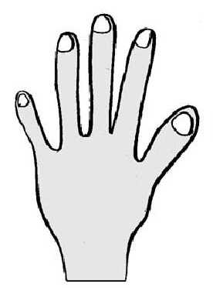
Prophet Muhammad (SAW)
Imam Ali (AS)
Bibi Fatimah (SA)
Imam Hasan (AS)
Imam Husain (AS)

Aqaid Chapter 12

Qayamat

One day everyone will die, after that Allah (SWT) will make alive all human beings

Everyone will be gathered at a place, where he/she will be shown what he/she has done in this life. He/She will be questioned about everything what he/she has done in this world

Anybody who works hard for an exam gets a good result and a good gift. In the same way, whoever does good deeds in this world will get a good result & gift in the hereafter

This day is known as Qayamat (Day of Judgement). On this day, people will be rewarded for their good deeds and punished for their bad deeds

WORKSHEET
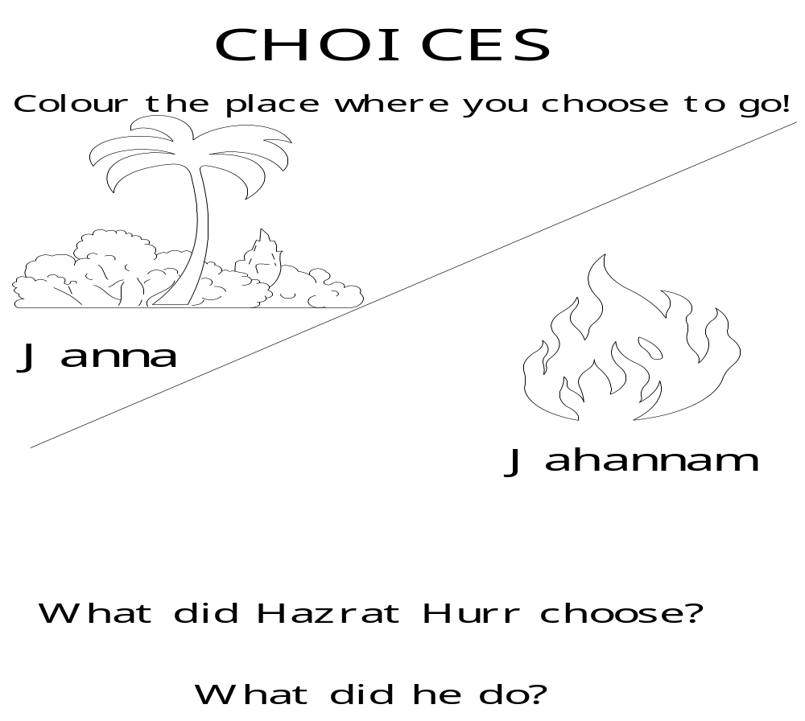
Aqaid Chapter 13

HOLY QURAN

The Holy Quran is the last book of Allah (SWT) which has been revealed on Prophet Muhammad (SAW) for our guidance

- We get sawab by seeing the script of Holy Quran
- Allah (SWT) is pleased when someone recites Holy Quran
- We shall follow the Holy Quran

The Holy Quran teaches us to:
- worship only Allah (SWT)
- treat others kindly
- respect and serve parents
- avoid bad deeds and do good deeds

The Holy Quran also has many true, interesting and moral stories of the times of previous Prophets (AS)

The Holy Quran has:
- 114 Surahs
- 30 Paras
- 6666 Ayats

Before reading the Holy Quran, it is important to start with
- A’uzu billahi minash shaitanir rajeem
- Bismilla hir Rahma nir Raheem

Except Surah Tawbah, which is the ninth Surah, all Surahs begin with Bismillah

We should pronounce the words correctly and read slowly

Some ayats of Quran are known as Ayat-e-Sajda, which means that when we recite them, it is necessary to do sajda. 4 ayats are there in Quran where sajda is necessary, and there are many others on which sajda is better, not necessary

WORKSHEET

Which is the largest surah of the Holy Quran?

Colour the picture below

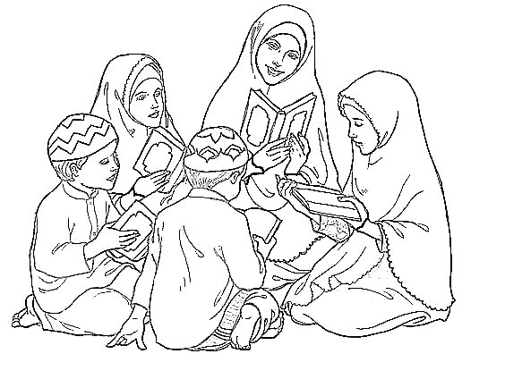

Aqaid Chapter 14

Angels

Allah created lots of angels, doing different things. Some deliver His messages, whilst some have special jobs like looking after each one of us, some deliver Rizq, some bring rains, some blow winds etc.

Each of us have two angels who write down everything we do. The one on the right side writes down all our good deeds whilst the one on the left side writes down all our bad deeds.

We cannot see angels but we know that they are there.

Some of the very special angels are:

Jibrail | He delivers the commands of Allah to His Prophets. It was Jibrail who brought the ayaat of the Quran to Prophet Muhammad (SAW).
Meekaail | He distributes sustenance (rizq) to Allah's creation. Rizq is the essential things required for life. e.g. air, water, food, clothing, shelter
Izraail | He is the angel who is responsible for death. He takes us back to Allah
Israfeel | He will announce the end of the world just before the day of Qayamat

Angels are ma’sum, i.e. they don’t do sin.

Angels are created from noor (light)

WORKSHEET

Match the name of the angel with the tasks which he does

Jibrail |  | Delivers the commands of Allah to His Prophets.
Meekaail |  | Distributes sustenance (rizq) to Allah's creation.
Izraail |  | Responsible for death
Israfeel |  | Announces the end of the world just before the day of Qayamat

WORKSHEET

Colour the pictures of the angels and try to learn what they do

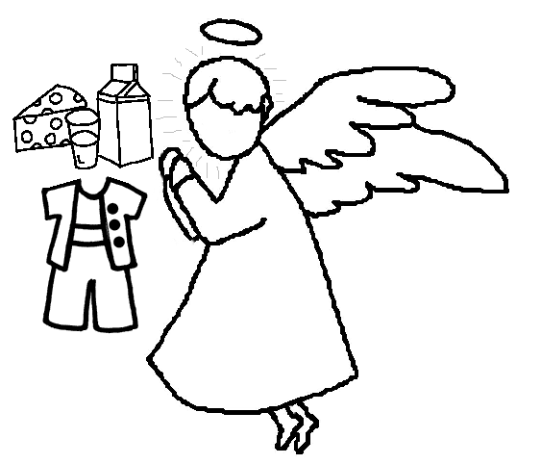
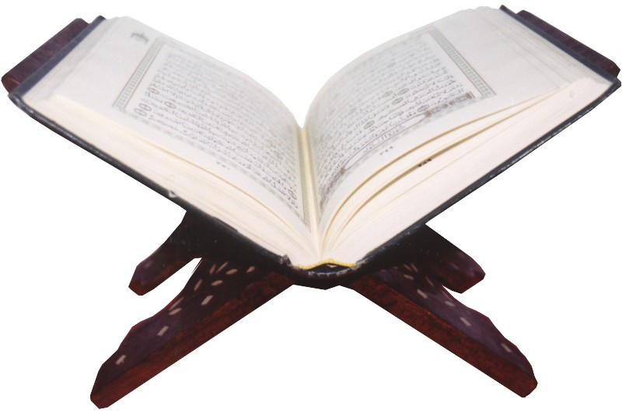

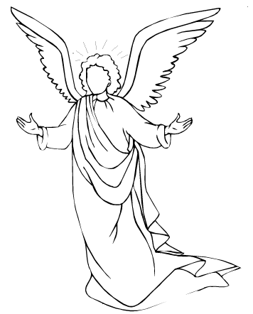

Jibrael

Meekail

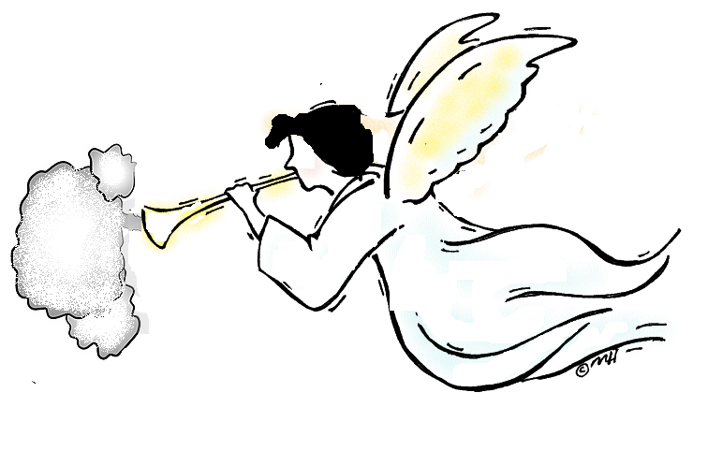
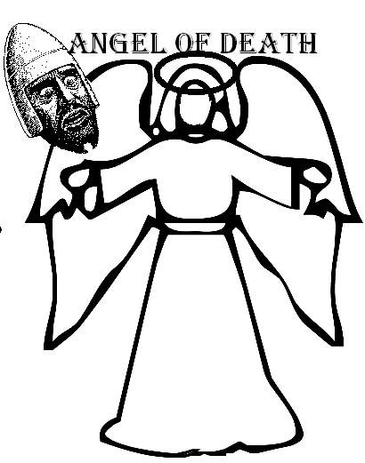

Meekail
Israfeel

Aqaid Chapter 15

Shaytan

Before Allah made human beings, He made other creatures such as
- Angels
- Jins
- the sun and the moon
- the sky
- the earth
- the animals
- the trees
- the angels

Among Jins,
- some were good and obedient and
- some were bad and disobedient.

There was a good Jin whose name was ‘Azazeel’ so Allah let him come to the heavens to live with the angels.

Now Allah decided to make man.

The 1st man Allah made was Prophet Adam (AS)

Allah told everyone in the heavens to bow down to Prophet Adam. All the angels listened to Allah and bowed to Prophet Adam but Azazeel did not listen to Allah.

He said that he was made from fire and was better than Prophet Adam (who was made from clay) so he would not bow down to him.

Iblees had been very bad because he did not listen to Allah. So Allah told him that he was not allowed to live in the heavens anymore and that he would go to hell and burn in the fire.

Hence he became enemy of Prophet Adam (AS) and human beings.

He tries his best that we don’t go to Jannat

We must ask refuge (panah) of Allah from Shaytan. We must always ask Allah (SWT) to save us from Shaytan

Whenever we think of bad things, we must immediately say A’uzubillahe Minash Shaytanir Rajeem’

Azazeel is also called as Iblis, and Shaytan

WORKSHEET: SHAYTAN:

Put a big cross on the picture of fire-of-hell where Shaytan will be.

You are not going to go in there because you listen to Allah.



