Akhlaq Chapter 01

Bismillah

   
(I begin) in the name of Allah, the most Kind and the most Merciful.

We should say     before we do anything because we want Allah to help us in what ever we are doing.

If we say     then Allah keeps Shaytan away from us and he cannot come and try to spoil what we are doing.

   

WORKSHEET

Colour in all the pictures before which you should say Bismillah:

Akhlaq Chapter 02

Woman’s Ring

A long time ago there lived a woman who always used to say     before she did anything.
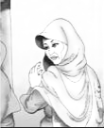

Now every night this woman, before she went to sleep would take off her ring and put it in her cupboard. And, as always, before she took off her ring she would say     

Her husband did not believe that just by saying     Allah would help you.

One night to show his wife that     did not make any difference, the husband took his wife's ring from the cupboard, where she had kept it safely, and threw it in the river.

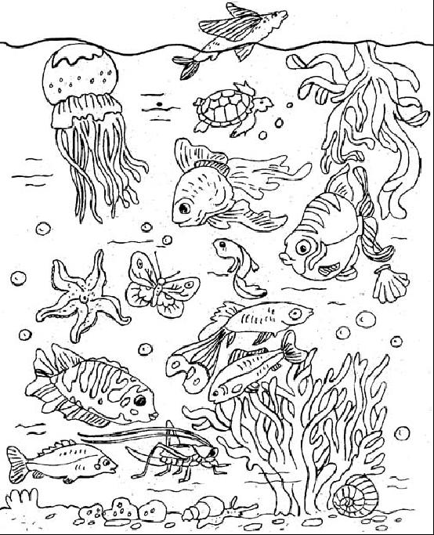
The next morning because the woman was late getting to the shops, she did not have time to get her ring, which she thought was still in the cupboard.

The woman went to the shops and bought a fish for their dinner that evening. When she got home, she began to cut the fish so that she could cook it and what do you think she found inside the fish?

Yes, there was her ring that her husband had thrown in the river. The fish had swallowed it.

The woman was very surprised to find her ring in the fish, and when her husband came home she told him all about it.

The husband was shocked. He then told her how he had thrown her ring in the river. He also told her how sorry he was and that now he truly believed that Allah looks after anyone who says:    

Moral:
Always say     before you do anything so that Allah will also look after you and when Allah looks after you then no-one can hurt you.

Akhlaq Chapter 03

Student Walks on Water

A long time ago, there lived a students who always came late to school.

One day, his teacher, Syed Murtaza, asked him why he was always late.

He replied that it was because he had to catch a boat to cross the river to get to school, and the boat was always late.

His teacher told him that he was giving him a piece of paper with something special written on it and with this paper in his hand the man would be able to walk on the water, but he must not look at what was written on the paper.

The next day the man went to the river and with the paper in his hand he stepped onto the water and began to walk on the water. The man reached his school in time.

Every morning the man walked on the water and reached his school on time, until one day when he looked at what his teacher had written on the paper.
It said:

The man thought to himself: "is that all it says". He then took the paper and went to walk on the water but this time he began to sink. He tried and tried but could no longer walk on the water.

That day he arrived to school late because he again had to wait for the boat to take him across the river.

When his teacher saw that he was late again he said to him that because he had thought what was written on the paper was not very important, he could no longer walk on water.

is very powerful if you truly believe in it.

WORKSHEET:

Colour the picture. Can you see the ring?

Draw 3 things you can start with:    
E.g.: Before starting your work:
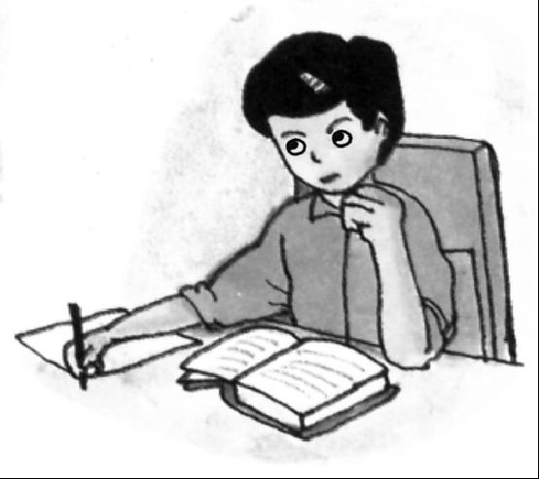
Akhlaq Chapter 04

Salawaat

Ahle-Bayt (AS): The family of the Prophet (SAW) are called his Ahle-bayt or Ahlul-Bayt

Whenever you hear the name of our Holy Prophet or his family, you should recite Salawaat.

    ▪  
O Allah!
Send Your blessings on Prophet Muhammad (SAW)
and his Household (Ahlul-bayt)

Salawaat is also known as Durood

When you are sitting in mosque and do not understand the lecture or Majlis, you should recite as many Salawaat as possible.

When you recite Salawaat you are asking Allah to send His blessings to the Holy Prophet and his family.

Inshallah on the day of Qayamat (Judgement) the Holy Prophet (SAW) and his family will ask Allah to forgive you in return for all the Salawaat you sent to them.

WORKSHEET:

    ▪  
Colour in the 14 beads that are on this special Tasbeeh of Salawaat for:
- the Holy Prophet (SAW)
- his daughter Bibi Fatima (AS) and
- the 12 Imams(AS)

1+1+12=14.

Remember to recite Salawaat as you colour each bead.

Akhlaq Chapter 05

Salaam-un-Alaykum

We are Muslims, which means that everything we do is for Allah.
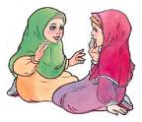
Allah tells us that all Muslims are brothers and sisters and that we should care for each other.

By saying Salaam-un-alaykum you are not just saying hello, but you are telling the person that you care about them and you will not hurt them in any way because

Salaam-un-alaykum means "Peace be on you."


So before you talk to a Muslim you should first say Salaam-un-alaykum. It is also good to shake hands with them. (Boys with boys and girls with girls)

When you wake up in the morning the first thing you should do is say Salaam-un-alaykum to your mummy and daddy.

If someone says Salaam-un-alaykum to you then you should reply with Wa-alaykum-us-Salaam Wa Rahmatullahi Wa Barakatuhu.

Wa Alaykum-us-Salaam means “And Peace be on you.”

Wa Alaykum-us-Salaam Wa Rahmatullahi Wa Barakatuhu, Taqi
Salaamun Alaykum Javad
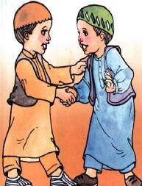

Allah does not like if you do not reply to Salaam.
WORKSHEET

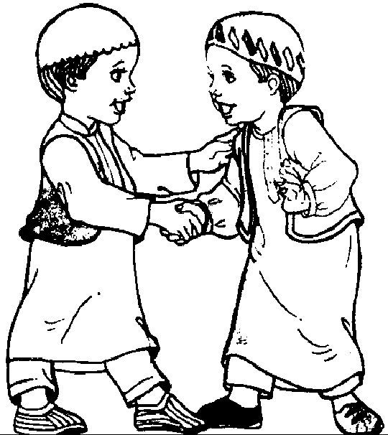
Say Salaam-un-alaykum and shake the hands of the person sitting on your right and then shake hands with the person on your left. Then Colour the picture:

Akhlaq Chapter 06


Fi-Amanillah & Khuda Hafiz

We are Muslims, which means that everything we do is for Allah.

Allah tells us that all Muslims are brothers and sisters and that we should care for each other.

By saying Fi-Amanillah, you are not just saying good-bye, but you are telling the person that you care about them because you are asking Allah to take care of them

Fi-Amanillah means: I leave you in the careof Allah.

Khudah-Hafiz means: May Allah take care of you.

Whenever you leave your mummy and daddy you should say Fi-Amanillah to them so that Allah may keep them safe.
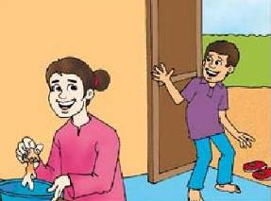
Fi-Amanillah Mummy
Fi-Amanillah Javad

Before you go to sleep you should say Fi-Amanillah.

WORKSHEET

Colour in the picture of the friends saying Fi-Amanillah to each other.

Akhlaq Chapter 07


Toilet Manners

You should go to the toilet as soon as you need to, and not wait to finish what you are doing.

Wear some slippers, because the floor may be wet and Najis

When you go to the toilet, close the door

When you go to the toilet, SIT on the seat. DO NOT STAND and do wee-wee

If there is a pipe connected to the tap, use it, else fill the jug with water and use it. Using pipe is better than using jug

If you have done wee wee, make sure to pour water three times.

If you have done poo, then wash yourself with your left hand until you are clean.


If you cannot wash yourself, call someone to wash you.

Flush the toilet and wash your hands.

Thank Allah for having made the water which cleans us

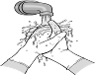
Say: Alhamdu lillah
⬇⬆⬇ 
(All praise is for Allah)

At school, if there is no pipe or jug, take some water in a cup. If there is no cup, then after you have done your wee-wee clean yourself with a tissue.

When you get home, tell your mummy that you used tissue and not water; so that she can help you become Pak again and also change your dress which may be Najis.

Remember that when you are sitting on the toilet you should not face or have your back to Qiblah.
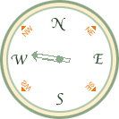

If the toilet is facing Qiblah then sit a little sideways.

Enter the toilet with your left foot.
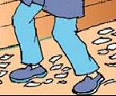

Leave the toilet with your right foot

WORKSHEET

Number the following in the right order, and then colour them in:
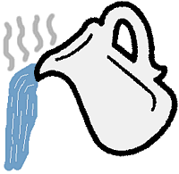
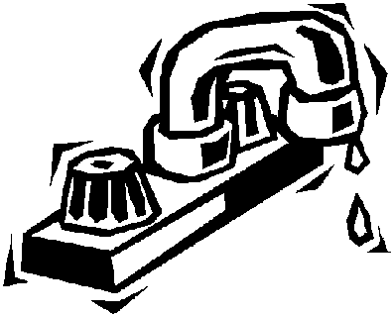
Akhlaq Chapter 08

Table Manners

When Zahid went home from Madressa, his mummy asked what he learnt today. This is how he explained to his mum what he had been taught about table manners.
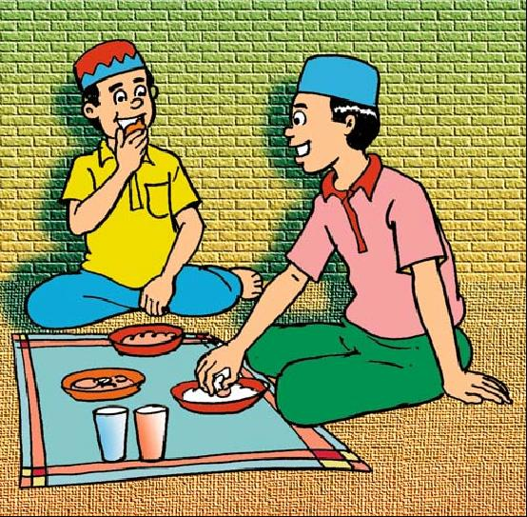
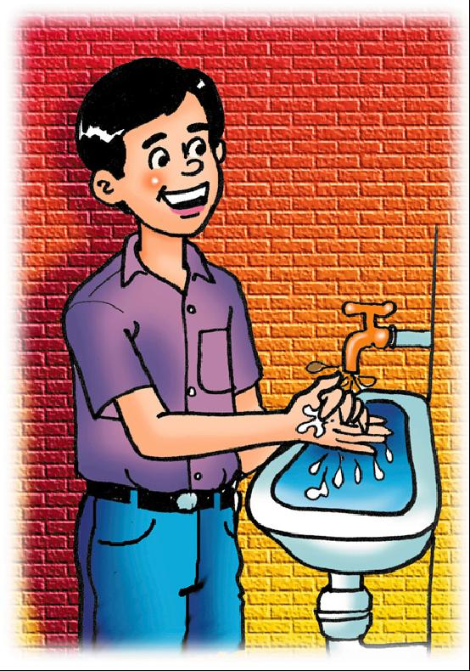
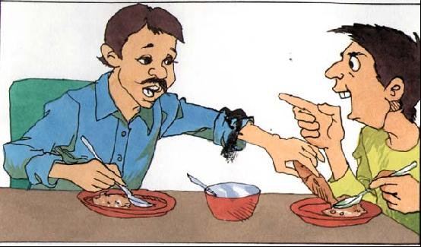
SALT

Always wash your hands before you start eating



Begin by saying “Bismil laahir Rahmaanir Rahim”

Take a pinch of salt before starting to eat.

Always eat with your right hand, and take small bites and chew the food.

Never talk with your mouth full or
look at other people faces or plate while eating.

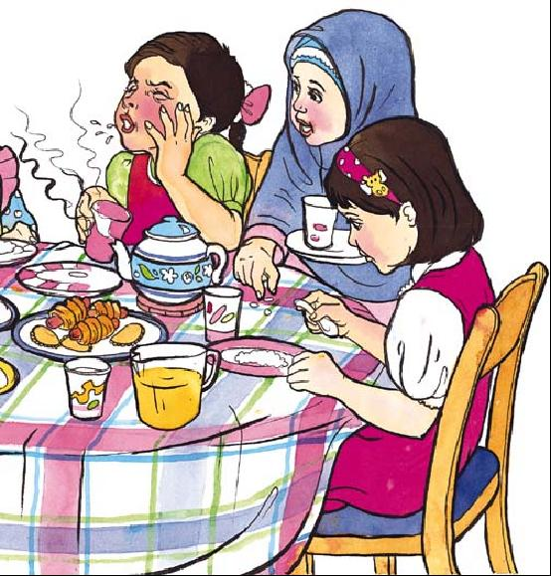

Don’t eat hot food or blow on it, and


Always finish all the food on your plate.

Do not over eat. Always put a little food on your
plate and add more if you are still hungry

Finally thank Allah for the food he has given you by saying :
AL-HAMDU-LILLAH (All praise is for Allah).

Wait for everyone on the table to finish before you get up

When you go home today show your parents what you were taught about table manners.

WORKSHEET

Look at the pictures below and put a cross on all the pictures that show bad table manners and a tick on all the pictures that show good table manners:


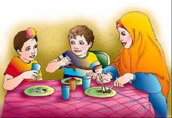
SALT
Akhlaq Chapter 09

Manners in the Imambargah



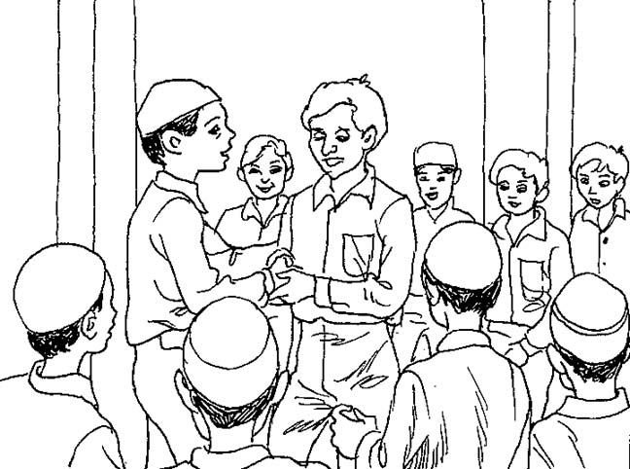



A mosque is a place for Namaz.

An Imambargah is a place for Majlis and other functions.

When you enter the Imambargah, remember to behave with respect:

Say Salaamun Alaikum to people as you see them

Remove your shoes

Do not talk during the Adhan, Namaz, Du'a or lecture

Find a place to sit. Do not squash anyone else around you

Listen carefully to the lecture

When ‘tabarruk’ is given, wait to be given one. Take only one

If you do not understand the lecture, recite Salawaat or Tasbeeh of Bibi Fatima (as)

Say khuda-hafiz to people as you leave
When leaving, leave slowly being careful not to push anyone

WORKSHEET

Look at the pictures below and put a cross on all the pictures that show what you must not do in an Imambargah and a tick on all the pictures that show good Akhlaq in an Imambargah:

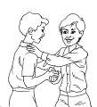




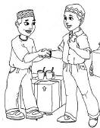
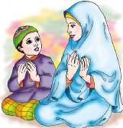
Akhlaq Chapter 10

Respect of Parents

Who do you think is most the most important person for you in the world?

Is it your best friend? OR Is it Superman?



Of course you know it is not them but your parents who are the most special people on this earth for you.




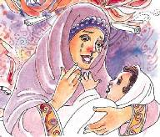
Your parents love you and take care of you.

When you were babies and your weren’t feeling well, your parents kept awake all night and made you comfortable.

They fed you and cuddled you when you were sad.

They always make you happy.

In the Holy Qur’an Allah tells us to respect our parents. We must:

- never talk to them in a loud voice
- never be rude to them
- always make them as happy as they make us.

WORKSHEET

Can you think of different ways you can be kind and loving to your mother and father? Draw what you think would make them happy?

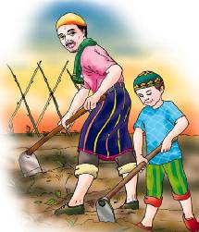
E.g.:

Akhlaq Chapter 11

What we should do/should not do?

What we should do?

We should follow our ALLAH, Prophet (SAW) and Imams (AS)
We should make our parents happy
We should respect our elders
We should listen to our teacher
We should learn our lessons
We should greet everyone with Salaam
We should always speak the truth
We should offer our prayers on time
We should love people who love Allah, Rasool and Imam
We should hate people who hate Allah, Rasool and Imam

What we should not do?

We should not lie
We should not bother our parents, and shall not make them angry
We should not say bad words
We should not listen to songs / music
We should not use other’s things without their permission
We should not say bad things about someone in his absence
WORKSHEET

Ruqayya is packing to go to Janna.

Circle what she needs to pack in her suitcase.

Kalima Good akhlaq Salaa

Kafan Sunglasses Fasting

Hajj Naughty deeds Qur’an

Story books Duas Swimming
Costume

Sadaqa Shorts T shirts
Akhlaq Chapter 12

Friday

Friday is the most important day of the week

Friday is the day of our Imam-e-Zamana (ATF)

We shall offer prayers, recite duas and do only those things on Friday by which Allah, Prophet and Imams get happy

We shall not spend Friday in games and play

WORKSHEET

Akhlaq Chapter 13

Friendship

A friend is a very important person in one's life.

Prophet Muhammad (S.A.W.) has said:

"The behaviour of everyone will be according to the beliefs and principles of his/her friend".

Qualities one should look for in a friend:

Knowledge

Imam Ali (A.S.) has said:

"The best of companions (friends) are those who have knowledge and patience."

If you have friends who have knowledge or are interested in learning then, rather than waste time talking about worthless things or gossiping you will talk about events and ideas.

Good Akhlaq

Because the akhlaq of a friend affects and rubs off on you it is important to have and be friends with those having good akhlaq. There is a Spanish saying which says:

"If you go to the wolves, it is howling which you will learn from them."

A Muslim friend is a mirror for his friend.

Imam Ja'fer As-Sadiq (A.S.) has said:

"A friend is someone who:
- What he feels towards you and what he says about you must be the same.
- He should think your good qualities as his good qualities and your bad qualities as his bad qualities.....
- He should help you as much as he can.
- He should not leave you alone when you are in trouble."
WORKSHEET

A friend need not be of your age. It could be family members/ teachers/ books.

Name a friend you have with these qualities:

      - Momin friend(s): _____________________________________________

      - Those who have knowledge and patience: ________________________

      - Those who have good akhlaq: __________________________________

      - Those who try to improve your bad habits: ________________________

      - Those who help you as much as they can: ________________________
Akhlaq Chapter 14

Manners of Sleeping
Before I go to sleep, I have a wash and change into my night clothes.
I visit the toilet and brush my teeth.
Then I do wuzu.
I go to my mummy and pappa and the rest of my family and say:
Fi amaanillah
   (May Allah keep you safe)
I give them a hug and a kiss.
I get into bed and recite Kalima, suras from the Qur’an that I know by heart, and a tasbeeh of Sayyida Fatemah Zahra (A.S.)
I think to myself, which angel has done more writing today, the angel on the right shoulder, writing all good deeds or the angel on the left, writing all bad deeds.
I then say sorry to Allah for anything bad that I have done and promise not to do it again.
I thank Allah for anything good that I have done and pray to do much better.
I never sleep on my tummy because that is how Shaytan sleeps.
Prophet Muhammad (SAW) used to sleep on his right side with his hand under his cheek.
I never sleep in total darkness. My mummy leaves a night light on for me – sometimes the light from the hall or the street shines through.

WORK SHEET:

Tick() in front of every column before sleeping.(with the help of your mother)

 |  | fri | sat | sun | mon | tue | wed | thu
1. | visit toilet/ brush teeth/wudhu
2. | Say fi amanillah to mummy/pappa
3. | Recite kalma/suras/ tasbeeh.
4. | Think of good deeds you did and thank A…for it.
5. | Think of bad deeds you did and ask forgiveness (tawbah) .

Mother’s signature:
Akhlaq Chapter 15

Manners of Waking Up
I am a Muslim. I wake up in the morning to pray Fajr Namaz. When I am getting out of bed, I say:
☺•    
Alhamdu-lillahi wallahu akber
(All praise is for Allah and Allah is greater than everything and everyone)
I send salaams to our 12th Imam (AS):
    ▪ 
Assalamu ‘alayka ya Hujjatibnil Hasan (ATFS)
I run to my mum and dad’s room and knock on the door and greet them saying:
▪ 
Assalamu ‘alaykum
(Peace be upon you)
They reply saying:
 ⬄▪ 
Wa ‘alaykumus Salaam
(And peace be upon you)
I greet everyone else in the house, put on my slippers and go to the washroom.
WORKSHEET
We remember Allah as soon as we wake up.
Draw / write / paste pictures of 3 other things you can do after you wake up

